Synthesis

***1) sync_reset_dff***

**Verilog code**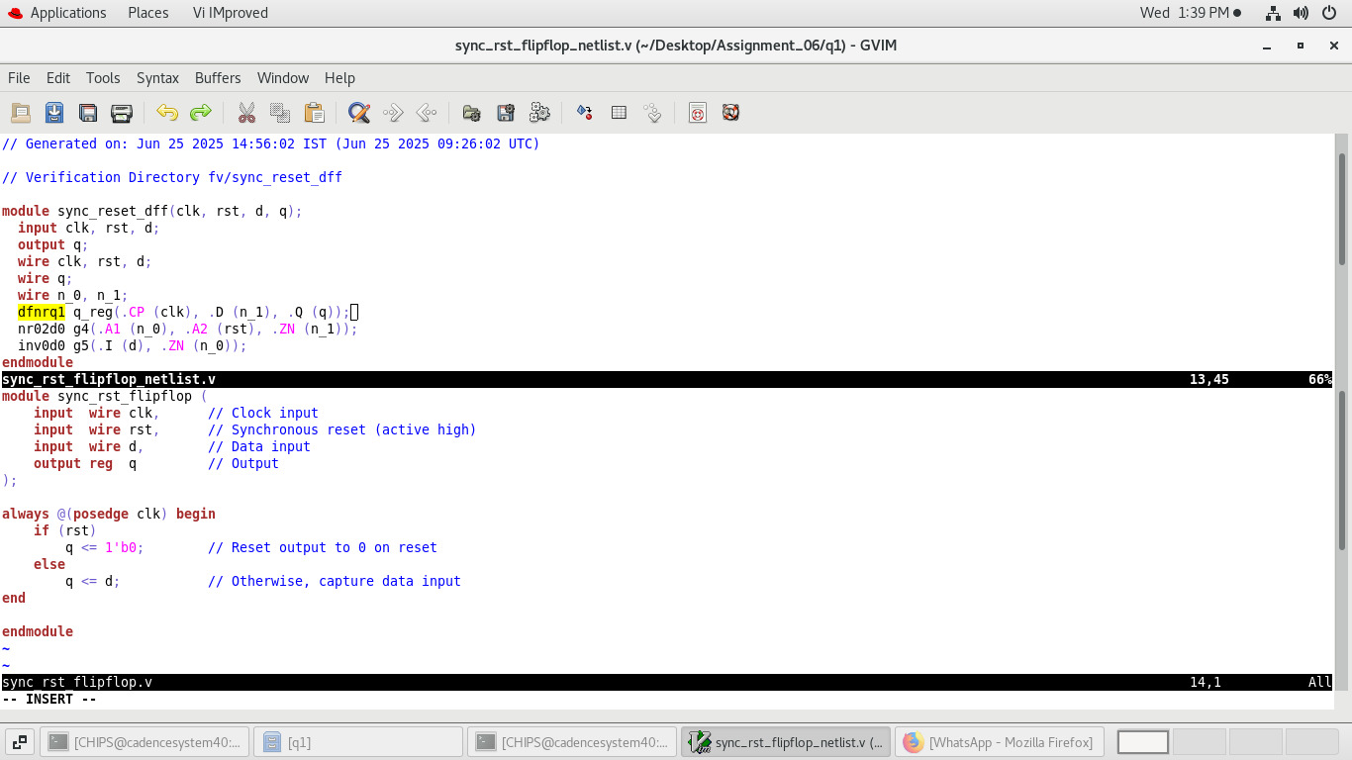

**Mark lib cell /instance /pins/nets**

Trace nets in netlist

1)n_1 is traced it is driven by g4/ZN and its load pin is q_reg/D

2)n_0 is driven by g5/ZN and its load pin is g4/A1

**Genus schematic: example**

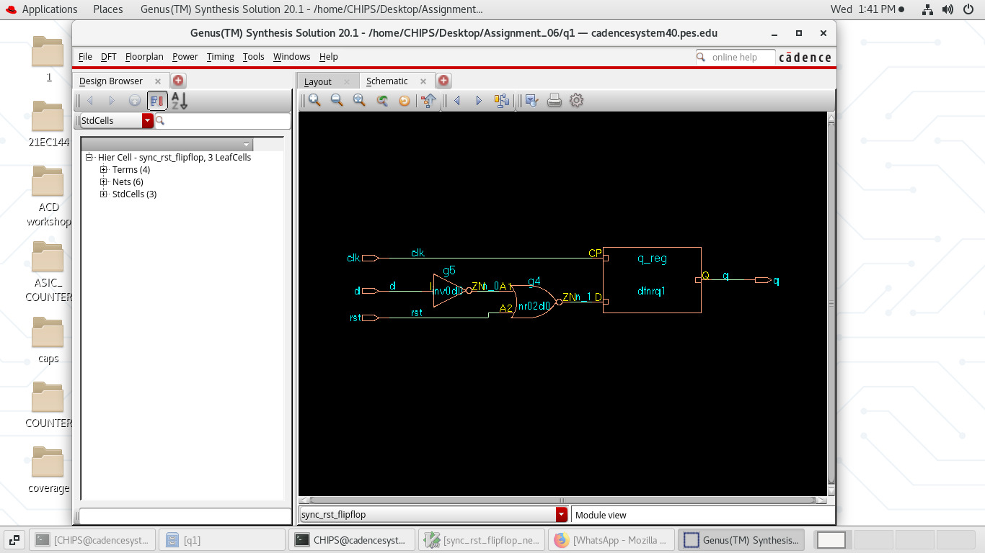

***Lib mapping:***

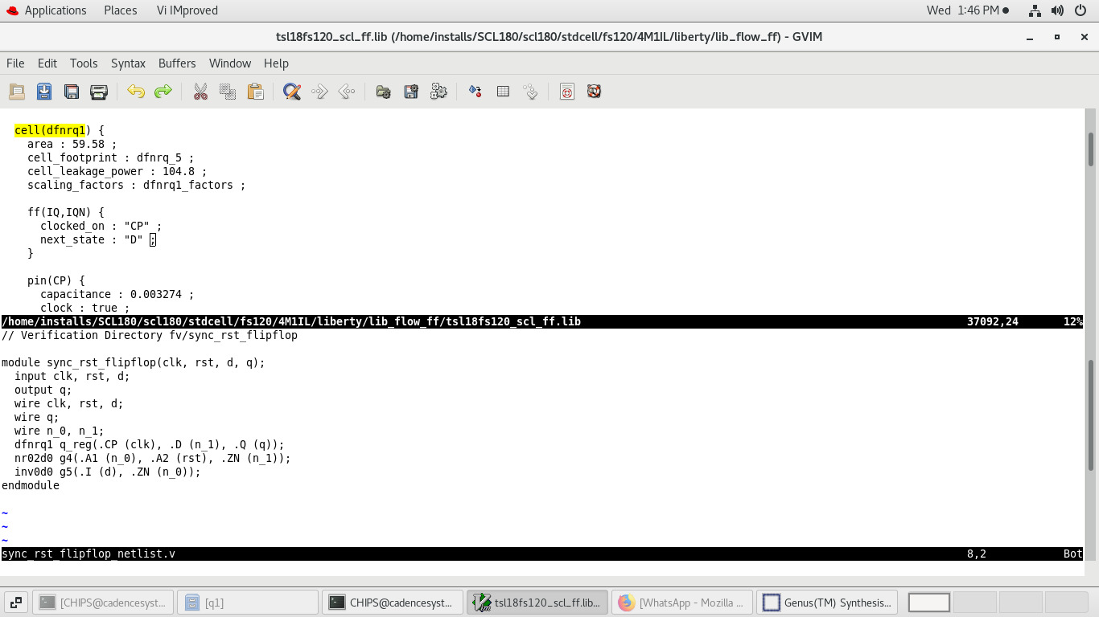

**Notes:**

1)flop name in rtl : q

2)flop name in netlist:q_reg

***2) sync_reset_dff***

**Verilog/Netlist:**

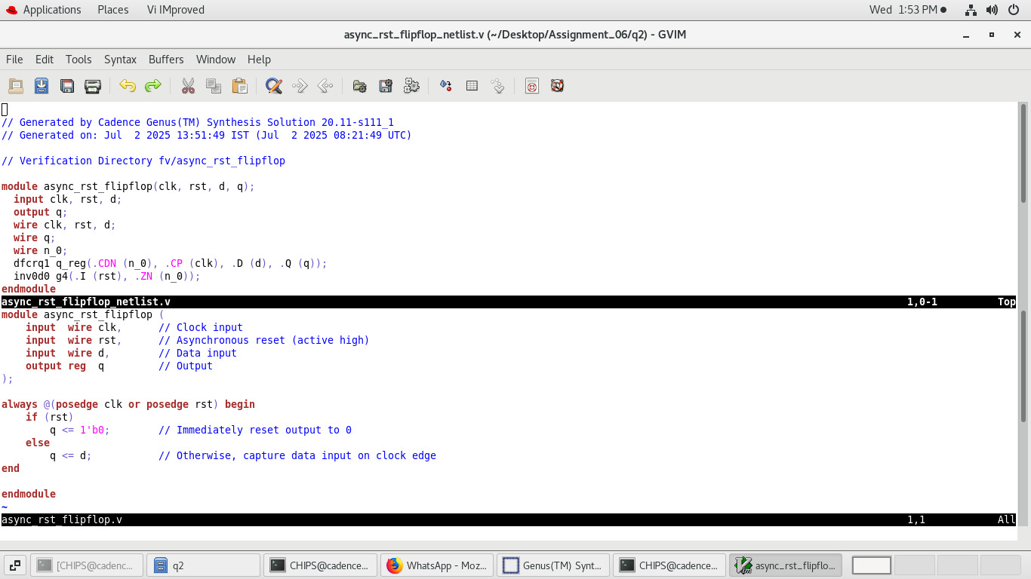

**Mark lib / instans / cell / nets**

1. n_0 is traced and is driven by ZN/g4 its load is CDN/q_reg

**Genus Schematic:**

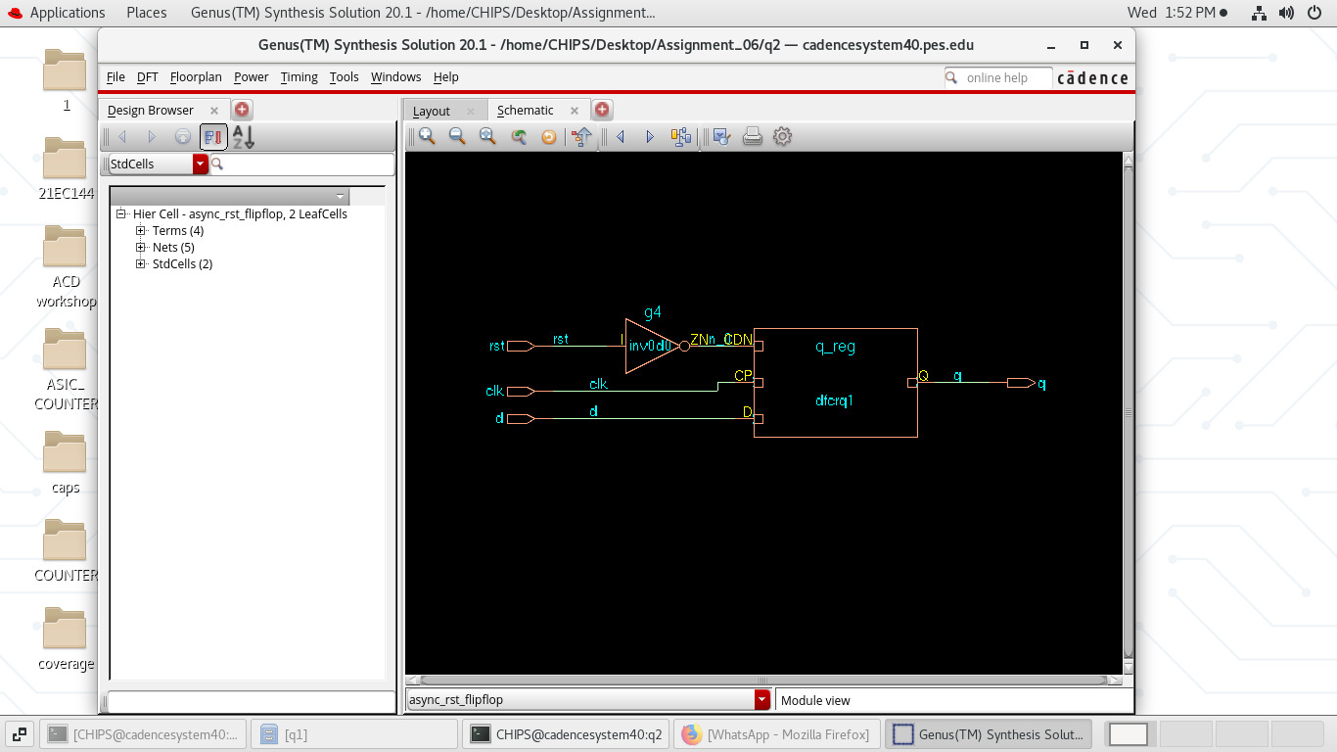

**Lib Mapping:**

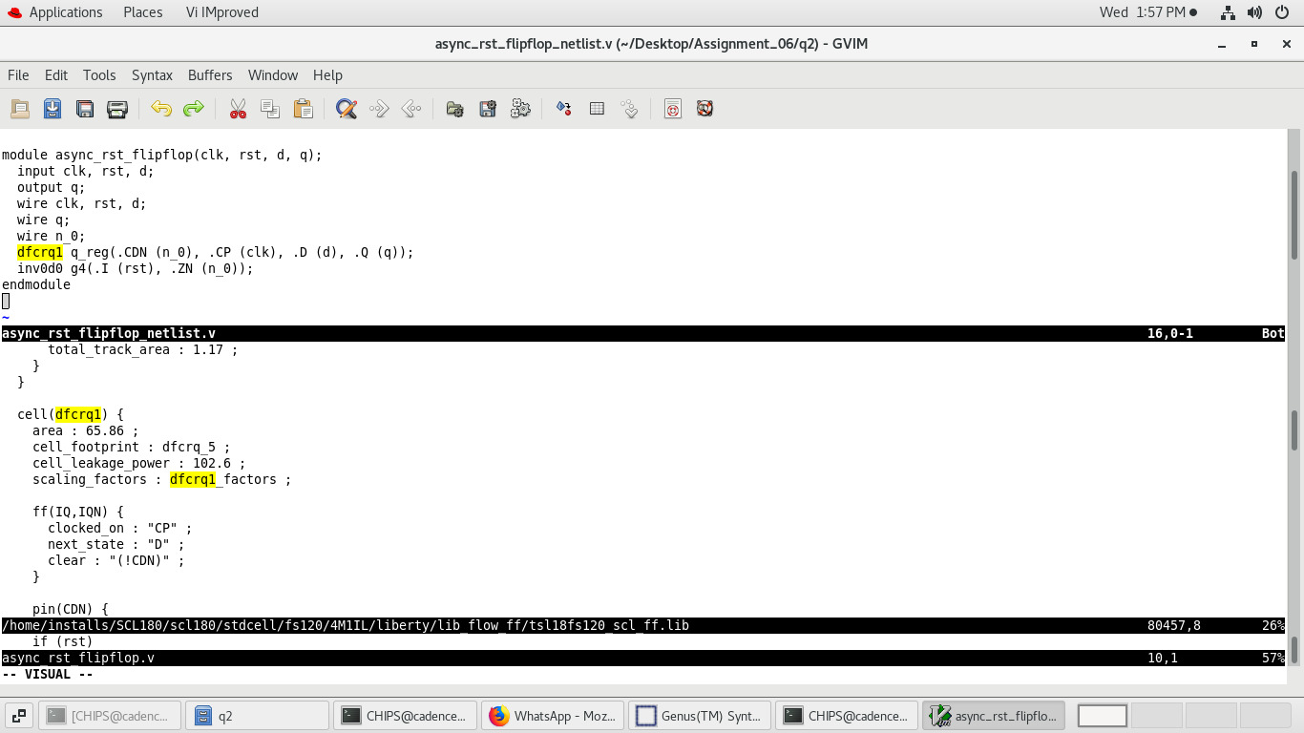

**Notes:**

1. Flop name in rtl: q
2. Flop name in netlist: q_reg

***3) Inferred Latch***

***Verilog/Netlist***

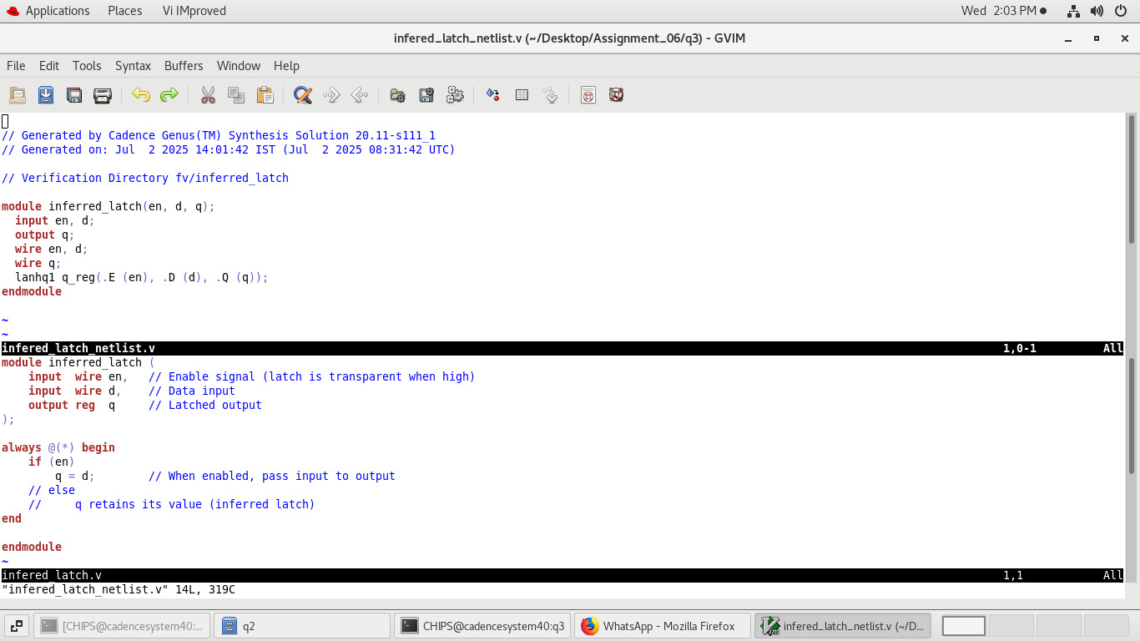

**Mark lib / instans / cell / nets**

Instance: lanhq1

**Genus Schematic:**

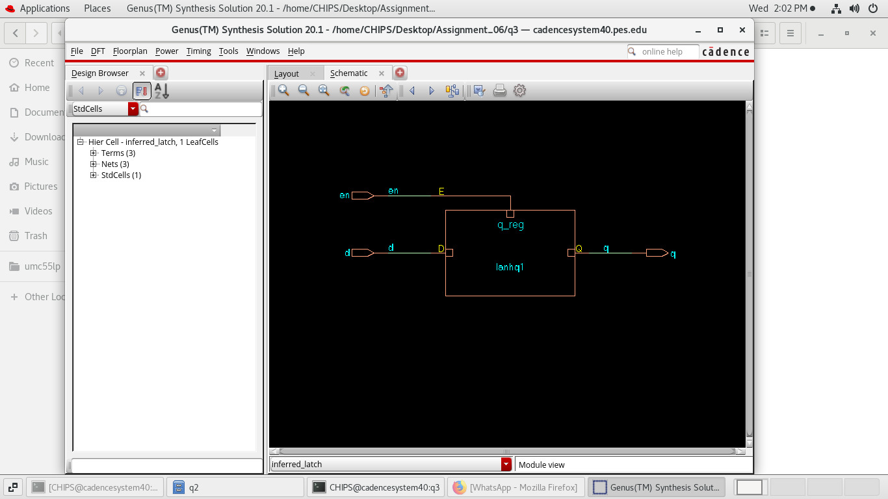

**Lib mapping:**

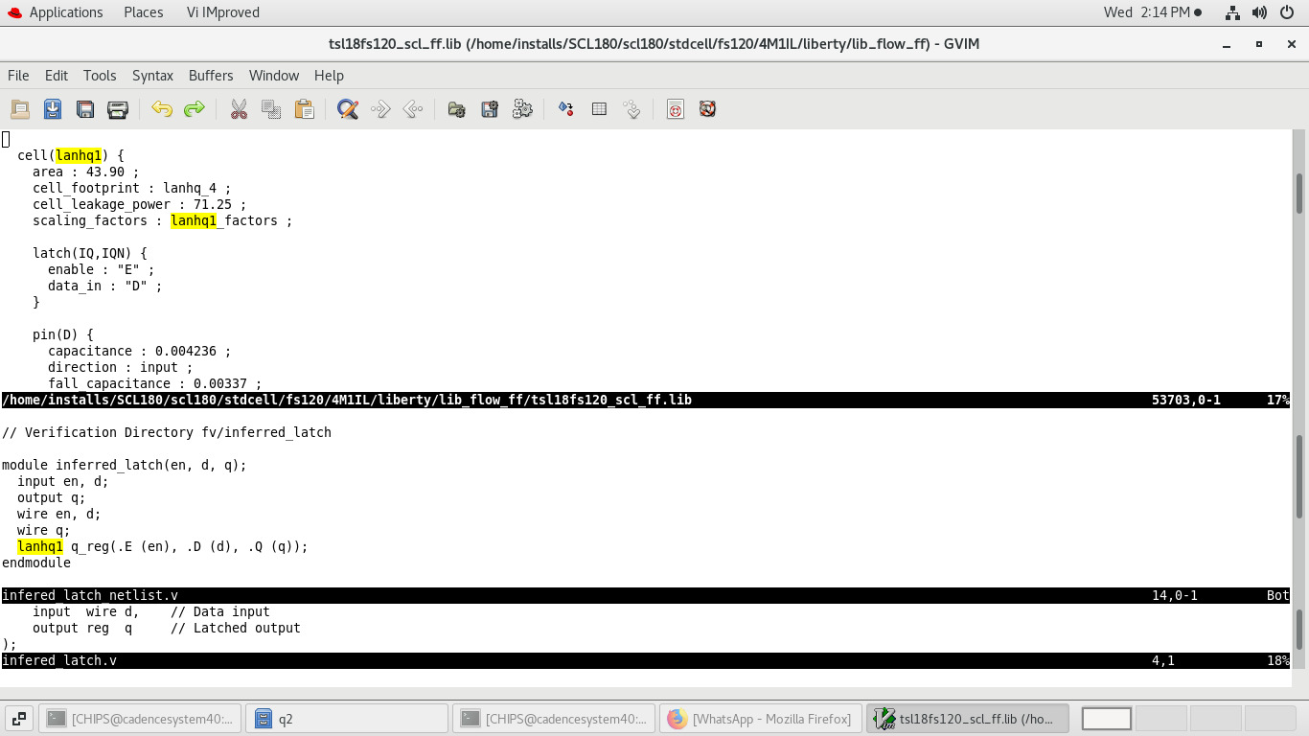

Flop name in rtl:q

Flop name in Netlist:q_reg

***4) design with multiple clock***

**Verilog:**

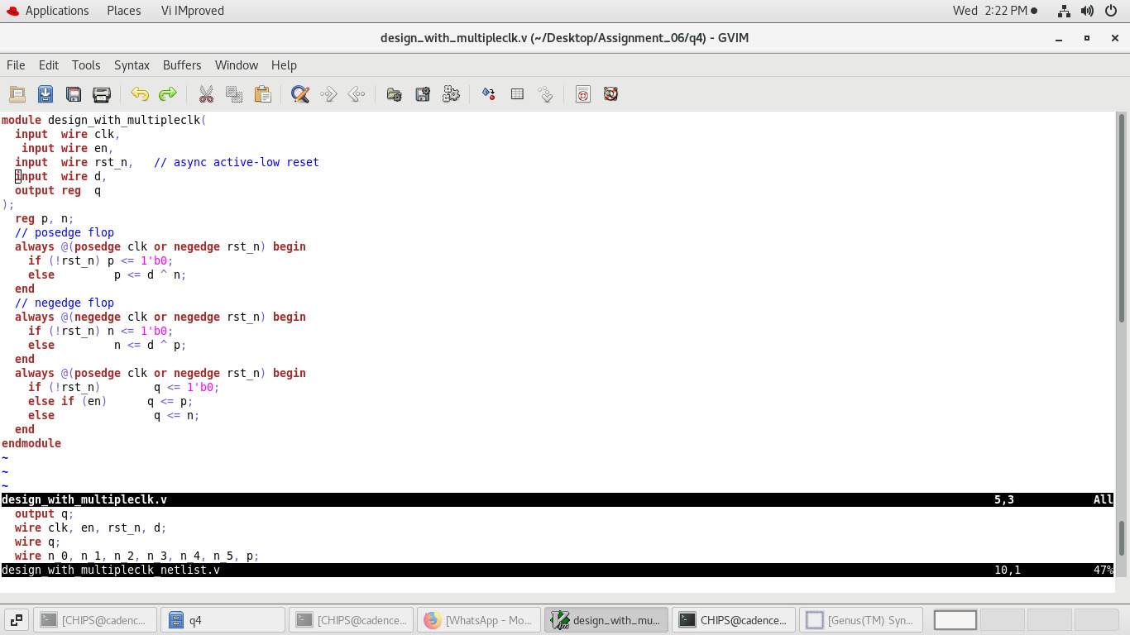

**Netlist:**

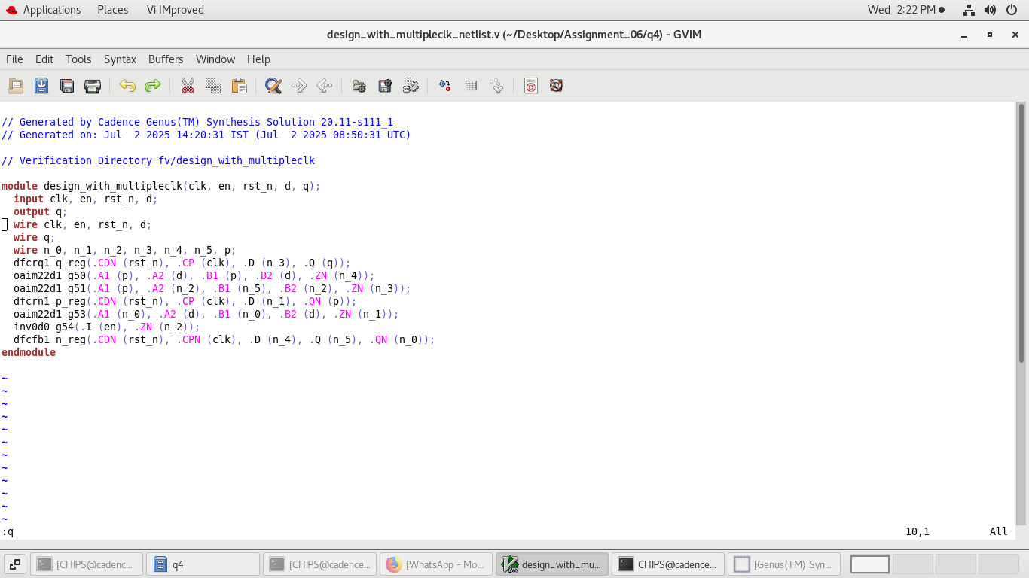

**Mark lib / instans / cell / nets**

1. n_0 is traced and is driven by g53/B1 its load is n_reg/QN
2. n_1 is traced and is driven by g53/ZN its load is p_reg/D
3. n_2 is traced and is driven by g54/ZN its load is g51/A2
4. n_3 is traced and is driven by g51/ZN its load is q_reg/D
5. n_4 is traced and is driven by g50/ZN its load is n_reg/D
6. n_5 is traced and is driven by g51/B1 its load n_reg/Q

**Genus Schematic:**

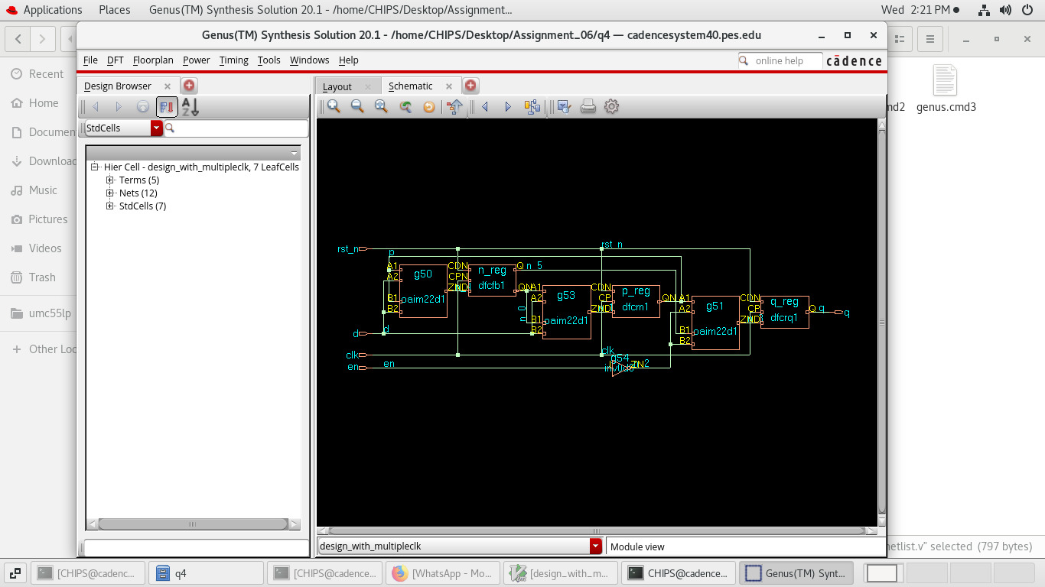

**Lib mapping:**

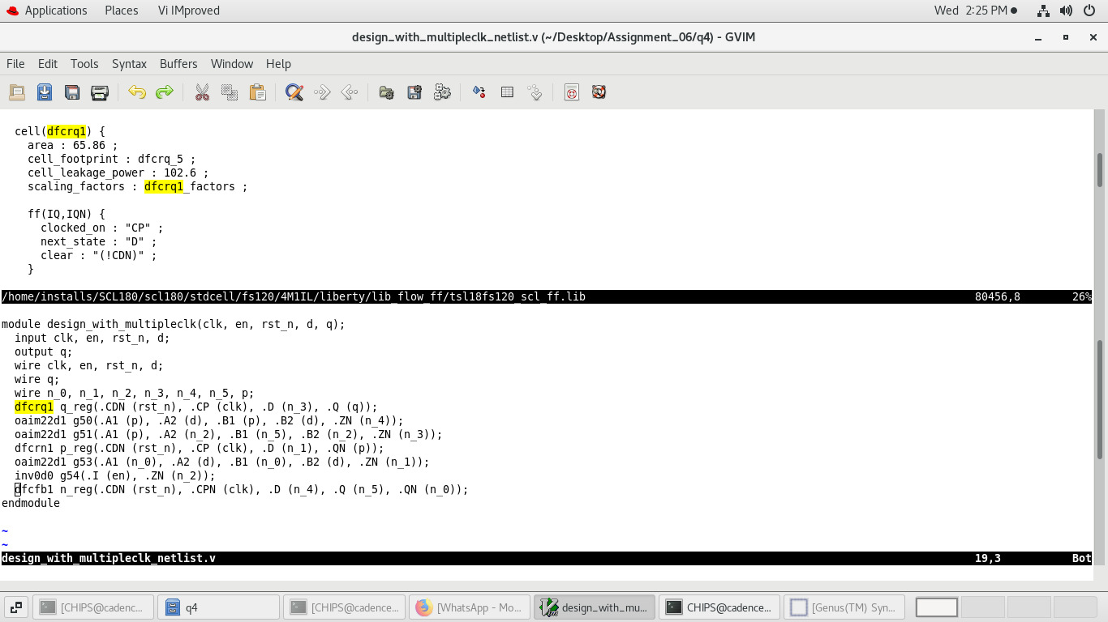

Flop name rtl: p, n, q

Flop name in netlist:p_reg, n_reg, q_reg