**Task- 1:**

Create two tables: users and orders.

Each user can have multiple orders.

Write a SQL query to fetch the names of users along with the total number of orders they have placed.

Code:

/* create the database */

create database task1;

/* use the database */

use task1;

/* create the tables for users and orders */

/* users table */

create table users(

user_id int primary key,

user_name varchar(50)

);

select * from users;

drop table orders;

/* orders table */

create table orders(

order_id int primary key,

user_id int,

order_date date,

foreign key(user_id) references users(user_id)

);

select * from orders;

/* insert the values into the users */

insert into users values

(1,"santosh"),

(2,"manibabu"),

(3,"gopi nadh"),

(4,"hari krishna"),

(5,"jeevan"),

(6,"vignan");

select * from users;

/* insert the values into the orders */

set foreign_key_checks=0;

insert into orders (order_id,user_id,order_date) values

(1,1,"2024-01-01"),

(2,1,"2024-01-05"),

(3,2,"2024-01-10"),

(4,2,"2024-01-15"),

(5,3,"2024-01-20"),

(6,3,"2024-01-25");

select * from orders;

select * from orders;

select * from users;

/* fetch the names with orders */

/* for join the both tables on left */

select * from users left join orders on

users.user_id = orders.user_id;

/* count the orders */

select users.user_name as users, count(orders.order_id) as total_orders from users

left join orders on users.user_id=orders.user_id group by

users.user_name, users.user_id;

select * from orders;

Output:

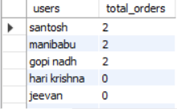

**Task-2:**

You are working with a database that stores information about students and their courses. There are three tables: students, courses, and enrolments.

Write a SQL query to display the names of students along with the courses they have enrolled in.

Code:

create database task2;

use task2;

create table students(

std_id int primary key,

std_name varchar(45)

);

insert into students values

(1,"santosh"),

(2,"mani babu"),

(3,"jeevan"),

(4,"gopi"),

(5,"hari"),

(6,"vignan");

select * from students;

create table courses(

crs_id int primary key,

crs_title varchar(45)

);

insert into courses values

(1,"Full stack java"),

(2,"Mern stack"),

(3,"devops"),

(4,"full stack python"),

(5,"full stack dot net"),

(6,"full stack java");

select * from courses;

create table enrollments(

std_id int,

crs_id int,

foreign key(std_id) references students(std_id),

foreign key(crs_id) references courses(crs_id)

);

insert into enrollments values

(1,2),

(1,3),

(2,3),

(2,4),

(3,4),

(3,5);

select * from enrollments;

select students.std_name as student_name,

courses.crs_title as course_title from enrollments join

students on enrollments.std_id = students.std_id join

courses on enrollments.crs_id=courses.crs_id;

Output:



**Task-3:**

You need to retrieve data from a database that tracks product sales. There are tables for products, sales, and customers.

Write a SQL query to show the total sales amount for each product category.

Code:

create database task3;

use task3;

create table products(

pro_id int primary key,

pro_name varchar(45),

pro_category varchar(45),

pro_price decimal(10,2)

);

insert into products values

(1,"laptops","electronics",250.00),

(2,"Head phones","electronics",100.00),

(3,"Chairs","furnitures",50.00),

(4,"cars","automobiles",2500.00),

(5,"mobiles","electronics",500.00);

select * from products;

create table sales (

sale_id int primary key,

pro_id int,

qty int,

foreign key(pro_id) references products(pro_id)

);

insert into sales values

(1,1,4),

(2,2,8),

(3,3,12),

(4,4,16),

(5,5,20);

select * from sales;

select products.pro_category as product_name,

sum(products.pro_price * sales.qty) as total_sale_amount from products join

sales on products.pro_id = sales.pro_id group by

product_name;

Output:

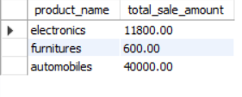

**Task-4:**

You have a database containing information about employees in a company.

Write a SQL query to list the names of employees along with their respective managers' names.

Code:

create database task4;

use task4;

create table manager(

mgr_id int primary key,

mgr_role varchar(50)

);

create table employees(

emp_id int primary key,

emp_name varchar(45),

mgr_id int,

foreign key(mgr_id) references manager(mgr_id)

);

insert into manager values

(1,"mahesh"),

(2,"suresh"),

(3,"prakash"),

(4,"ganesh"),

(5,"bhaskar");

update manager set mgr_role="bhaskar" where mgr_id=5;

select * from manager;

insert into employees values

(1,"santosh",1),

(2,"mani babu",2),

(3,"gopinadh",3),

(4,"jeevan",4),

(5,"hari",5);

select * from employees;

select employees.emp_name as employee_name,

manager.mgr_role as manager_role from employees left join manager on employees.mgr_id = manager.mgr_id;

Output:

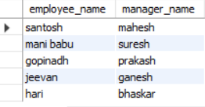

**Task-5:**

You are managing a database for an online store.

Write a query to retrieve the top 10 bestselling products based on the total number of units sold.

Code:

create database task5;

use task5;

create table products(

pdt_id int primary key,

pdt_name varchar(50)

);

insert into products values

(1,"mobiles"),

(2,"laptops"),

(3,"air conditioners"),

(4,"televisions"),

(5,"cloths"),

(6,"shoes"),

(7,"gadgets"),

(8,"books"),

(9,"gifts"),

(10,"choclates");

create table orders(

odr_id int primary key,

pdt_id int,

pdt_qty int,

foreign key(pdt_id) references products(pdt_id)

);

insert into orders values

(1,1,2),

(2,2,3),

(3,3,5),

(4,4,8),

(5,5,3),

(6,6,4),

(7,7,10),

(8,8,2),

(9,9,12),

(10,10,7);

use task5;

select products.pdt_name as product_name,

sum(orders.pdt_qty) as total_units from products join

orders on products.pdt_id=orders.pdt_id group by

products.pdt_id,products.pdt_name order by total_units desc

limit 10;

Output:

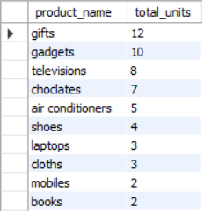

**Task-6:**

You have tables for students, courses, and grades.

Write a SQL query to display the average grade for each student.

Code:

drop database task6;

create database task6;

use task6;

create table students(

std_id int primary key,

std_name varchar(50)

);

insert into students values

(1,"santosh"),

(2,"manibabu"),

(3,"gopi"),

(4,"jeevan"),

(5,"hari"),

(6,"vignan"),

(7,"santosh"),

(8,"gopi"),

(9,"hari"),

(10,"santosh");

select * from students;

create table courses(

crs_id int primary key,

crs_name varchar(50)

);

insert into courses values

(1,"python"),

(2,"java"),

(3,"javascript"),

(4,"mern stack"),

(5,"full stack"),

(6,"dot Net"),

(7,"java"),

(8,"python"),

(9,"javascript"),

(10,"php");

select *from courses;

create table grades(

grades_id int,

std_id int,

crs_id int,

grade int,

foreign key(std_id) references students(std_id),

foreign key(crs_id) references courses(crs_id)

);

insert into grades values

(1,1,1,10),

(2,2,2,9),

(3,3,3,6),

(4,4,4,8),

(5,5,5,5),

(6,6,6,10),

(7,7,7,5),

(8,8,8,6),

(9,9,9,10),

(10,10,10,8);

select * from grades;

select students.std_id, students.std_name as student_name,

avg(grades.grade) as average_grade from students join

grades on students.std_id = grades.grades_id group by

students.std_id,students.std_name order by students.std_id;

Output:

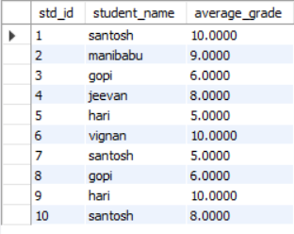

**Task-7:**

You are working with a database for a social media platform.

Write a query to show the users who have the most friends.

Code:

create database task7;

use task7;

create table users (

user_id int primary key,

user_name varchar(50),

friends_count int

);

insert into users values

(1,"santosh",10),

(2,"mani babu",8),

(3,"jeevan",15),

(4,"haribabu",11),

(5,"gopi",14),

(6,"vignan",20);

select * from users;

select user_id, user_name, friends_count as total_friends from users order by total_friends desc limit 3;

Output:

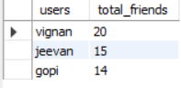

**Task-8:**

You have tables for employees and departments.

Write a query to display the department names along with the total number of employees in each department.

Code:

create database task8;

use task8;

create table departments (

dept_id int primary key,

dept_name varchar(50)

);

insert into departments values

(1,"police"),

(2,"railways"),

(3,"aviation"),

(4,"busses");

select * from departments;

create table employees(

emp_id int primary key,

emp_name varchar(50),

dept_id int,

foreign key(dept_id) references departments(dept_id)

);

insert into employees values

(1,"santosh",1),

(2,"gopi",2),

(3,"jeevan",3),

(4,"vignan",4);

select * from employees;

select departments.dept_name, count(employees.emp_id) as

total_employees from departments left join employees on

departments.dept_id = employees.dept_id group by

departments.dept_name order by total_employees desc;

Output:

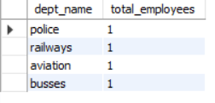

**Task-9:**

You need to retrieve data from a database tracking product inventory.

Write a query to display products with low stock (less than 10 units).

Code:

create database task9;

use task9;

create table products(

pdt_id int,

pdt_name varchar(50),

pdt_stock int

);

insert into products values

(1,"laptops",9),

(2,"cameras",12),

(3,"phones",5),

(4,"tablets",15),

(5,"watches",2);

select products.pdt_id, products.pdt_name as products,products.pdt_stock as

lowstockes from products where products.pdt_stock < 10;

Output:

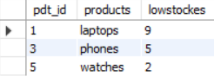

**Task-10:**

You have tables for customers and orders.

Write a query to show the average order value for each customer.

Code:

create database task10;

use task10;

create table customers (

cms_id int primary key,

cms_name varchar(50)

);

create table orders(

odr_id int primary key,

cms_id int,

odr_orders int,

foreign key(cms_id) references customers(cms_id)

);

insert into customers values

(1,"santosh"),

(2,"gopi"),

(3,"hari"),

(4,"vignan"),

(5,"jeevan"),

(6,"santosh"),

(7,"hari");

select * from customers;

insert into orders values

(1,1,16),

(2,2,13),

(3,3,14),

(4,4,20),

(5,5,30),

(6,6,20),

(7,7,25);

select * from orders;

select

customers.cms_id, customers.cms_name, avg(orders.odr_orders) AS ordervalue

from customers left join orders on

customers.cms_id = orders.cms_id group by

customers.cms_id, customers.cms_name;

Output:

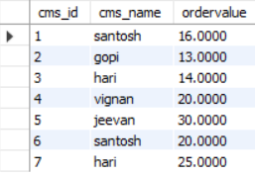

**Task-11:**

In a database storing movie information,

Write a query to show the top 5 highest-rated movies by users.

Code:

create database task11;

use task11;

create table movie_info(

mve_id int primary key auto_increment,

mve_name varchar(50),

mve_rating int

);

insert into movie_info(mve_name,mve_rating) values

("bahubali",9),

("stranger things",7),

("dark",4),

("agnathavasi",2),

("okkadu",6),

("jalsa",8),

("Pokiri",7),

("salar",9);

select movie_info.mve_name as movies, movie_info.mve_rating as

movie_rating_by_10 from movie_info where

movie_info.mve_rating > 5 limit 5;

Output:

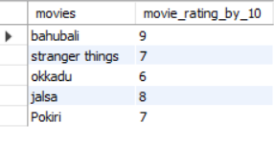

**Task-12:**

You have tables for invoices and payments.

Write a query to show the unpaid invoices and their total amount.

Code:

create database task12;

use task12;

create table invoices(

ivs_id int primary key auto_increment,

ivs_name varchar(50)

);

select * from invoices;

create table payments(

pmt_id int primary key auto_increment,

ivs_id int,

pmt_status varchar(50),

pmt_amount decimal(5,2),

foreign key(ivs_id) references invoices(ivs_id)

);

insert into invoices(ivs_name) values

("furnitures"),

("grocessories"),

("houses"),

("rents"),

("cars");

insert into payments values

(1,"paid",100.00),

(2,"not paid",150.00),

(3,"paid",100.00),

(4,"paid",220.00),

(5,"not paid",200.00);

update payments set ivs_id=5 where pmt_id=5;

select * from payments;

select * from invoices;

select invoices.ivs_name as invoices,

payments.pmt_status as payment_status,payments.pmt_amount as

total_amount from invoices join payments on

invoices.ivs_id = payments.ivs_id

where payments.pmt_status = "not paid";

Output:

