**Joins**:

* join are used with select statement
* used to retrieve the data from multiple tables from same database
* fetching the records from different tables will be vary easy there are 3 types of mysql
* **Joins:**

1. Inner join (simple join)
2. Outer join -> left outer join -> right outer join
3. Right join -> right outer join

**1.Innerjoin:** in order to returns all the rows from multiple tables while the join condition is satisfied.

* This is most commonly used joins in mysql
* Syntax: select columns from tables inner join table2 on table1. col1=table2.col1

Code:

/* create the database */

create database joins;

/*select the database */

use joins;

/*create the table for users*/

create table users(

user_id int primary key auto_increment,

user_name varchar(50),

user_email varchar(50)

);

insert into users(user_name,user_email) values

("santosh","santhu@gmail.com"),

("gopi","gopi@gmail.com"),

("mani","mani@gmail.com"),

("vignan","vignan@gmail.com"),

("hari","hari@gmail.com");

select * from users;

/* create the table for employees */

create table employees(

emp_id int primary key auto_increment,

emp_role varchar(50),

user_id int,

foreign key(user_id) references users(user_id)

);

insert into employees(emp_role,user_id) values

("java developer",1),

("python developer",2),

("dot net developer",3),

("javascript developer",4),

("react js developer",5);

alter table employees add column address varchar(50);

update employees set address="ongole" where emp_id=5;

select * from employees;

/* inner join */

select users.user_name as employee_name,

employees.emp_role as employee_role from users inner join

employees on users.user_id = employees.user_id;

Output:

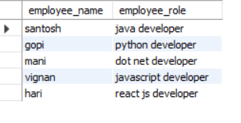

**2.Outer left join:** return all rows from the left hand side table and all the rows from right hand side table by satisfying the join condition.

Syntax: select cols from table1 left outer join table2 on table1.col=table2.col1;

Code:

select users.user_name as employee_name,

employees.address as employee_role from users left outer join

employees on users.user_id = employees.user_id;

Output:

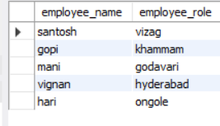

**3.Right join:** right outer join

* Return all rows from the right hand table with right hand table rows on to the right table by satisfying the join condition.
* Syntax: select cols from table1 right join table2 on table2 on table1.col=table2.col;

Code:

/* right join */

select users.user_name,employees.phone_num as phone_number

from users right outer join employees on

users.user_id=employees.user_id;

output:

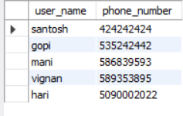

**4.Selfjoin:** the data/rows in the table are combined /joined with some data/rows in the same table

Syntax: select col_name from table1, table2 where conditions;

Code:

/* selft join */

select users.user_name as username, employees.password from

users, employees where users.user_id=employees.user_id;

output:



**5.Cross join:** return all the records from both the tables (table1 & table2)

Syntax: select col_name from table1 cross join table2;

/* cross join */

select users.user_name,users.user_email,employees.emp_role from users cross join employees;

output:

