Code:
<!DOCTYPE html>
<html>
<head>
</head>
<body>
<h1>This is a heading</h1>
<p>This is a paragraph.</p>
</body>
</html>
Output:
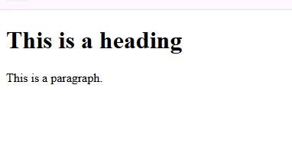
Code:
<h1 title="Heading Tooltip">Main Title</h1>
<p title="Paragraph Tooltip">This is a text block.</p>
<a href="https://www.w3schools.com">Visit Example Link</a>
<img src="image.jpg" alt="hi" height="400" width="600">
Output:
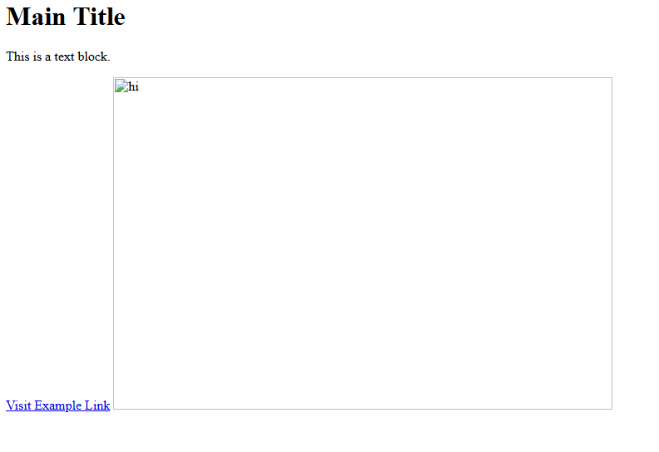
Code:
<!DOCTYPE html>
<html>
<head>
<title>Student Records</title>
<style>
table {
border-collapse: collapse;
width: 300px;
}
caption {
font-weight: bold;
margin-bottom: 8px;
}
th, td {
border: 1px solid #000;
padding: 8px;
text-align: center;
}
th {
background-color: #f2f2f2;
}
</style>
</head>
<body>

<table>
<caption>Student Records</caption>
<thead>
<tr>
<th>First Name</th>
<th>Marks</th>
</tr>
</thead>
<tbody>
<tr>
<td>Vimal</td>
<td>70</td>
</tr>
</tbody>
</table>

</body>
</html>
Output:
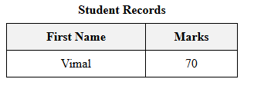
Code:
<!DOCTYPE html>
<html>
<head>
<title>HTML Lists</title>
<style>
body {
font-family: Arial, sans-serif;
}
ul, ol, dl {
margin-bottom: 20px;
}
li {
margin: 5px 0;
}
dt {
font-weight: bold;
}
dd {
margin-left: 20px;
}
</style>
</head>
<body>

<h2>Unordered List</h2>
<ul>
<li>HTML</li>
<li>CSS</li>
<li>JavaScript</li>
</ul>

<h2>Ordered List</h2>
<ol>
<li>Step One</li>
<li>Step Two</li>
<li>Step Three</li>
</ol>

<h2>Nested List</h2>
<ul>
<li>Frontend
<ul>
<li>HTML</li>
<li>CSS</li>
</ul>
</li>
<li>Backend
<ol>
<li>Java</li>
<li>Python</li>
</ol>
</li>
</ul>

<h2>Description List</h2>
<dl>
<dt>HTML</dt>
<dd>HyperText Markup Language</dd>

<dt>CSS</dt>
<dd>Cascading Style Sheets</dd>
</dl>

</body>
</html>
Output:
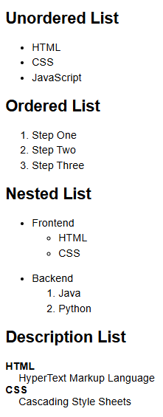
Code:
<!DOCTYPE html>
<html lang="en">
<head>
<meta charset="UTF-8">
<meta name="viewport" content="width=device-width, initial-scale=1.0">
<title>Form Validation</title>
<style>
body { font-family: sans-serif; padding: 20px; }
form { max-width: 300px; margin: auto; }
fieldset { padding: 20px; }
legend { font-weight: bold; padding: 0 10px; }
label { display: block; margin-top: 10px; }
input { width: 100%; padding: 8px; margin-top: 5px; box-sizing: border-box; }
button { width: 100%; padding: 10px; margin-top: 20px; cursor: pointer; }
.error { color: red; font-size: 12px; margin-top: 5px; }
</style>
</head>
<body>

<form id="registrationForm">
<fieldset>
<legend>Registration Form</legend>

<label for="username">Username:</label>
<input type="text" id="username" name="username">

<label for="email">Email:</label>
<input type="email" id="email" name="email">

<label for="password">Password:</label>
<input type="password" id="password" name="password">

<button type="submit" id="submitBtn">Register</button>
</fieldset>
</form>

<script>
const form = document.getElementById('registrationForm');
const usernameField = document.getElementById('username');
const emailField = document.querySelector('#email');
const passwordField = document.getElementById('password');

form.addEventListener('submit', function(event) {
validateForm(event);
});

function validateForm(event) {
let isValid = true;

const existingErrors = document.querySelectorAll('.error');
existingErrors.forEach(error => error.remove());

if (usernameField.value.trim() === '') {
isValid = false;
showError(usernameField, 'Username is required.');
}

if (!validateEmail(emailField.value)) {
isValid = false;
showError(emailField, 'Invalid email format.');
}

if (passwordField.value.length < 8) {
isValid = false;
showError(passwordField, 'Password must be at least 8 characters long.');
}

if (!isValid) {
event.preventDefault();
}
}

function validateEmail(email) {
const emailPattern = /^[^\s@]+@[^\s@]+\.[^\s@]+$/;
return emailPattern.test(email);
}

function showError(field, message) {
let errorDiv = document.createElement('div');
errorDiv.className = 'error';
errorDiv.innerText = message;
field.parentNode.insertBefore(errorDiv, field.nextSibling);
}
</script>

</body>
</html>
Output:
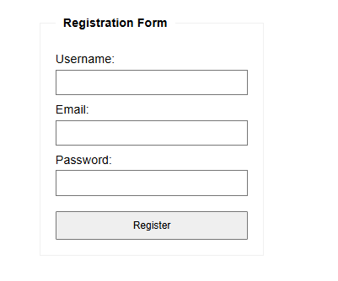
Code:
<!DOCTYPE html>
<html>
<head>
<title>Consolidated Web Programming Elements</title>
</head>
<body style="font-family:sans-serif;padding:20px;">
<h1 style="color:blue;" title="This is heading tag">Style and Title Attribute Heading</h1>
<p style="height:50px;color:blue;" title="This is paragraph tag">This paragraph uses inline height and color styles.</p>
<p style="color:red;">This is a red paragraph content.</p>
<hr>
<p><b>Bold text</b> and <strong>Important text</strong>.</p>
<p><i>Italic text</i> and <em>Emphasized text</em>.</p>
<p><mark style="background-color:yellow;">Marked text</mark>, <u>Underlined text</u>, and <strike>Strikethrough text</strike>.</p>
<p><tt>Monospaced font</tt>, <big>Larger font</big>, and <small>Smaller font</small>.</p>
<p>Chemical: H<sub>2</sub>O | Math: E=mc<sup>2</sup></p>
<p><del>Deleted text</del> and <ins>Inserted text</ins>.</p>
<hr>
<a href="https://www.google.com" target="_blank" style="text-decoration:none;color:green;">External Link with Inline Style</a>
<hr>
<table style="width:100%;border:1px solid black;border-collapse:collapse;">
<caption style="font-weight:bold;">Student Records</caption>
<tr style="background-color:gray;color:white;">
<th style="border:1px solid black;padding:8px;">First_Name</th>
<th style="border:1px solid black;padding:8px;">Last_Name</th>
<th style="border:1px solid black;padding:8px;">Marks</th>
</tr>
<tr style="background-color:#eee;">
<td style="border:1px solid black;padding:8px;">Vimal</td>
<td style="border:1px solid black;padding:8px;">Jaiswal</td>
<td style="border:1px solid black;padding:8px;">70</td>
</tr>
</table>
<hr>
<ul type="square" style="color:darkgreen;">
<li>HTML</li>
<li>Java</li>
</ul>
<ol type="I">
<li>First Step</li>
<li>Second Step</li>
</ol>
<dl>
<dt style="font-weight:bold;">Aries</dt>
<dd>- One of the 12 horoscope signs.</dd>
</dl>
<hr>
<form action="action.html" method="get" style="border:1px solid #ccc;padding:10px;">
<fieldset>
<legend>Registration Form</legend>
<label style="display:block;margin-top:10px;">Account holder name:</label>
<input type="text" name="uname" size="40" required style="border:1px solid blue;">
<label style="display:block;margin-top:10px;">Email Address:</label>
<input type="email" name="email" style="width:200px;" required>
<label style="display:block;margin-top:10px;">Telephone (xxx-xxx-xxxx):</label>
<input type="tel" name="phone" pattern="[0-9]{3}-[0-9]{3}-[0-9]{4}" required>
<label style="display:block;margin-top:10px;">Favorite Color:</label>
<input type="color" name="favcolor">
<label style="display:block;margin-top:10px;">Disabled Field:</label>
<input type="text" name="id" value="1001" disabled style="background-color:#ddd;">
<button type="submit" style="margin-top:15px;padding:10px;background-color:blue;color:white;border:none;">Submit Data</button>
</fieldset>
</form>
<div id="errorDisplay" class="error" style="color:red;font-size:12px;margin-top:10px;"></div>
</body>
</html>
Output:
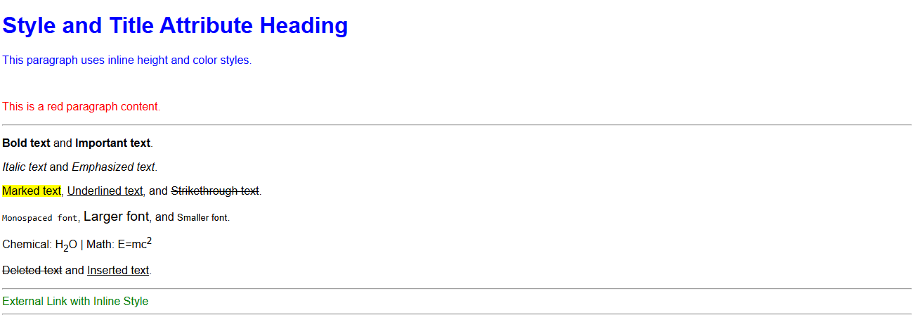
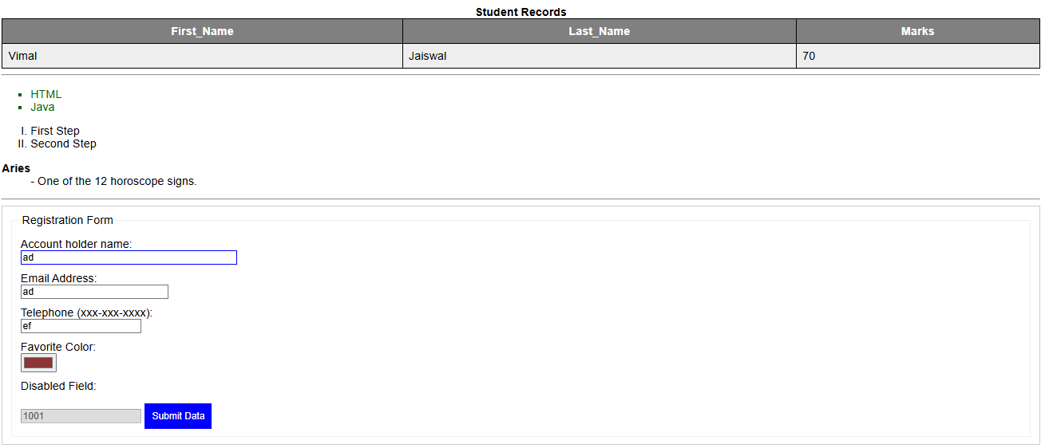

Code:
<!DOCTYPE html>
<html lang="en">
<head>
<meta charset="UTF-8">
<meta name="viewport" content="width=device-width, initial-scale=1.0">
<title>Form Validation</title>
<style>
body { font-family: sans-serif; padding: 20px; }
form { max-width: 300px; margin: auto; }
label { display: block; margin-top: 10px; }
input { width: 100%; padding: 8px; margin-top: 5px; box-sizing: border-box; }
button { width: 100%; padding: 10px; margin-top: 20px; cursor: pointer; }
.error { color: red; font-size: 12px; margin-top: 5px; }
</style>
</head>
<body>
<form id="registrationForm">
<label for="username">Username:</label>
<input type="text" id="username" name="username">
<label for="email">Email:</label>
<input type="email" id="email" name="email">
<label for="password">Password:</label>
<input type="password" id="password" name="password">
<button type="submit" id="submitBtn">Register</button>
</form>
<script>
const form = document.getElementById('registrationForm');
const usernameField = document.getElementById('username');
const emailField = document.querySelector('#email');
const passwordField = document.getElementById('password');
form.addEventListener('submit', function(event) {
validateForm(event);
});
function validateForm(event) {
let isValid = true;
const existingErrors = document.querySelectorAll('.error');
existingErrors.forEach(error => error.remove());
if (usernameField.value.trim() === '') {
isValid = false;
showError(usernameField, 'Username is required.');
}
if (!validateEmail(emailField.value)) {
isValid = false;
showError(emailField, 'Invalid email format.');
}
if (passwordField.value.length < 8) {
isValid = false;
showError(passwordField, 'Password must be at least 8 characters long.');
}
if (!isValid) {
event.preventDefault();
}
}
function validateEmail(email) {
const emailPattern = /^[^\s@]+@[^\s@]+\.[^\s@]+$/;
return emailPattern.test(email);
}
function showError(field, message) {
let errorDiv = document.createElement('div');
errorDiv.className = 'error';
errorDiv.innerText = message;
field.parentNode.insertBefore(errorDiv, field.nextSibling);
}
</script>
</body>
</html>
Output:
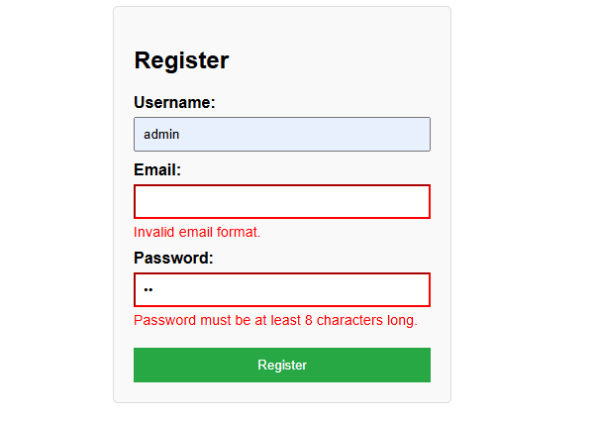
Code:
<!DOCTYPE html>
<html lang="en">
<body>

<figure>
<canvas id="myCanvas" width="200" height="100" style="border:1px solid #000;"></canvas>
<figcaption>Fig.1 - A dynamic graphic rendered via Canvas.</figcaption>
</figure>

<hr>

<section>
<h2>Developer Notes</h2>
<blockquote cite="https://www.w3.org.org">
<p>The layout engine must preserve the integrity of the whitespace.</p>
<footer>— <cite>Web Standards Documentation</cite></footer>
</blockquote>

<p>To initialize the canvas, use this code:</p>
<pre>
function draw() {
const canvas = document.getElementById('myCanvas');
const ctx = canvas.getContext('2d');
ctx.fillStyle = "blue";
ctx.fillRect(10, 10, 150, 80);
}
</pre>
</section>

<hr>

<form>
<fieldset>
<legend>User Feedback</legend>
<label for="name">Name:</label>
<input type="text" id="name" name="name">
<button type="submit">Submit</button>
</fieldset>
</form>

<noscript>
<p style="color: red;">Warning: JavaScript is required to view the canvas graphics.</p>
</noscript>

</body>
</html>
Output:
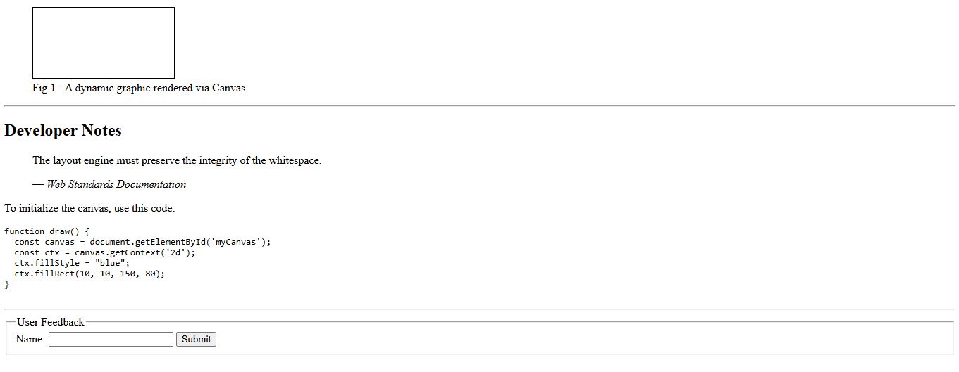
Code:
<!DOCTYPE html>
<html lang="en">
<head>
<meta charset="UTF-8">
<meta name="viewport" content="width=device-width, initial-scale=1.0">
<title>Form Validation</title>
<style>
body { font-family: sans-serif; padding: 20px; }
form { max-width: 300px; margin: auto; }
fieldset { padding: 20px; }
legend { font-weight: bold; padding: 0 10px; }
label { display: block; margin-top: 10px; }
input { width: 100%; padding: 8px; margin-top: 5px; box-sizing: border-box; }
button { width: 100%; padding: 10px; margin-top: 20px; cursor: pointer; }
.error { color: red; font-size: 12px; margin-top: 5px; }
</style>
</head>
<body>

<form id="registrationForm">
<fieldset>
<legend>Registration Form</legend>

<label for="username">Username:</label>
<input type="text" id="username" name="username">

<label for="email">Email:</label>
<input type="email" id="email" name="email">

<label for="password">Password:</label>
<input type="password" id="password" name="password">

<button type="submit" id="submitBtn">Register</button>
</fieldset>
</form>

<script>
const form = document.getElementById('registrationForm');
const usernameField = document.getElementById('username');
const emailField = document.querySelector('#email');
const passwordField = document.getElementById('password');

form.addEventListener('submit', function(event) {
validateForm(event);
});

function validateForm(event) {
let isValid = true;

const existingErrors = document.querySelectorAll('.error');
existingErrors.forEach(error => error.remove());

if (usernameField.value.trim() === '') {
isValid = false;
showError(usernameField, 'Username is required.');
}

if (!validateEmail(emailField.value)) {
isValid = false;
showError(emailField, 'Invalid email format.');
}

if (passwordField.value.length < 8) {
isValid = false;
showError(passwordField, 'Password must be at least 8 characters long.');
}

if (!isValid) {
event.preventDefault();
}
}

function validateEmail(email) {
const emailPattern = /^[^\s@]+@[^\s@]+\.[^\s@]+$/;
return emailPattern.test(email);
}

function showError(field, message) {
let errorDiv = document.createElement('div');
errorDiv.className = 'error';
errorDiv.innerText = message;
field.parentNode.insertBefore(errorDiv, field.nextSibling);
}
</script>

</body>
</html>
Output:
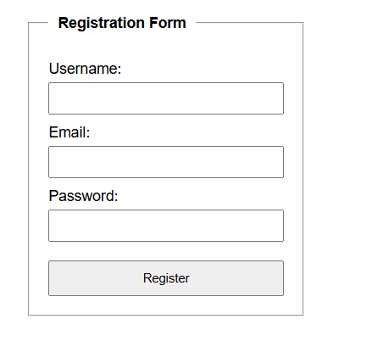
Code:
<!DOCTYPE html>
<html lang="en">
<head>
<meta charset="UTF-8">
<title>Comprehensive HTML5 Example</title>
<style>
input:required:invalid, input:focus:invalid {
background-image: url(/images/invalid.png);
background-position: right top;
background-repeat: no-repeat;
border: 1px solid red;
}
input:required:valid {
background-image: url(/images/valid.png);
background-position: right top;
background-repeat: no-repeat;
background: hsl(180, 50%, 90%);
border: 1px solid #999;
}
.help { display: none; font-size: 90%; }
input:focus + .help { display: inline-block; }
mark { background-color: yellow; }
</style>
</head>
<body>

<header>
<h1>Website Header</h1>
<nav>
<a href="#section1">Home</a> | <a href="#form">Forms</a>
</nav>
</header>

<main>
<article>
<section id="section1">
<h2>Main Article Section</h2>
<p>This is a <mark>highlighted</mark> piece of text within a paragraph[cite: 67].</p>

<figure>
<div style="width:100px; height:50px; background:grey;">Image Placeholder</div>
<figcaption>Fig.1 - Example of a figure caption.</figcaption>
</figure>

<details>
<summary>Click to see additional info</summary>
<p>This content is only visible when the user demands it[cite: 62].</p>
</details>

<aside>
<p>This is an aside with related information[cite: 60].</p>
</aside>
</section>

<section>
<h3>Multimedia and Graphics</h3>
<canvas id="myCanvas" width="200" height="50" style="border:1px solid #000;"></canvas>
<svg width="100" height="50"><circle cx="25" cy="25" r="20" fill="blue" /></svg>
<br>
<audio controls src="audio.mp3">Audio not supported</audio>
<video controls width="250" src="video.mp4">Video not supported</video>
</section>
</article>

<section id="form">
<h3>Interactive Form</h3>
<form>
<label>Your Name: </label>
<input type="text" name="name" required placeholder="Enter your name">

<br><br><label>Email Address: </label>
<input type="email" name="email" required placeholder="arinchat@gmail.com">

<br><br><label>Website URL: </label>
<input type="url" name="website" required pattern="https?://.+" title="Starts with http:// or https://">

<br><br><label for="Age">Age: </label>
<input type="number" name="Age" value="21" required min="18" max="75">
<span class="help">Format: Number between 18 and 75</span>

<br><br><label>Satisfaction: </label>
<input type="range" name="satisfaction" min="1" max="5" value="3">

<br><br><label>Country: </label>
<input list="Countries" placeholder="Type a country name">
<datalist id="Countries">
<option value="USA">
<option value="India">
<option value="UK">
</datalist>

<br><br><label>Choose Date: </label><input type="date" name="Date">
<br><br><label>Choose Month: </label><input type="month" name="Month">
<br><br><label>Choose Color: </label><input type="color" name="Color">

<br><br><label>Task Progress: </label>
<progress value="70" max="100"></progress>
<br><label>Scalar Meter: </label>
<meter value="0.6">60%</meter>

<br><br><button type="submit">Submit</button>
</form>
</section>
</main>

<noscript>JavaScript is required for full functionality[cite: 162].</noscript>

<footer>
<p>Current Time Element: <time datetime="2024-05-01">May 2024</time> [cite: 68]</p>
</footer>

</body>
</html>
Output:
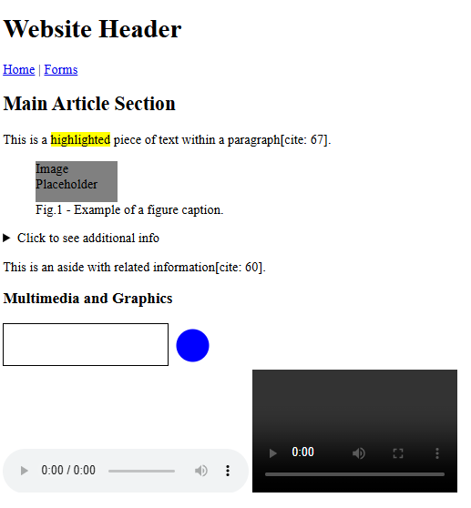
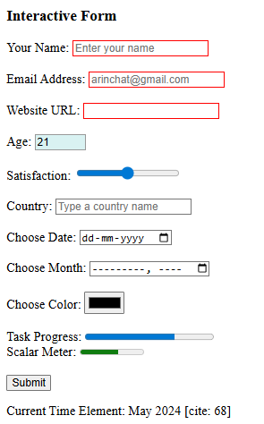
Code:
<!DOCTYPE html>
<html lang="en">
<head>
<meta charset="UTF-8">
<title>Comprehensive HTML5 Features</title>
</head>
<body>

<header>
<h1>Web Development Overview</h1>
<nav>
<a href="#form-section">Registration</a> |
<a href="#media-section">Media</a>
</nav>
</header>

<main>
<article>
<section id="intro">
<h2>Introduction to HTML</h2>
<p>HTML is the standard markup language used to structure content on the web[cite: 1].
You can <mark>highlight important text</mark> using the mark tag[cite: 67].</p>

<details>
<summary>View More Details</summary>
<p>This is self-contained content revealed on demand[cite: 62].</p>
</article>
</section>

<section id="media-section">
<h3>Graphics and Multimedia</h3>
<figure>
<canvas id="myCanvas" width="100" height="50" style="border:1px solid #000;"></canvas>
<svg width="100" height="50"><circle cx="25" cy="25" r="20" fill="green" /></svg>
<figcaption>Fig.1 - Example of Canvas and SVG elements[cite: 63].</figcaption>
</figure>

<audio controls src="audio.mp3">Audio not supported</audio>
<video controls width="250" src="video.mp4">Video not supported</video>
</section>

<section id="form-section">
<h3>User Information Form</h3>
<form>
<label>Your Name: </label>
<input type="text" name="name" required placeholder="Enter your full name">

<br><br><label>Email Address: </label>
<input type="email" name="email" required placeholder="arinchat@gmail.com">

<br><br><label>Personal Website: </label>
<input type="url" name="website" required pattern="https?://.+" title="Starts with http:// or https://">

<br><br><label for="Age">Age: </label>
<input type="number" name="Age" value="21" required min="18" max="75">

<br><br><label>Course Satisfaction: </label>
<input type="range" name="satisfaction" min="1" max="5" value="3">

<br><br><label>Student ID: </label>
<input type="text" required name="ID" pattern="[0-9][A-Z]{3}" placeholder="1ABC" title="Single digit followed by three uppercase letters">

<br><br><label>Preferred Sport: </label>
<input list="players" placeholder="Type a player name">
<datalist id="players">
<option value="Sachin">
<option value="Dhony">
<option value="Kohli">
</datalist>

<br><br><label>Choose Date: </label><input type="date" name="Date">
<br><br><label>Theme Color: </label><input type="color" name="Color">

<br><br><label>Project Completion: </label>
<progress value="75" max="100"></progress>
<br><label>Storage Usage: </label>
<meter value="0.6" min="0" max="1">60%</meter>

<br><br><button type="submit">Submit Form</button>
</form>
</section>
</article>
</main>

<aside>
<p>This is a sidebar related to the main content[cite: 60].</p>
</aside>

<footer>
<p>&copy; 2024 - <time datetime="2024-05-15">May 15, 2024</time></p>
</footer>

<noscript>Please enable JavaScript to view the full graphics.</noscript>

</body>
</html>
Output:
