Baseball Case Study Using Different
Regressor
Introduction to Regressor using Linear , KNN, SVM, Naive Bayes, Random forest Regressor with python


| “It ain't over 'til it's over.”
― Yogi Berra

Baseball is one of the most popular sports in North America and still growing. The 30 major league teams drew a total of 79.5 million people in 2007, up 4.5 percent from 76 million in 2006.
Baseball is a bat-and-ball game played between two opposing teams who take turns batting and fielding. The game proceeds when a player on the fielding team, called the pitcher, throws a ball which a player on the batting team tries to hit with a bat. The objective of the offensive team (batting team) is to hit the ball into the field of play, allowing its players to run the bases, having them advance counter-clockwise around four bases to score what are called "runs". The objective of the defensive team (fielding team) is to prevent batters from becoming runners, and to prevent runners' advance around the bases. A run is scored when a runner legally advances around the bases in order and touches home plate (the place where the player started as a batter). The team that scores the most runs by the end of the game is the winner!

Lets built different Machine Learning models to predict the wins(W) in the base ball

Introduction

In this project we will examine and built different model that will predict the wins(W) of the baseball matches by features that are collected in the data set, using different Regressor machine learning models

Lets get started

Problem Definition

This data set utilizes data from 2014 Major League Baseball seasons in order to develop an algorithm that predicts the number of wins for a given team in the 2015 season based on several different indicators of success. There are 16 different features that will be used as the inputs to the machine learning and the output will be a value that represents the number of wins.
-- Input features: Runs, At Bats, Hits, Doubles, Triples, Homeruns, Walks, Strikeouts, Stolen Bases, Runs Allowed, Earned Runs, Earned Run Average (ERA), Shutouts, Saves, and Errors
-- Output: Number of predicted wins (W) ---> considered as target variable for prediction
By the problem statement we have to predict the number of wins so lets do Linear regression and other some regression models

Data set
Data set used in the project is baseball.csv and it contains 30 rows and 17 columns like wins(W), At Bats(AB), etc. we can fin the Data set here
The python libraries and packages we will use namely:
- Numpy
- pandas
- seaborn
- matplotlib
- yellowbrick
- Scikit-learn
We will use specifications like wins, at bats.. etc to predict the wins using Machine Learning models

Importing necessary libraries

At first in all machine learning models we will import all necessary libraries which are useful for analysis the data set and next to create models for prediction

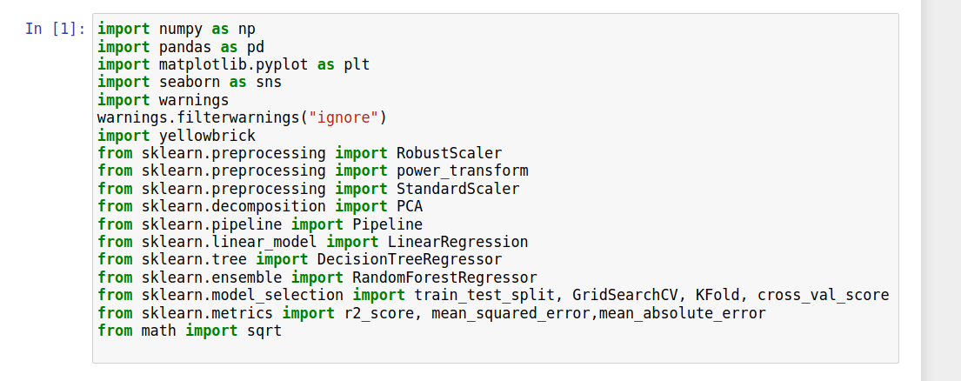

Now tat we have imported libraries, lets load the data set and we will displays the first 5 lines of the dataset

Reading the CSV file of data

Here we are going to load the data set using Pandas read_csv method, which converts data set into Data Frame format

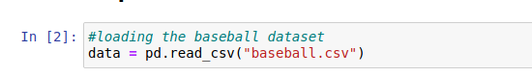

Now lets print first 5 lines of the data set, in pandas we will use head() method to print the head of data set (ie first 5 lines) of data set

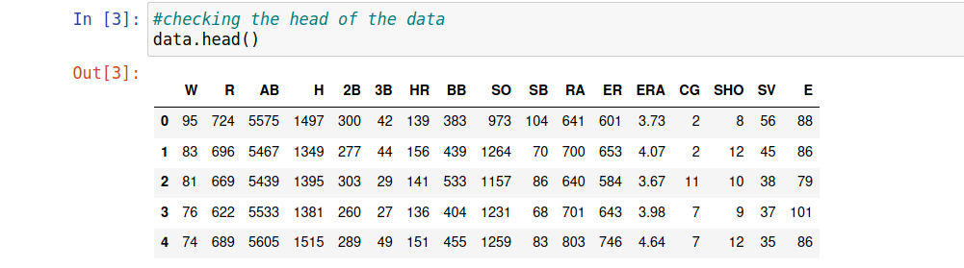

Here we display the first 5 lines of the data

Examining the data set

After importing the data, to learn more amount of data, we will use .info(), and .describe() methods
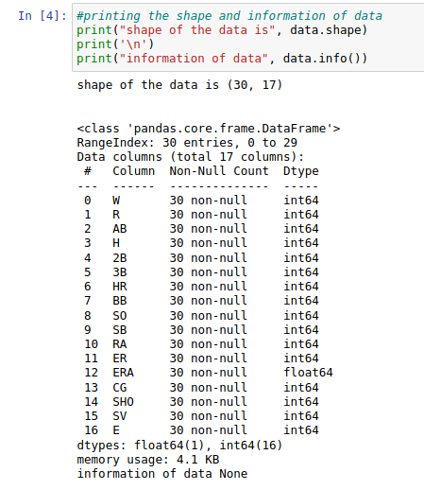

The .info() method will give you a concise summary of the Data Frame. This method will print the information about the Data Frame including the index dtype and column dtypes, non-null values, and memory usage, and .shape() is the method that shows the shape of the data

Exploratory Data Analysis
It is the most important step we are going to analyze the data set so that we get inferences from the data lets start with Descriptive Statistics method in pandas .describe()
The .describe() method will give you the statistics of the columns.
- count shows the number of responses.
- unique shows the number of unique categorical values.
- top shows the highest-occurring categorical value.
- freq shows the frequency/count of the highest-occurring categorical value.
Here is the output:

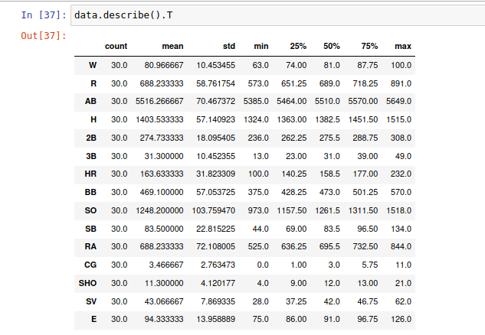

Now we have to check for the null values , in pandas we have a method .isnull() to know where are the null values and the method .sum() gives us the information of sum of all null values

Here is the output:

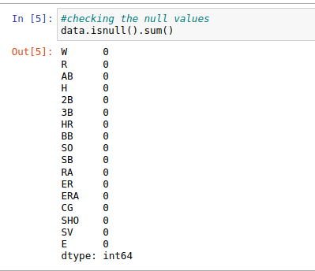

We are lucky we don't have any null values so lets proceed further, i am going to follow some steps of reducing dimensions using PCA

Have you observed one thing we have previously on data sets which has over 1000+ columns but now we only have 30 columns and its a small data set which was very small which has much affect on correlation and outlier behavior

the reason why i am applying PCA is when we are dealing with small data set there is huge affect on Bias-Variance Trade off as we know bias is the difference between the model prediction and true value and Variance is the variability of model prediction

Here we can observe the concept of under fitting and over fitting

Models with low bias and high variance over fit the data, while models with high bias and low variance underfit the data.

Models trained on a small data set are more likely to see patterns that do not exist, which results in high variance and very high error on a test set. These are the common signs of over fitting. So, your main goal when working with small data sets is to avoid over fitting.

So lets try with the PCA which we reduce the dimension to see how smaller data sets works by the problem statement

Correlation
Correlation is an indication about the changes between two variables

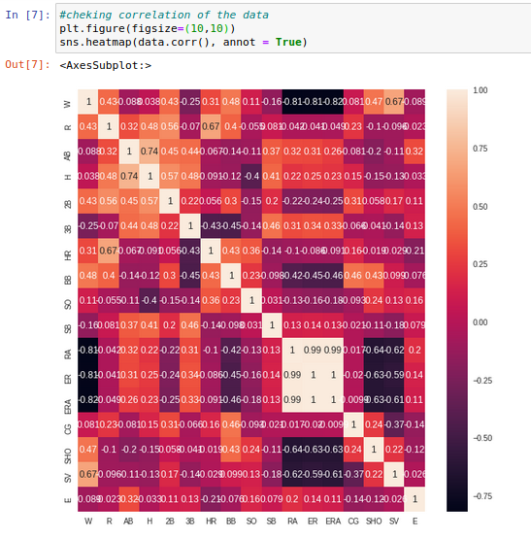

By the heat map we can clearly say that we have two highly correlated values in the data set we have to drop those two columns{ERA, ER}
We can drop those data as these columns as they will be treated as redundant columns because of correlation

for eg ERA is positively correlated with RA with 0.99 percent
ER is positively correlated with ER with 0.99 percent

Actually the range of correlation is 0.3 – 0.8 and above that range is considered as highly correlated values

so lets drop highly correlated values

so we have dropped those columns {ERA, ER}

For getting more reference on pandas : https://pandas.pydata.org/pandas-docs/stable/

Outliers

Now we are dealing with most important concept Outliers which mainly affects the data wen used for model creation

When using a small data set, outliers can have a huge impact on the model. So, when working with scarce data, you’ll need to identify and remove outliers. Another approach can be to use techniques that are robust to outliers like quantile regression. Removing the impact of outliers is essential for getting a sensible model with a small data set. so we are going to apply Robust scalar to handle the outliers before standardization

lets check the outliers in data set I have created a function to detect the outliers and also applied a loop to apply that to all data set so we got this output:

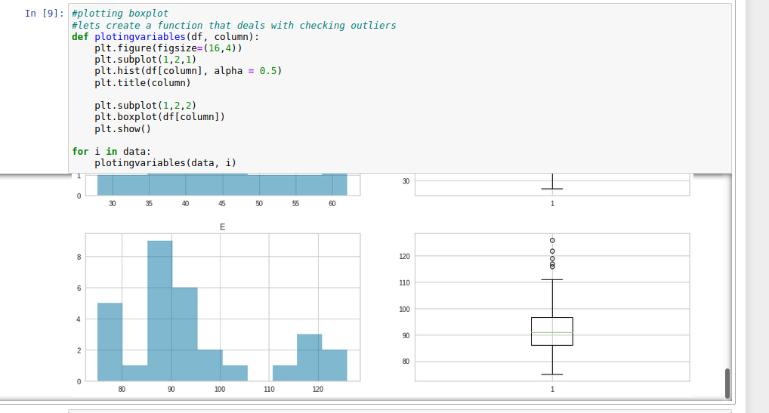

We got only one column {E} with Outliers that are extreme values, so we will apply Robust Scalar in scaling step to remove those outliers

Lets check the distribution of the data using hist plot

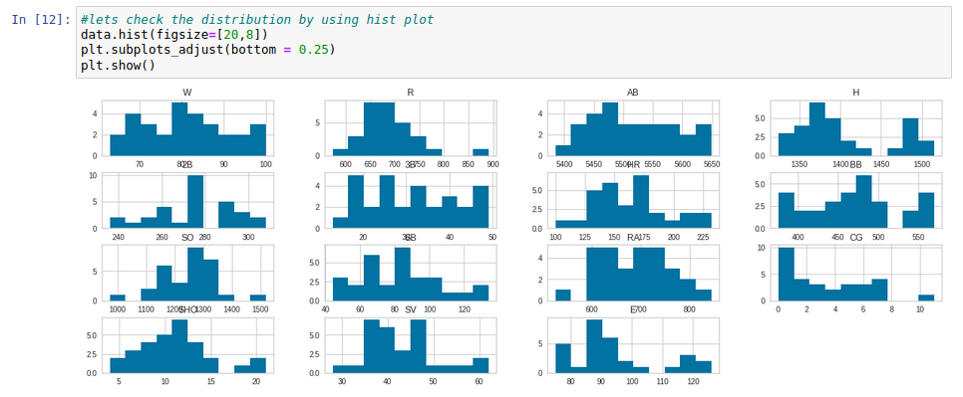
Lets check the density of the data using density plot

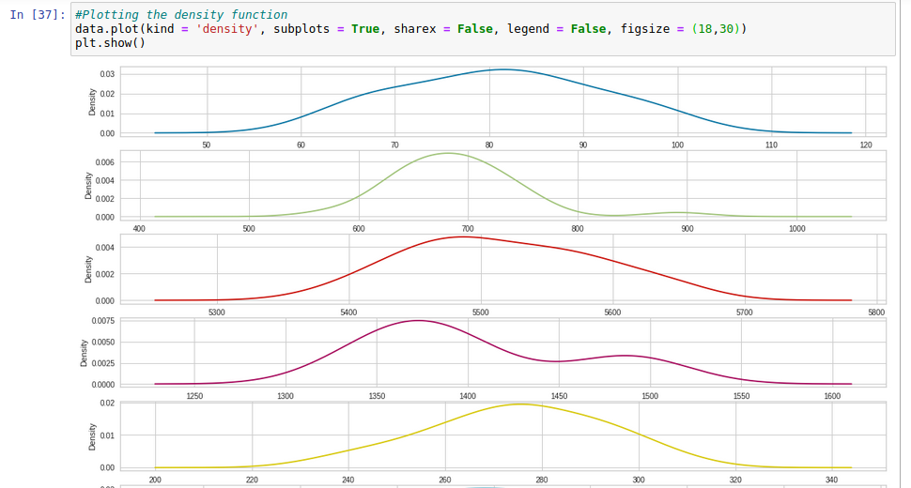

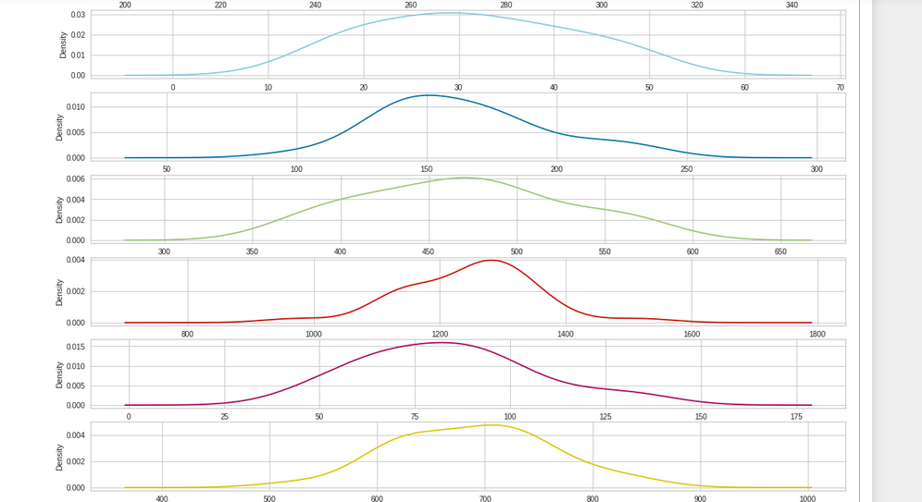
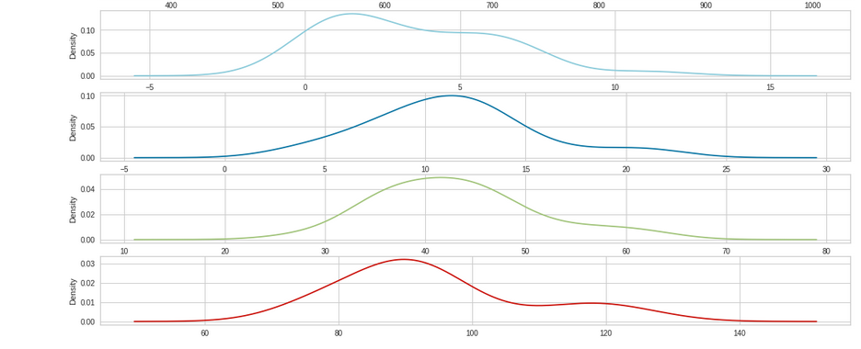

Dividing the Dependent and Independent variables

Now we have to divide the dependent and independent variables in the data set so that we ave to perform scaling and model creation and also it is the first step of PCA

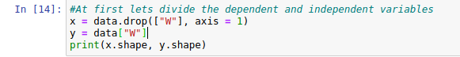

Feature Scaling

In the feature scaling we have to scale the data such that we have to make the data in standardized form so that we can start building models, because all the machine learning models deals with the standardized data

We are going to apply
- Robust Scalar for removing outliers ,
- Power Transform for reducing skewness of the data, and at last
- Standard scalar for standardizing data in the range of -1 to +1

And I am using pipelines to make a clean code

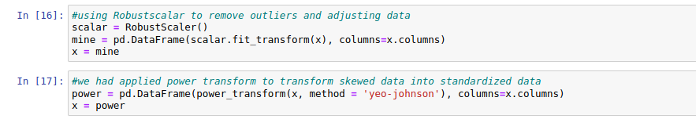

Lets check the skewness using the dist plot

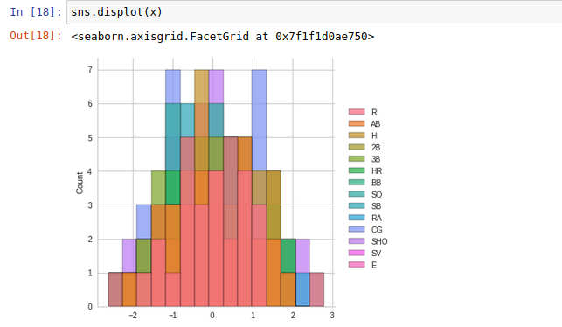
We have taken care of skewnees , outliers and other terms now its the main thing is to apply a simple model to make prediction pf results
As we are dealing with small data set we have to give more data to training so that there will be no under fitting or over fitting

As we are dealing with the data small we need simple model to make predictions, so I am using Linear regression, Decision tree and Random forest

lets create instance of all models

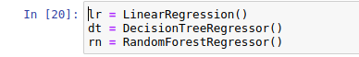

Now lets divide [x] into train and test set

Here I allocated 30 percent of data to testing and remaining to training so that model trains well to give us goog predictions

Now I am going to create multiple pipelines with
- standard scalar to scale the data
- PCA to reduce dimensionality, and
- Model here I am using Linear regression, Decision tree and random forest

I will create a list of pipelines to make our work easier

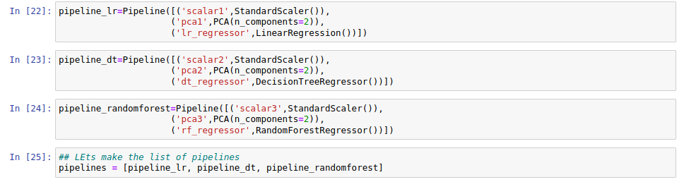

Fitting the pipeline with train data

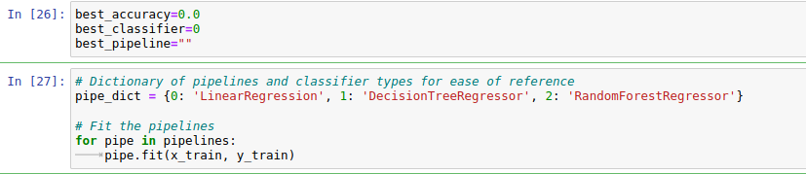

Now I am creating a loop for model creation and prediction, as I am using regression models for prediction I am using some metrics for evaluating model, they are R2score or coefficient of determination , mean squared error, mean absolute error and Root mean squared error(RMSE)

model creation :

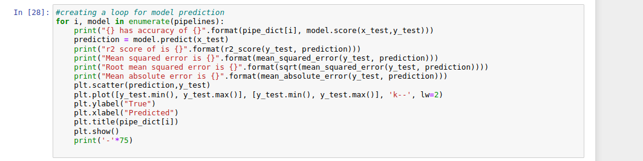

Lets see the output of above code:

For linear regression :

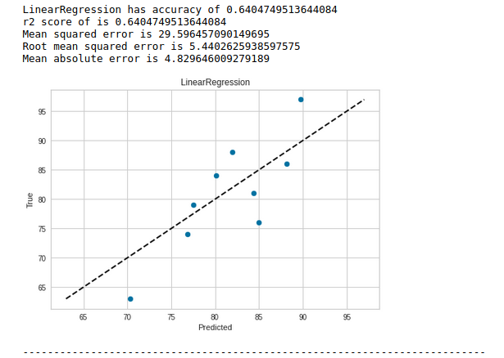

For Decision Tree Regressor:

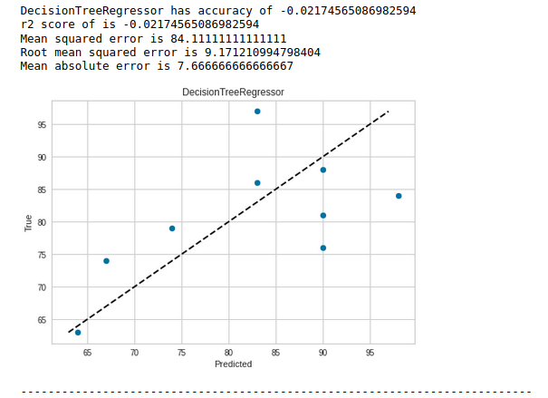

For Random Forest Regressor:

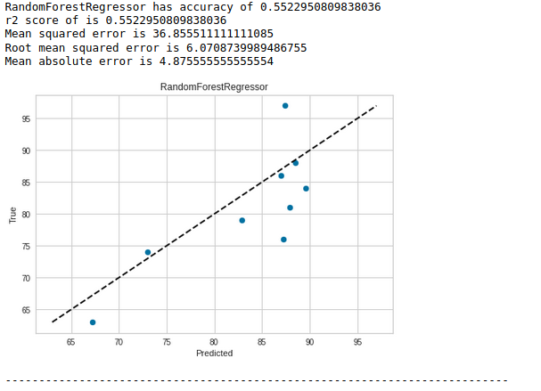

A we can see we predicted and also plotted the regression and also plotted the best fit line of regression, now we have to select the best model base on score an RMSE , the model which has low RMSE will perform good than others, lets create some loop to find that outliers

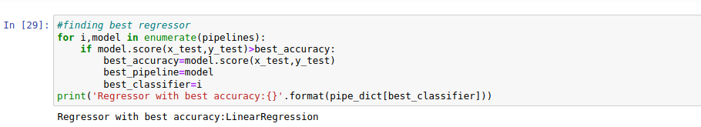

We can see we got linear regression with best model, we can still improve the score of the model by hyper parameter tuning

Now lets save the best model we got , before that I am gonna check the model with Residual plots , and
Error prediction plot, I am using yellowbrick visualization package for that

Error Prediction plots gives the identity and best fit lines for the model

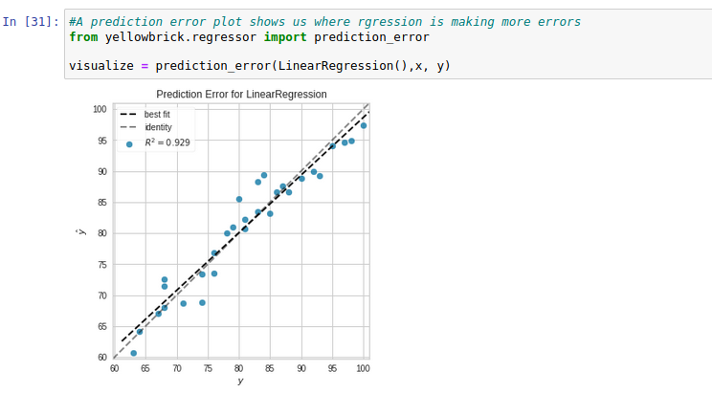

We can see we have both line for best fit and identity line, and also we can see the errors that our model makes

Residual plots mainly deals with the distribution and also shows the difference between the test and training data

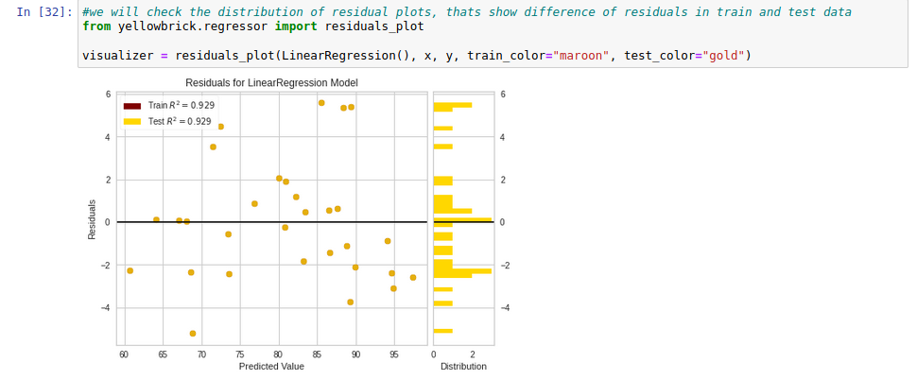

Saving the model

Now we can save the best model for further use here, I am using a package in python called Joblib for saving the model it uses two methods to save and load the model data like
- dump() - its is mainly used to save the model
- load() - It is used to load the saved model

We have to save the model using extension like .obj or .pkl , we can select any one of them

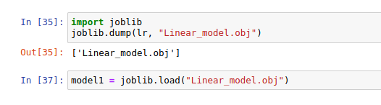

Now lets jump to the conclusions, now we have to use our model to get prediction to see how well it performs

Conclusion
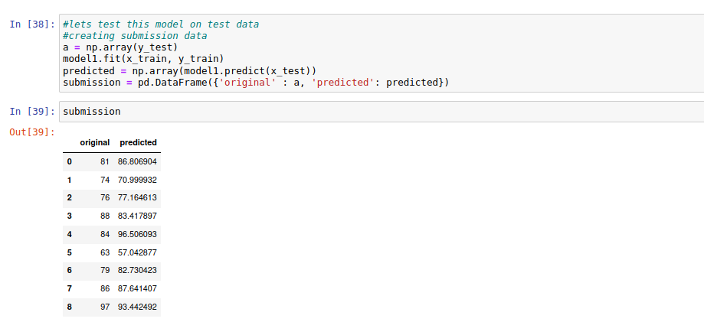
We can conclude one thing with this data set

Small Data Is Just Another Challenge That You Can Overcome!

I already used the same baseball data set in creating normal linear regression, you can find that notebook here.

Also you can find the notebook for above code here

References

For PCA:

https://scikit-learn.org/stable/modules/generated/sklearn.decomposition.PCA.html

https://www.youtube.com/watch?v=FgakZw6K1QQ&t=67s

