Insurance Claim Fraud Detection
Using Different Classifiers

Introduction to classification using Decision Tree, Logistic Regression, KNN, SVM, Naive Bayes, Random Forest Classifiers with Python


Insurance fraud is any act committed to defraud an insurance process. It occurs when a claimant attempts to obtain some benefit or advantage they are not entitled to, or when an insurer knowingly denies some benefit that is due. According to the United States Federal Bureau of Investigation, the most common schemes include premium diversion, fee churning, asset diversion, and workers compensation fraud.

| “Rather fail with honor than succeed by fraud”
----- Sophocles

Let’s build different machine-learning models to classify the insurance claim is fraudulent or not

Introduction

In this project we are going to examine the data and build different machine learning models, that will detect if the insurance is fraudulent or not by specifications given in the data set

Lets get Started……………

Problem Statement

Insurance fraud is a huge problem in the industry. It's difficult to identify fraud claims. Machine Learning is in a unique position to help the Auto Insurance industry with this problem.

In this project, you are provided a data set which has the details of the insurance policy along with the customer details. It also has the details of the accident on the basis of which the claims have been made.

In this example, you will be working with some auto insurance data to demonstrate how you can create a predictive model that predicts if an insurance claim is fraudulent or not.

Here i am going to use many Classifiers to make predictions.

Data Set
Data set used in the project is Automobile_insurance_fraud.csv that contains 1000 instances and 40 features through which we have to analyze and and build a machine learning model that predicts.

The python libraries and packages we will use in project namely
- Numpy
- Pandas
- Matplotlib
- Seaborn
- Scikit-learn

we will use specifications like age, policy-number etc to classify the insurance fraudulent or not.

Importing necessary libraries

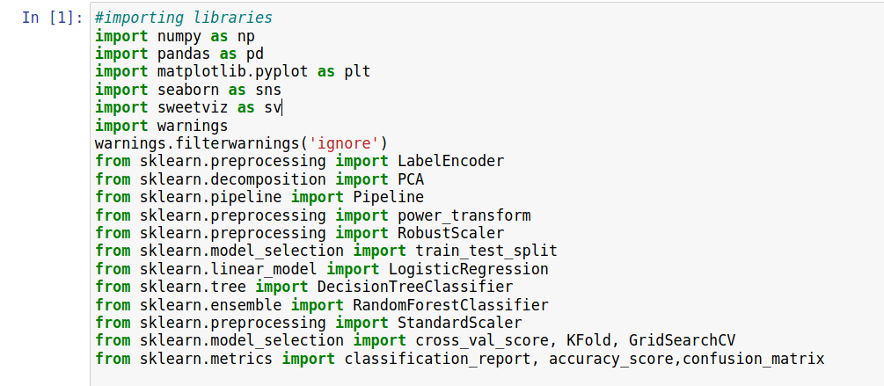

Reading the CSV file of the dataset
Pandas read_csv() method imports a CSV file to DataFrame format.
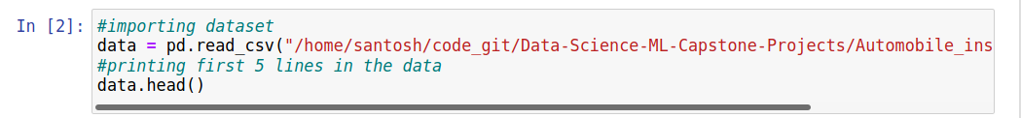
.head() method in pandas displays first 5 lines in the dataset,

Exploratory Data Analysis
EDA is the step where we analyze the data set fully such that we can understand all the data, using that information we are going to build the model

Examining the Dataset
After importing the data, to learn more about the dataset, we’ll use .head() .info() and .describe() methods.
We have already discussed about .head() method which displays first 5 lines in the data
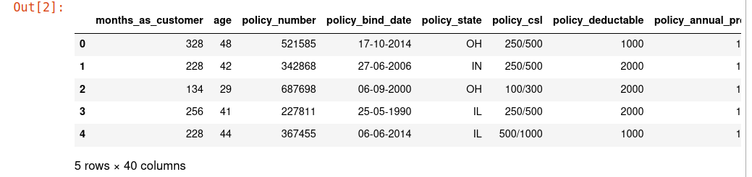
A small introduction about data set, it contains mixture of both categorical and numerical columns, and the target variable we have in our data set is “fraud_reported” which has only two values “yes” or “no”.
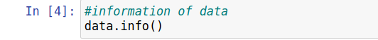

The .info() method will give you a concise summary of the Data Frame. This method will print the information about the Data Frame including the index dtype and column dtypes, non-null values, and memory usage. Here is the output
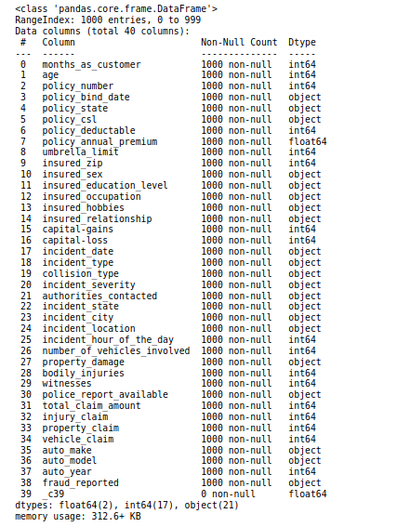

Descriptive Statistics

The .describe() method will give you the statistics of the columns.
- count shows the number of responses.
- unique shows the number of unique categorical values.
- top shows the highest-occurring categorical value.
- freq shows the frequency/count of the highest-occurring categorical value.
Here is the output:

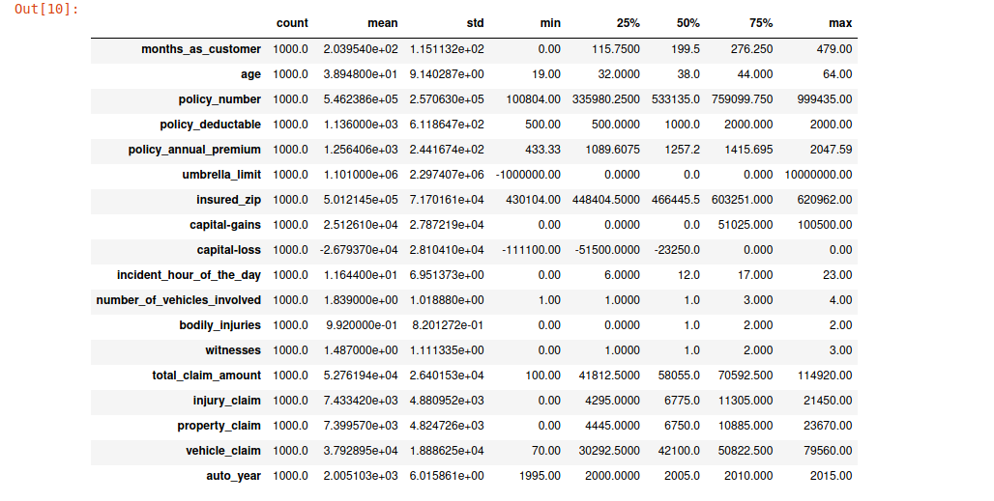

The shape of the dataset

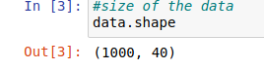

As we can see that _c39 column does not a contain any data now need to keep them lets drop the column, as we can observe there are no null values in the data set but the data contains ? marks in the place of null values lets check them

we gotta replace them, lets proceed further, by dropping _c39 column

We are creating lists for both categorical and numerical features
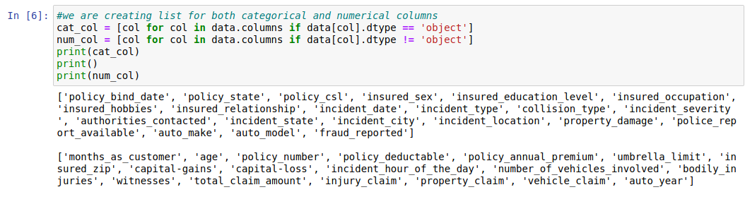
Lets check the null values if we have any we have to replace them with appropriate methods

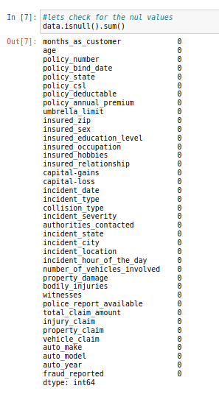

There is one thing in the data set which we have to observe in this data set we have no null values we have ? Int place of null so we have to replace ? With appropriate value

We have 4 columns with ? value in it lets replace them with appropriate value, here I am going to replace them with most frequent value, and lets check with the numerical columns in the data set

there is no "?" mark in the dataset so lets continue further with EDA
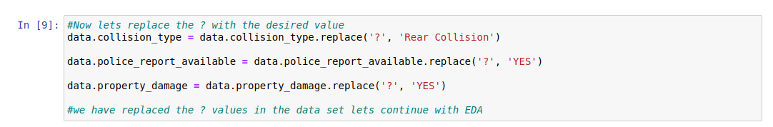
Lets see the some visualizations lest start with the histplot

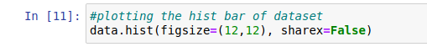

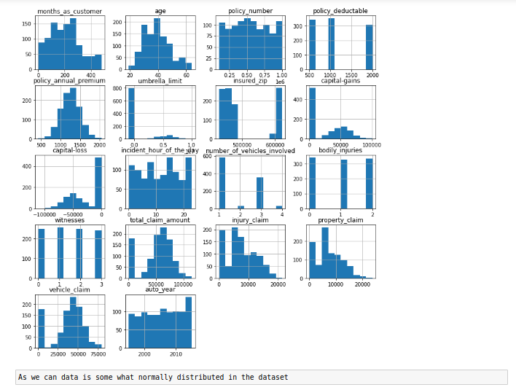

we are using new library for visualization called Sweetviz in this visualization is represented in the form of HTML report we can see all the details along with the association of the data

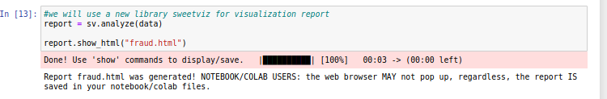
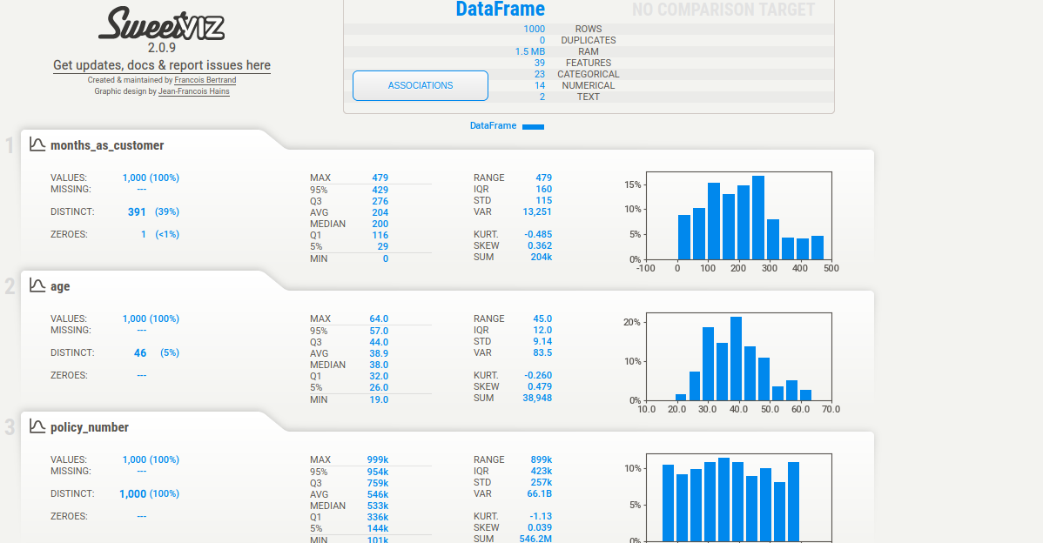

Now lets check with the correlation o the data

Correlation
As we know correlation range between 0.3 to 0.8, any thing above that treated as highly correlated we ave to check weather data correlation is in the range if not drop those columns

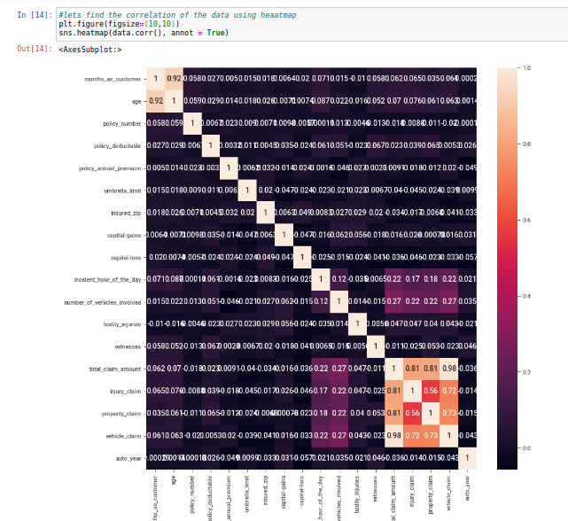
By observing the data correlation we have one column total_claim_amount which is highly correlated we can drop that column

Outiers
In machine learning outliers is the most important to take care of as there are more outliers predictions differ

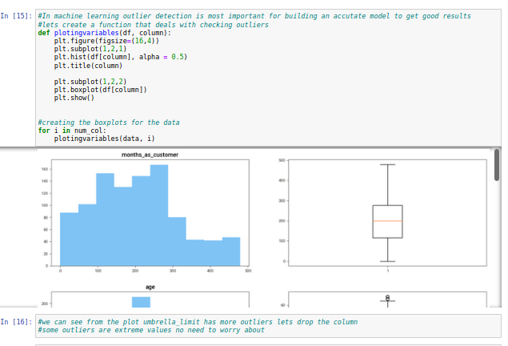

Violin plots shows us the the distribution of data along with the median of data

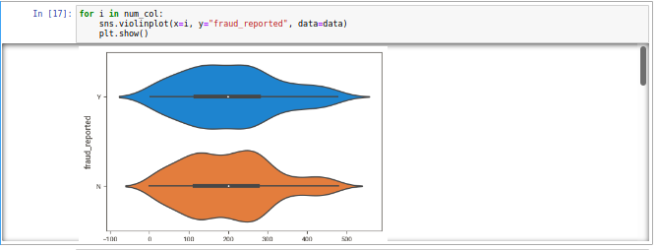

Feature Engineering

Its the step where we are going to handle the features that we are going to change them into numerical form so the we can create model, because all machine learning models only deals wit the numerical data

Have you remembered we have created two lists at the starting we are going to use them for feature engineering

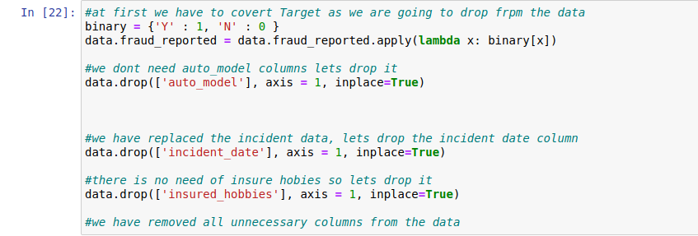

After changing all those features we are going the dataset looks like

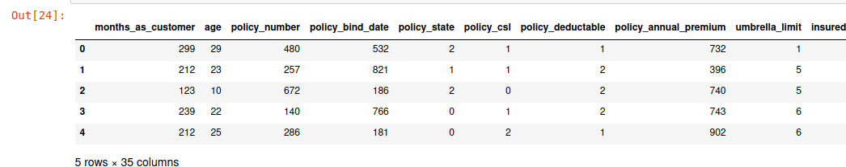

we can see that here are more features in the data and we cannot easily say which is really important if we design a model with this there will be less accuracy due to the more data we call it "Curse of Dimensionality"

We are going to apply one of the dimensionality reduction technique principal component analysis(PCA)

Now we have to scale the data before using them to create models

Feature Scaling

Feature scaling mainly deals with the scaling data to remove outliers, removing skewness and standardizing data,
I am using standard scalar, robust scalar and power transform, and

I used Label encoder to encode most repetitive values in the data set

Diving dependent and independent variables

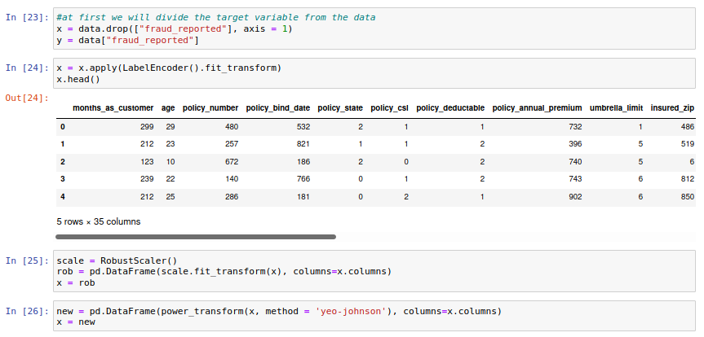

After converting the data Lets start with model creation I am using pipelines for that as shown below:

Now lets create pipelines
Pipelines Creation
1. Data Prepossessing by using Standard Scaler
2. Reduce Dimension using PCA
3. Apply Classifier

Diving the dependent and independent variables

Model Creation
I am using some basic classifiers Logistic regression, Decision tree and random forest along with pipeline

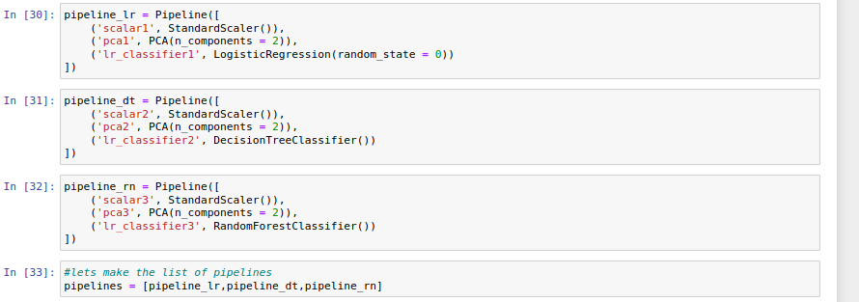

At last I have create a list that contains all the pipelines so that we can handle them easily

Now lets fit the pipelines wit training data

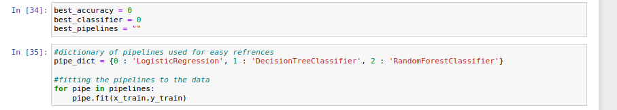

We have fitted the data, lets start to predict using test data

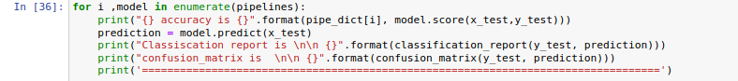

lets see the prediction result as we are using classifiers we gona have some metrics which shows how good model is predicting

For Logistic Regression:

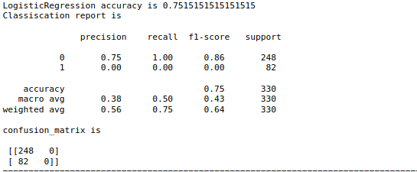
Evaluation metrics we are using are Classification report which gives the information of precision, recall,f1-score and support , confusion matrix and accuracy score which shows the score of how good model works

For Decision Tree classifier

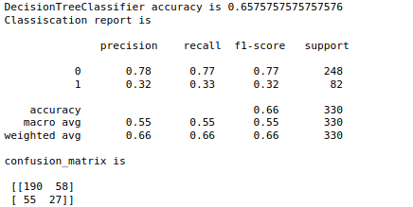

For Random Forest Classifier

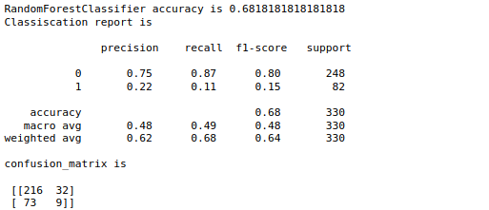

Lets find the cross val scores of the model to find the best model

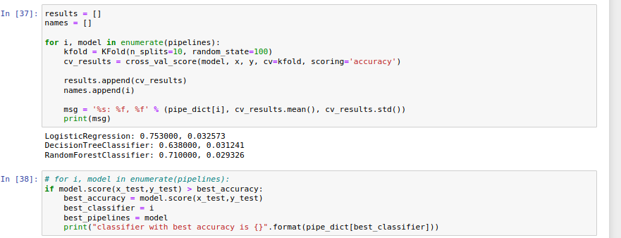

We have Logistic regression with best model, lets start with hyper parameter training

Hyper Parameter Tuning
Logistic regression does not have critical parameters to do so lets arrange the basic parameters to get good score

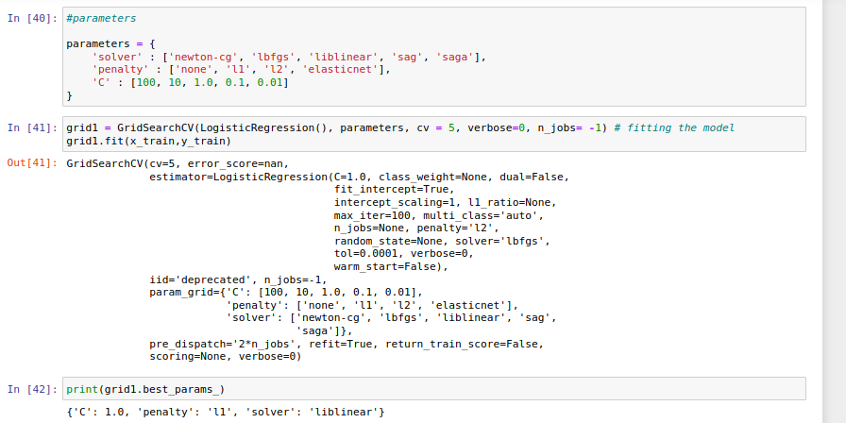

we have used Grid search CV for best parameter tuning and got best parameters so lets predict by using tuned model we get

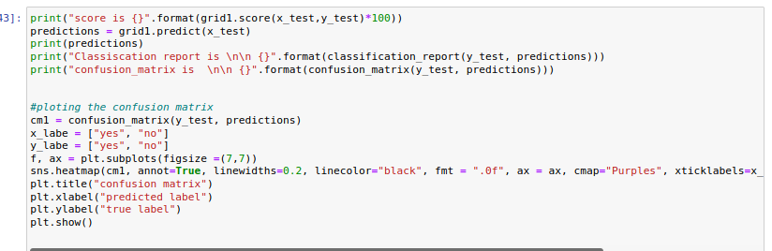
And the results are :
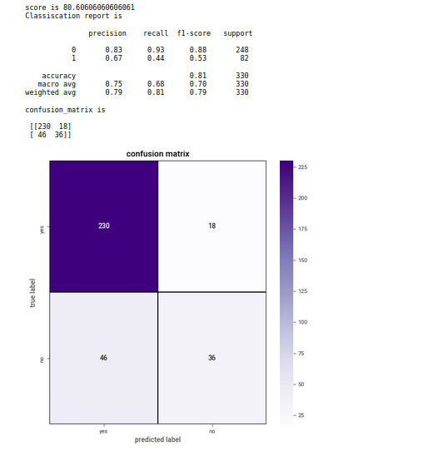

Lets plot AUC-ROC curve for checking the area under the curve
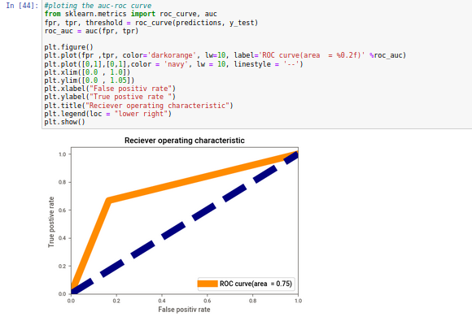

Yay..............by hyper parameter tuning we increased accuracy from 75 percent to 81 percent,so lets go ahead and save the model

Saving the model
we have used Joblib package for the saving and loading the model

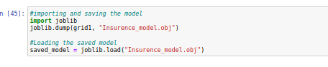

Conclusion
we have created the model lets test it on the sample data ans see how it works

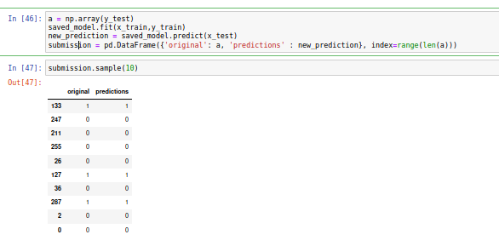

You can find my notebook in here.

References

For PCA:

https://scikit-learn.org/stable/modules/generated/sklearn.decomposition.PCA.html

https://www.youtube.com/watch?v=FgakZw6K1QQ&t=67s

