Project 1 :

Title : Developing GUI for Data Augumentation

Aim : To develop a Graphical user interface for generating artifically augmented data used for training deep learning models.

Users : Deebul Nair / Santosh Thoduka

Requirements :
- Build a pipeline to artificial generate annotated data for training deep learning models.
- Pipeline includes starting from capturing images using provided camera (Realsense), generate semantic labels of the captured image and then generate the artificial images.
- GUI required for the end user from capturing to labelling and generating new data.
- Making the software pip/conda installable
- Writing test cases
- Integration with github CI
Delivarables :
- At the end of SDP course, expected to deliver working software as per the above mentioned requirements.
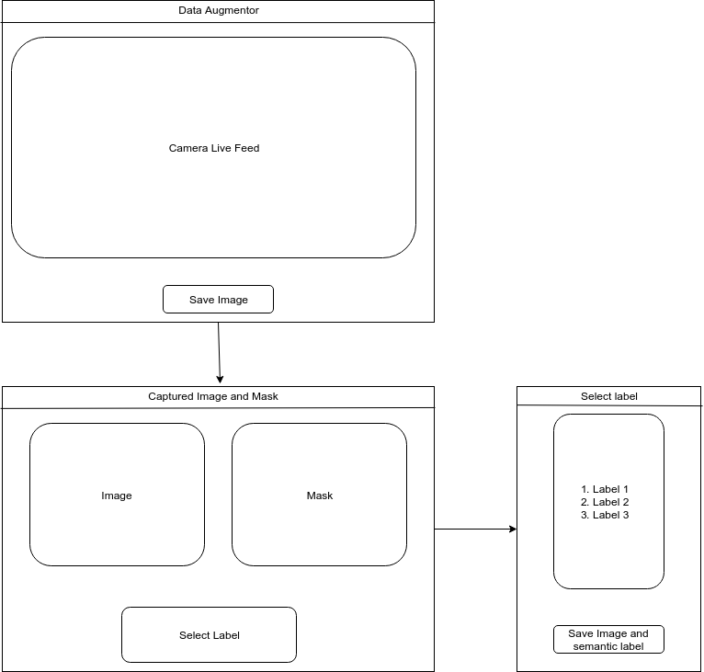

Project 2 :

Title : Integrating Data Augumentation in labelme

Aim : To integrate Data augmentor tool to existing open source software labelme.

Users : Deebul Nair / Santosh Thoduka

Requirements :
- Integrate the Data augmentor tool to existing GUI of label which is used for annotating already captured images.
- End to end software to annotate and augment the given dataset.
- Making the software pip/conda installable
- Writing test cases
- Integration with github CI
Delivarables :
- At the end of SDP course, expected to deliver working software as per the above mentioned requirements.
