A Survey-Based Analysis of JEE Main Preparation and Performance
An Exploratory Data Analysis of a Student Survey
Introduction to Data Handling and Visualization – Course Project Report
Member | Roll No. | Contribution
Janga Sriharshith | S20240030373 | [Contribution]
B RaviChandra | S20240010022 | [Contribution]
G Mohan Sai Teja | S20240030371 | [Contribution]

Survey link: https://tally.so/r/vGQNBd

Introduction
Every year a large number of students spend months preparing for JEE Main. Around this preparation there are many common beliefs: more study hours means a better result, mock tests show how you will do, and sleep and phone time must be cut down. Most of this is advice from seniors and coaching centres, not something checked with data. We wanted to see what real students’ answers say about it.
For this project we made a short online survey among first-year engineering students(freshers) and asked how they prepared (mode of preparation, months, daily hours, mock tests, PYQs), how they lived during that time (sleep, screen time, stress) and what JEE Main percentile they got. We then cleaned the data and analysed it using summary statistics, plots and correlation.

Research question: How are preparation methods, study habits and lifestyle factors related to the JEE Main percentile of first-year engineering students?
We looked at it through three smaller questions:
- RQ1. Is mock-test performance (score and number of tests) related to percentile?
- RQ2. Does percentile differ by preparation mode, study hours, preparation duration, PYQ practice, school board, location or number of attempts?
- RQ3. How are sleep, screen time and stress related to percentile and to study habits?

Methodology

Research design
This is a one-time (cross-sectional) survey. Students answered once, after the exam, about their preparation period. We did not change anything in the students’ routine, so the study can only show relationships between variables, not causes.

Questionnaire
The questionnaire was made in Tally. Online form: https://tally.so/r/vGQNBd. It has 15 short questions .
It was used for this course project and for wider academic study of how JEE preparation strategies that are related to results.

Fully anonymous: no names, no emails, and nothing is shared with anyone. 15 short questions.”
No. | Question | Answer type / options
1 | Which state are you from? | Dropdown list of states
2 | How did you primarily prepare for JEE? | Self-study / Online coaching / Offline coaching / Hybrid
3 | Which school board did you study under for Class 12? | CBSE / State Board / ICSE / Other
4 | Where did you spend most of your JEE preparation? | Metropolitan city / Other city / Town /  Rural area
5 | How many times did you appear for JEE Main? | 1 (first attempt) / 2 / 3 or more
6 | For approximately how many months did you seriously prepare for JEE? | Number of months
7 | On average, how many hours per day did you spend preparing for JEE? | Number of hours per day
8 | Approximately how many JEE-style mock tests did you take per month? | Number of tests per month
9 | What was your average score in JEE Main-style mock tests? (Out of 300) | Number out of 300
10 | How frequently did you practice previous-year questions (PYQs)? | Never / Rarely / Sometimes / Often / Very  Often
11 | Which subject did you find most difficult in JEE preparation? | Physics / Chemistry / Mathematics
12 | During your serious JEE preparation, how many hours did you sleep on an average night? | Number of hours
13 | How many hours per day did you spend on your phone/screens for NON-academic purposes? | Number of hours per day
14 | How stressed were you during your JEE preparation? | Rating 1 to 10
15 | What was your JEE Main percentile? | Number between 0 and 100

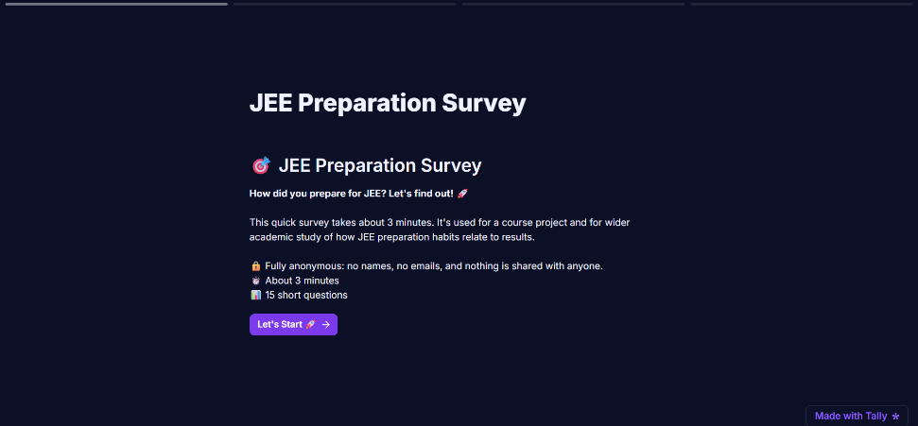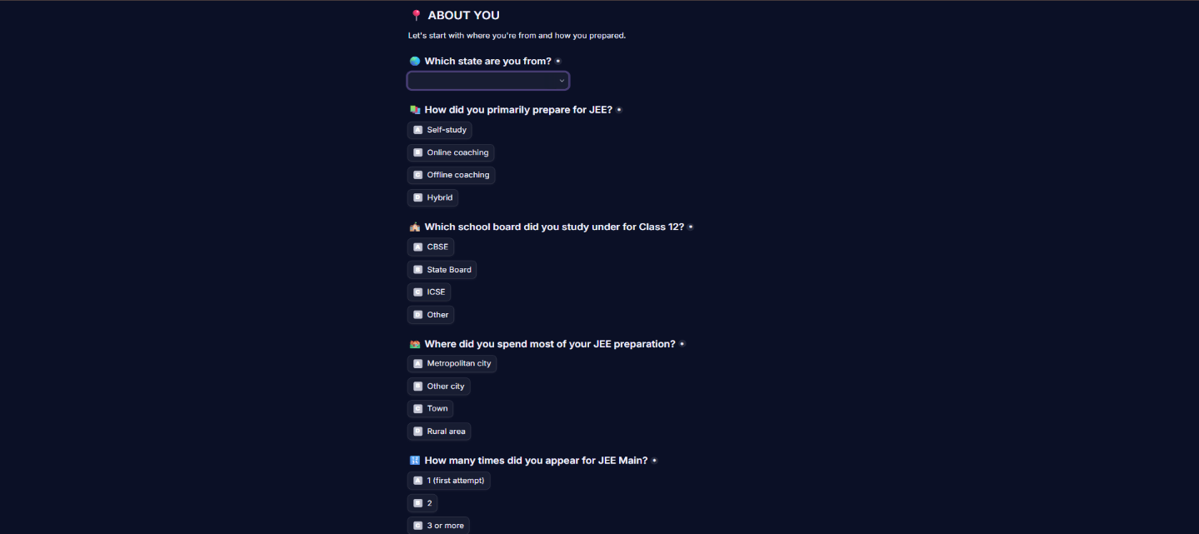


Table 1. Variables in the survey.
No. | Variable | Description | Type
1 | state | Home state | Categorical
2 | prep_mode | Main way of preparing | Categorical
3 | school_board | Class 12 board | Categorical
4 | prep_location | Where most preparation was done | Categorical
5 | attempts | Number of JEE Main attempts | Numeric (1, 2, 3+)
6 | prep_months | Months of serious preparation | Numeric
7 | study_hours | Average study hours per day | Numeric
8 | mock_tests | Mock tests per month | Numeric
9 | mock_score | Average mock score (out of 300) | Numeric
10 | pyq_frequency | How often PYQs were practised | Categorical (ordered)
11 | difficult_subject | Most difficult subject | Categorical
12 | sleep_hours | Average sleep per night | Numeric
13 | screen_hours | Non-academic screen time per day | Numeric
14 | stress_level | Stress during preparation (1–10) | Numeric (rating)
15 | percentile | JEE Main percentile | Numeric

Data collection
The survey link was shared online and responses were collected from 12 October to 19 October 2026. The Tally form was connected to a Google Sheet, so every submission was added to the sheet as a new row automatically. After the responses were collected, the sheet was downloaded as a CSV file and saved as raw_data.csv. This file was never edited; all cleaning was done on a copy in Python. In total we got 53 responses.
Tally form
survey link
Respondents
anonymous
Google Sheets
rows added
automatically
raw_data.csv
downloaded,
not edited
Python
cleaning and
analysis
Figure 1. How the data was collected.

Sampling
We used snowball sampling strategy. The survey was first sent to 2-3 persons in the target group (a first-year engineering student), who forwarded it to others they know, and they forwarded it further. We chose this because there is no list of JEE candidates to pick a random sample from, and it was the quickest way to reach enough students in the time we had.
The drawback is that the sample is not random. People who know each other are similar, which is why 35.8% of responses are from Telangana and 67.9% of students used offline coaching. Also, only students who got into engineering colleges could answer, so students with low results are missing. So the results are about these 53 students and should not be generalised to all JEE aspirants.

Data Preprocessing

Organizing the data
The raw file had 53 rows and 19 columns. The 15 survey columns had the full question text as their names, so we renamed them to short names like prep_months and stress_level (Table 1). We dropped four columns that are not needed for analysis (index, Submission ID, Respondent ID and Submitted at). The cleaned dataset has 53 rows and 15 columns and is saved as cleaned_data.csv.

Missing values, duplicates and data types
There were no missing values in any column and no duplicate rows, so nothing had to be filled in or removed. The attempts column was stored as text (“1 (first attempt)”, “2”, “3 or more”), so we took the number from it. This means “3 or more” is counted as 3. The mock_tests column was converted from decimal to integer.

Outliers
We used box plots (Figure 2) and the IQR rule (values below Q1 − 1.5×IQR or above Q3 + 1.5×IQR) to find unusual values, and then checked each one before deciding what to do.
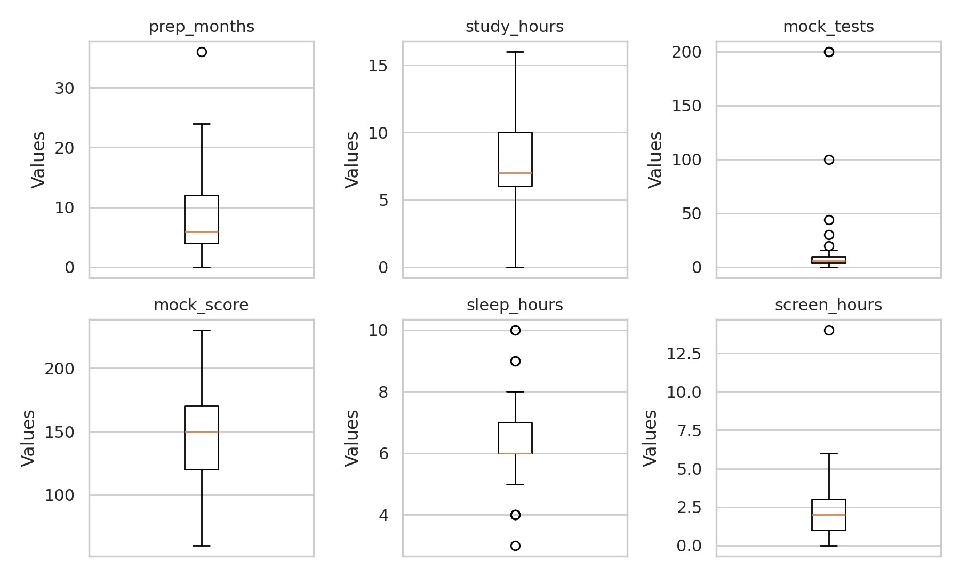
Figure 2. Box plots of six numeric variables before cleaning. The points far above the rest in mock_tests are clearly visible.

Table 2. Outliers and how they were handled.
Variable | Unusual values | What we did
mock_tests | 44, 100, 200, 200 | Replaced with the median (6). More than 30 full mock tests a month is not realistic, and 100 or 200 is most likely a typing mistake. Responses are anonymous, so we could not ask the students.
prep_months | 36 | Kept. Three years of preparation is possible for a repeat attempt.
sleep_hours | 3, 4, 9, 10 | Kept. Sleep habits differ between students.
screen_hours | 14 | Kept. Very high but possible.
study_hours | none | No outliers.
Only mock_tests was changed. After this its mean is 6.87 and its maximum is 30 (earlier the mean was 16.68, which was misleading). This replacement is our assumption and not a verified correction, and we mention it in the limitations. We did not change any percentile values, because low percentiles (the lowest is 58) are real answers.

Grouped variables
For comparisons we also made three grouped versions of numeric variables: study hours (0–4, 5–6, 7–8, 9–10 and above 10 per day), preparation duration (0–3, 4–6, 7–12 and above 12 months) and screen time (0–2, 3–5 and above 5 hours per day).

Results and Analysis

Descriptive statistics

Table 3. Summary statistics of the numeric variables (n = 53).
Variable | Mean | SD | Min | Q1 | Median | Q3 | Max
attempts | 1.62 | 0.63 | 1 | 1 | 2 | 2 | 3
prep_months | 9.11 | 7.67 | 0 | 4 | 6 | 12 | 36
study_hours | 7.55 | 3.43 | 0 | 6 | 7 | 10 | 16
mock_tests | 6.87 | 5.04 | 0 | 4 | 6 | 8 | 30
mock_score | 145.34 | 37.87 | 60 | 120 | 150 | 170 | 230
sleep_hours | 6.35 | 1.52 | 3 | 6 | 6 | 7 | 10
screen_hours | 2.27 | 2.22 | 0 | 1 | 2 | 3 | 14
stress_level | 7.02 | 2.30 | 1 | 6 | 8 | 9 | 10
percentile | 92.07 | 8.98 | 58 | 87.50 | 97.27 | 98.20 | 99.95
On average the students prepared for 9.11 months (median 6) and studied 7.55 hours a day. They took about 7 mock tests a month and scored 145.34 out of 300 on average. Average sleep was 6.35 hours and non-academic screen time was 2.27 hours a day. The median stress rating was 8 out of 10, so most students found the preparation stressful. The mean preparation time is higher than the median because a few students prepared much longer (maximum 36 months).
The mean percentile is 92.07 but the median is 97.27. Most students reported very high percentiles and a few reported much lower ones (lowest 58), which pulls the mean down. Because of this we give medians along with means in the rest of the report.

Table 4. Categorical variables.
Variable | No. of categories | Most common category | Share
state | 13 | Telangana (19) | 35.8%
prep_mode | 4 | Offline coaching (36) | 67.9%
school_board | 2 | State Board (32) | 60.4%
prep_location | 4 | Metropolitan city (32) | 60.4%
pyq_frequency | 5 | Often (26) | 49.1%
difficult_subject | 3 | Mathematics (19) | 35.8%

Respondent profile
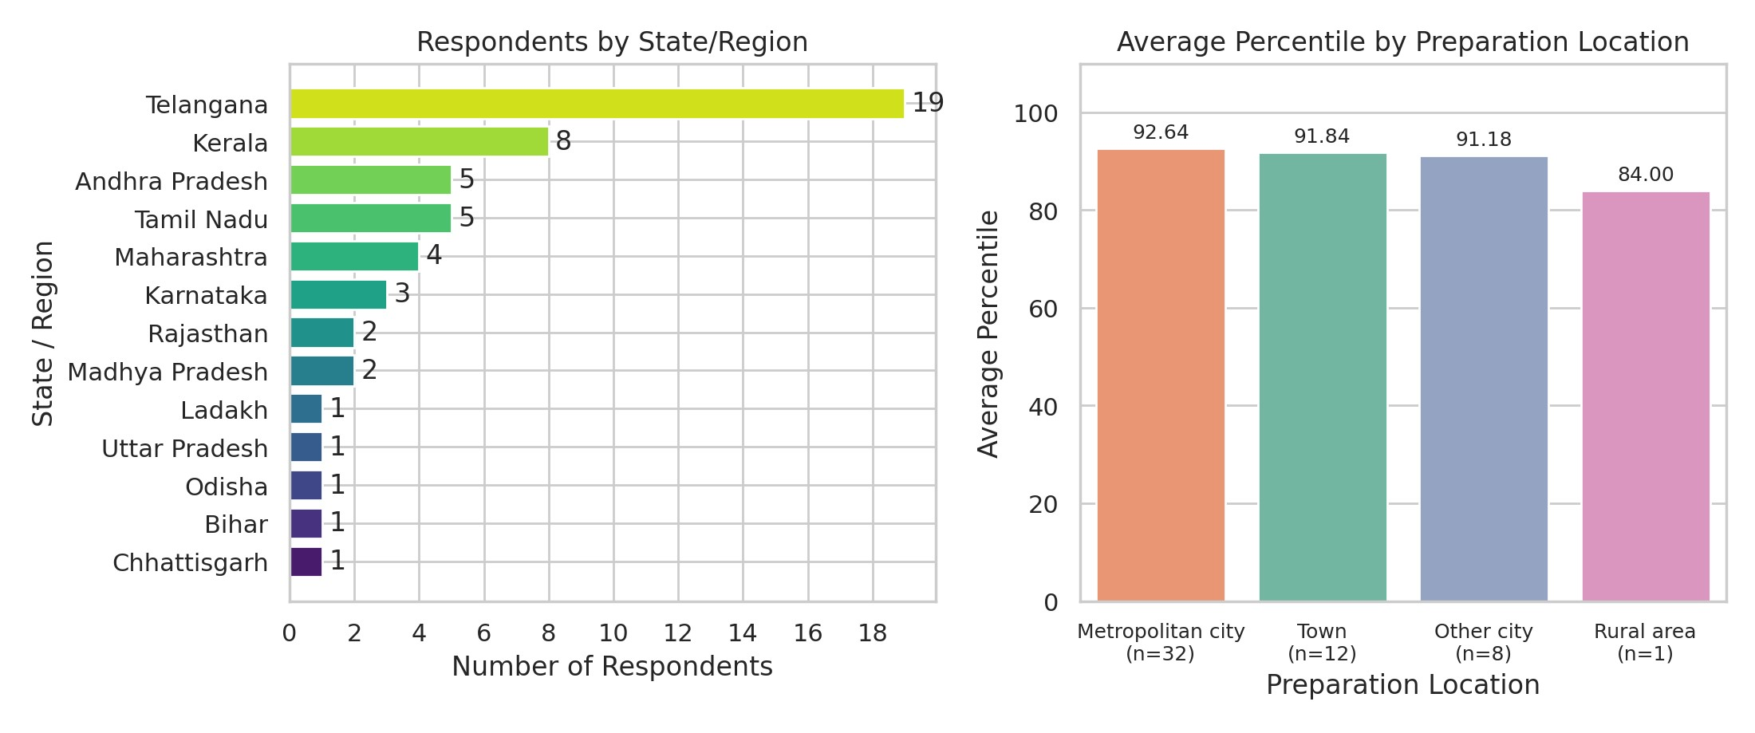
Figure 3. Respondents by state (left) and average percentile by preparation location (right).
Telangana has the most responses (19), then Kerala (8), Tamil Nadu and Andhra Pradesh (5 each). Most students prepared in a metropolitan city (32), then a town (12), another city (8) and a rural area (1). The average percentile is almost the same for metropolitan city (92.64), town (91.84) and other city (91.18). The rural value (84.00) comes from a single student, so it cannot be treated as a group average. We do not see a clear effect of location.

Distribution of percentile
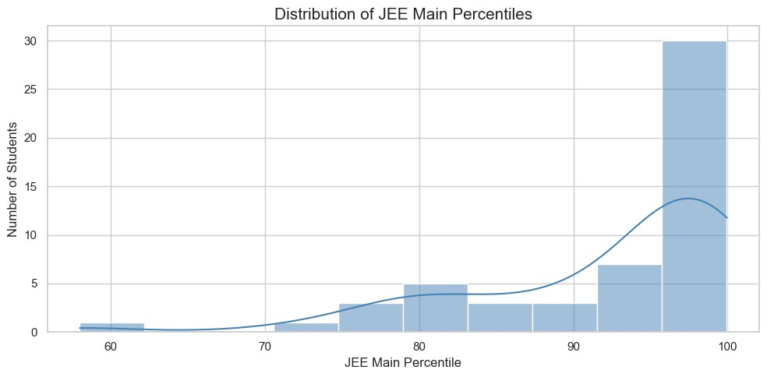
Figure 4. Distribution of JEE Main percentile (n = 53).
Most percentiles lie between 95 and 100: 31 of 53 students (58.5%) reported 95 or above, and only 7 reported below 80. This means our sample is mostly high scorers, which is expected because of the way the sample was collected.

Preparation method
Table 5. Percentile by preparation method.
Preparation method | n | Mean | Median
Offline coaching | 36 | 93.08 | 97.69
Self-study | 10 | 90.26 | 92.50
Hybrid | 5 | 90.09 | 92.00
Online coaching | 2 | 87.96 | 87.96
Offline coaching has the highest mean (93.08) and median (97.69) and online coaching the lowest (87.96). But offline coaching has 36 students while online coaching has only 2, so this table does not show that one method is better than another.

Study hours and percentile
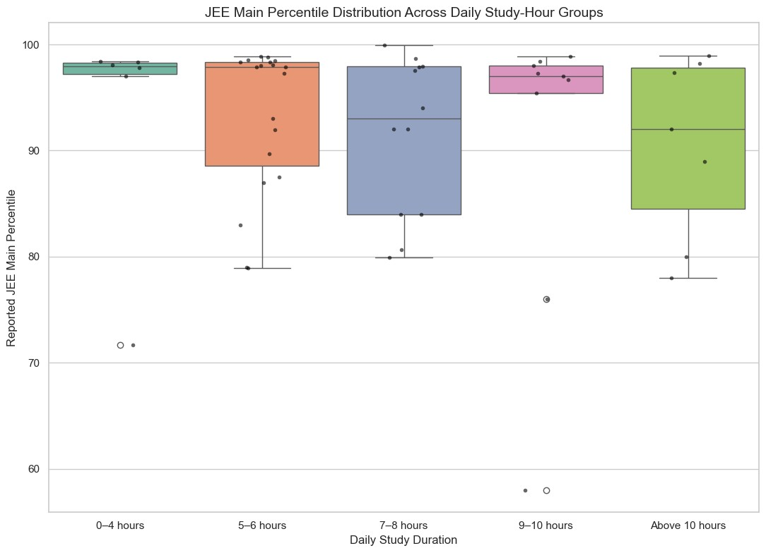
Figure 5. Percentile for different daily study-hour groups.
Table 6. Percentile by daily study hours.
Study hours per day | n | Mean | Median
0–4 hours | 6 | 93.57 | 97.95
5–6 hours | 19 | 93.19 | 97.90
7–8 hours | 12 | 91.56 | 93.00
9–10 hours | 9 | 90.63 | 97.00
Above 10 hours | 7 | 90.51 | 92.00
The mean goes down slightly from 93.57 (0–4 hours) to 90.51 (above 10 hours), but the medians do not follow any pattern and the boxes overlap a lot. The correlation between study hours and percentile is only r = −0.10. So in our data, studying more hours is not linked to a higher percentile. This does not mean that studying more reduces marks. It may be that students who find the subjects harder study longer, or that hours are only roughly reported, or that how well one studies matters more than how long.

Mock-test score and percentile
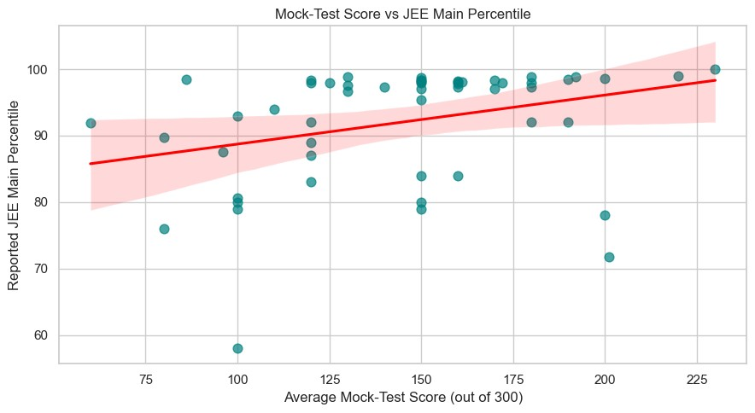
Figure 6. Average mock score vs JEE Main percentile with regression line.
The line goes upward, so students with higher mock scores tend to have higher percentiles. The relationship is statistically significant: Pearson r = 0.311 (p = 0.0234) and Spearman ρ = 0.411 (p = 0.0023), with n = 53. Since r² is about 0.10, mock score explains only around 10% of the differences in percentile. The points are quite spread out: among students with a mock score of about 100, percentiles range from 58 to 98. Mock score is the strongest relationship we found with percentile, but it is not a strong predictor. The number of mock tests per month has only a very weak relationship (r = 0.14).

Preparation duration and PYQ practice
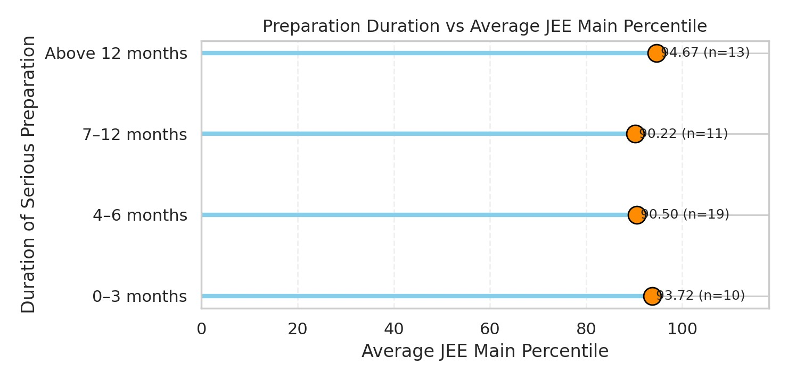
Figure 7. Average percentile by preparation duration.
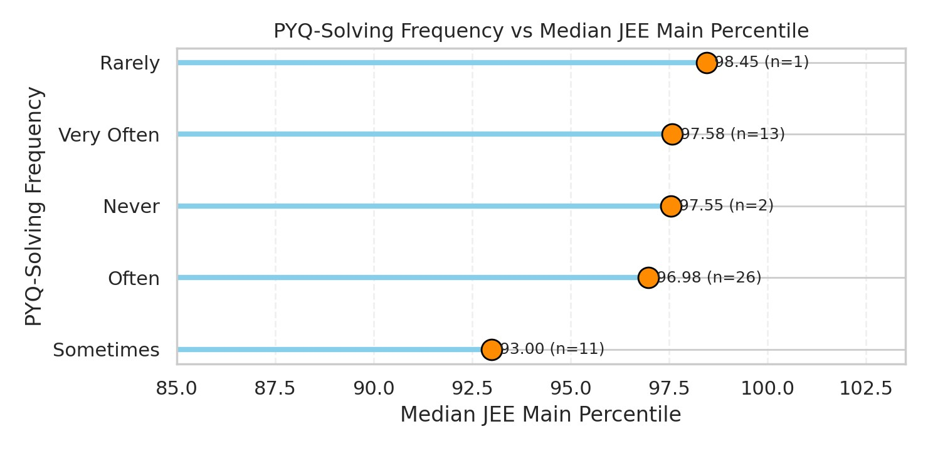
Figure 8. Median percentile by how often PYQs were practised.
Students who prepared for more than 12 months have the highest mean percentile (94.67, n = 13), followed by 0–3 months (93.72, n = 10), while 4–6 months (90.50, n = 19) and 7–12 months (90.22, n = 11) are lower. So percentile does not keep rising with more months (r = 0.08). For PYQs, “Very Often” has a median of 97.58, “Often” 96.98 and “Sometimes” 93.00, but the medians are high in every group and “Never” (n = 2) and “Rarely” (n = 1) are too small to read anything from. We cannot claim a clear link between PYQ practice and percentile.

School board and average percentile
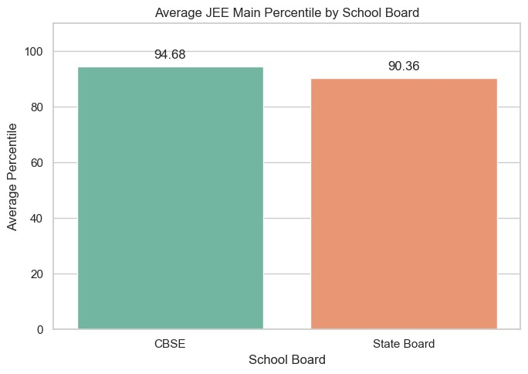
Figure 9. Average percentile by school board (CBSE n = 21, State Board n = 32).
CBSE students have a higher mean (94.68) and median (97.91) than State Board students (90.36 and 93.00). This is only a difference in our sample. We did not run a significance test, and the two groups may differ in other ways (coaching, location, state), so we cannot say the board is the reason. By attempts, first-attempt students (n = 24) have a mean of 93.68, second-attempt students (n = 25) 90.58 and three or more attempts (n = 4) 91.75, which are small differences.

Most difficult subject
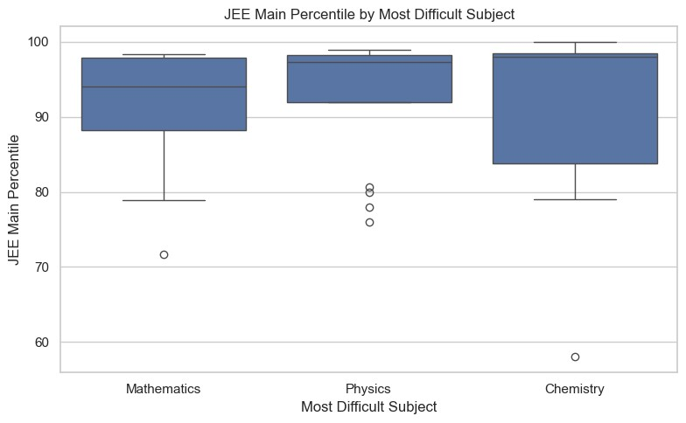
Figure 10. Percentile by most difficult subject.
Table 7. Percentile by most difficult subject.
Most difficult subject | n | Mean | Median
Mathematics | 19 | 91.86 | 94.00
Physics | 18 | 92.94 | 97.28
Chemistry | 16 | 91.34 | 98.00
The three subjects were named almost equally (Mathematics 19, Physics 18, Chemistry 16). The mean percentiles differ by only about 1.6 points and the boxes overlap, so the subject a student found hardest has no clear link with percentile.

Screen time, sleep and stress
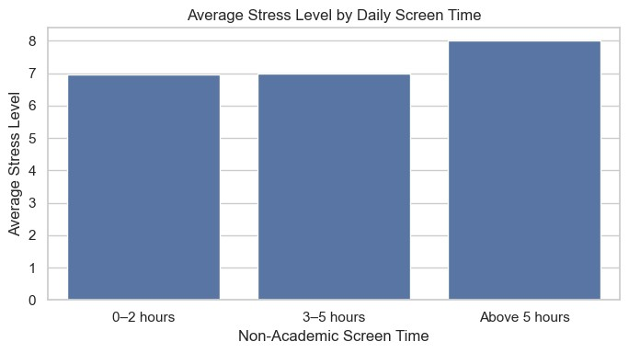
Figure 11. Average stress level by daily non-academic screen time (0–2 h: n = 34, 3–5 h: n = 17, above 5 h: n = 2).
Average stress is almost the same for 0–2 hours (6.97) and 3–5 hours (7.00) of screen time. The higher value for above 5 hours (8.00) is based on only two students, so we cannot conclude that more screen time increases stress. The correlations of lifestyle variables with percentile are also small: sleep r = 0.18, stress r = 0.06 and screen time r = 0.01. Lifestyle is, however, linked with study habits: students who studied more reported less screen time (r = −0.39) and less sleep (r = −0.26).

Correlation analysis
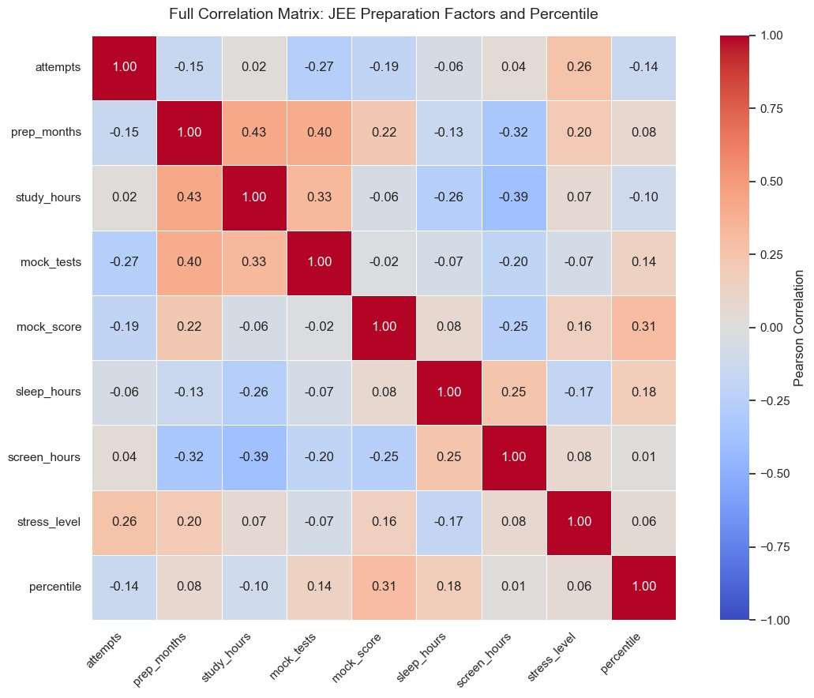
Figure 12. Correlation matrix of all numeric variables.
We call a correlation very weak below 0.15, weak from 0.15 to 0.35 and moderate from 0.35 to 0.60. For 53 students, a correlation has to be above about 0.27 (positive or negative) to be significant at the 5% level, so a value like 0.18 cannot be told apart from no relationship.
Table 8. Main correlations.
Pair of variables | r | Strength | Significant at 5%?
prep_months and study_hours | 0.43 | Moderate positive | Yes
prep_months and mock_tests | 0.40 | Moderate positive | Yes
study_hours and screen_hours | −0.39 | Moderate negative | Yes
mock_score and percentile | 0.31 | Weak positive | Yes (p = 0.023)
sleep_hours and percentile | 0.18 | Weak positive | No
study_hours and percentile | −0.10 | Very weak negative | No
stress_level and percentile | 0.06 | Very weak | No
screen_hours and percentile | 0.01 | None | No
Students who prepared for more months also studied more hours and took more mock tests, and students who studied more used their phones less. Most variables have little relationship with percentile itself; only mock score stands out. Correlation does not prove cause, and with 53 students these values are not very certain.

Conclusion and Limitations
We collected 53 responses from first-year engineering students through an online survey, cleaned the data and analysed how preparation and lifestyle are related to JEE Main percentile.
RQ1: Mock score has a weak but significant positive relationship with percentile (r = 0.31, ρ = 0.41); it explains only about 10% of the variation. RQ2: Study hours, preparation duration, PYQ practice, location, attempts and difficult subject show no clear pattern with percentile. Offline coaching and CBSE students have higher averages, but the groups are of very different sizes, so these are only observations in our sample. RQ3: Sleep, screen time and stress have little relationship with percentile, but students who studied more hours had less screen time and sleep. Overall, no single habit, including the number of study hours, explained the percentile; mock-test performance was the most useful indicator in our data.
Limitations
- Only 53 students, collected by snowball sampling, so the sample is not random and not representative of all JEE aspirants (35.8% are from Telangana).
- Only students who entered engineering colleges answered, so percentiles are mostly high (median
97.27).
- All answers are self-reported and may not be exact.
- Some groups are very small: online coaching (2), rural (1), PYQ “Never” and “Rarely” (3) and screen time above 5 hours (2).
- Four unrealistic mock-test values (44, 100, 200, 200) were replaced with the median, and “3 or more” attempts was counted as 3.
- This is an observational survey, so it shows relationships and not causes.

