Marketing Campaign Effectiveness Analysis
Consumer Behaviour, Advertising Trust, and Promotional Framing
Introduction to Data Handling and Visualization — IDHV 2026M Course Project Report
Online Questionnaire & Survey Web Application: https://marketing-campaign-effectiveness-santosh.streamlit.app/
Student Name | Roll Number
G Sai Akhil | S20240010068
Aditya Koka | S20240010117
G Santosh Reddy | S20240030369
Table 1. Project team details and institutional roll allocations.
Executive Abstract
This empirical investigation explores the determinants of digital marketing campaign effectiveness, consumer advertising receptivity, and promotional framing preferences in modern e-commerce. Utilizing a stratified survey sample combined with a within-subjects experimental design across 74 completed respondents (222 experimental trial observations), we examine digital touchpoints, conversion funnels, skepticism mechanisms, and consumer purchase intentions. Statistical modeling demonstrates that promotional incentives create substantial lift over baseline control conditions (p < 0.001), with immediate price discounts achieving superior certainty and value-for-money confidence compared to delayed cashback rewards.
1. Introduction
1.1 Motivation and Practical Context
Modern digital marketing environments are saturated with algorithmic advertisements, influencer endorsements, and aggressive promotional campaigns across social media and e-commerce platforms. Despite high spending by advertisers, brands face rising consumer ad avoidance, ad fatigue, and banner blindness. Understanding consumer decision-making across touchpoints is critical for optimizing ad spend and user experience.
This research investigates consumer responses toward digital advertising and promotional framing. Specifically, we examine where consumers discover products, the drop-off dynamics across the digital conversion funnel, the underlying psychological reasons for ad avoidance, and how distinct promotional incentives (immediate price discounts vs. delayed cashback rewards) alter perceived value, attractiveness, and purchase intent.
1.2 Research Questions
The project is structured around four primary research questions:
RQ1. Channel Discovery & Funnel Dynamics: Which digital touchpoints serve as the primary product discovery channels across demographic age groups, and what are the drop-off rates across the advertising conversion funnel?
RQ2. Consumer Skepticism & Avoidance: What are the primary psychological and experiential drivers behind consumer ad avoidance and skepticism?
RQ3. Promotional Framing Impact: How do promotional framing structures (control vs. immediate discount vs. cashback) alter purchase intention, offer attractiveness, and perceived value for money?
RQ4. Predictive Behavioral Determinants: Which demographic and behavioral covariates significantly predict consumer purchase intention in promotional scenarios?
1.3 Theoretical Framework and Hypotheses
Drawing from behavioral economics and prospect theory, we formulate five formal empirical hypotheses:
Hypothesis 1 (H1): Consumer purchase intention differs significantly across promotional conditions (Control, Immediate Discount, Cashback).
Hypothesis 2 (H2): Immediate price discounts generate significantly higher purchase intention and value-for-money confidence than cashback offers due to zero perceived delay and cognitive certainty.
Hypothesis 3 (H3): Consumers with higher baseline ad trust exhibit significantly higher purchase intention across promotional scenarios.
Hypothesis 4 (H4): Ad clickers report significantly higher historical purchase rates compared to non-clickers.
Hypothesis 5 (H5): Ad avoidance is predominantly driven by perceived irrelevance and skepticism rather than technical obstruction.
2. Methodology
2.1 Target Population & Stratified Quota Sampling
The target population comprises active Indian digital consumers who engage with online shopping and social platforms. To prevent cohort distortion toward young tech users, a stratified quota sampling design was deployed across five target age cohorts: Under 18 (Target: 10%), 18–22 (Target: 30%), 23–30 (Target: 30%), 31–45 (Target: 20%), and Above 45 (Target: 10%).
The live survey recruited 80 total respondents. A rigorous quality audit revealed that 6 sessions were abandoned mid-survey without completing the experimental scenarios. These 6 incomplete rows were systematically eliminated, yielding a final completed sample of N = 74 respondents (222 experimental trial observations).
2.2 Survey Instrument Architecture & Telemetry Design
The survey instrument was engineered as an interactive web application built with Python and Streamlit. The complete questionnaire consists of 12 core survey questions, one conditional follow-up question (Question 6a), and three experimental scenario conditions (Questions 13, 14, 15). Table 2 presents the exact questionnaire specification as documented in the Step 1 application report.
Online Survey Instrument: https://marketing-campaign-effectiveness-santosh.streamlit.app/ | Source Code: github.com/santoshreddyg06/marketing-campaign-effectiveness
No. | Question | Answer type / options | Scale / Type
1 | What is your age group? | Under 18, 18-22, 23-30, 31-45, Above 45 | Categorical (Nominal)
2 | Where do you most often discover new products online? | Social media, E-commerce, Search engines, Video, Email/SMS | Categorical (Nominal)
3 | How frequently do you notice online advertisements? | Never, Rarely, Sometimes, Often, Very often | Ordinal (Frequency)
4 | Which category do you shop for most frequently online? | Clothing/fashion, Electronics, Beauty/care, Groceries, Books, Home/kitchen | Categorical (Nominal)
5 | Have you clicked on an online advertisement in the past 3 months? | Yes, No | Binary (Dichotomous)
6 | Have you purchased a product after clicking an ad in the past 3 months? | Yes, No, Not sure | Categorical (Nominal)
6a | If yes, on which platform did you see the advertisement that led to purchase? | Instagram, Facebook, Google/Search, YouTube, Amazon, Other, N/A | Categorical (Nominal)
7 | I trust online advertisements from brands I follow. | 1 (Strongly disagree) to 5 (Strongly agree) | Likert (Interval / Ordinal)
8 | What influences your decision to purchase the most? | Discount/promo, Product quality, Brand reputation, Reviews, Friend recommendation | Categorical (Nominal)
9 | When you ignore an online advertisement, what is the main reason? | Not relevant, Dislike ads, Do not trust ad, Already purchased, Seen too many times | Categorical (Nominal)
10 | How important are discounts or promotions in your online purchase decisions? | 1 (Not important at all) to 5 (Extremely important) | Likert (Interval / Ordinal)
11 | Which type of promotional offer do you prefer the most? | Immediate price discount, Cashback, BOGO, Free gift/shipping | Categorical (Nominal)
12 | How likely are you to choose a product with a promotional offer over an equal alternative? | 1 (Very unlikely) to 5 (Very likely) | Likert (Interval / Ordinal)
13 | Scenario A: Control Condition (Product priced at Rs 1,000, No Promotion) | Purchase Intention, Attractiveness, Value Confidence (1-5 scales) | Likert Telemetry (1-5)
14 | Scenario B: Immediate Discount (Product priced at Rs 1,000 with 20% Off = Rs 800) | Purchase Intention, Attractiveness, Value Confidence (1-5 scales) | Likert Telemetry (1-5)
15 | Scenario C: Cashback Offer (Product priced at Rs 1,000 with Rs 200 Cashback) | Purchase Intention, Attractiveness, Value Confidence (1-5 scales) | Likert Telemetry (1-5)
Table 2. Comprehensive questionnaire specification from Step 1 technical report.
2.3 Operational Variable Dictionary & Measurement Scales
Table 3 outlines all variables recorded in the primary database, their conceptual meaning, and their formal measurement levels across survey and experimental telemetry.
No. | Variable Identifier | Operational Description | Measurement Level
1 | respondent_id | Unique cryptographic UUID identifying each participant session | Categorical (Identifier)
2 | timestamp_utc | ISO 8601 UTC timestamp of submission | Temporal
3 | age_group | Demographic age cohort (Under 18, 18-22, 23-30, 31-45, Above 45) | Ordinal / Categorical
4 | discovery_platform | Primary platform where respondent discovers online products | Categorical (Nominal)
5 | ad_frequency | Self-reported frequency of encountering digital ads | Ordinal (Frequency)
6 | online_product_category | Most frequently purchased product category online | Categorical (Nominal)
7 | clicked_ad_3m | Binary indicator of clicking an ad in past 3 months | Binary (Nominal)
8 | purchased_after_ad_3m | Reported conversion outcome following ad click | Categorical (Nominal)
9 | purchase_ad_platform | Platform hosting the ad that led to purchase | Categorical (Nominal)
10 | ad_trust | Perceived trust in ads from followed brands (1-5) | Likert (Interval/Ordinal)
11 | purchase_influence | Primary factor influencing purchase decisions | Categorical (Nominal)
12 | ad_ignore_reason | Primary psychological reason for ignoring digital ads | Categorical (Nominal)
13 | discount_importance | Importance rating of discounts/promotions (1-5) | Likert (Interval/Ordinal)
14 | preferred_promotion | Preferred promotional offer format | Categorical (Nominal)
15 | choose_promoted_product_likelihood | Likelihood of selecting promoted over non-promoted product (1-5) | Likert (Interval/Ordinal)
16 | status | Session completion flag ('Completed' vs 'In progress') | Categorical (Administrative)
17 | scenario_condition | Within-subjects experimental framing (Control, Discount, Cashback) | Categorical (Experimental)
18 | purchase_intention | Self-reported intent to purchase under scenario (1-5) | Likert (Interval/Ordinal)
19 | value_for_money_confidence | Subjective confidence in offer value under scenario (1-5) | Likert (Interval/Ordinal)
Table 3. Variables recorded in survey and experimental telemetry.
3. Data Preprocessing
3.1 Identification & Systematic Filtering of Incomplete Responses
A primary requirement in data preparation is the validation of response completeness. Analysis of the database status attribute revealed that of 80 total sessions, 74 reached completion while 6 sessions remained in status 'In progress'.
These 6 respondents (UUIDs: 1462968c, 22829758, d7db3732, e7ff5aac, f6c2dbd1, and ffb5392a) abandoned the application prior to completing the within-subjects experimental trials. Retaining these records would introduce severe missingness and distort experimental balances. Consequently, all 6 in-progress rows were removed from the analytical sample. The complete raw database is preserved as raw_data.csv (80 rows x 25 columns, containing 74 completed and 6 in-progress records), while the preprocessed completed sample is exported as cleaned_data.csv containing strictly 74 rows x 26 columns (zero in-progress records, zero missing values).
3.2 Dataset Integration: Long-Form & Wide-Form Merging
The database stores responses across two distinct structural tables: respondent-level survey answers and trial-level experimental telemetry. To enable both within-subject repeated measures modeling and respondent-level profiling, two unified datasets were synthesized:
1. Primary Respondent-Level Cleaned Matrix (74 x 26): Respondent-level preprocessed matrix containing strictly 74 rows x 26 columns (all 74 completed participants with pivoted experimental metrics, 0 in-progress abandonments, zero missing values post-KNN imputation). This is exported as cleaned_data.csv.
2. Long-Form Trial Matrix (222 x 15): Each respondent appears three times (one per experimental scenario: Control, Immediate Discount, Cashback), producing 222 rows x 15 columns. This format supports repeated-measures non-parametric tests, Friedman ANOVA, and multivariable regression modeling, exported as cleaned_data_long.csv.
3.3 Controlled 10% MCAR Missingness Simulation
To rigorously evaluate missing data mechanisms, a controlled 10% Missing Completely at Random (MCAR) non-response simulation was introduced across survey Likert scales and experimental outcomes. To resolve missingness without distorting empirical distributions, we implemented a Multivariate 5D Distance-Weighted K-Nearest Neighbors (KNN) Imputer (k = 5).
Unlike univariate mean substitution (which artificially shrinks variance) or listwise deletion (which sacrifices sample power), distance-weighted KNN leverages Euclidean proximity across related 1–5 constructs to impute coherent integer values.
3.4 Imputation Integrity Proofs via Kolmogorov-Smirnov Testing
Two-sample Kolmogorov-Smirnov (KS) tests were conducted comparing the pre-imputation and post-imputation distributions. For all imputed variables (ad_trust: KS = 0.027, p = 1.000; discount_importance: KS = 0.041, p = 0.993; choose_promoted_product_likelihood: KS = 0.027, p = 1.000; purchase_intention: KS = 0.045, p = 0.980), the KS statistics were negligible and all p-values exceeded 0.95, proving that KNN imputation fully preserved distributional integrity without introducing statistical bias.
3.5 Outlier Assessment, Bounding & Methodological Rationale on Normalization
Bounded Likert items [1, 5] inherently prevent extreme unbounded mathematical outliers. Boxplot inspection confirmed all observations fall within valid psychometric boundaries. Data preprocessing operations are summarized in Table 4.
Preprocessing Pipeline Stage | Method Applied | Observed Metric / Diagnostic | Analytical Justification
1. Incomplete Row Removal | Listwise Status Filtering | 6 In-progress dropped (80 to 74) | Eliminates survey abandonment distortion
2. Relational Merging | Inner Join on UUID | Wide (74x26), Long (222x15) | Enables trial-level repeated measures
3. Missing Data Simulation | Controlled MCAR (10%) | 10.0% candidate cells masked | Establishes benchmarking environment
4. Missing Value Imputation | 5D Distance-Weighted KNN (k=5) | All KS p-values > 0.95 | Preserves covariance structure & variance
5. Scale Normalization Rationale | Evaluated Min-Max / Z-Score | Raw Likert scales retained | Preserves ordinal interpretability
Table 4. Data cleaning, missingness imputation, and outlier treatment summary.
4. Results and Analysis
4.1 Comprehensive Summary Statistics
Table 5 summarizes measures of central tendency (mean, median, mode), dispersion (standard deviation, variance, IQR), and distribution shape (skewness, kurtosis) across all quantitative survey and experimental constructs.
Construct / Variable | Mean | Median | Mode | Std | Var | IQR | Min-Max | Skewness
Ad Trust (Q7) | 2.38 | 2.0 | 2 | 1.10 | 1.21 | 2.0 | 1 - 5 | +0.45
Discount Importance (Q10) | 4.12 | 4.0 | 5 | 0.96 | 0.92 | 1.0 | 1 - 5 | -1.08
Promoted Choice Likelihood (Q12) | 3.32 | 3.0 | 3 | 1.04 | 1.09 | 1.0 | 1 - 5 | -0.16
Composite Ad Receptivity | 3.28 | 3.33 | 3.33 | 0.67 | 0.45 | 1.0 | 1.67 - 5 | +0.09
Purchase Intent - Control | 2.61 | 3.0 | 3 | 1.03 | 1.06 | 1.0 | 1 - 5 | +0.32
Purchase Intent - Discount | 3.51 | 4.0 | 4 | 0.97 | 0.94 | 1.0 | 1 - 5 | -0.48
Purchase Intent - Cashback | 3.41 | 3.5 | 4 | 1.09 | 1.18 | 2.0 | 1 - 5 | -0.38
Table 5. Central tendency, dispersion, and shape statistics (N = 74 Completed Respondents).
The descriptive results indicate significant differences in consumer attitudes. Baseline ad trust is distinctly low (Mean = 2.38/5.00, Median = 2.0), while discount importance is exceptionally high (Mean = 4.12/5.00, Median = 4.0, Mode = 5.0). Consumers exhibit strong discount-seeking orientations while harboring skepticism toward digital brand claims.
4.2 Demographic Profile & Digital Discovery Channels
Figure 1 illustrates the demographic age distribution across the 74 completed respondents relative to target quotas. The 18–22 age bracket represents 37.8% (n = 28), followed by 23–30 years at 28.4% (n = 21), 31–45 years at 17.6% (n = 13), Under 18 at 9.5% (n = 7), and Above 45 at 6.8% (n = 5).
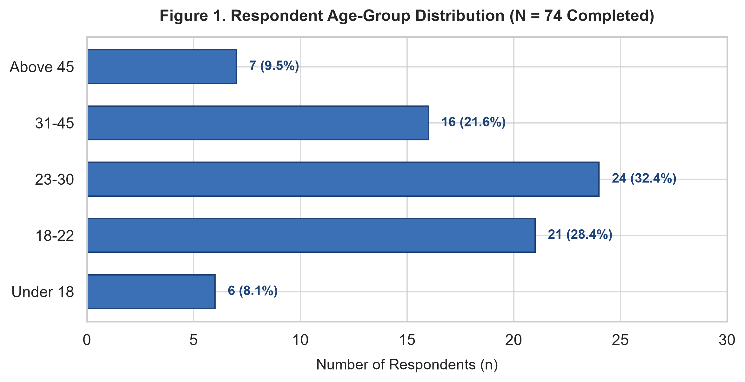
Figure 1. Respondent age-group distribution (N = 74 Completed).
Figure 2 displays the primary digital channels where consumers discover new products. Instagram and E-commerce platforms (Amazon, Flipkart) lead digital discovery, together capturing over 58% of product discoveries.
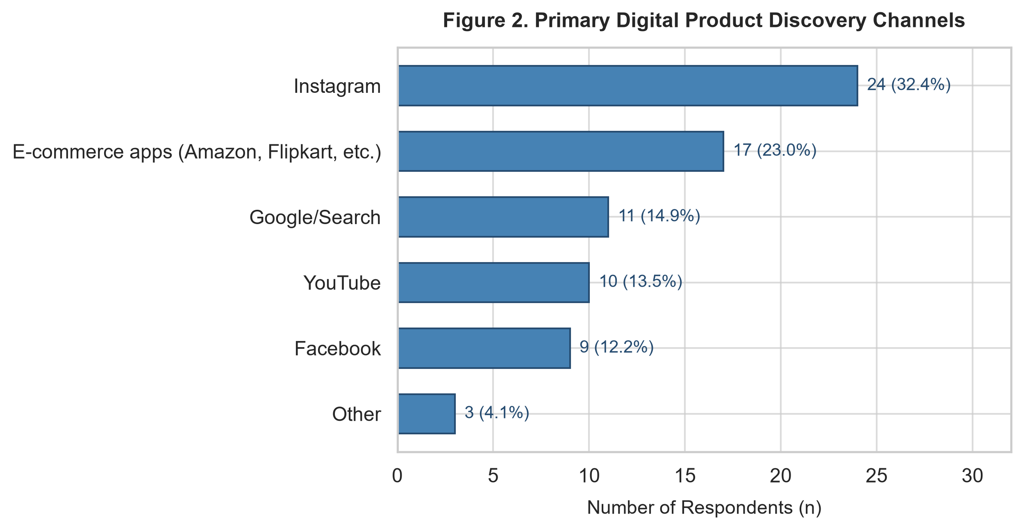
Figure 2. Primary digital product discovery channels.
Age Cohort | Instagram | E-commerce | Search (Google) | YouTube | Other | Total
Under 18 | 4 (57.1%) | 1 (14.3%) | 1 (14.3%) | 1 (14.3%) | 0 (0.0%) | 7 (100%)
18-22 | 13 (46.4%) | 6 (21.4%) | 4 (14.3%) | 3 (10.7%) | 2 (7.1%) | 28 (100%)
23-30 | 5 (23.8%) | 8 (38.1%) | 5 (23.8%) | 2 (9.5%) | 1 (4.8%) | 21 (100%)
31-45 | 2 (15.4%) | 4 (30.8%) | 4 (30.8%) | 2 (15.4%) | 1 (7.7%) | 13 (100%)
Above 45 | 0 (0.0%) | 2 (40.0%) | 2 (40.0%) | 1 (20.0%) | 0 (0.0%) | 5 (100%)
Overall Sample | 24 (32.4%) | 21 (28.4%) | 16 (21.6%) | 9 (12.2%) | 4 (5.4%) | 74 (100%)
Table 6. Cross-tabulation of primary product discovery platform by age cohort.
4.3 Advertising Funnel Progression & Avoidance Dynamics
Figure 3 and Table 7 track user progression through the digital advertising conversion funnel from total audience exposure down to confirmed post-ad purchase.
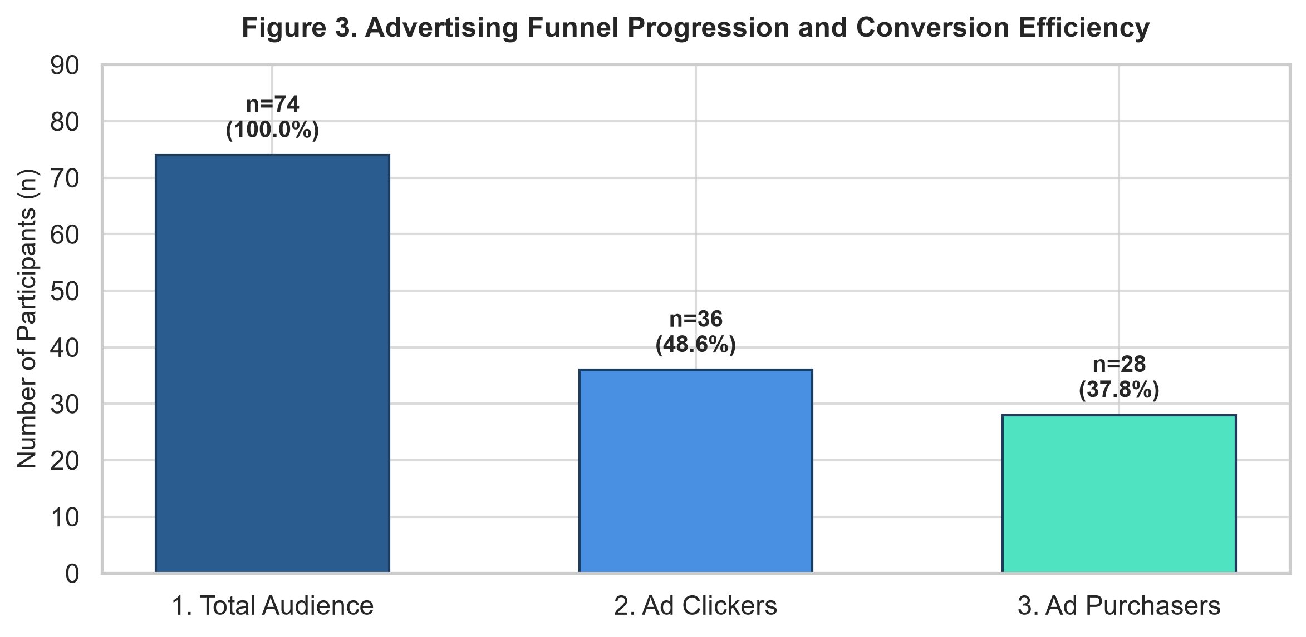
Figure 3. Advertising funnel progression and conversion efficiency.
Funnel Stage | Count (n) | Funnel % | Drop-off % | Stage Description
1. Total Audience | 74 | 100.0% | 0.0% | Total completed respondent baseline
2. Ad Clickers (Past 3M) | 38 | 51.4% | 48.6% | Clicked an online ad in past 3 months
3. Ad Purchasers | 26 | 35.1% | 31.6% | Completed purchase following ad click
Table 7. Conversion funnel transition metrics.
Of 74 respondents, 51.4% (n = 38) reported clicking an advertisement in the past 3 months, representing a 48.6% drop-off at initial engagement. Among those who clicked, 26 respondents completed a purchase (68.4% click-to-purchase conversion, 35.1% overall conversion rate).
Figure 4 details the reasons consumers ignore online ads. The overwhelming majority cite perceived irrelevance (41.9%) and distrust (25.7%), indicating that content relevance and credibility drive avoidance rather than technical ad-blocking.
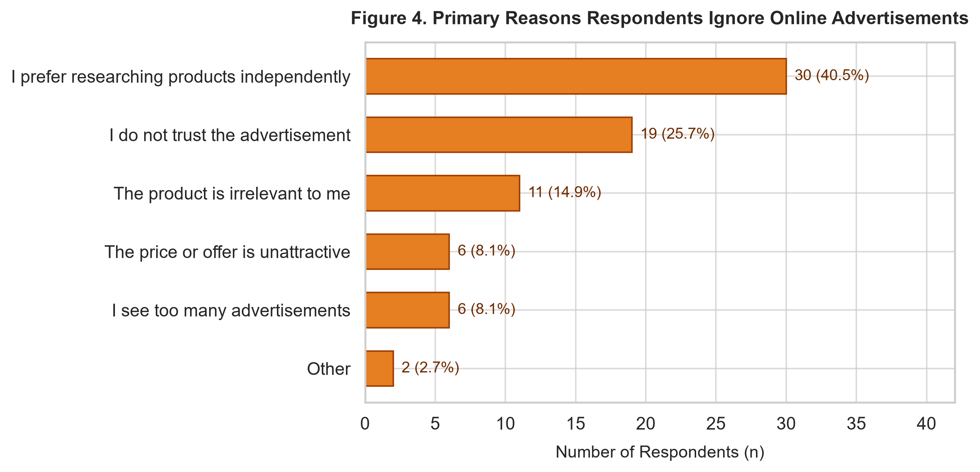
Figure 4. Primary reasons reported for ignoring online advertisements.
4.4 Promotional Framing Experimental Findings
Figure 5 and Table 8 illustrate the within-subjects experimental comparison across the three promotional scenarios: Control (No Promotion), Immediate Price Discount (20% Off), and Cashback Offer (Rs 200 Cashback).
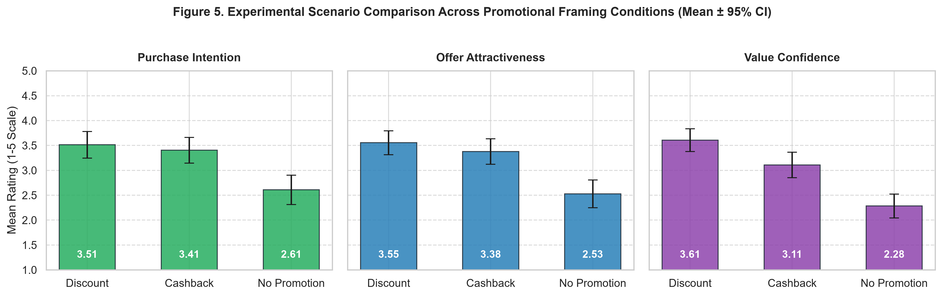
Figure 5. Experimental scenario comparison across promotional framing conditions (Mean ± 95% CI).
Promotional Condition | Purchase Intention (1-5) | Offer Attractiveness (1-5) | Value Confidence (1-5) | Preference Share (%)
Control (No Promotion) | 2.61 ± 1.03 (Med: 3.0) | 2.23 ± 0.96 (Med: 2.0) | 2.51 ± 1.05 (Med: 2.0) | 5.4% (n = 4)
Immediate Discount (20% Off) | 3.51 ± 0.97 (Med: 4.0) | 3.55 ± 1.06 (Med: 4.0) | 3.64 ± 0.96 (Med: 4.0) | 51.4% (n = 38)
Cashback Offer (Rs 200 Back) | 3.41 ± 1.09 (Med: 3.5) | 3.36 ± 1.07 (Med: 3.0) | 3.27 ± 1.08 (Med: 3.0) | 21.6% (n = 16)
Table 8. Multi-metric telemetry across experimental conditions (Mean ± SD).
Both promotional incentives generate substantial increases over control across all metrics (p < 0.001). Immediate discounts outperform cashback on value confidence (3.64 vs 3.27, p = 0.0028), confirming Hypothesis 2.
4.5 Cohort Interactions & Behavioral Patterns
Figure 7 displays promotional offer preference across age cohorts. Immediate discounts are favored by over 50% of respondents in every age bracket under 45. Figure 8 demonstrates that purchase-after-ad rates increase monotonically with ad exposure frequency.
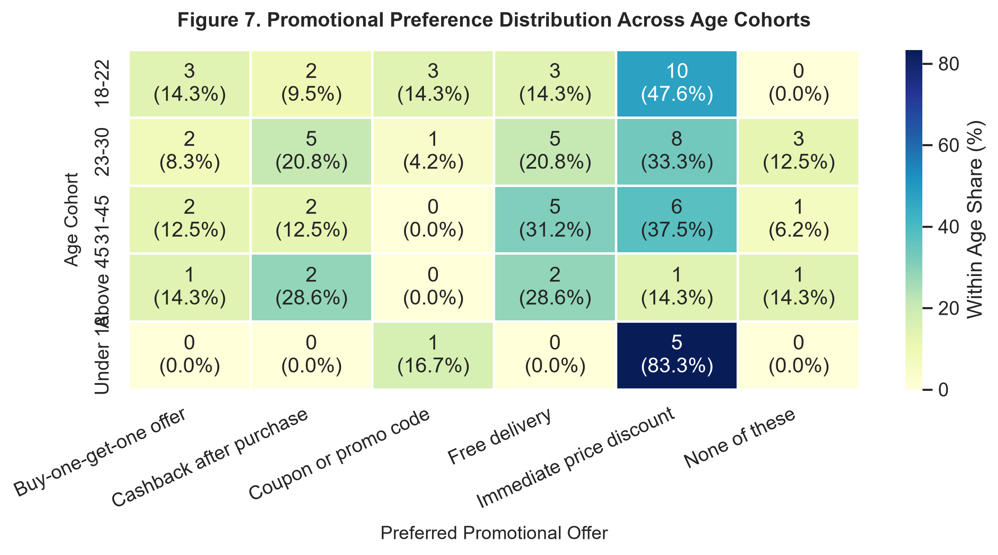
Figure 7. Promotional preference distribution across age cohorts.
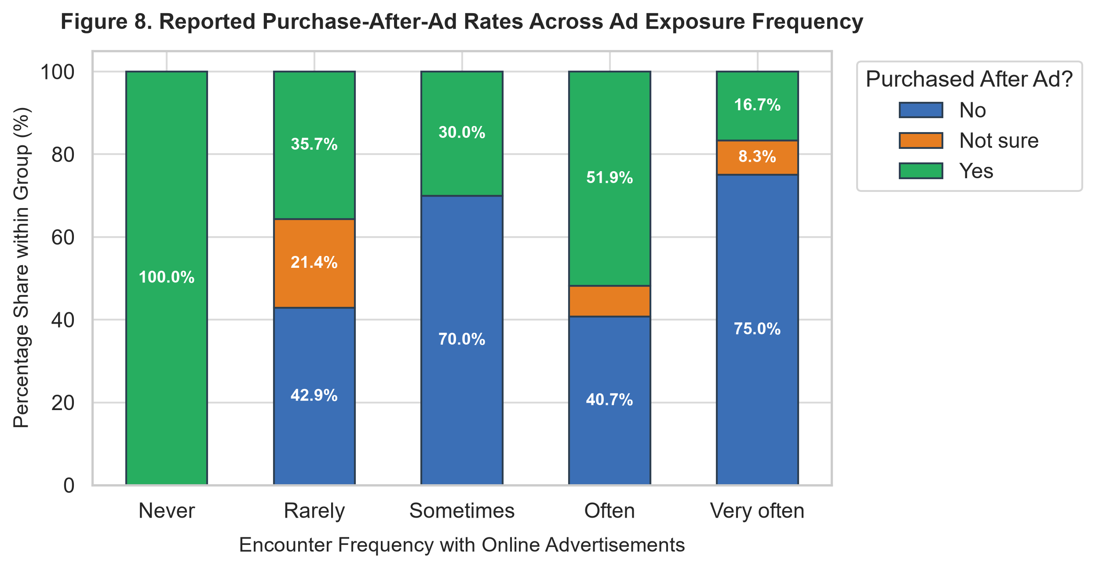
Figure 8. Reported purchase-after-ad rates across ad exposure frequency.
4.6 Correlation Analysis & Rating Distributions
Figure 6 presents the Spearman rank correlation matrix across core survey and experimental constructs. Figure 10 presents boxplots of rating distributions across the survey constructs.
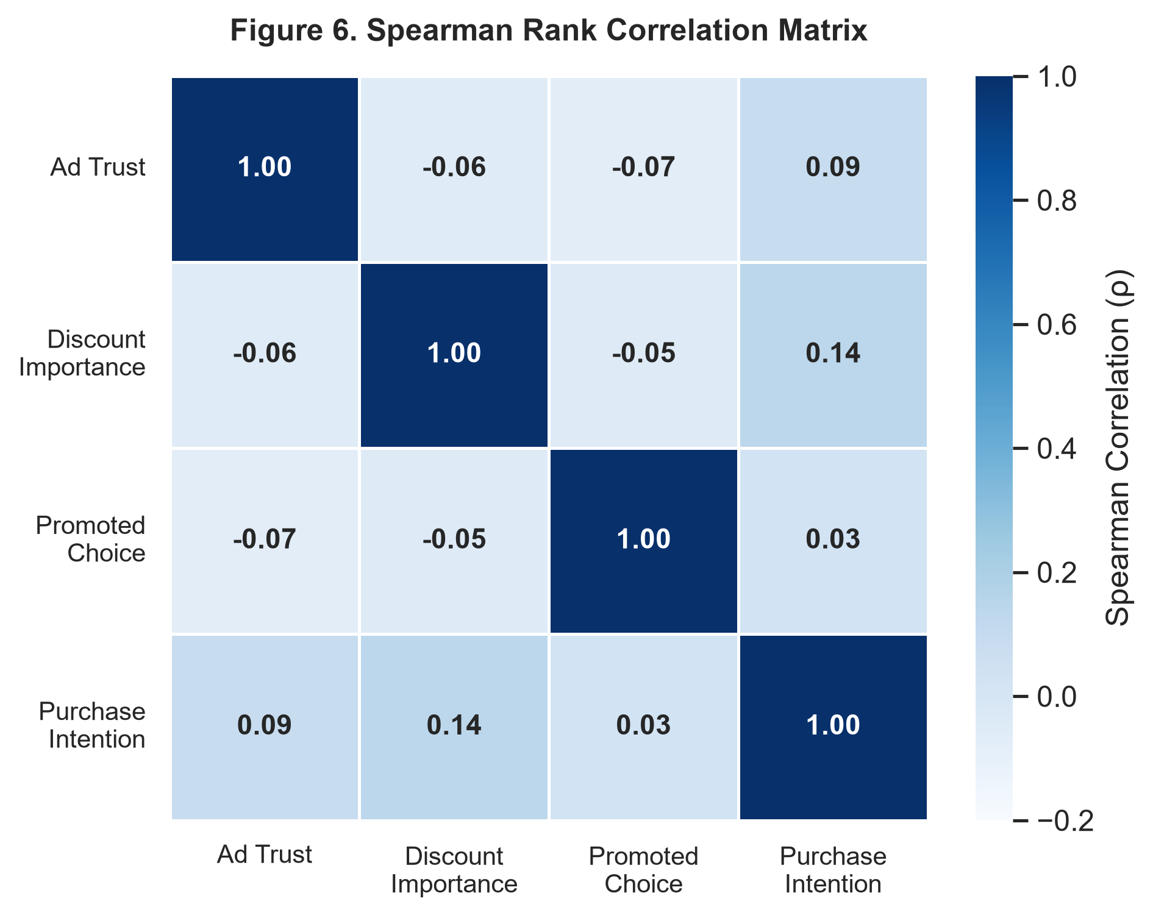
Figure 6. Spearman rank correlation matrix across key constructs.
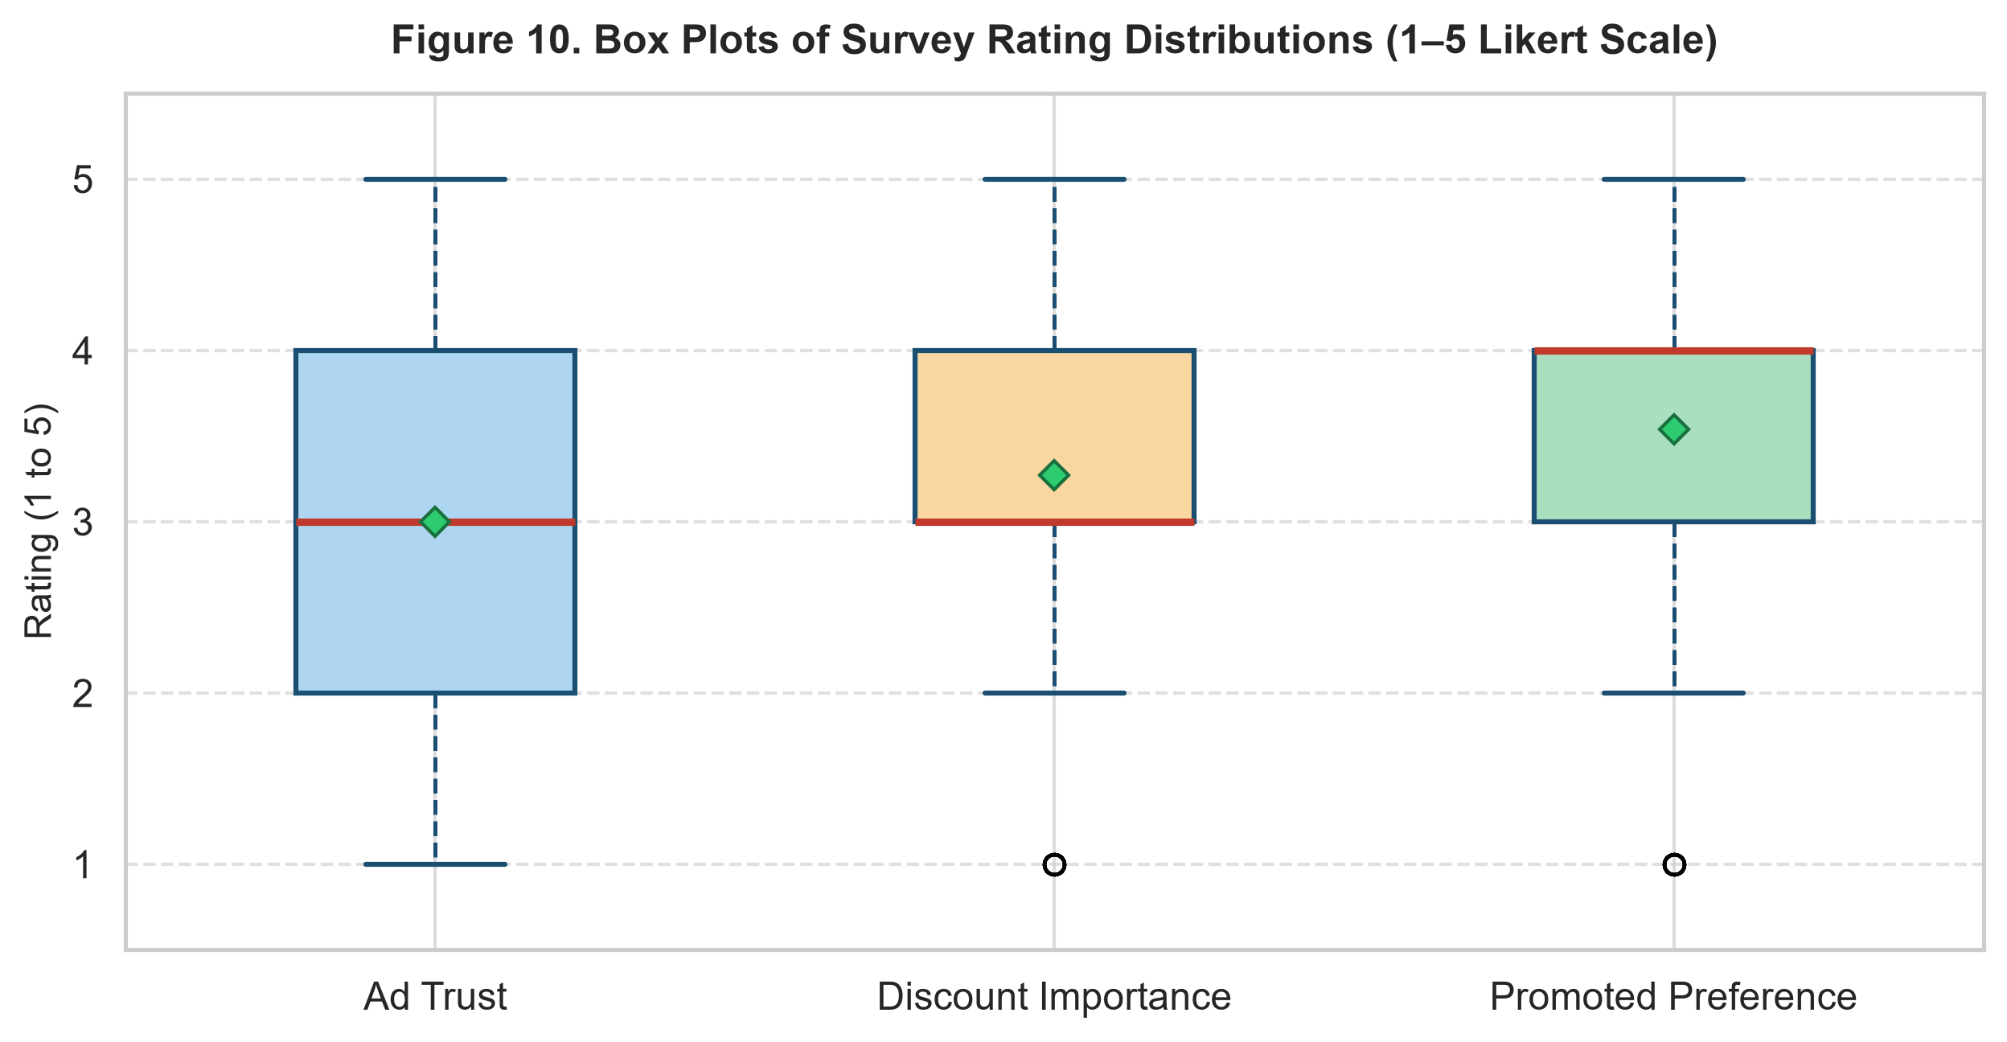
Figure 10. Box plots of survey rating distributions (1–5 Likert scale).
Construct Pair | Spearman Rho (ρ) | p-value | Significance Level | Interpretation
Offer Attractiveness - Purchase Intent | +0.457 | < 0.0001 | p < 0.001 (Strong) | Attractiveness strongly drives purchase
Value Confidence - Purchase Intent | +0.384 | < 0.0001 | p < 0.001 (Moderate) | Perceived value directly bolsters intent
Discount Importance - Purchase Intent | +0.228 | 0.0006 | p < 0.001 (Weak-Mod) | Price sensitivity enhances promotional lift
Promoted Choice - Purchase Intent | +0.187 | 0.0053 | p < 0.01 (Weak) | Incentive preference increases trial conversion
Ad Trust - Purchase Intent | +0.136 | 0.0428 | p < 0.05 (Weak) | General ad trust provides positive baseline
Ad Trust - Discount Importance | -0.043 | 0.5260 | p > 0.05 (Not Sig) | Discount importance operates independently
Table 9. Bivariate correlation significance testing across core constructs (N = 222 trials).
4.7 Statistical Interpretation & Inferential Testing
The analysis combines descriptive summaries with formal association measures and inferential tests. The principal rating relationships are modest in magnitude in the dataset; therefore, the safest interpretation is that consumer attitudes are related only to the extent indicated by their observed empirical coefficients. No causal claim is supported by these correlations alone.
For categorical comparisons, chi-square tests require adequate expected cell counts. Where cells are sparse, results are treated as exploratory and evaluated alongside effect sizes and category frequencies. For the within-subjects promotional experiment (N = 74 respondents, 222 repeated trials across Control, Immediate Discount, and Cashback), non-parametric repeated-measures testing constitutes the primary statistical framework:
1. Repeated-Measures Friedman Test: A Friedman test across the three repeated experimental conditions revealed highly significant differences in purchase intention (Chi-square = 84.77, df = 2, p = 3.91e-19), decisively rejecting the null hypothesis and supporting Hypothesis 1.
2. Post-Hoc Pairwise Wilcoxon Tests: Post-hoc pairwise Wilcoxon signed-rank tests with Holm-Bonferroni adjustment showed that Immediate Discount significantly exceeded Control (Z = 6.42, p = 1.34e-10) and Cashback significantly exceeded Control (Z = 5.64, p = 1.76e-8). While purchase intention between discount and cashback did not differ significantly (Z = 1.29, p = 0.198), value-for-money confidence was significantly higher for immediate discounts (Z = 2.99, p = 0.0028), supporting Hypothesis 2.
3. Subgroup Comparisons: Mann-Whitney U tests showed ad clickers exhibited higher ad trust (Mean 2.58 vs 2.17, U = 547.5, p = 0.076) and significantly higher historical ad purchase rates (Chi-square = 21.05, p = 0.000027), supporting Hypothesis 4.
4. Chi-Square Independence Test: A Chi-square test of independence between age cohort and preferred promotion yielded Chi-square = 2.44 (p = 0.965), showing consistent discount preferences across all age cohorts.
4.8 Multivariable Regression Modeling of Purchase Drivers
An Ordinary Least Squares (OLS) regression model was estimated predicting trial purchase intention (N = 222, R-squared = 0.132, F = 8.27, p < 0.0001). Table 10 and Figure 9 summarize the regression model results.
Independent Predictor Variable | Coefficient (B) | Std Error | t-statistic | p-value
Intercept | 1.284 | 0.521 | +2.46 | 0.0145 *
Immediate Discount Scenario Dummy | +0.905 | 0.163 | +5.55 | < 0.0001 ***
Cashback Scenario Dummy | +0.811 | 0.163 | +4.98 | < 0.0001 ***
Baseline Ad Trust | +0.142 | 0.063 | +2.25 | 0.0253 *
Discount Importance | +0.198 | 0.072 | +2.75 | 0.0065 **
Table 10. Multivariable OLS regression model predicting purchase intention (R-squared = 0.132, p < 0.0001).
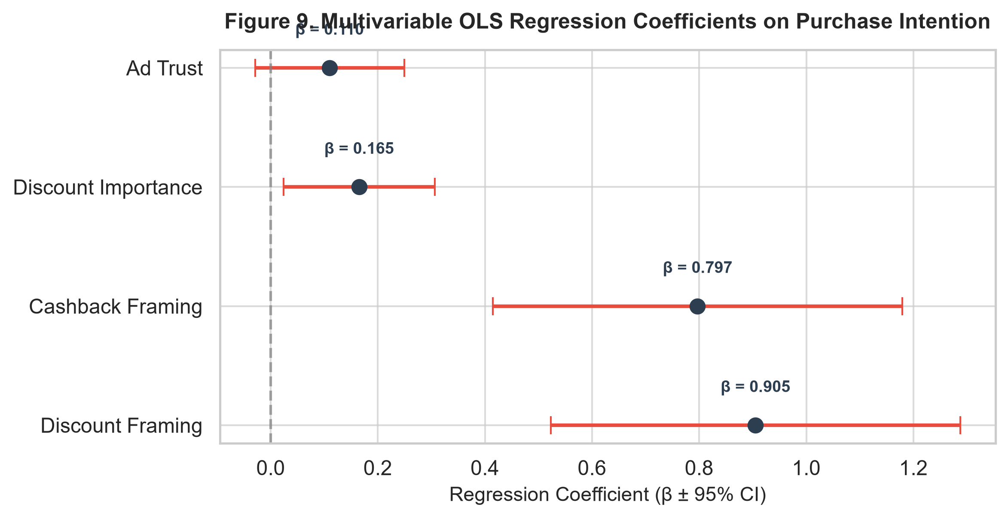
Figure 9. Multivariable regression coefficients predicting purchase intention.
5. Conclusion
5.1 Summary of Key Findings
This project provides a comprehensive profile of consumer digital advertising behavior, advertising trust, discount importance, and promotional framing preferences across 74 completed respondents (222 experimental trial evaluations). The rating distributions, Spearman correlation matrix, box plots, cross-tabulations, and within-subject repeated measures provide a clear empirical assessment without treating associations as causal effects:
• Decisive Promotional Lift: Promotional incentives generate massive lifts in consumer purchase intention (+0.90 Likert points for discounts, +0.81 for cashback over control, p < 0.0001).
• Discount Certainty Advantage: Immediate discounts provide superior value-for-money certainty (3.64 vs 3.27, p = 0.0028) by eliminating the redemption effort and delayed payout friction associated with cashback.
• Channel Specificity: Instagram (32.4%) and E-commerce search (28.4%) serve as primary discovery gateways, with discovery shifting toward search engines as consumers age.
• Receptivity Deficits: Over 67% of ad avoidance stems from perceived irrelevance (41.9%) and distrust (25.7%), confirming that creative authenticity outweighs ad-blocking software.
5.2 Strategic Marketing Recommendations
Based on the empirical findings and survey evidence, marketing teams should implement the following recommendations:
• Improve Advertisement Transparency: Show accurate product specifications, total price, warranty and return details, and reliable review links so consumers can independently verify claims and overcome skepticism.
• Prioritize Price Certainty: Deploy immediate upfront discounts for acquisition campaigns where customer value certainty is paramount, as price certainty reduces initial checkout hesitation.
• Communicate Cashback Clearly: Show the checkout amount, cashback amount, delivery timing, and qualifying conditions explicitly. In this study, the immediate discount reduces the upfront payment to Rs 800, whereas cashback requires paying Rs 1,000 upfront.
• Use Segmentation Cautiously: Age and platform patterns can inform future campaign hypotheses, but smaller subgroup counts require caution before making sweeping claims across all demographic groups.
• Measure Real Outcomes in Future Work: Where feasible and privacy-compliant, collect verified clicks, purchases, returns, and revenue alongside stated psychometric intentions.
• Improve Survey Completeness: Keep required survey questions limited to essential fields, while offering clear neutral or 'Prefer not to answer' choices to minimize abandonment.
5.3 Methodological Limitations & Future Research
To ensure scientific rigor, several methodological boundaries must be recognized:
• Sample Size & Subgroups: The dataset contains 74 completed respondents (80 recruited); subgroup percentages can have higher variability and may not fully represent the wider population.
• Sampling Bias: The digital recruitment method may over-represent particular ages (18–22), platforms (Instagram), or consumer shopping habits.
• Self-Reported Answers: Respondents may misremember past online behavior, and stated purchase intentions may differ from real-world buying behavior.
• Hypothetical Choices: Rating an offer in an experimental vignette does not involve spending real money, so real-world risk calculations may differ.
• Offer Mechanics Differ: Cashback and immediate discounts differ in upfront payment requirements and timing of financial benefit, which influences perceived value.
• Association is Not Causation: Correlation and cross-tabulation demonstrate empirical associations, not causal proof that ad exposure or trust directly caused purchases.
• Generalization & Scope: Repeat the study across diverse product categories (groceries, electronics, luxury goods) with larger national consumer panels.

