Marketing Campaign Effectiveness Analysis
Final Research Questionnaire & Experimental Telemetry Specification
Introduction to Data Handling and Visualization — IDHV 2026M Course Project Documentation
Live Deployed Questionnaire: https://marketing-campaign-effectiveness-hk5tpqzrnecejgm7kimg9q.streamlit.app/ | Source Repository: github.com/santoshreddyg06/marketing-campaign-effectiveness
Student Name | Roll Number
G Sai Akhil | S20240010068
Aditya Koka | S20240010117
G Santosh Reddy | S20240030369
1. Survey Overview & Administration Protocol
This document specifies the complete final questionnaire administered for the empirical investigation on digital advertising effectiveness and promotional framing. Data collection was conducted through a bespoke web application engineered in Python using Streamlit, deployed to Streamlit Community Cloud, and synchronized in real time with Google Sheets via a Google Cloud API Service Account.
Ethical & Privacy Assurance: The survey is strictly anonymous. No personal identifiers (names, email addresses, phone numbers, IP addresses) were collected. Participation was voluntary. To prevent response distortion and demographic skew, stratified quota sampling was enforced across five age brackets (Under 18: 10%, 18–22: 30%, 23–30: 30%, 31–45: 20%, Above 45: 10%; Target N = 80).
The questionnaire is structured into two sequential phases:
Phase 1 (Consumer Behavior Survey): 12 consumer behavior questions capturing product discovery channels, ad exposure frequency, historical ad engagement (clicks and purchases), advertising skepticism mechanisms, discount importance, and promotional framing preferences.
Phase 2 (Promotional Framing Experiment): A within-subjects experimental trial evaluating consumer responses to Rs. 2,000 wireless headphones across three distinct promotional framing conditions (Immediate ₹400 Discount, Delayed ₹400 Cashback, and Baseline Control), evaluated on three 5-point Likert telemetry outcome scales.
2. Part 1: General Consumer Behaviour Questionnaire
Introductory Participant Prompt: 'Thank you for participating! This survey is completely anonymous: no names or personal details are collected. Please answer the following questions regarding your online shopping habits and advertising perceptions.'
Question 1: What is your age group? * (Required)
Type: Categorical (Ordered Quota Filter)
Response Options: Under 18 • 18–22 • 23–30 • 31–45 • Above 45
Logic / Purpose: Configured as the sole mandatory field in the application to enforce demographic quota constraints.
Question 2: Which platform do you most often use to discover or learn about products?
Type: Categorical (Nominal Channel Attribution)
Response Options: Instagram • YouTube • Google/Search • E-commerce apps (Amazon, Flipkart, etc.) • Facebook • Other
Logic / Purpose: Identifies the respondent's primary digital discovery gateway.
Question 3: How frequently do you encounter online advertisements?
Type: Ordinal (5-Point Exposure Frequency)
Response Options: Never • Rarely • Sometimes • Often • Very often
Logic / Purpose: Measures self-reported volume of exposure to digital advertising.
Question 4: Which type of product do you most frequently purchase online?
Type: Categorical (Nominal Product Category)
Response Options: Electronics • Clothing and fashion • Food and groceries • Beauty and personal care • Home and lifestyle • Other
Logic / Purpose: Captures the respondent's dominant online purchasing category.
Question 5: In the past three months, have you clicked on an online advertisement to learn more about a product?
Type: Binary / Categorical (Upper-Funnel Engagement)
Response Options: Yes • No • Not sure
Logic / Purpose: Stages audience transition from ad exposure to active consideration.
Question 6: In the past three months, have you purchased a product after seeing an online advertisement?
Type: Binary / Categorical (Lower-Funnel Conversion)
Response Options: Yes • No • Not sure
Logic / Purpose: Stages audience transition to actual commercial acquisition.
Question 6a: If yes, which platform did you see the advertisement on before purchasing?
Type: Categorical (Conditional Channel Attribution)
Response Options: Instagram • YouTube • Google/Search • E-commerce apps (Amazon, Flipkart, etc.) • Facebook • Other • Cannot remember
Logic / Purpose: Conditional logic: Displayed only if respondent answered 'Yes' to Question 6. Recorded as 'Not applicable' for non-purchasers.
Question 7: How much do you trust product information shown in online advertisements?
Type: Continuous Rating (1–5 Likert Scale)
Response Options: 1 – Do not trust at all • 2 – Rarely trust • 3 – Neutral / Moderate trust • 4 – Mostly trust • 5 – Trust completely
Logic / Purpose: Quantifies baseline institutional advertising trust (ad_trust).
Question 8: What most influences your decision to purchase a product after seeing an advertisement?
Type: Categorical (Nominal Influence Driver)
Response Options: Price or discount • Product quality and features • Customer reviews and ratings • Brand reputation • Recommendation from friends or family • The advertisement itself • Other
Logic / Purpose: Identifies the psychological factor driving conversion.
Question 9: What is the main reason you ignore an online advertisement?
Type: Categorical (Nominal Skepticism / Avoidance Driver)
Response Options: The product is irrelevant to me • I do not trust the advertisement • The price or offer is unattractive • I see too many advertisements (ad fatigue) • I prefer researching products independently • Other
Logic / Purpose: Identifies the core driver behind ad resistance.
Question 10: How important is a discount when deciding whether to purchase a product?
Type: Continuous Rating (1–5 Likert Scale)
Response Options: 1 – Not at all important • 2 – Slightly important • 3 – Moderately important • 4 – Very important • 5 – Extremely important
Logic / Purpose: Measures subjective price sensitivity (discount_importance).
Question 11: Which promotional offer would most encourage you to consider purchasing a product?
Type: Categorical (Nominal Promotional Preference)
Response Options: Immediate price discount • Cashback after purchase • Coupon or promo code • Free delivery • Buy-one-get-one (BOGO) offer • None of these
Logic / Purpose: Evaluates baseline stated preference across deal structures.
Question 12: If two products were otherwise equally suitable, how likely would you be to choose the one with a promotional offer?
Type: Continuous Rating (1–5 Likert Scale)
Response Options: 1 – Very unlikely • 2 – Unlikely • 3 – Neither likely nor unlikely • 4 – Likely • 5 – Very likely
Logic / Purpose: Measures competitive promotion preference (choose_promoted_product_likelihood).
3. Part 2: Within-Subject Promotional Framing Experiment
Experimental Context: 'Imagine you are shopping online and considering a pair of wireless Bluetooth headphones originally priced at ₹2,000. Assume the product is relevant to your needs and its price is affordable. You evaluate the following three purchase scenarios.'
Presentation Order Randomization: To prevent order and fatigue bias, the display sequence of the three scenarios was dynamically randomized for each participant session using the Fisher-Yates shuffle algorithm (random.shuffle()).
Condition | Offer Title | Commercial Stimulus Description | Effective Price
Scenario A  (Discount) | ₹400 Immediate Discount | You receive an immediate ₹400 discount applied at checkout. You pay ₹1,600 immediately. No waiting period or post-purchase redemption required. | ₹1,600  (Pay Now)
Scenario B  (Cashback) | ₹400 Post-Purchase Cashback | You pay the full ₹2,000 at checkout and receive ₹400 cashback credited to your original payment method within 7 days after purchase. No minimum spend applies. | ₹1,600  (₹2,000 Upfront)
Scenario C  (Control) | No Promotion (Control) | You see the headphones advertised at regular price. No promotional discount, cashback, coupon, or special offer is available. You pay ₹2,000 at checkout. | ₹2,000  (Full Price)
Table A1. Experimental treatment conditions and commercial stimulus framing.
Visual Stimuli Presented in Web Application
The following visual stimuli were rendered in the Streamlit application interface for each scenario:
Scenario A: Immediate Discount | Scenario B: Delayed Cashback | Scenario C: Baseline Control
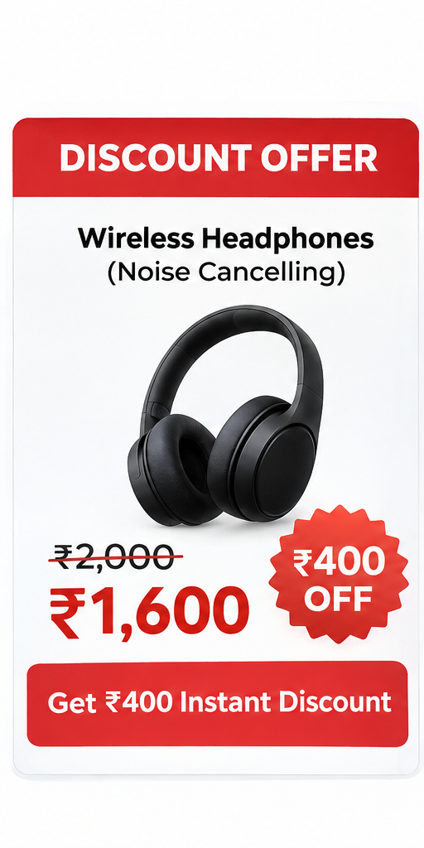 | 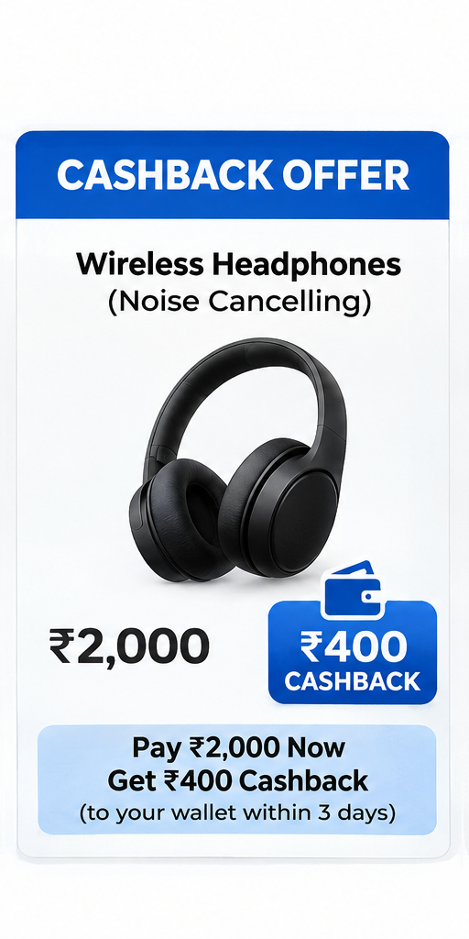 | 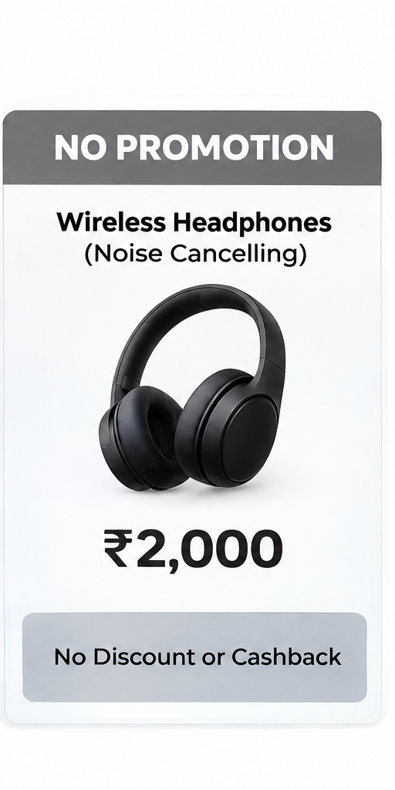
Figure A1. Visual stimulus cards rendered in the Streamlit questionnaire application.
4. Part 3: Experimental Outcome Telemetry Measures
For each of the three randomized scenarios (Discount, Cashback, Control), respondents evaluated the purchase option using three continuous 5-point Likert psychometric measures:
Question 13 [purchase_intention]: "How likely are you to purchase this product?"
Scale: 1 – Very unlikely | 2 – Unlikely | 3 – Neither likely nor unlikely | 4 – Likely | 5 – Very likely
Measurement Rationale: Primary dependent variable measuring commercial conversion probability.
Question 14 [offer_attractiveness]: "How attractive do you find this offer / purchase option?"
Scale: 1 – Not attractive at all | 2 – Slightly attractive | 3 – Moderately attractive | 4 – Very attractive | 5 – Extremely attractive
Measurement Rationale: Psychological valuation measuring immediate perceptual deal appeal.
Question 15 [value_for_money_confidence]: "How confident are you that this option provides good value for money?"
Scale: 1 – Not confident at all | 2 – Slightly confident | 3 – Moderately confident | 4 – Very confident | 5 – Extremely confident
Measurement Rationale: Cognitive assessment measuring perceived economic certainty and transaction security.
5. Telemetry Capture & Status Lifecycle Management
The web application incorporates automated state tracking to record session completeness and eliminate manual data entry:
1. Initial Survey Submission (Phase 1): Upon initiating the survey, a unique UUID is assigned (e.g., e87556d4-8853-467e). After submitting Part 1, the respondent's answers are appended to the 'Survey Responses' Google Sheet and assigned status = 'In progress'.
2. Atomic Experiment Commit (Phase 2): Upon completing all three experimental scenario trials, the telemetry ratings are committed as 3 rows to the 'Experiment Responses' sheet in a single atomic batch (append_rows()), and the survey record is updated to status = 'Completed'.
3. Quality Audit & Incomplete Dropping: Participants who abandon the application after Part 1 retain status = 'In progress'. In data preprocessing, these 6 incomplete records were audited and dropped to preserve experimental balance, establishing the final N = 74 completed sample.

