**Application URL**

<http://localhost:8080/>

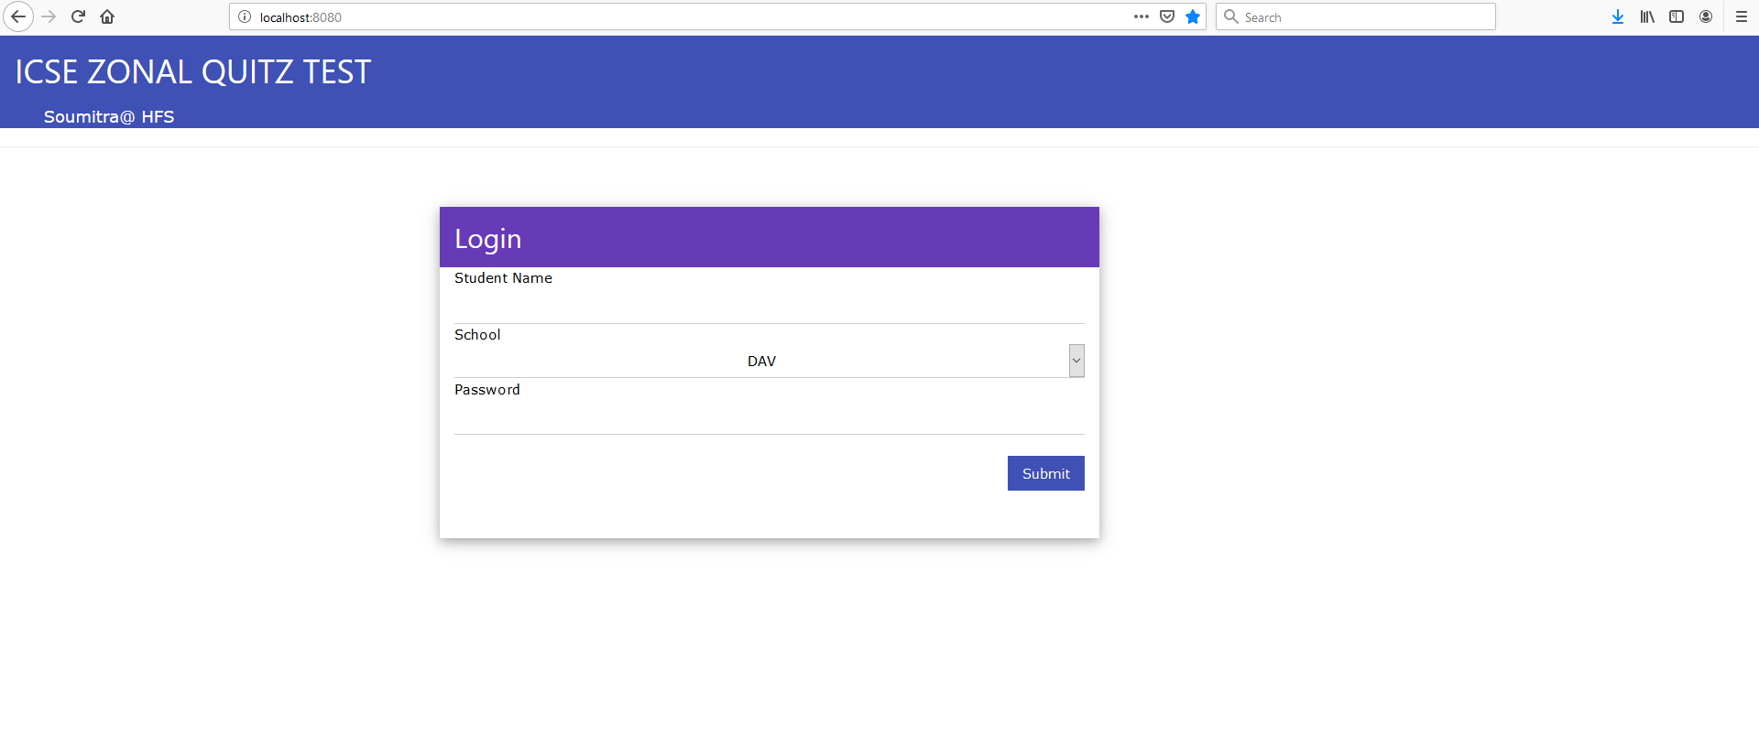

**Default Password** - admin

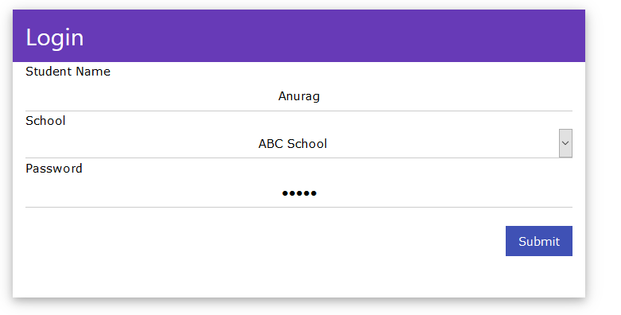

**Question Page**

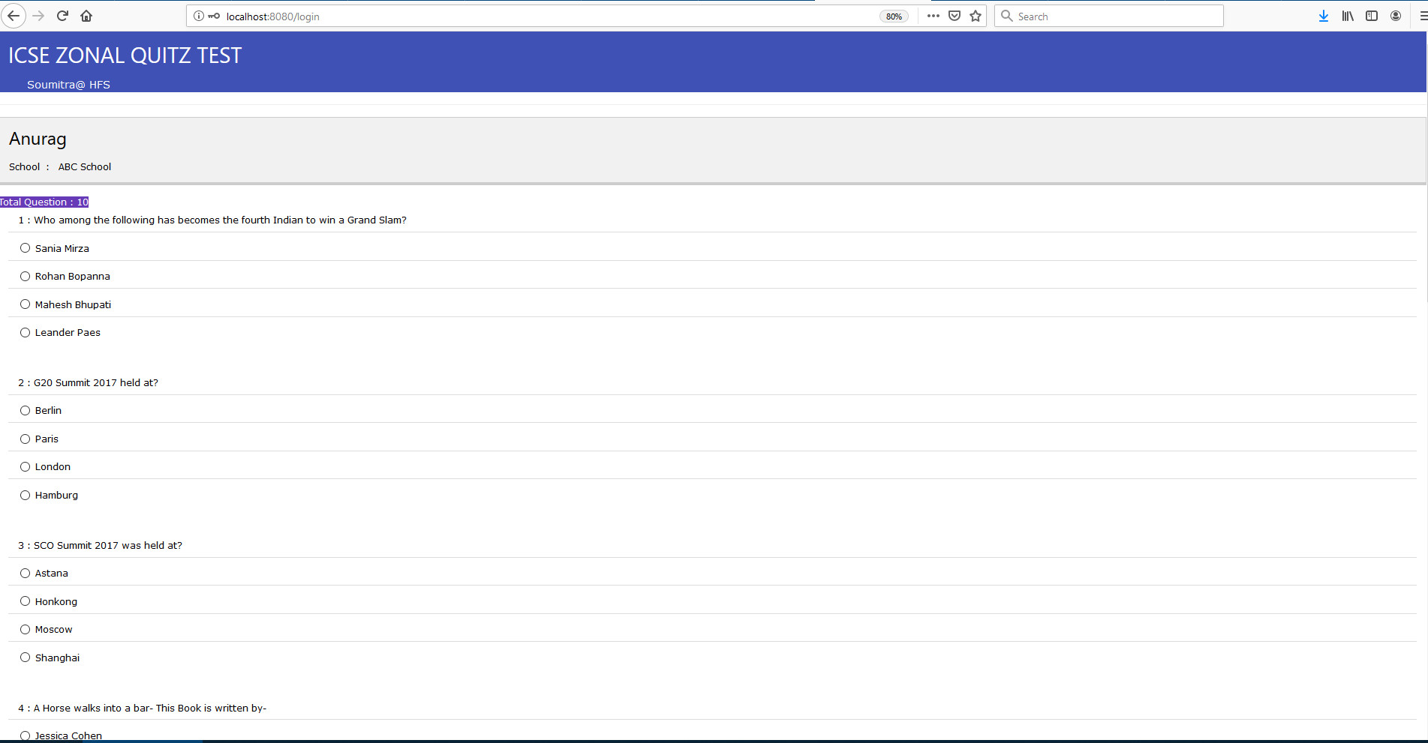

**Submit Answer**

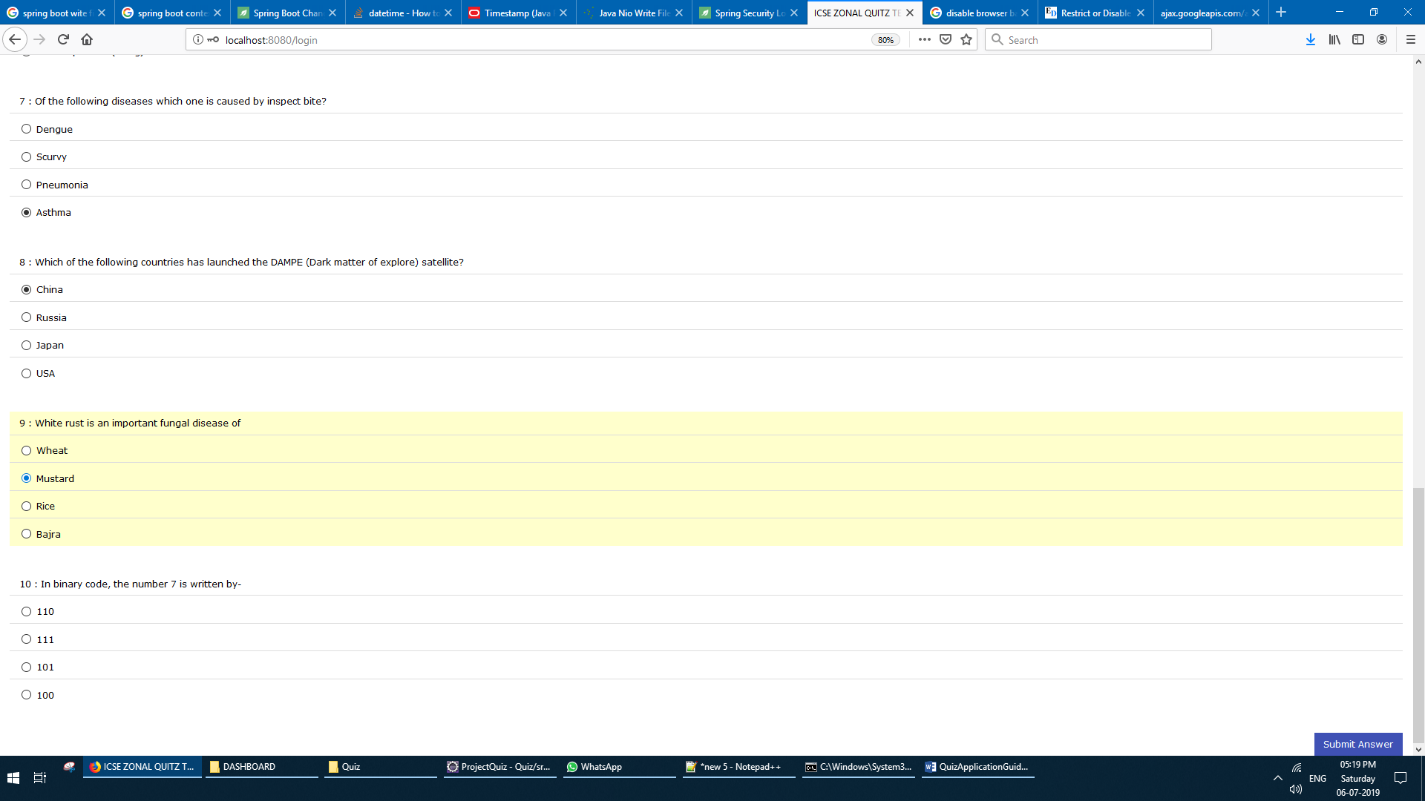

**Result Page**

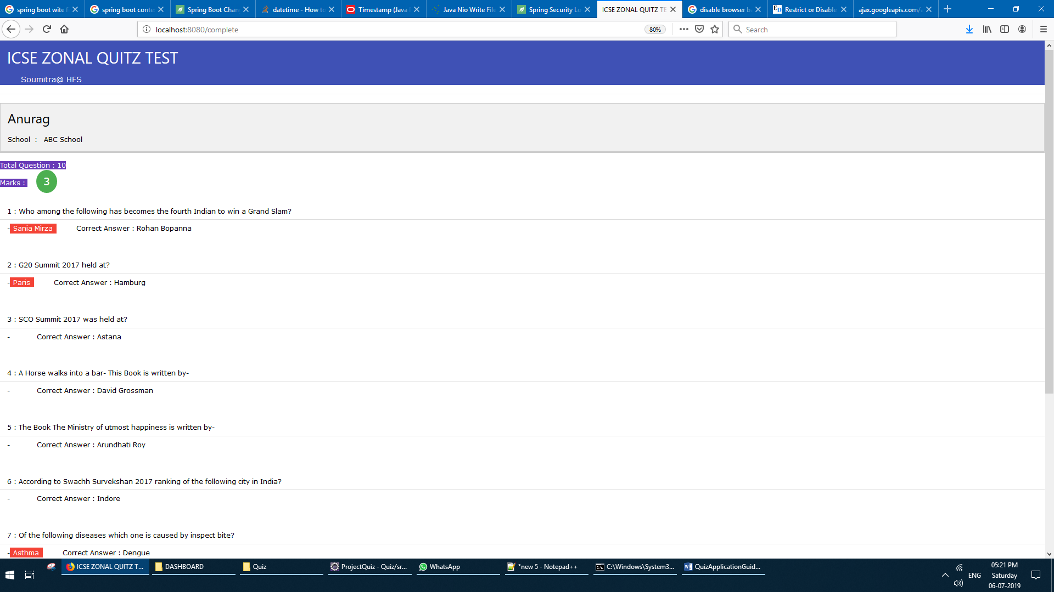

**Logout Button At Bottom Right**

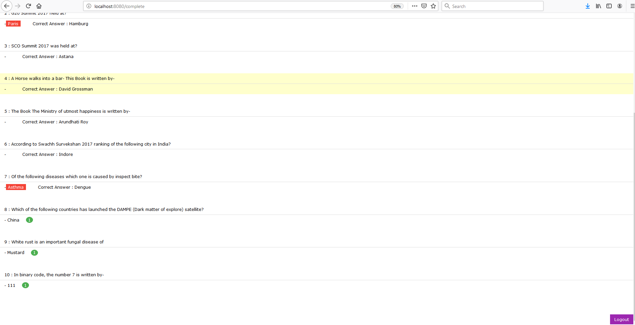

**Wrong answer is marked with red**

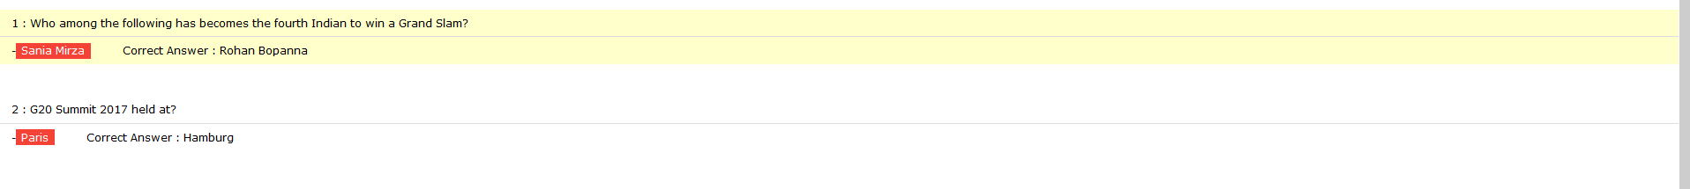

**Correct answer is marked with Green**

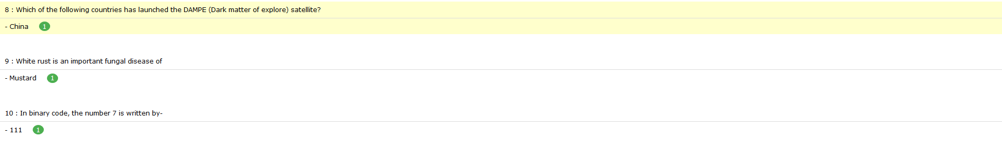

**Question Not Attended**



**aplication.properties: To Configure application**

**Modifying Password**

1. **Open application. Properties**
2. **Go under section # ------ password -----**
3. **Modify the highlighted text**



**Modifying Headers**



1. **Open application. Properties**
2. **Go under section # ------ Header Lables -----**
3. **Modify the highlighted text**

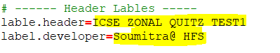

**Adding School**

1. **Open application. Properties**
2. **Go under section # ------ School Details below -----**
3. **Write the no of school you want to add beside below property**

**school.count=**

1. **Add the school as show below**

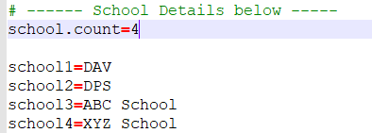

**Adding Question Answer And Options**

1. **Open application. Properties**
2. **Go under section # ------ Questions Answer below -----**
3. **Add the Question and answer as show below**

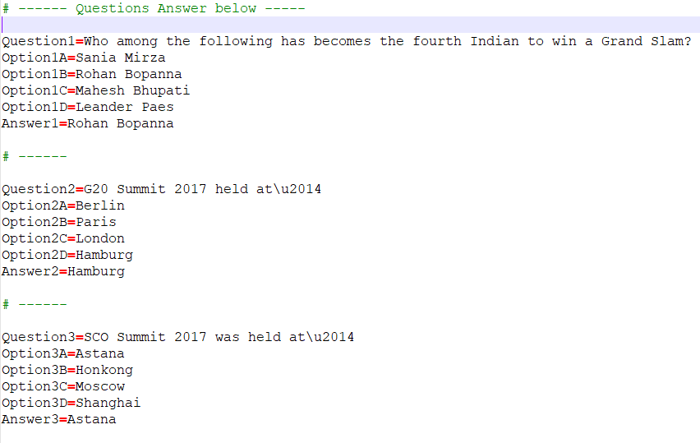

**Run.bat**

**When you run**

**java -jar QuizApp.war --spring.config.location=application.properties**

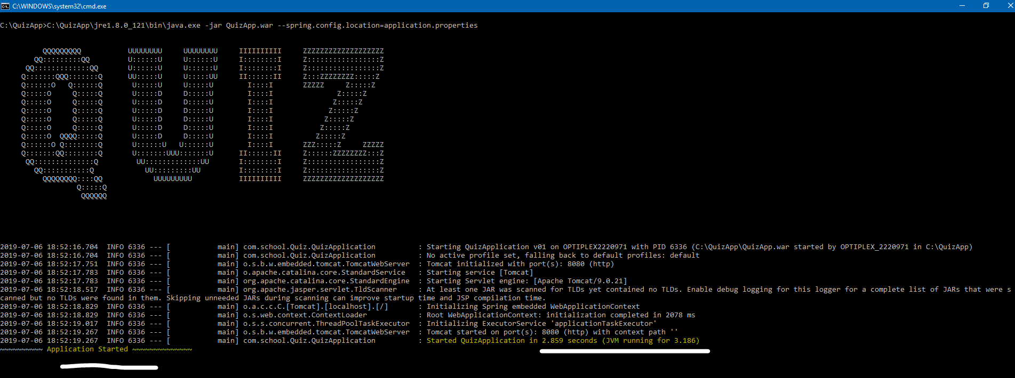

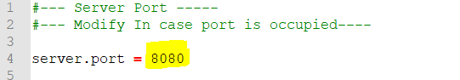

**For example if you change the port to 9090 then your application url will also change**

**server.port = 9090**

<http://localhost:9090/>