**Setting Up Selenium**

**Step 1: Installing Java**

* Download and install latest release of java platform from the following link

<https://www.oracle.com/technetwork/java/javase/downloads/index.html>

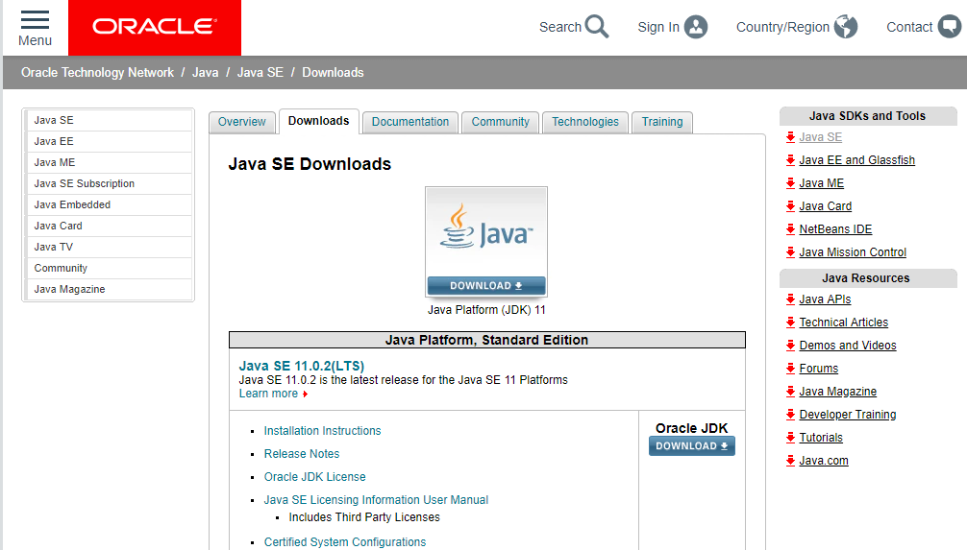

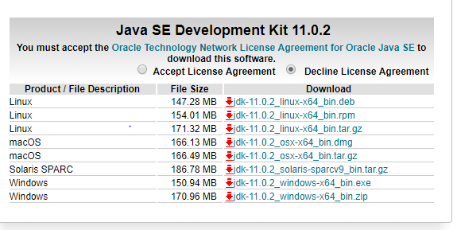

**Step 2: Installing Eclipse**

* Download and install latest release for Eclipse from the following link

<https://www.eclipse.org/downloads/>

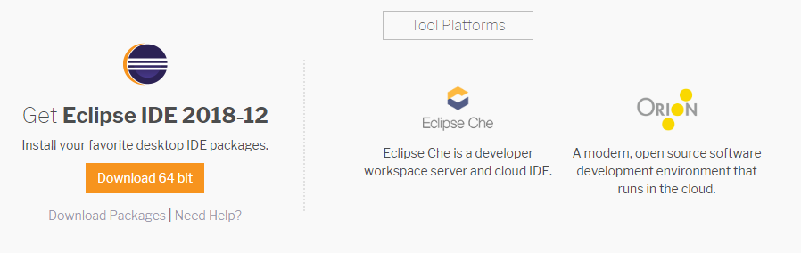

**Step 3: Download Selenium jar files**

* Open the given link below to download jar files for selenium

<https://selenium-release.storage.googleapis.com/index.html>

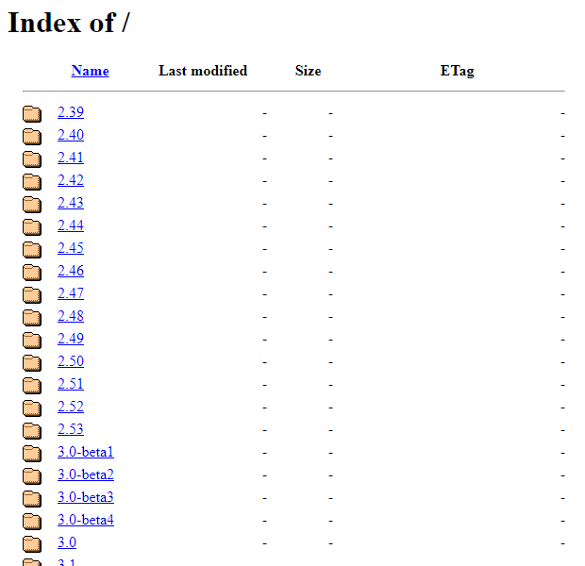

**Step 3: Configuring Eclipse for Selenium**

* Open Eclipse and set path for your directory in eclipse Launcher window and click launch.

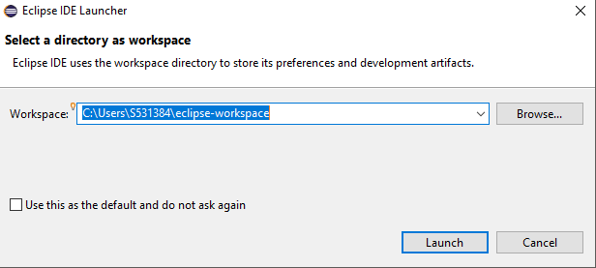

* After Eclipse is Launched, go to
* **File ->New-> JavaProject**

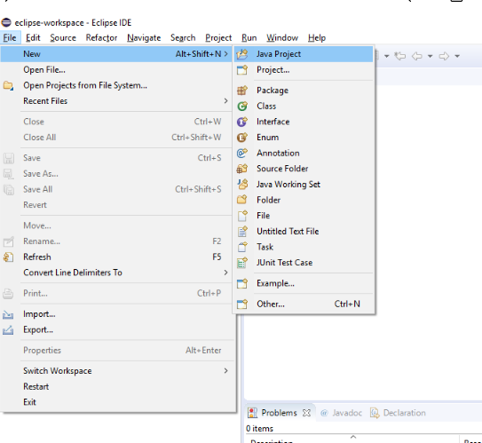

* Enter **Project name**
* Click **Finish**

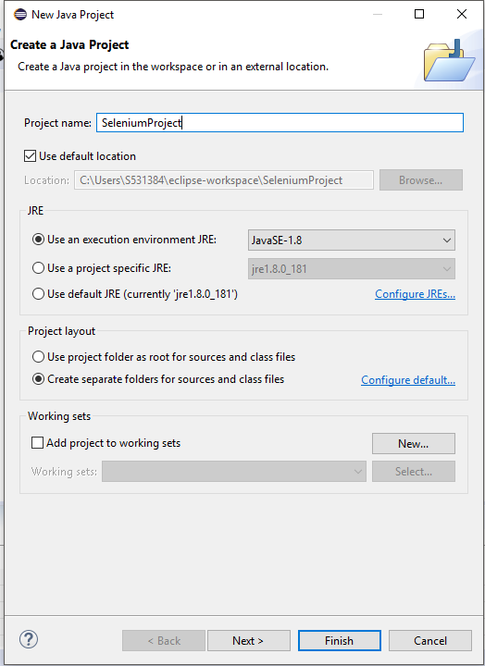

* Under Package Explorer tab, right click on the project name, go to
* **Build Path -> Configure Build Path**

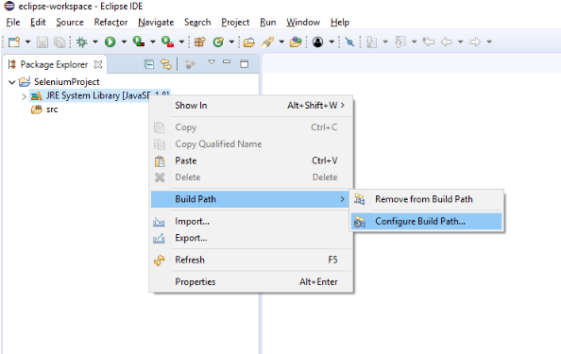

* Click On the Libraries tab, select Classpath then click on Add External JARs.

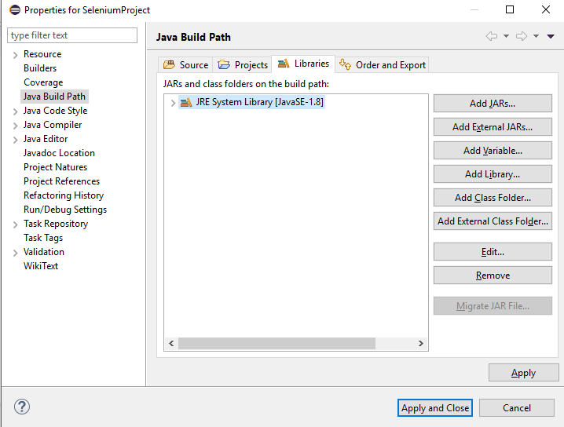

* Find all The Jar files that we downloaded, select them and click on **Open**
* After adding all the JAR files, Click on **Apply and Close**

