published | Test 1
title | Test 2
product | Test 3
Audience | Test 4
search_terms | Test 5
summary | Test 6
access_warning | Test 7
release_date | Test 1
reissue_date | Test 2
published_date | Test 3
duration | Test 4
course_series | Test 5
membership_level | Test 6
version_numbers | Test 7
collect_feedback | Test 1
editing_division | Test 2
editing_department | Test 3
study_access | Test 4
study_division | Test 5
study_department | Test 6

Table of Contents
Summary 2
Description 2
Image 2
Bullet list 2
Number list 3
Table 3
Finally 4
Font style test 4

Summary
Supplier bookings with the load modes ‘Other’ and ‘Loose Cargo’ along with their associated records are now visible in the Order Explorer (OE) grid.

Description
Supplier bookings with load modes of ‘Other’ or ‘Loose Cargo’ and their associated Advanced Order Manager (AOM) records were not available in Order Explorer (OE) grid.

Important: I want to add text here. Supplier bookings with load modes of ‘Other’ or ‘Loose Cargo’ used to be known as Loose Cargo (LSE). Refer to Simplified Load Mode in NEO portal for the load mode’s previous naming conventions.

Image
Here is an example image.

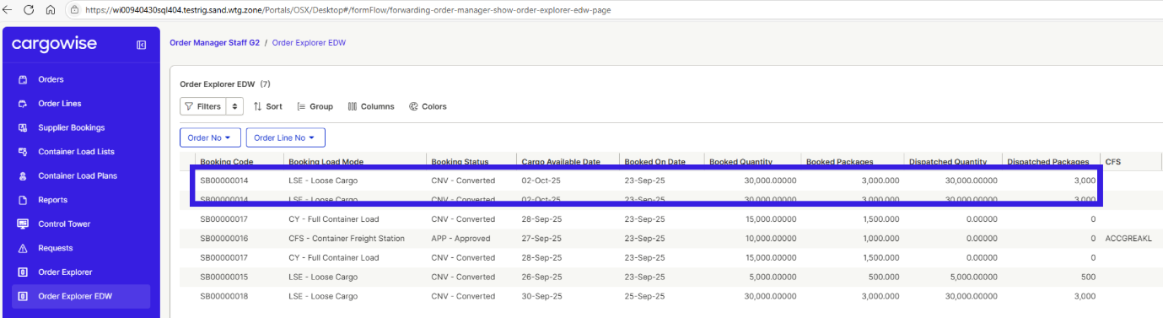

Bullet list
Here is some bullet items.
- Integral to the success of our business, our people and unique culture help drive the delivery of our long-term strategy
- Our work environment stimulates creativity and innovation, with a focus on freedom and responsibility.
- Our credo, mantras and values give us focus and purpose and are our deeply held beliefs, highest priorities and the fundamental forces that drive us forward every day

Number list
Here is some number list.
- WiseTech's strong cultural foundations stem from our productivity systems and operating principles which make up The WiseTech Way.
- We value a strong and diverse workforce and are focused on attracting and retaining the best people to work at WiseTech.
- We pride ourselves on our culture of learning, collaboration, and continuous development.

Table
Greenhouse Gas (GHG) emissions (tCO2e)
Emissions | FY25 | FY24
Scope 1 | 284 | 348
Scope 2 (Market-based) | 1,449 | 3,301
Scope 3 | 68,408 | 22,557
Category 1: Purchased goods and services | 34,387 | 12,173
Category 2: Capital goods | 8,026 | 3,020
Category 3: Fuel and energy related activities not included in Sc1 or Sc2 | 368 | 700
Category 5: Waste generated in operations | 785 | N/A
Category 6: Business travel | 1,391 | 1,197
Category 7: Employee commuting (including work from home emissions) | 4,073 | 3,751
Category 8: Upstream leased assets | 2,292 | 1,717
Category 11: Use of sold products | 17,088 | N/A

Finally
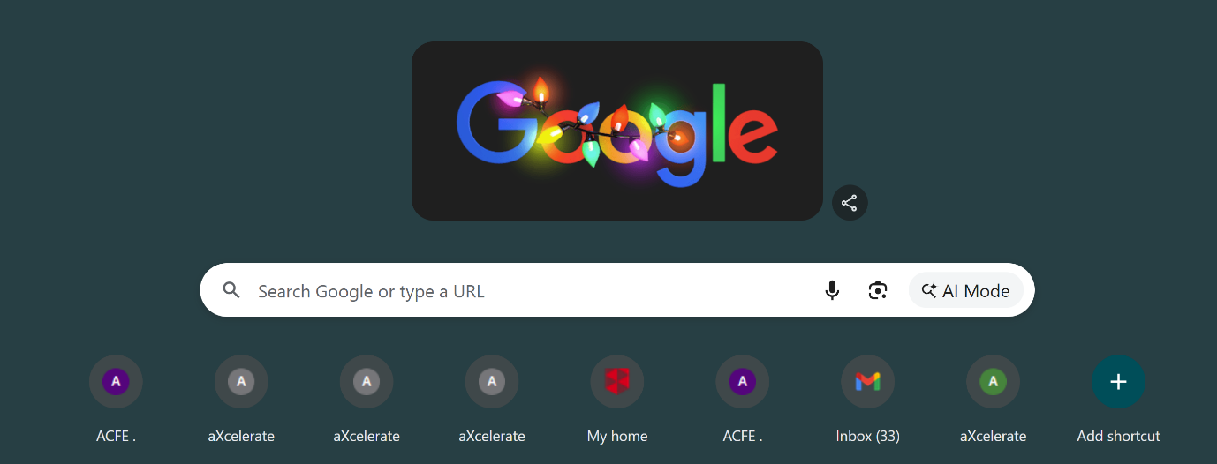
Image two here

Font style test
This is bold
This is italic
This is italic Bold
This is hyperlink

There are video scams on social media featuring fake footage of what may appear to be Richard White offering a lucrative investment opportunity. The person depicted in these videos is not Richard White and the opportunity offered is neither real nor is it associated with or endorsed by Richard White or WiseTech. We have notified the various social media platforms. If you see them DO NOT click the link and block or delete them immediately.

We are also proud to acknowledge the outstanding group of finalists who represented WiseTech across several award categories. Their achievements underscore the depth of talent and professionalism within our Finance team.

The inaugural Corporate Accountant Awards, hosted by Accounting Times, highlights the incredible work achievements of in-house finance professionals in Australia.

JSON Code

{
"id": 1,
"sectionTitle": "Why this matters",
"sectionRole": "intro",
"title": "Importance of Effective Communication",
"widget_name": "wta-scroll-animator",
"blockType": "intro_text",
"description": "Introduce the significance of understanding key elements of effective workplace communication and its impact on team collaboration.",
"atomicUnitIds": [],
"atomicUnits": [],
"estimatedWordCount": 50
},
{
"id": 2,
"sectionTitle": "Key elements",
"sectionRole": "core",
"title": "Key Elements of Effective Workplace Communication",
"widget_name": "wta-text-reveal",
"blockType": "concept_list",
"description": "Present the key elements of effective workplace communication, allowing learners to explore each element individually. Include active listening techniques, non-verbal communication cues, clarity in written communication, feedback mechanisms, role of empathy, and communication tools.",
"atomicUnitIds": [
1,
2,
3,
4,
5,
6
],
"atomicUnits": [
{
"id": 1,
"atomicUnit": "active listening techniques",
"text": "Learner will be able to identify active listening techniques in team meetings.",
"unitRole": "enumerated-item",
"groupLabel": "key elements of effective workplace communication"
},
{
"id": 2,
"atomicUnit": "non-verbal communication cues",
"text": "Learner will be able to identify non-verbal communication cues in workplace interactions.",
"unitRole": "enumerated-item",
"groupLabel": "key elements of effective workplace communication"
},
{
"id": 3,
"atomicUnit": "clarity in written communication",
"text": "Learner will be able to identify the importance of clarity in written communication for project updates.",
"unitRole": "enumerated-item",
"groupLabel": "key elements of effective workplace communication"
},
{
"id": 4,
"atomicUnit": "feedback mechanisms",
"text": "Learner will be able to identify feedback mechanisms that enhance team collaboration.",
"unitRole": "enumerated-item",
"groupLabel": "key elements of effective workplace communication"
},
{
"id": 5,
"atomicUnit": "role of empathy",
"text": "Learner will be able to identify the role of empathy in resolving workplace conflicts.",
"unitRole": "enumerated-item",
"groupLabel": "key elements of effective workplace communication"
},
{
"id": 6,
"atomicUnit": "communication tools",
"text": "Learner will be able to identify communication tools commonly used in Australian offices.",
"unitRole": "enumerated-item",
"groupLabel": "key elements of effective workplace communication"
}
],
"estimatedWordCount": 300
}

