Summary
Supplier bookings with the load modes ‘Other’ and ‘Loose Cargo’ along with their associated records are now visible in the Order Explorer (OE) grid.

Description
Supplier bookings with load modes of ‘Other’ or ‘Loose Cargo’ and their associated Advanced Order Manager (AOM) records were not available in Order Explorer (OE) grid.

Important: I want to add text here. Supplier bookings with load modes of ‘Other’ or ‘Loose Cargo’ used to be known as Loose Cargo (LSE). Refer to Simplified Load Mode in NEO portal for the load mode’s previous naming conventions.

Image
Here is an example image.

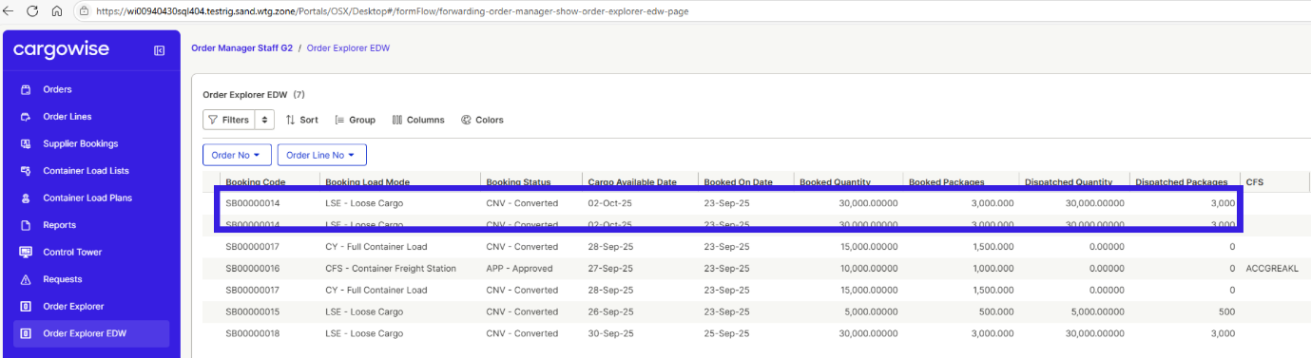

Bullet list
Here is some bullet items.
- Integral to the success of our business, our people and unique culture help drive the delivery of our long-term strategy
- Our work environment stimulates creativity and innovation, with a focus on freedom and responsibility.
- Our credo, mantras and values give us focus and purpose and are our deeply held beliefs, highest priorities and the fundamental forces that drive us forward every day

Number list
Here is some number list.
- WiseTech's strong cultural foundations stem from our productivity systems and operating principles which make up The WiseTech Way.
- We value a strong and diverse workforce and are focused on attracting and retaining the best people to work at WiseTech.
- We pride ourselves on our culture of learning, collaboration, and continuous development.

Table
Greenhouse Gas (GHG) emissions (tCO2e)
Emissions | FY25 | FY24
Scope 1 | 284 | 348
Scope 2 (Market-based) | 1,449 | 3,301
Scope 3 | 68,408 | 22,557
Category 1: Purchased goods and services | 34,387 | 12,173
Category 2: Capital goods | 8,026 | 3,020
Category 3: Fuel and energy related activities not included in Sc1 or Sc2 | 368 | 700
Category 5: Waste generated in operations | 785 | N/A
Category 6: Business travel | 1,391 | 1,197
Category 7: Employee commuting (including work from home emissions) | 4,073 | 3,751
Category 8: Upstream leased assets | 2,292 | 1,717
Category 11: Use of sold products | 17,088 | N/A

