**MARKS 10**

**Input can be hardcoded for both of the programs**

**Question** → 1) Write a program of Balancing Brackets, use a suitable data structure to print whether the string entered is a Balanced Brackets or Unbalanced String

**Sample input**

( [ [ { } ] ] )

**Sample Output**

The entered String has Balanced Brackets

**Sample Input**

( [ [ { } ] ] ) )

**Sample Output**

The entered Strings do not contain Balanced Brackets

-------------------------------------------------------------------------------------------------------------------------------

**MARKS 10**

**Question 2)** Find a pair with a given sum in Binary Search Tree

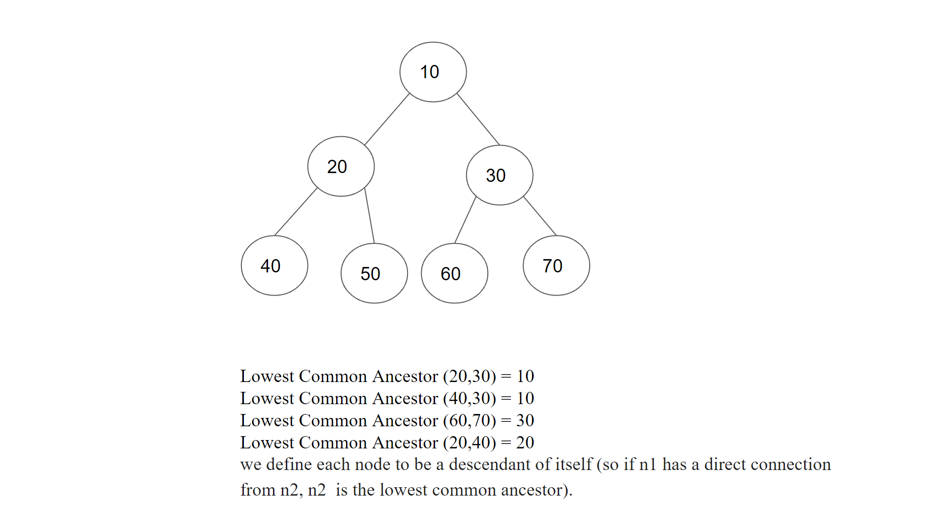

**Sum = 130**

**Pair is (60,70)**

**If the sum is not found, print nodes are not found.**

-------------------------------------------------------------------------------------------------------------------------------