**Topics: Descriptive Statistics and Probability**

1. Look at the data given below. Plot the data, find the outliers and find out $μ, σ, σ^{2}$

|  |  |
| --- | --- |
| **Name of company** | **Measure X** |
| Allied Signal | 24.23% |
| Bankers Trust | 25.53% |
| General Mills | 25.41% |
| ITT Industries | 24.14% |
| J.P.Morgan & Co. | 29.62% |
| Lehman Brothers | 28.25% |
| Marriott | 25.81% |
| MCI | 24.39% |
| Merrill Lynch | 40.26% |
| Microsoft | 32.95% |
| Morgan Stanley | 91.36% |
| Sun Microsystems | 25.99% |
| Travelers | 39.42% |
| US Airways | 26.71% |
| Warner-Lambert | 35.00% |

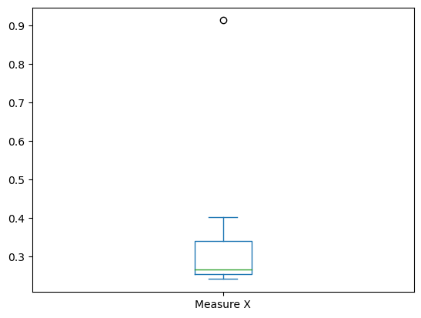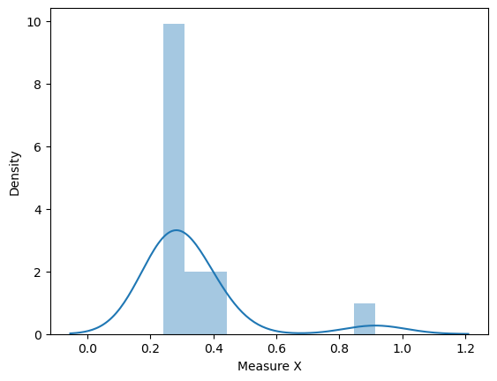

Mean = 0.332,

Var = 0.02871,

Std=0.169



Answer the following three questions based on the box-plot above.

1. What is inter-quartile range of this dataset? (please approximate the numbers) In one line, explain what this value implies.IQR = Q3-Q1=12-5=7 2nd quartile range is the median.
2. What can we say about the skewness of this dataset? Positively skewed data
3. If it was found that the data point with the value 25 is actually 2.5, how would the new box-plot be affected?

The median value will remain same, but the interquartile range will change. Moreover there will not have any outlier.



Answer the following three questions based on the histogram above.

1. Where would the mode of this dataset lie? Mode will lie between 4 &10,approximately 4,5,6,7,8
2. Comment on the skewness of the dataset.positively skewed
3. Suppose that the above histogram and the box-plot in question 2 are plotted for the same dataset. Explain how these graphs complement each other in providing information about any dataset.

They both are right-skewed and both have outliers the median can be easily visualized in box plot where as in histogram mode is more visible.

1. AT&T was running commercials in 1990 aimed at luring back customers who had switched to one of the other long-distance phone service providers. One such commercial shows a businessman trying to reach Phoenix and mistakenly getting Fiji, where a half-naked native on a beach responds incomprehensibly in Polynesian. When asked about this advertisement, AT&T admitted that the portrayed incident did not actually take place but added that this was an enactment of something that “could happen.” Suppose that one in 200 long-distance telephone calls is misdirected. What is the probability that at least one in five attempted telephone calls reaches the wrong number? (Assume independence of attempts.)

probability o call geng misdirected = (1/200)

Hence probability of call not getting misdirected = 1-(1/200) = 199/200

Number of phone calls attempted = 5

Therefore, probability that at least one in 5 attempted call reaches the wrong number is:=1-(199/200) ^5= 0.025

1. Returns on a certain business venture, to the nearest $1,000, are known to follow the following probability distribution

|  |  |
| --- | --- |
| x | P(x) |
| -2,000 | 0.1 |
| -1,000 | 0.1 |
| 0 | 0.2 |
| 1000 | 0.2 |
| 2000 | 0.3 |
| 3000 | 0.1 |

1. What is the most likely monetary outcome of the business venture?2000
2. Is the venture likely to be successful? Explain

Yes because the total earnings of the venture is 800 and highest probability is 2000/-

1. What is the long-term average earning of business ventures of this kind? Explain

The long-term average is Expected value = Sum (X * P(X)) = 800$ which means on an average the returns will be + 800$

1. What is the good measure of the risk involved in a venture of this kind? Compute this measure

X*p(x)

-200

-100

0

200

600

300

data.var()

Out[3]:

-200 75000.0

dtype: float64

In [4]:

data.std()

Out[4]:

-200 273.861279

dtype: float64