Note:- All the Mentoned Program Need to Write in the A4 Paper.

1. **Program to manipulate the IP address of a system.**

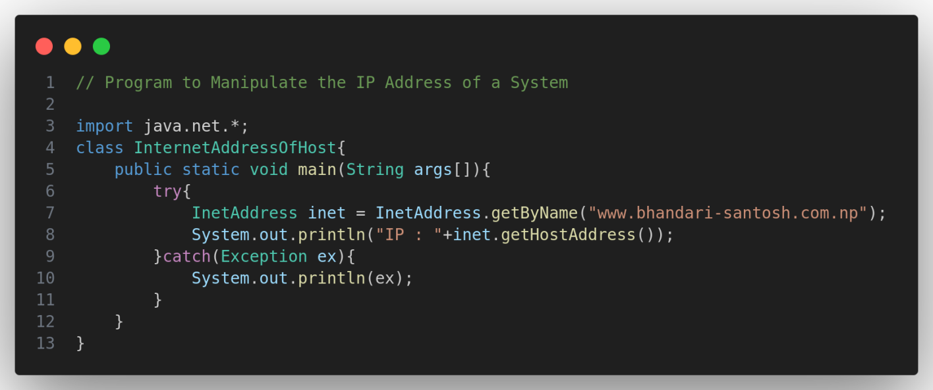

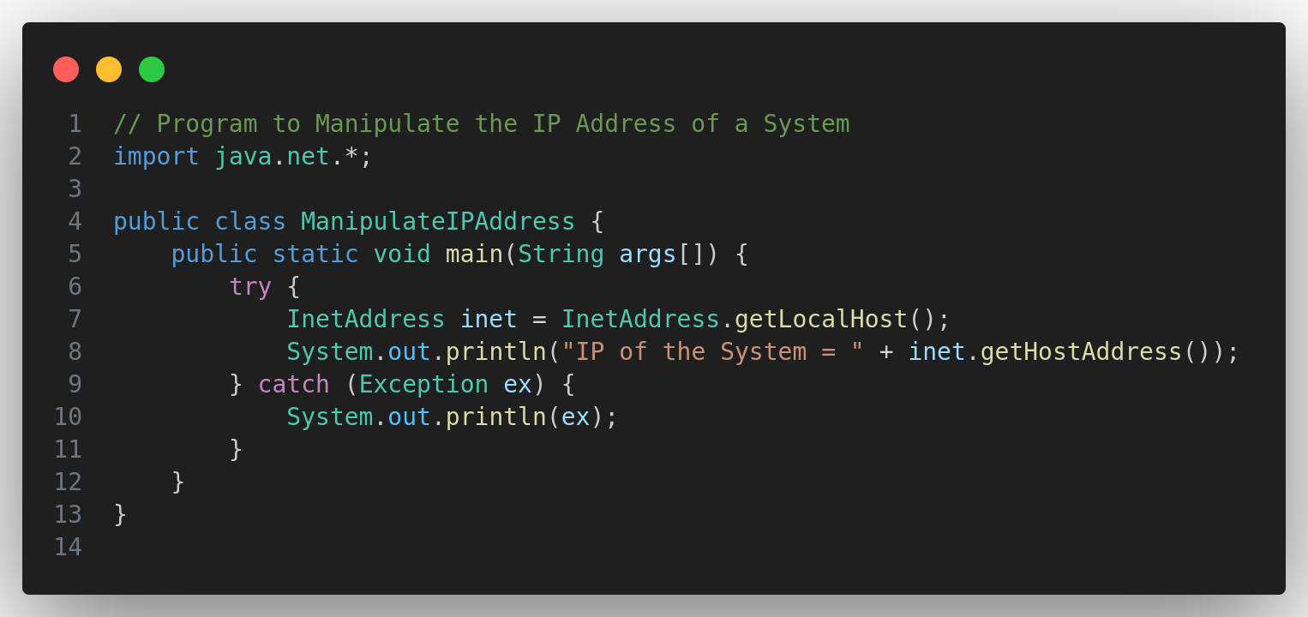

1. **Program to obtain the information about the (a) Host (b)Port (c)Protocol**

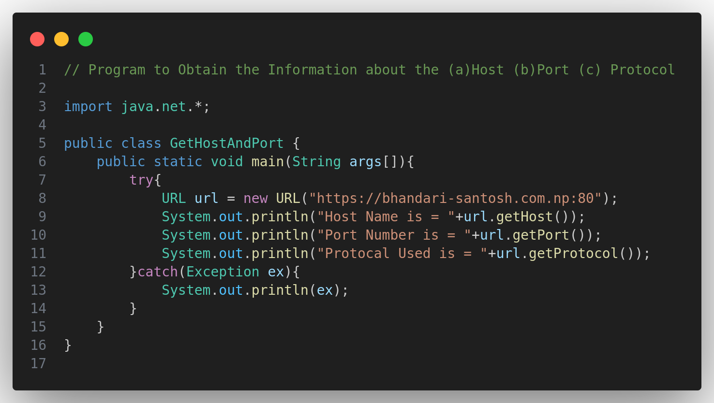

1. **Program to access daytime service from server using socket.**

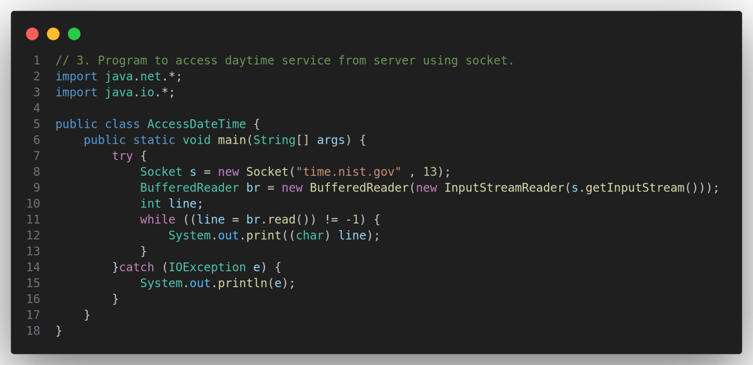

1. **Program to get remote and local socket address.**

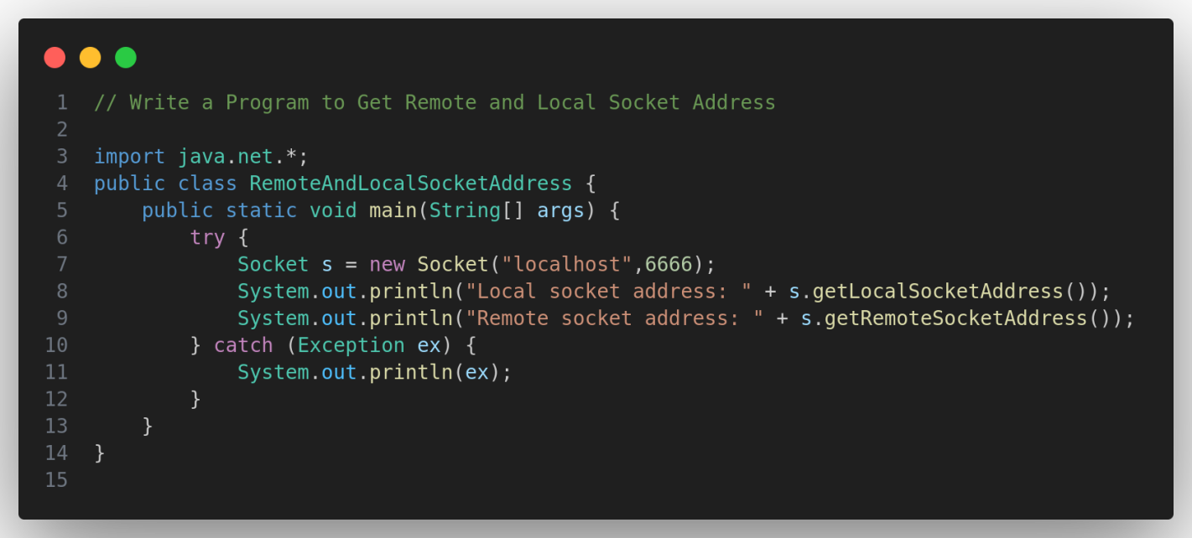

1. **Program to find port No. running on server.**

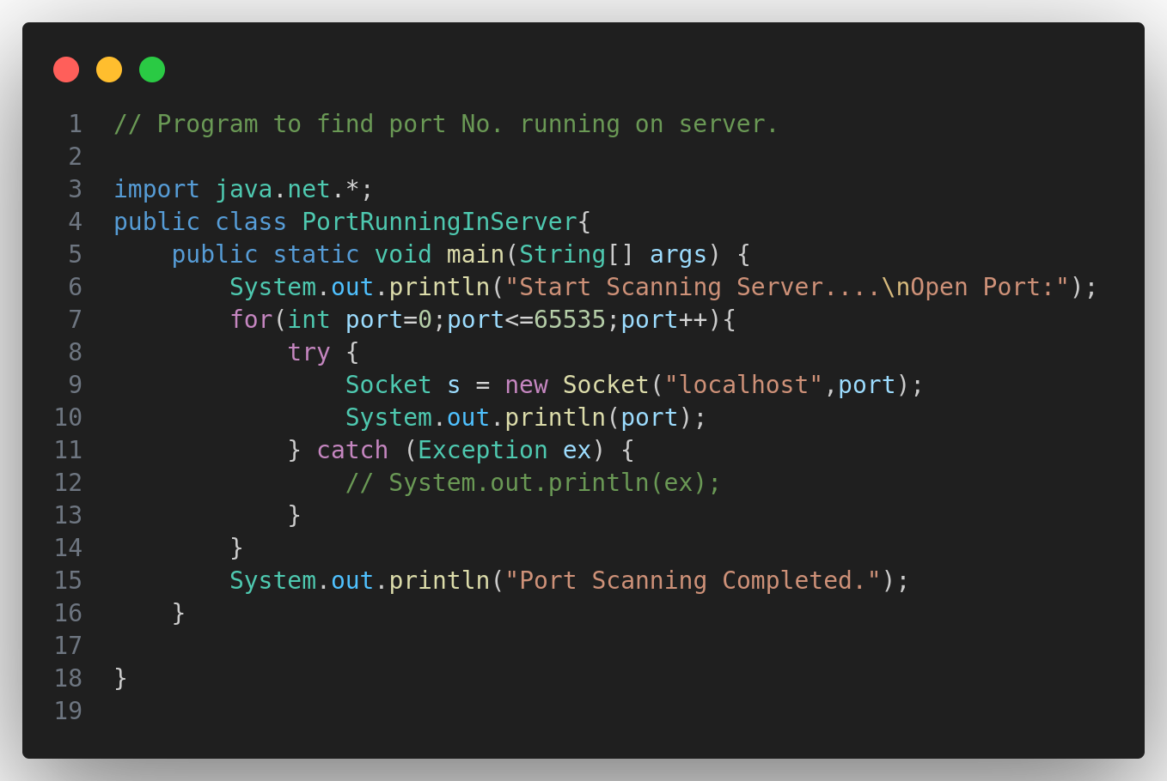

1. **Program to read the source Code of the web page.**

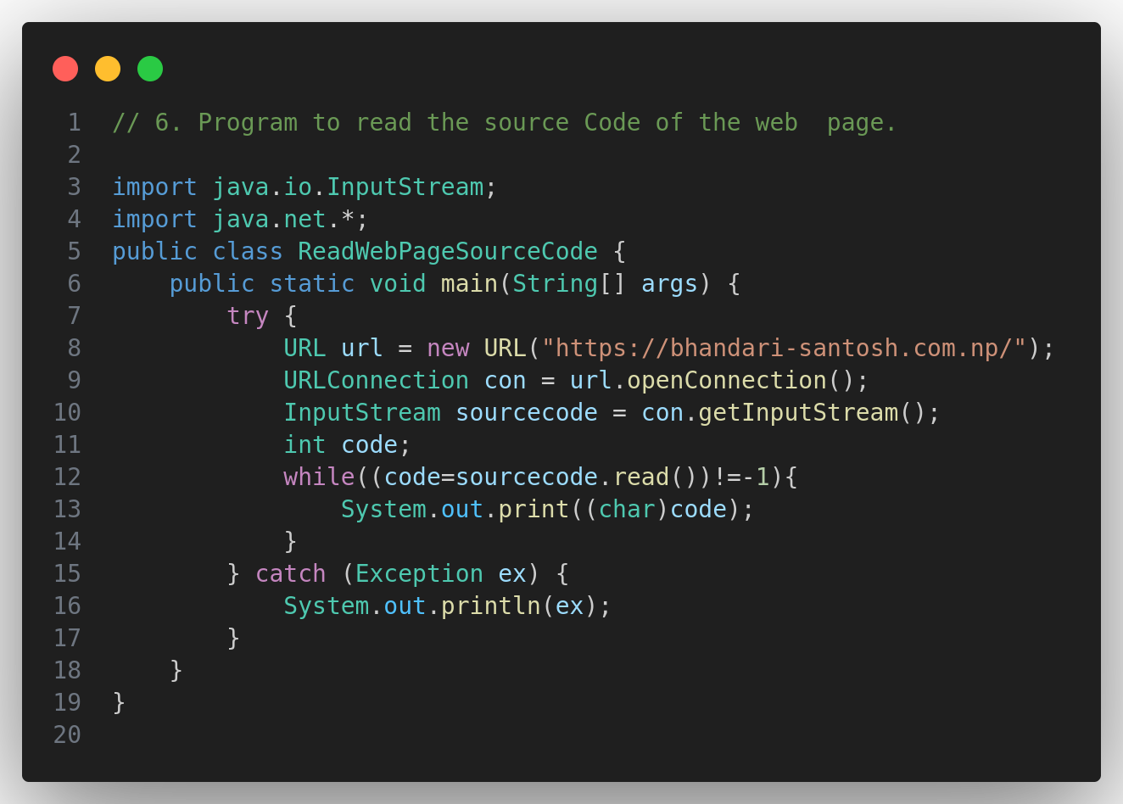

1. **Program to create Socket for sending and receiving data.**

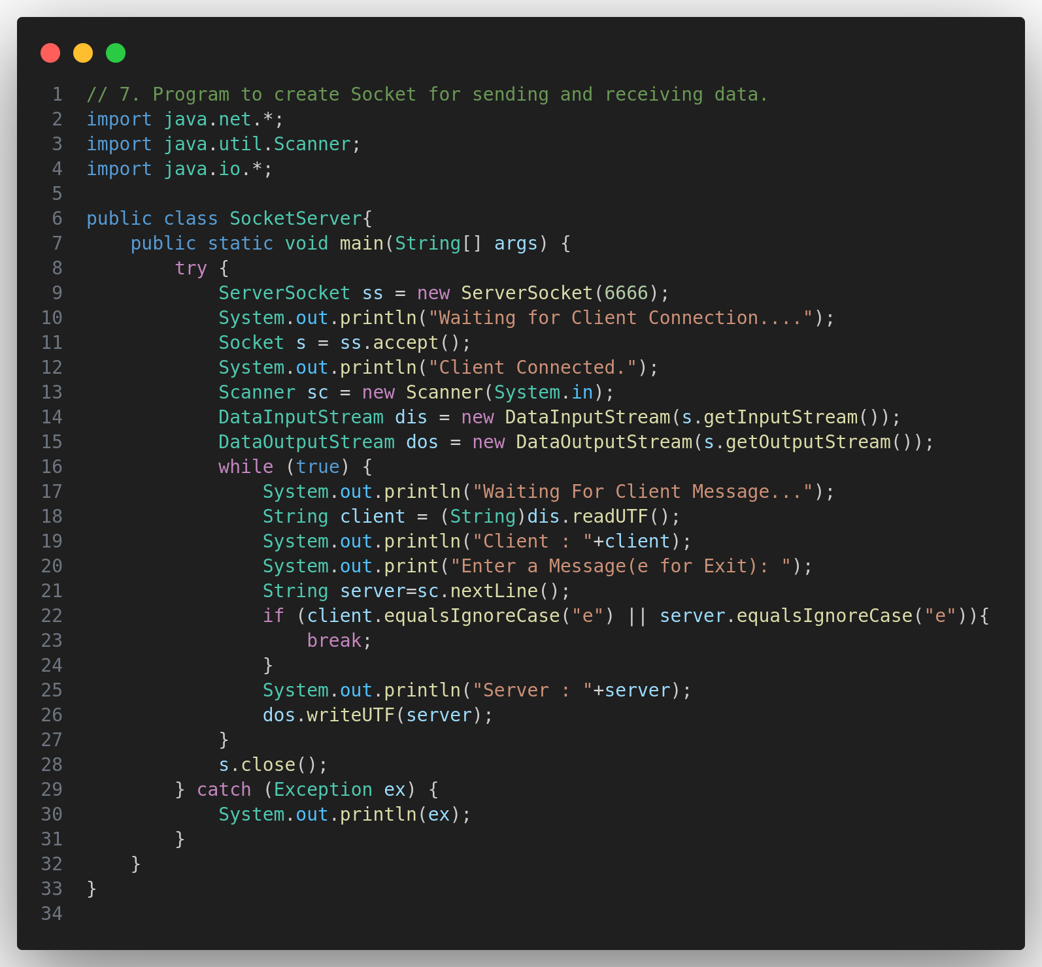

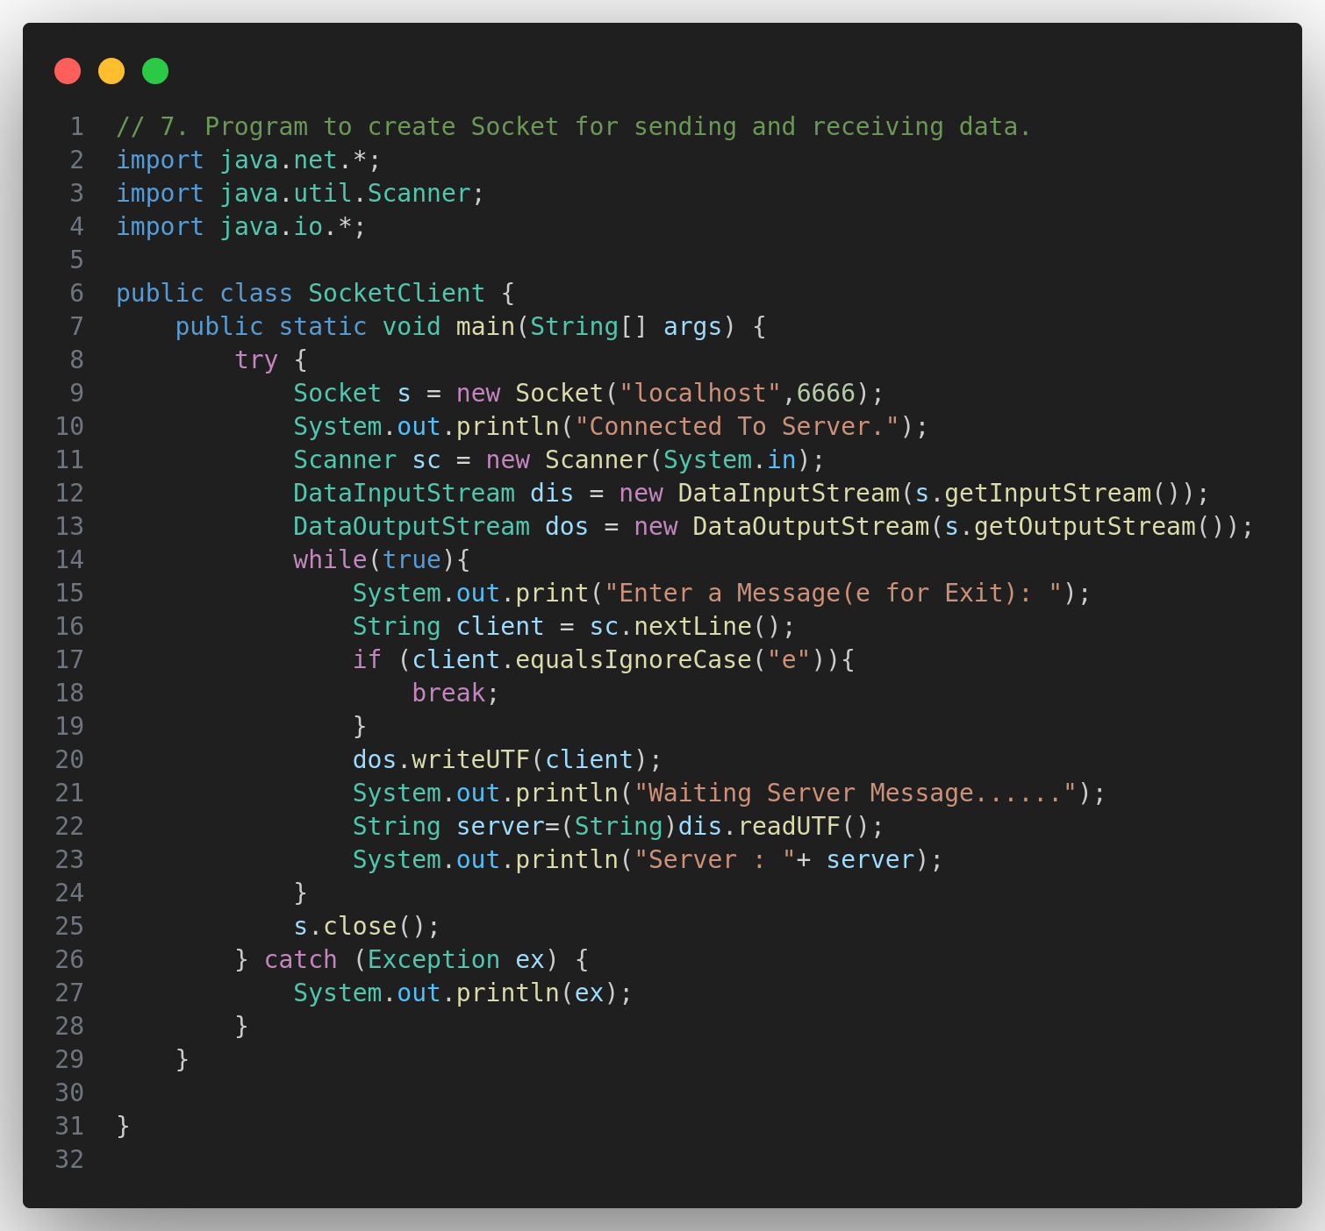

1. **RMI Client & Server Side**

