Customer Lifetime Value Prediction Using Elastic Net Regression

Exploratory Data Analysis Report
Dataset: UCI Online Retail Dataset
Subject: Machine Learning
Student Name | Santosh Kumar Bal
Roll Number | [Enter Roll Number]
Faculty / Guide Name | [Enter Faculty / Guide Name]
College / University Name | [Enter College / University Name]
Programme | B.Tech
Date | [Enter Submission Date]

Table of Contents

(If the page numbers above do not appear, right-click the table and choose "Update Field" in Microsoft Word.)

2. Introduction

2.1 What is Exploratory Data Analysis?
Exploratory Data Analysis (EDA) is the process of examining a dataset using summary statistics and visualisations before any model is built. Its purpose is to understand the structure of the data, check its quality, discover patterns and relationships, and identify unusual values. EDA does not train a predictive model; it provides the evidence needed to decide how the data should be cleaned and prepared.

2.2 Why EDA is important in Machine Learning
A machine learning model can only learn from the information it is given. If the data contain missing values, duplicated records, wrongly recorded quantities or extreme values, the model may learn misleading relationships. EDA helps the practitioner to (i) detect data-quality problems early, (ii) understand the distribution of each variable so that suitable scaling or transformation can be chosen, (iii) study the relationships among variables, and (iv) avoid modelling mistakes such as target leakage.

2.3 Why EDA is important for customer transaction data
Customer transaction data are recorded at the level of individual invoice lines, not at the level of customers. A single customer may appear in many rows, some rows may represent returns or cancellations, and some rows may not be linked to any customer at all. Before customer behaviour can be studied, the analyst must understand how purchases, cancellations, prices and customer identifiers are represented. Transaction data also tend to be highly skewed, because a few very large orders or very active customers can dominate totals.

2.4 How EDA supports Customer Lifetime Value prediction
Customer Lifetime Value (CLV) prediction estimates how much revenue a customer is likely to generate in the future. To do this, the raw transaction table must be converted into customer-level features such as how recently, how often and how much a customer purchased. EDA shows whether these features can be built reliably from the available data, how they are distributed, how strongly they are related to one another, and which records must be treated carefully (for example cancellations and records without a CustomerID). These findings directly guide the preprocessing and the choice of regularised regression (Elastic Net) in the later modelling stage of this project.

3. Dataset Overview
The file Online Retail.xlsx was loaded into Python (pandas) and inspected. All values reported in this section were computed from the file. The dataset contains 541,909 rows and 8 columns, and each row is one product line within an invoice.
Table 1: Dataset overview (computed from the actual file)
Item | Value
Dataset name | Online Retail (file: Online Retail.xlsx)
Dataset source | UCI Machine Learning Repository
Number of rows | 541,909
Number of columns | 8
Column names | InvoiceNo, StockCode, Description, Quantity, InvoiceDate, UnitPrice, CustomerID, Country
Date range (InvoiceDate) | 2010-12-01 08:26 to 2011-12-09 12:50 (373 days)
Unique customers (non-missing CustomerID) | 4,372
Unique invoices (InvoiceNo, including cancellations) | 25,900
Unique products (StockCode) | 4,070
Number of countries | 38

Table 2: Data types as loaded by pandas
Column | pandas data type | Comment
InvoiceNo | object | Mixed content: 532,618 numeric and 9,291 text values (text values are the "C"/"A"-prefixed invoices)
StockCode | object | Mixed content: 487,036 numeric and 54,873 text values
Description | object (text) | Text; contains missing values
Quantity | int64 | Integer
InvoiceDate | datetime64 | Valid date-time
UnitPrice | float64 | Decimal
CustomerID | float64 | Stored as float because of missing values; all non-missing values are whole numbers
Country | object (text) | Text

Observation: The data cover 373 days, from 1 December 2010 to 9 December 2011. Only the first 305 calendar days have at least one sales invoice; the file records no invoices on any Saturday. December 2011 is only a partial month, because the last record is dated 2011-12-09.

4. Data Dictionary
The dataset contains eight columns. One additional column, TotalAmount, was derived during EDA after confirming that Quantity and UnitPrice exist.
Table 3: Data dictionary
Column | Description | Data type
InvoiceNo | Unique invoice (transaction) number. Invoices whose number begins with "C" represent cancellations (see Section 9). | Text / mixed
StockCode | Product (item) code identifying each product. | Text / mixed
Description | Name of the product. | Text
Quantity | Number of units of the product on that invoice line. Negative for cancelled/returned lines. | Integer
InvoiceDate | Date and time at which the invoice was generated. | Date-time
UnitPrice | Price of one unit of the product (sterling, according to the UCI documentation; the currency is not stored in the file). | Float
CustomerID | Identifier of the customer. Stored as a number; missing for some rows. | Float (whole numbers)
Country | Name of the country where the customer is located. | Text
TotalAmount (derived) | Value of the line = Quantity × UnitPrice. Created in this report. | Float

5. Data Quality Analysis
This section measures the number and percentage of problematic records. All percentages are calculated out of the total of 541,909 rows unless stated otherwise. A single row can have more than one problem, so the categories overlap and must not be added together.
Table 4: Data quality summary
Quality check | Records affected | % of all rows
Missing values in Description | 1,454 | 0.27%
Missing values in CustomerID | 135,080 | 24.93%
Exact duplicate rows (excluding first occurrence) | 5,268 | 0.97%
Negative Quantity | 10,624 | 1.96%
Zero Quantity | 0 | 0.00%
Zero UnitPrice | 2,515 | 0.46%
Negative UnitPrice | 2 | 0.00%
Rows on cancelled invoices (InvoiceNo starts with "C") | 9,288 | 1.71%
Data-type issues (InvoiceNo, StockCode mixed types; CustomerID float) | 3 columns | -

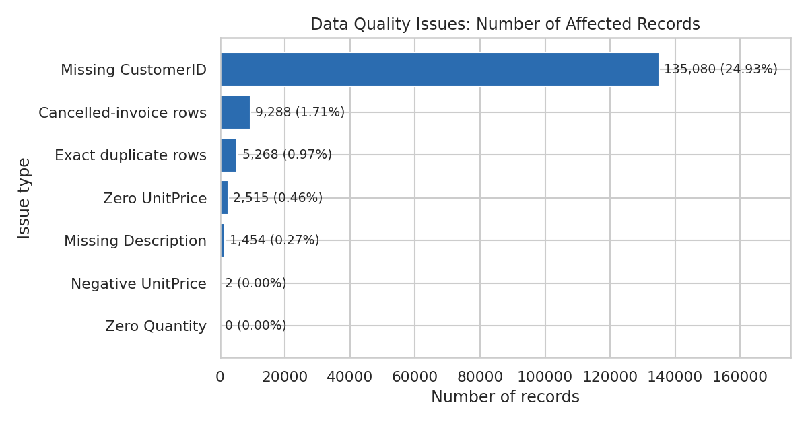
Figure 1: Number of records affected by each data-quality issue

5.1 Detailed observations
- Negative quantities: 10,624 rows have a negative Quantity. Of these, 9,288 belong to invoices beginning with "C" and every "C" row has a negative Quantity (no "C" row has a positive quantity). The remaining 1,336 negative-quantity rows do not begin with "C"; all of them have UnitPrice = 0 and no CustomerID, and 862 of them have no Description. Their descriptions include entries such as "check", "damages" and "damaged", which suggests stock adjustments rather than customer purchases.
- Zero quantities: No row has Quantity = 0.
- Zero and negative unit prices: 2,515 rows have UnitPrice = 0, and 2 rows have a negative UnitPrice. Of the zero-price rows, 2,475 have no CustomerID and 1,454 have no Description. The two negative-price rows belong to invoices beginning with "A" and carry the description "Adjust bad debt", i.e., accounting adjustments and not sales.
- Missing CustomerID: 135,080 rows (24.93%) have no CustomerID; they belong to 3,710 distinct invoices. Because CLV is a customer-level quantity, these rows cannot be assigned to any customer.
- Non-product stock codes: 2,796 rows use stock codes that contain no digits (for example POST = 1,256 rows, DOT = 710, M = 571, BANK CHARGES = 37, AMAZONFEE = 34). These represent postage, manual entries and fees rather than merchandise.
- Description consistency: The file has 4,070 distinct StockCodes but 4,223 distinct Descriptions, so some products carry more than one description text.
- Data-type issues: InvoiceNo and StockCode contain a mixture of numbers and text and should be converted to a single string type; CustomerID is stored as a decimal number and should be converted to an integer/string identifier after missing values are handled.

5.2 Definition of a "valid sale" used in later sections
For the customer-level sections of this report (Sections 10-15), a row is treated as a valid customer sale only if it (i) has a CustomerID, (ii) is not on a cancelled invoice, (iii) has Quantity > 0 and (iv) has UnitPrice > 0. Under this definition, 397,884 rows (73.42%) are valid and 144,025 rows (26.58%) are excluded from the customer-level calculations. This definition is used only to compute exploratory statistics; the final preprocessing decisions are discussed in Section 18.

6. Missing Value Analysis
Table 5: Missing-value count and percentage by column
Column | Missing count | Missing % | Present count
InvoiceNo | 0 | 0.00% | 541,909
StockCode | 0 | 0.00% | 541,909
Description | 1,454 | 0.27% | 540,455
Quantity | 0 | 0.00% | 541,909
InvoiceDate | 0 | 0.00% | 541,909
UnitPrice | 0 | 0.00% | 541,909
CustomerID | 135,080 | 24.93% | 406,829
Country | 0 | 0.00% | 541,909

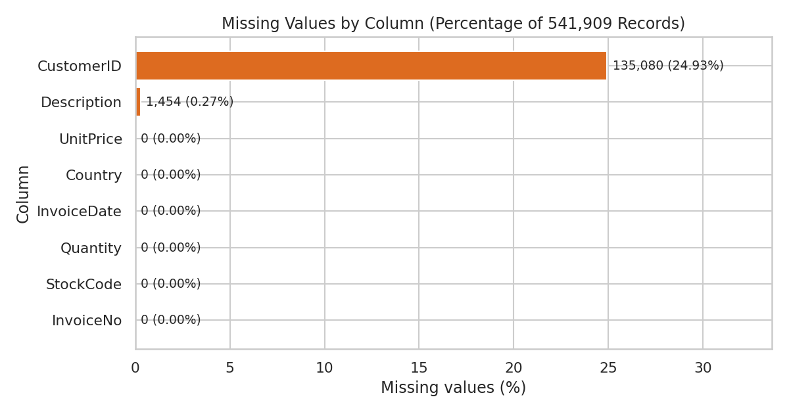
Figure 2: Missing values by column (percentage of all records)
Observation: Only two columns contain missing values: CustomerID (135,080 rows, 24.93%) and Description (1,454 rows, 0.27%). All 1,454 rows with a missing Description also have a missing CustomerID (and UnitPrice = 0), so they overlap completely with the CustomerID problem.

6.1 EDA analysis versus final preprocessing
No rows were deleted from the dataset during the missing-value analysis. The table below separates what was done in this EDA from what is planned for the final preprocessing stage.
Table 6: Missing-value handling: EDA versus planned preprocessing
Column | In this EDA | Planned final preprocessing (proposal)
CustomerID | Rows kept in the raw data. Excluded only from customer-level calculations (Sections 10-15) because they cannot be linked to a customer. | Drop rows with missing CustomerID before building customer-level features. Imputation is not appropriate, since an identifier cannot be estimated and any guess would mix transactions of different customers.
Description | Rows kept. Not used in any calculation. | Not required as a model input. These rows are already removed by the CustomerID rule; no separate imputation is needed.

7. Duplicate Analysis
A row was counted as a duplicate when all eight original columns were identical to an earlier row. The dataset contains 5,268 duplicate rows (0.97% of all rows) in addition to their first occurrences; in total 10,147 rows belong to a group of identical rows.
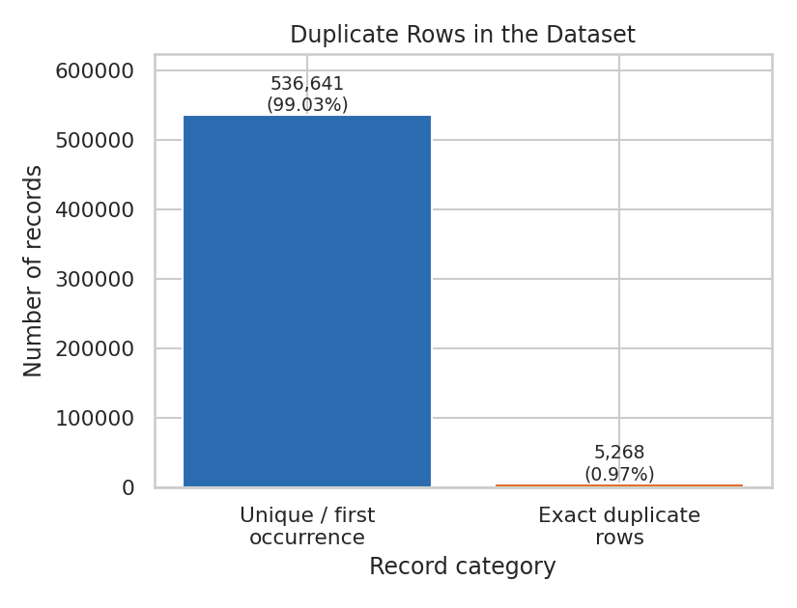
Figure 3: Exact duplicate rows versus unique/first-occurrence rows
Among the 5,268 duplicate rows, 37 are on cancelled invoices and 43 have no CustomerID. The duplicate rows that are valid customer sales carry a combined value of £24,199.01, which is 0.27% of the total valid customer revenue (£8,911,407.90).
Why duplicates matter for customer-level analysis: Duplicate rows inflate Quantity and TotalAmount, which in turn inflates a customer's Monetary Value and total quantity. If a duplicate belongs to a separate invoice line, it may also change order-level statistics. Duplicates are therefore checked before features are aggregated per customer.
Assumption (not verifiable from the data): Identical rows may be data-entry or system duplicates, but the same item could also legitimately be scanned twice on the same invoice. The file has no line-number column that would allow this to be confirmed. The proposed treatment is to remove exact duplicates in preprocessing; since their effect on total valid revenue is small, this decision is not expected to change the overall picture.

8. Transaction Analysis
The derived column TotalAmount = Quantity × UnitPrice was created after verifying that both columns exist. Unless stated otherwise, the distributions below use the 397,884 valid customer-sale rows defined in Section 5.2.

8.1 Transactions over time
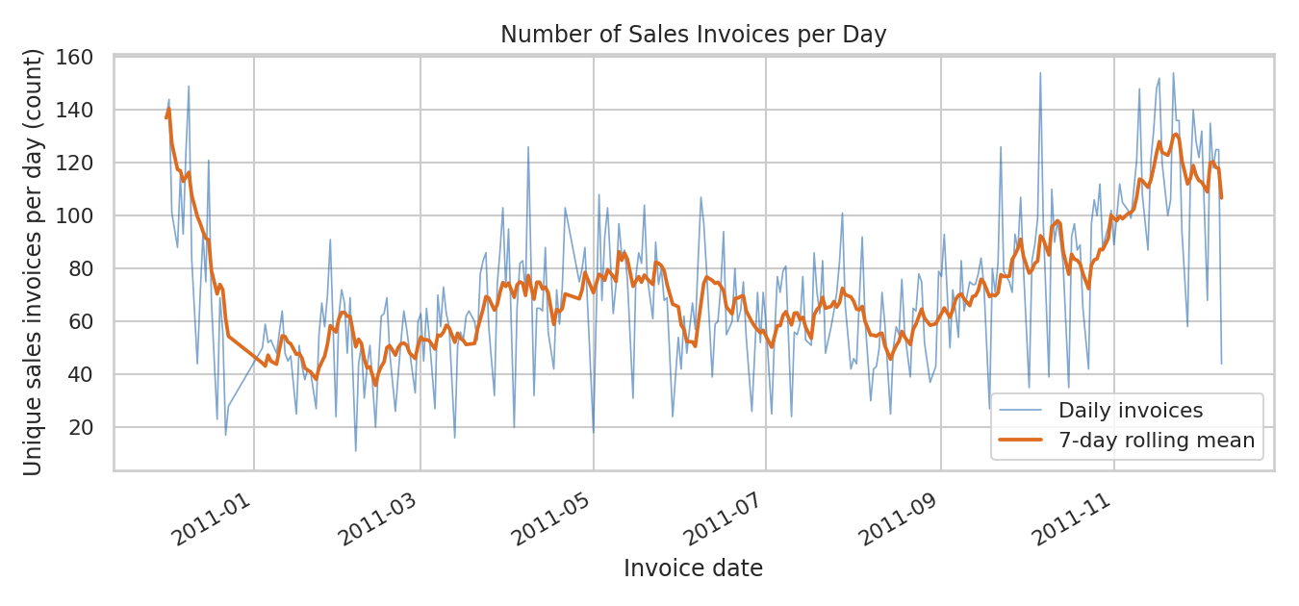
Figure 4: Number of unique sales invoices per day, with 7-day rolling mean
On the 305 days with sales, the average is 72.34 sales invoices per day, and the busiest day is 2011-10-06 with 154 invoices. Daily counts fluctuate strongly from day to day. The 7-day average is highest at the very start of the data (December 2010) and again in the final months (October to December 2011). No invoices are recorded on Saturdays; by invoice count, Thursday is the busiest recorded weekday (4,689 invoices) and Sunday has 2,207.

8.2 Monthly transaction volume and revenue
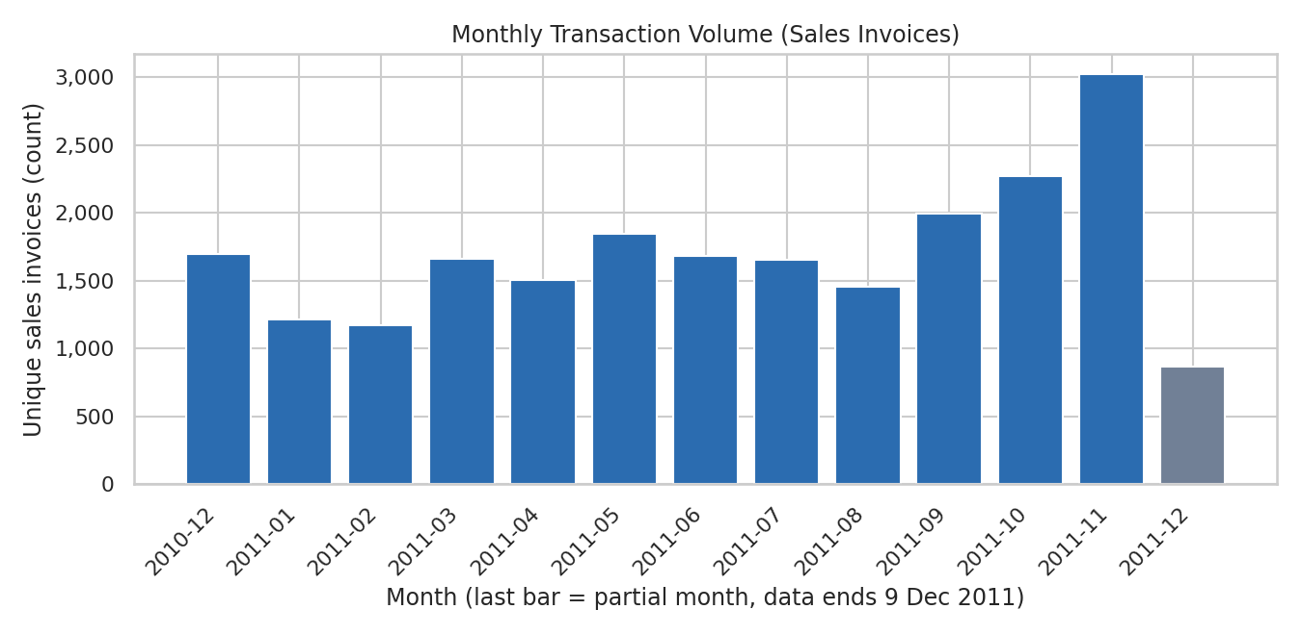
Figure 5: Monthly transaction volume (unique sales invoices per month)
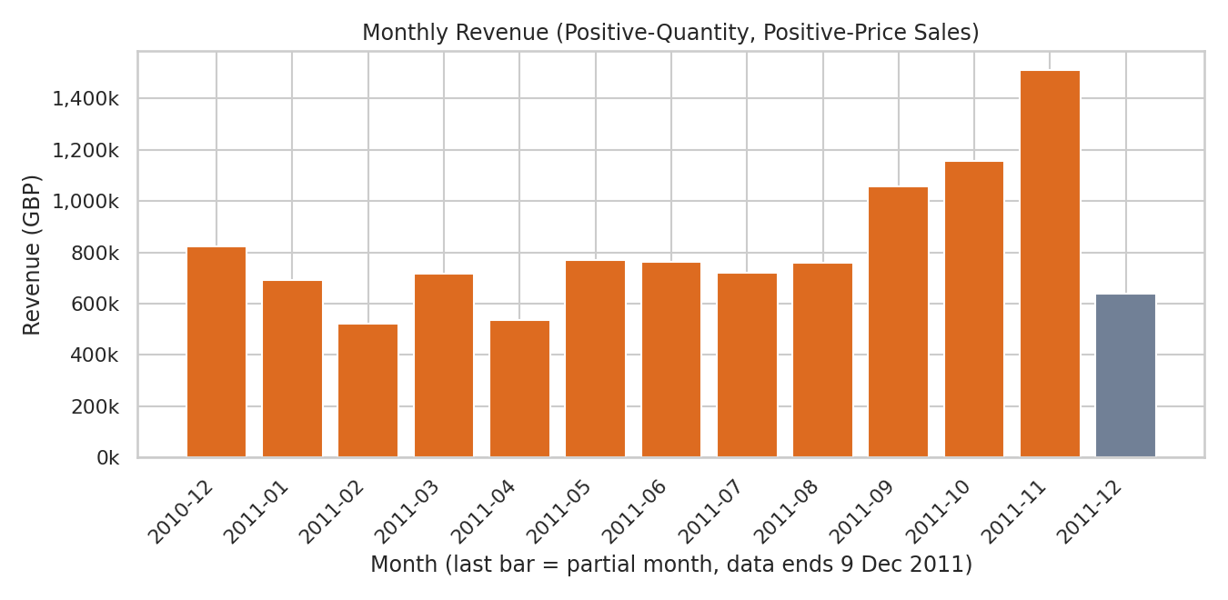
Figure 6: Monthly revenue from sales rows (Quantity > 0 and UnitPrice > 0)
Table 7: Monthly invoices, revenue and cancellations
Month | Sales invoices | Revenue (£) | Cancelled invoices | Cancelled share of invoices
2010-12 | 1,699 | 823,746.14 | 326 | 16.10%
2011-01 | 1,216 | 691,364.56 | 260 | 17.62%
2011-02 | 1,174 | 523,631.89 | 219 | 15.72%
2011-03 | 1,665 | 717,639.36 | 318 | 16.04%
2011-04 | 1,504 | 537,808.62 | 240 | 13.76%
2011-05 | 1,848 | 770,536.02 | 314 | 14.52%
2011-06 | 1,683 | 761,739.90 | 329 | 16.35%
2011-07 | 1,657 | 719,221.19 | 270 | 14.01%
2011-08 | 1,459 | 759,138.38 | 278 | 16.00%
2011-09 | 1,994 | 1,058,590.17 | 333 | 14.31%
2011-10 | 2,275 | 1,154,979.30 | 362 | 13.73%
2011-11 | 3,021 | 1,509,496.33 | 441 | 12.74%
2011-12 (partial) | 869 | 638,792.68 | 146 | 14.38%
Revenue in this table includes all rows with positive Quantity and UnitPrice, including rows with no CustomerID, and is measured before subtracting cancellations. "Cancelled share of invoices" = cancelled invoices ÷ (sales + cancelled invoices) for that month.
Observed patterns: The monthly revenue ranges from £523,631.89 (2011-02) to £1,509,496.33 (2011-11). The highest number of monthly invoices is also in 2011-11 (3,021). From September to November 2011, both invoice counts and revenue are clearly higher than in the preceding months (for example, invoices rise from 1,459 in August to 3,021 in November). The data span only one full annual cycle (plus the first days of a second December), so it is not possible to confirm from this dataset alone that the autumn increase is a repeating seasonal effect. December 2011 is incomplete and should not be compared directly with other months.

8.3 Distributions of Quantity, UnitPrice and TotalAmount
Table 8: Descriptive statistics of valid customer-sale rows
Statistic | Quantity (units) | UnitPrice (£) | TotalAmount (£)
Count | 397,884 | 397,884 | 397,884
Mean | 12.99 | 3.12 | 22.40
Standard deviation | 179.33 | 22.10 | 309.07
Minimum | 1.00 | 0.00 | 0.00
25th percentile | 2.00 | 1.25 | 4.68
Median | 6.00 | 1.95 | 11.80
75th percentile | 12.00 | 3.75 | 19.80
95th percentile | 36.00 | 8.50 | 67.50
99th percentile | 120.00 | 14.95 | 202.50
Maximum | 80,995.00 | 8,142.75 | 168,469.60
Skewness | 409.89 | 204.03 | 451.44

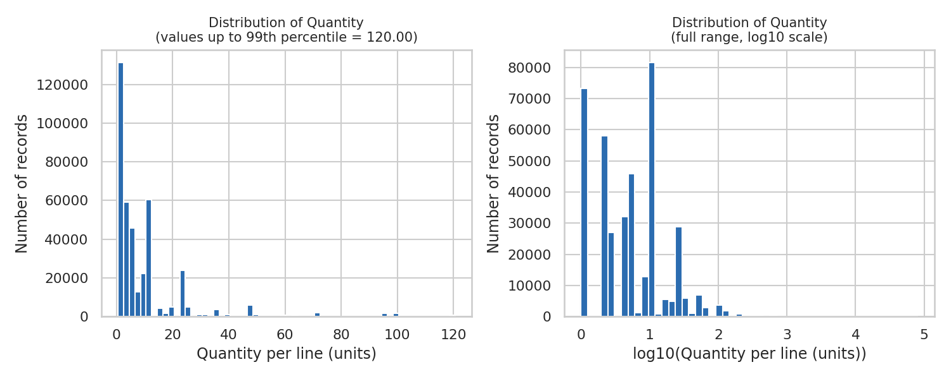
Figure 7: Distribution of Quantity per invoice line (left: up to 99th percentile; right: full range on log10 scale)
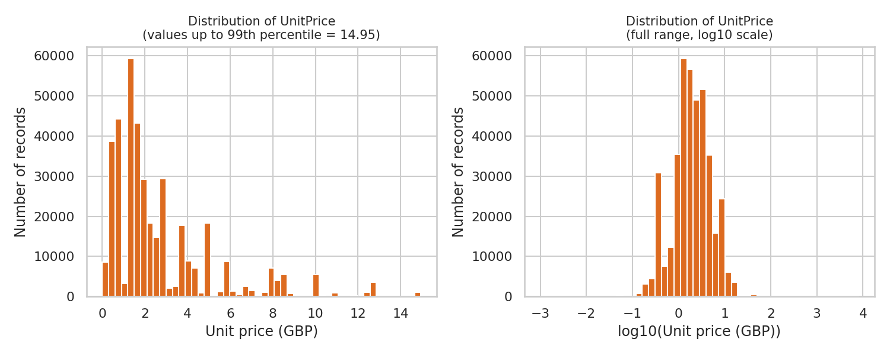
Figure 8: Distribution of UnitPrice (left: up to 99th percentile; right: full range on log10 scale)
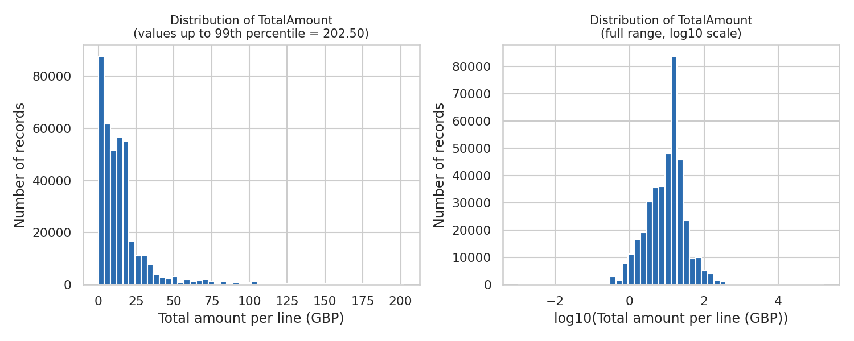
Figure 9: Distribution of TotalAmount per invoice line (left: up to 99th percentile; right: full range on log10 scale)
Observed patterns: All three variables are strongly right-skewed. The median Quantity is 6.00 units per line, but the maximum is 80,995; the median UnitPrice is £1.95 while the maximum is £8,142.75; the median TotalAmount is £11.80 while the maximum is £168,469.60. The 99th percentile is far below the maximum in all three cases (Quantity 120.00, UnitPrice £14.95, TotalAmount £202.50). Most lines therefore involve small quantities of low-priced items, and a small number of rows are extreme. On the log scale the distributions look approximately bell-shaped, which suggests that a logarithmic transformation is a suitable way to handle this skewness.

9. Cancelled Transaction Analysis
InvoiceNo was inspected first. Every InvoiceNo is either a plain number or begins with a letter: 9,288 rows begin with "C" and 3 rows begin with "A". The "C" invoices all have negative Quantity and a positive UnitPrice, which confirms that in this dataset a leading "C" marks a cancellation (a returned or cancelled order). The three "A" rows are the "Adjust bad debt" accounting entries mentioned in Section 5 and are not cancellations.
Table 9: Cancellation statistics
Measure | Value
Cancelled invoices (unique InvoiceNo starting with "C") | 3,836
Cancelled invoices as % of all unique invoices | 14.81% (of 25,900)
Rows on cancelled invoices | 9,288 (1.71% of all rows)
Cancelled quantity (units) | 277,574 units (4.97% of 5,588,376 units on positive-quantity, positive-price rows)
Cancelled value (Quantity × UnitPrice) | £896,812.49 (8.41% of £10,666,684.54 on positive-quantity, positive-price rows)
Cancelled rows with a CustomerID | 8,905 rows (1,589 distinct CustomerIDs)
Cancelled rows without a CustomerID | 383

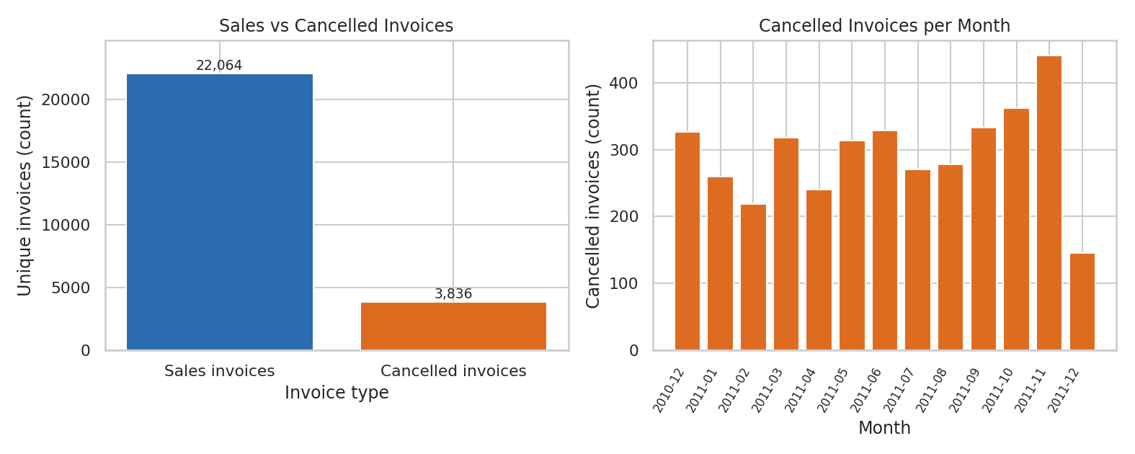
Figure 10: Sales versus cancelled invoices (left) and cancelled invoices per month (right)
Observation: About one in seven unique invoice numbers (14.81%) is a cancellation. Monthly cancelled invoices range between 219 and 441 (Table 6), with the highest count in November 2011, the same month with the highest sales volume; the cancelled share of invoices in each full month stays between 12.74% and 17.62%. Cancelled value is 8.41% of gross sales value.
Important limitation: The dataset does not contain a column linking a cancellation invoice to the original invoice it reverses. A cancellation therefore cannot always be matched to a specific sale, and a cancellation may be dated in a later month than the sale.
Why cancellations matter for CLV modelling: CLV is intended to represent the value a customer actually contributes. If cancelled orders are ignored, spending is overstated for customers who return goods; if cancellation rows are simply added as negative amounts, spending is reduced but the timing and frequency of purchases may be distorted. Section 10 shows a concrete example in which two customers appear among the top-10 by gross revenue mainly because of large orders that were cancelled. The treatment of cancellations must therefore be decided explicitly before the customer features and the target are built.

10. Customer Analysis
The file contains 4,372 unique CustomerIDs. After applying the valid-sale definition, 4,338 customers have at least one valid sale; the remaining 34 CustomerIDs occur only on cancelled or zero-price rows. Customer-level quantities were calculated for these 4,338 customers: number of orders (distinct valid invoices), total spending, average order value (total spending ÷ orders) and total quantity purchased.
Table 10: Customer-level descriptive statistics (4,338 customers)
Variable | Mean | Median | 25th pct | 75th pct | Maximum
Orders per customer | 4.27 | 2.00 | 1.00 | 5.00 | 209.00
Total spending (£) | 2,054.27 | 674.49 | 307.42 | 1,661.74 | 280,206.02
Average order value (£) | 419.17 | 293.90 | 178.63 | 430.11 | 84,236.25
Total quantity (units) | 1,191.29 | 379.00 | 160.00 | 992.75 | 196,915.00

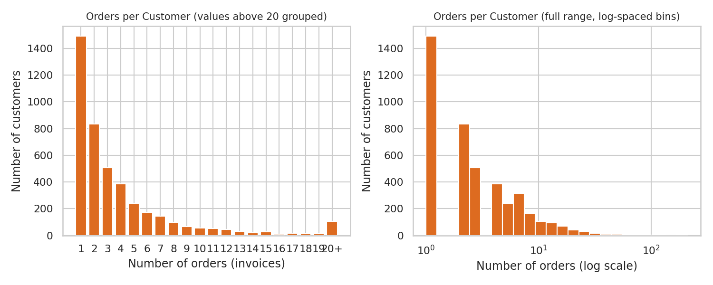
Figure 11: Distribution of the number of orders per customer
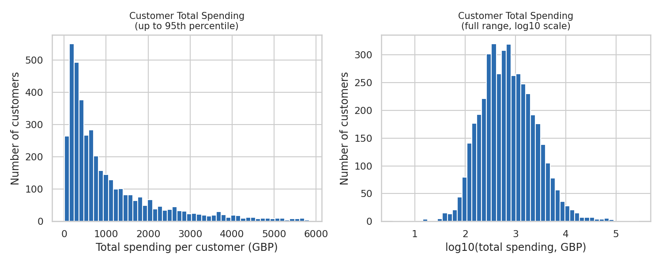
Figure 12: Distribution of total spending per customer
Observed patterns: The median customer placed 2 orders, while the maximum is 209. 1,493 customers (34.42%) placed only one order and the remaining 65.58% are repeat customers. Total spending is strongly right-skewed: the mean (£2,054.27) is about three times the median (£674.49).

10.1 Revenue concentration
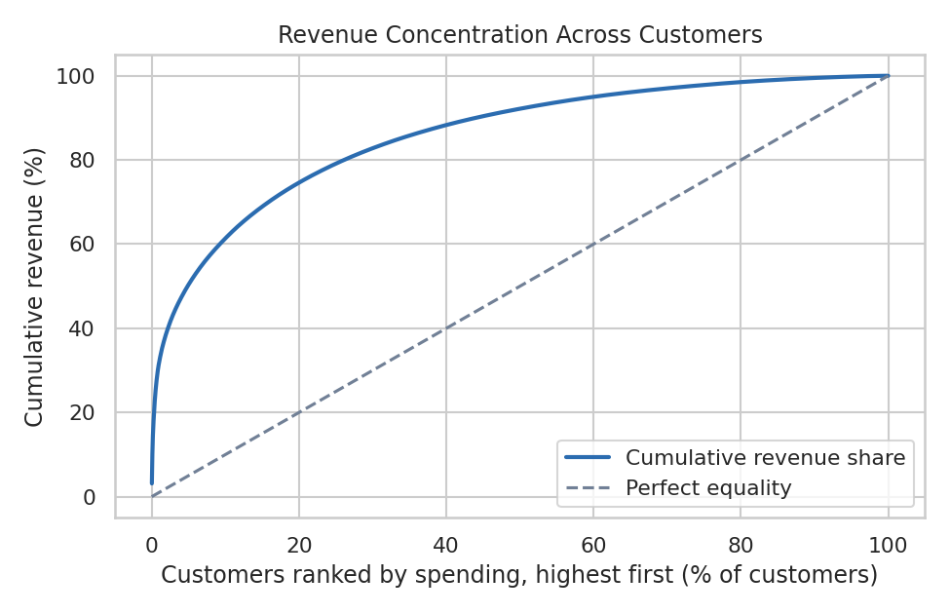
Figure 13: Cumulative share of revenue versus share of customers (ranked by spending)
Table 11: Revenue concentration (valid customer sales)
Customer group | Share of valid customer revenue
Top 1% of customers | 31.78%
Top 5% of customers | 50.38%
Top 10% of customers | 61.38%
Top 20% of customers | 74.62%
Bottom 50% of customers | 7.83%
Number of customers needed to reach 50% of revenue | 212 customers (4.89% of customers)

Observation: Revenue is concentrated in a subset of customers: the top 20% of customers account for 74.62% of valid customer revenue, whereas the bottom half together account for 7.83%.

10.2 Top customers
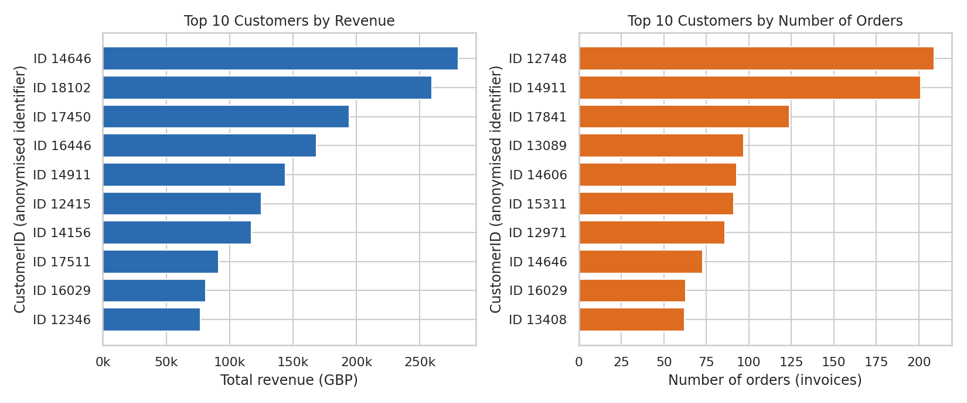
Figure 14: Top 10 customers by total revenue (left) and by number of orders (right)
CustomerID is used only as an anonymous numeric identifier; the dataset contains no names or contact details, and none are shown.
Case study: cancelled large orders. Two of the top-10 customers by gross revenue are notable. Customer 16446 (rank 4, £168,472.50) and customer 12346 (rank 10, £77,183.60) each have one very large order (Quantity 80,995 at £2.08 on 2011-12-09, and Quantity 74,215 at £1.04 on 2011-01-18, respectively). For both customers, a cancellation invoice for the identical quantity and price appears on the same day (C581484 and C541433). Customer 12346's entire recorded spending comes from that single cancelled order. These customers rank highly only when cancellations are ignored, which shows why gross revenue can be misleading for CLV.

11. RFM-Style Analysis
RFM analysis summarises a customer's purchase behaviour with three quantities. For this exploratory analysis the reference date was set to 2011-12-10, one day after the last invoice in the file, and the calculations use the valid customer sales of 4,338 customers.
- Recency: how recently the customer purchased, measured as the number of days between the customer's last valid purchase and the reference date. Smaller values mean more recent activity.
- Frequency: how often the customer purchased, measured as the number of distinct valid invoices.
- Monetary Value: how much the customer spent, measured as the sum of Quantity × UnitPrice over the customer's valid sales.
Table 12: RFM descriptive statistics
Measure | Mean | Median | 25th pct | 75th pct | 95th pct | Maximum
Recency (days) | 93.06 | 51.00 | 18.00 | 142.75 | 312.00 | 374.00
Frequency (orders) | 4.27 | 2.00 | 1.00 | 5.00 | 13.00 | 209.00
Monetary Value (£) | 2,054.27 | 674.49 | 307.42 | 1,661.74 | 5,841.84 | 280,206.02

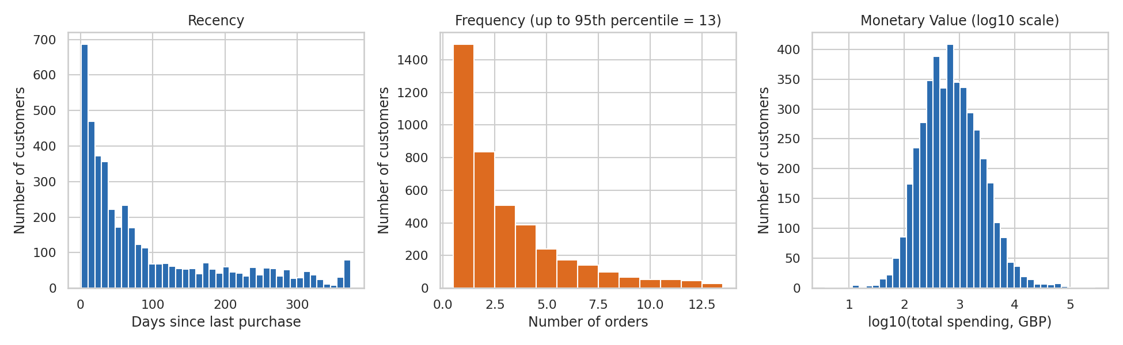
Figure 15: Distributions of Recency, Frequency and Monetary Value
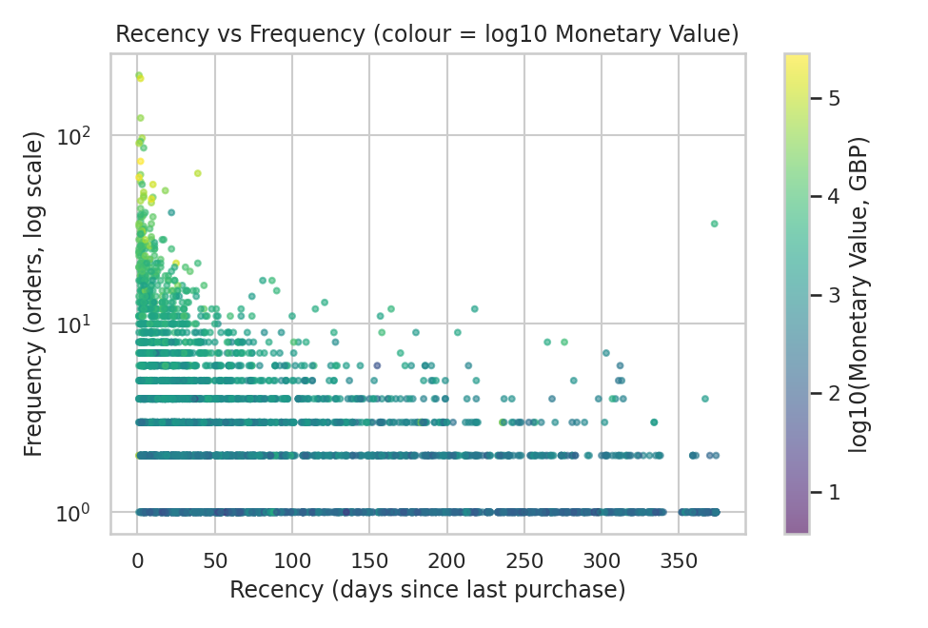
Figure 16: Recency versus Frequency for each customer (colour shows log10 Monetary Value)
Observed patterns: Recency is right-skewed: the median customer bought 51.00 days before the reference date, and the 25th percentile is 18.00 days, while the 95th percentile is 312.00 days, so there is also a long tail of customers who have not purchased for most of a year. Frequency is concentrated at low values (median 2.00), and Monetary Value is right-skewed and roughly bell-shaped on the log scale. In the scatter plot, customers with high frequency and high spending are concentrated at low recency values; this is a descriptive association only.
Why RFM-type features are useful for CLV prediction: Recency indicates whether a customer is still active, Frequency indicates how habitually the customer buys, and Monetary Value indicates the customer's spending level. Together they summarise past behaviour, which is the information from which future value is to be predicted. However, RFM analysis here is only an exploratory summary; it is not the final ML model. In the project, these quantities become input features for Elastic Net Regression.

12. Country Analysis
The Country column has 38 distinct values in the raw data (including "Unspecified", which appears in 446 rows). The figures below are computed from valid customer sales, which cover 37 countries. "Transactions" means distinct sales invoices, and revenue is the sum of TotalAmount.
Table 13: Top 10 countries by revenue (valid customer sales)
Country | Customers | Transactions (invoices) | Revenue (£)
United Kingdom | 3,920 | 16,646 | 7,308,391.55
Netherlands | 9 | 94 | 285,446.34
EIRE | 3 | 260 | 265,545.90
Germany | 94 | 457 | 228,867.14
France | 87 | 389 | 209,024.05
Australia | 9 | 57 | 138,521.31
Spain | 30 | 90 | 61,577.11
Switzerland | 21 | 51 | 56,443.95
Belgium | 25 | 98 | 41,196.34
Sweden | 8 | 36 | 38,378.33

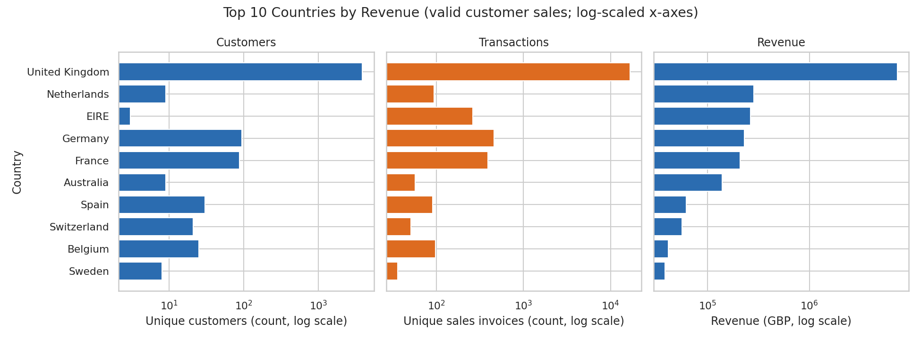
Figure 17: Customers, transactions and revenue for the top 10 countries by revenue (log-scaled axes)
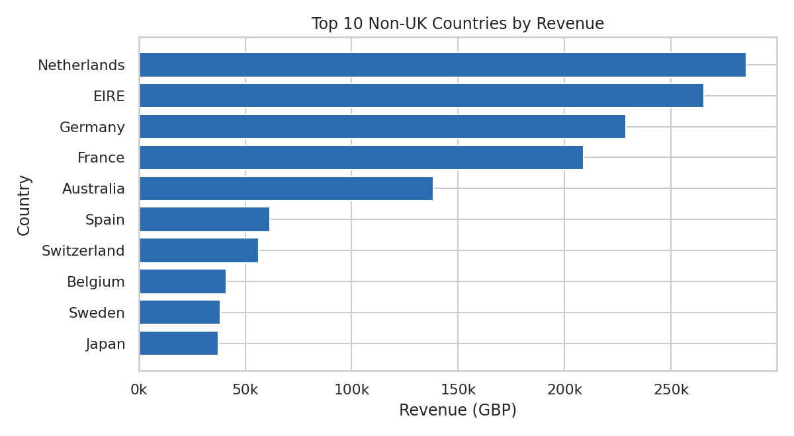
Figure 18: Top 10 non-UK countries by revenue
Observations: The United Kingdom accounts for 90.20% of customers, 89.82% of transactions and 82.01% of revenue, so the dataset is dominated by one country. The remaining 17.99% of revenue is spread across 36 other countries. Several countries have very few customers: 9 countries have only one customer. Some small countries generate large revenue relative to their number of customers (for example, the Netherlands has 9 customers and £285,446.34 revenue, and EIRE has 3 customers and £265,545.90), which means that country-level statistics for such countries are driven by only a handful of customers. 8 customers appear under more than one country.
Because so many countries have very few customers, using Country directly as a model input would create many sparse categories. A simpler grouping (for example UK versus non-UK) can be considered in the feature-engineering stage; this is a proposal and not an EDA result.

13. Correlation Analysis
Seven customer-level features were calculated for the 4,338 customers with valid sales: Recency, Frequency, MonetaryValue, AverageOrderValue, TotalQuantity, CustomerTenure (days from the customer's first valid purchase to the reference date 2011-12-10) and PurchaseFrequency (orders per month, calculated as Frequency divided by tenure in months, with tenure counted as at least one month). Their definitions are given in Section 15.
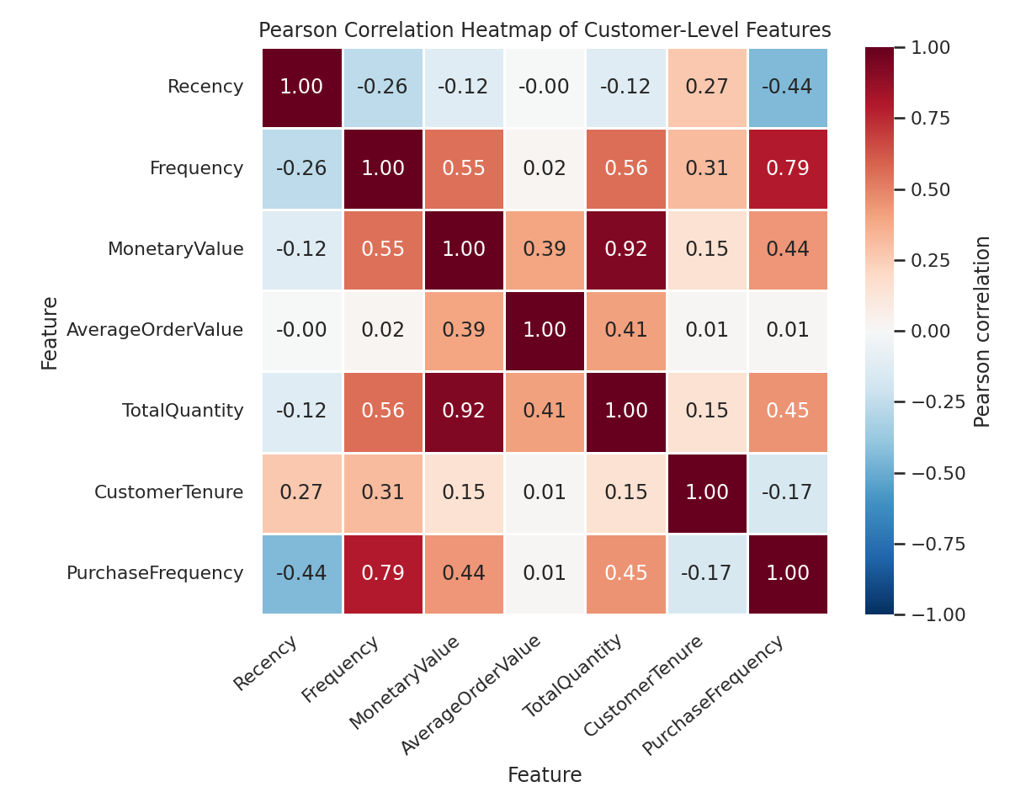
Figure 19: Pearson correlation heatmap of customer-level features
Table 14: Strongest feature pairs (ranked by absolute Pearson correlation)
Feature pair | Pearson | Spearman | Pearson after log(1+x)
MonetaryValue vs TotalQuantity | 0.92 | 0.93 | 0.92
Frequency vs PurchaseFrequency | 0.79 | 0.55 | 0.62
Frequency vs TotalQuantity | 0.56 | 0.76 | 0.75
Frequency vs MonetaryValue | 0.55 | 0.81 | 0.81
TotalQuantity vs PurchaseFrequency | 0.45 | 0.48 | 0.49
MonetaryValue vs PurchaseFrequency | 0.45 | 0.48 | 0.50
Recency vs PurchaseFrequency | -0.44 | -0.78 | -0.70
AverageOrderValue vs TotalQuantity | 0.41 | 0.62 | 0.64
MonetaryValue vs AverageOrderValue | 0.39 | 0.68 | 0.71

13.1 Positive correlations
The strongest positive Pearson correlation is between MonetaryValue and TotalQuantity (0.92), which is expected because customers who buy more units spend more. Frequency is positively correlated with PurchaseFrequency (0.79), TotalQuantity (0.56) and MonetaryValue (0.55). MonetaryValue also has a moderate positive correlation with AverageOrderValue (0.39). Rank-based (Spearman) and log-transformed correlations are generally higher than the raw Pearson values; for example, Frequency versus MonetaryValue is 0.55 (Pearson) but 0.81 (Spearman) and 0.81 (after log(1+x)). This indicates that the raw Pearson values are reduced by the extreme values and the skewness described earlier.

13.2 Negative correlations
Recency is negatively correlated with PurchaseFrequency (-0.44 Pearson; -0.78 Spearman) and with Frequency (-0.26 Pearson; -0.56 Spearman). Because a small Recency value means a recent purchase, this says that customers who bought recently tend to have ordered more often. CustomerTenure is weakly negatively correlated with PurchaseFrequency (-0.17), partly by construction, since tenure appears in the denominator of PurchaseFrequency. AverageOrderValue is almost uncorrelated with Recency (-0.00) and with Frequency (0.02).

13.3 Potential multicollinearity
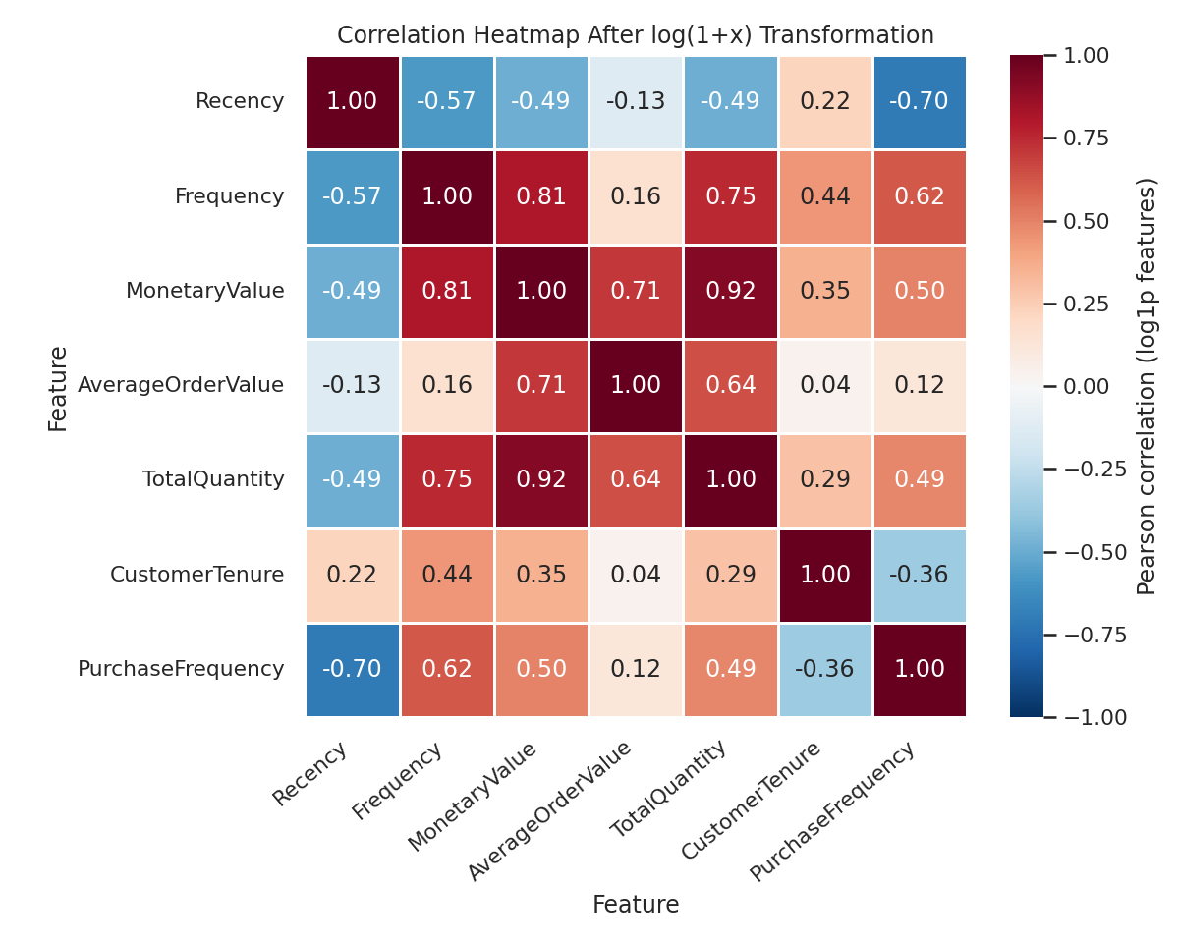
Figure 20: Correlation heatmap after log(1+x) transformation of the features
Table 15: Variance Inflation Factors (standardised log(1+x) features)
Feature | VIF
Recency | 2.76
Frequency | 116.25
MonetaryValue | 207.07
AverageOrderValue | 70.61
TotalQuantity | 6.76
CustomerTenure | 8.87
PurchaseFrequency | 10.02

After the log transformation, several correlations are large (for example MonetaryValue with Frequency 0.81, and with TotalQuantity 0.92), and the Variance Inflation Factors of MonetaryValue (207.07), Frequency (116.25) and AverageOrderValue (70.61) are very high. A VIF above roughly 5-10 is commonly taken as a sign of serious multicollinearity. This is partly built into the feature definitions: AverageOrderValue is defined as MonetaryValue divided by Frequency, and PurchaseFrequency is derived from Frequency and CustomerTenure, so some features are mathematical functions of others.
Connection to Elastic Net Regression: Ordinary least-squares regression becomes unstable when predictors are highly correlated, because coefficient estimates can change greatly with small changes in the data. Elastic Net combines an L1 penalty (which can shrink some coefficients exactly to zero and so perform feature selection) with an L2 penalty (which stabilises coefficients of correlated predictors and tends to keep groups of correlated features together). In scikit-learn the objective is: (1 / 2n) ‖y − Xw‖² + α · l1_ratio · ‖w‖₁ + ½ · α · (1 − l1_ratio) · ‖w‖₂². The multicollinearity observed here is therefore one of the reasons for choosing Elastic Net. Because the penalty depends on coefficient size, the features must also be standardised before fitting.
Caution: Correlation measures association, not causation. In addition, these correlations were calculated between features computed over the full period; they are not correlations with the future CLV target, which has not yet been defined at this stage (Section 16).

14. Outlier Analysis
Potential outliers were examined with boxplots (drawn with logarithmic axes because of the extreme right skew) and with the standard interquartile-range (IQR) rule, which flags values above Q3 + 1.5 × IQR. Quantity, UnitPrice and TotalAmount are analysed at row level (valid customer sales); MonetaryValue and Frequency are analysed at customer level.
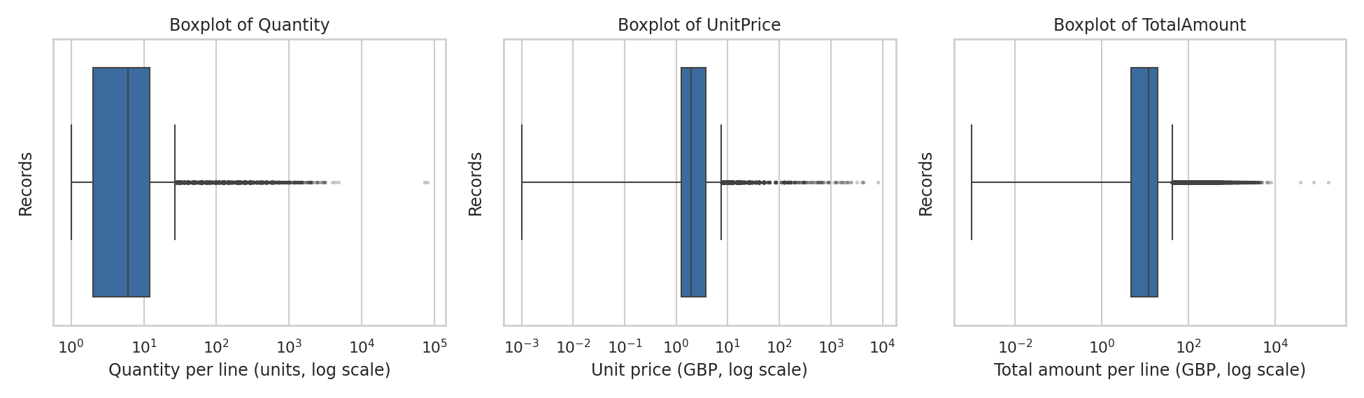
Figure 21: Boxplots of Quantity, UnitPrice and TotalAmount (valid customer sales, log-scaled x-axes)
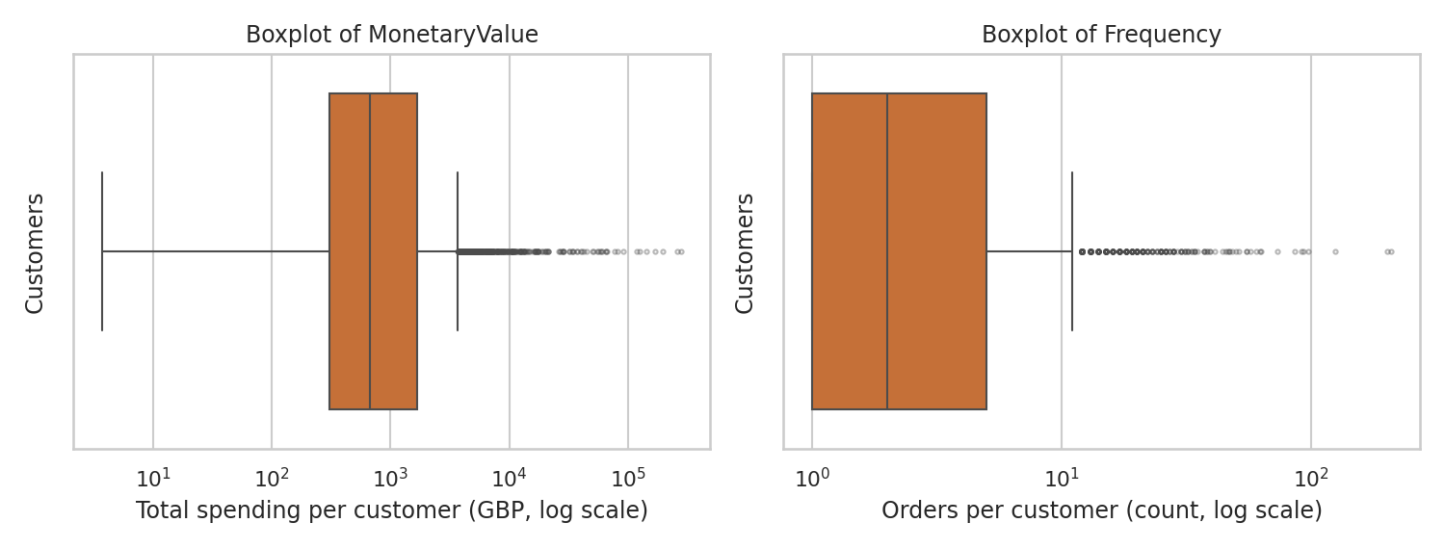
Figure 22: Boxplots of customer-level MonetaryValue and Frequency (log-scaled x-axes)
Table 16: IQR-based outlier summary
Variable | Points above upper fence | % of observations | Upper fence | Maximum
Quantity (units) | 25,647 | 6.45% | 27.00 | 80,995.00
UnitPrice (£) | 34,356 | 8.63% | 7.50 | 8,142.75
TotalAmount (£) | 31,241 | 7.85% | 42.48 | 168,469.60
MonetaryValue (£, customers) | 427 | 9.84% | 3,693.23 | 280,206.02
Frequency (orders, customers) | 285 | 6.57% | 11.00 | 209.00

Observation: The IQR rule flags 6.45% to 9.84% of observations in these variables, so "statistically unusual" does not automatically mean "erroneous". The extreme values are, however, much larger than the fence values: the maximum Quantity is 80,995 against an upper fence of 27.00.

14.1 Erroneous or non-customer records versus legitimate high-value customers
- Very large quantities: Only 3 non-cancelled rows have Quantity above 10,000. Two of them (Quantity 74,215 and 80,995) were cancelled by matching cancellation invoices on the same day (Section 10.2); these are likely order errors or reversed orders, and they are the largest values of TotalAmount in the data. The third (Quantity 12,540) has UnitPrice = 0.
- Very high unit prices: 54 non-cancelled rows have UnitPrice above £1,000. All of them use non-product stock codes (DOT = 28, M = 23, and one each of AMAZONFEE, POST and B). The largest UnitPrice among valid sales (£8,142.75) is a POSTAGE row. These are charges and manual entries, not merchandise prices.
- Non-product rows inside valid sales: 1,414 valid-sale rows use non-product codes (POST 1,099, M 284, DOT 16, BANK CHARGES 12, PADS 3); their value is £143,655.25, or 1.61% of valid customer revenue.
- High-value, high-frequency customers: In contrast, customers such as 14646 (73 orders, £280,206.02), 18102 (60 orders, £259,657.30) and 14911 (201 orders, £143,825.06) accumulated their spending over many separate orders. Based on the order history alone these look like legitimate large buyers, and 16 customers have 50 or more orders. Such customers are precisely the ones whose future value is most important to predict.
Effect on CLV prediction: A regression model that minimises squared error is sensitive to extreme values. A single erroneous transaction such as a cancelled 80,995-unit order can dominate a customer's Monetary Value, distort the mean and standard deviation used for scaling, and pull the fitted coefficients towards fitting that one record. At the same time, deleting all statistically unusual customers would remove genuine high-value customers and bias the model against predicting large CLV. The proposed approach is therefore selective: correct or exclude records that are demonstrably errors or non-customer entries (cancelled-and-reversed orders, non-product codes), keep legitimate high-value customers, and reduce the influence of remaining skew with a transformation such as log(1+x) and/or robust scaling.

15. Feature Engineering Preview
The following customer-level features were computed in this EDA to study their distributions and relationships. In the final pipeline they will be computed only from transactions in the historical feature window (Section 16), with the reference date set to the end of that window.
Table 17: Customer-level features
Feature | Definition | Why it may be useful for CLV prediction
Recency | Days from the customer's last valid purchase to the reference date. | Customers who purchased recently are more likely to still be active; long inactivity may signal churn.
Frequency | Number of distinct valid invoices placed by the customer. | Indicates purchase habit; repeat buyers are expected to keep purchasing more often than one-time buyers.
MonetaryValue | Sum of Quantity × UnitPrice over the customer's valid sales. | Measures past spending level, which is a natural indicator of future spending.
AverageOrderValue | MonetaryValue ÷ Frequency. | Separates customers who spend a lot per order from those who order often but in small amounts.
TotalQuantity | Sum of Quantity over the customer's valid sales. | Captures purchase volume, which may differ from spending when product prices vary.
CustomerTenure | Days from the customer's first valid purchase to the reference date. | Measures how long the customer has been active; longer relationships give more evidence about behaviour.
PurchaseFrequency | Frequency ÷ tenure in months (tenure counted as at least one month), i.e. orders per month. | Normalises the number of orders by the time available, so customers with different tenures can be compared.

Some of these features are derived from one another (Section 13.3). This is acceptable for Elastic Net Regression, whose penalty is designed for correlated predictors, but the retained set will be finalised during model development.

16. Future CLV Target Methodology
The planned target variable is Future_CLV: the revenue generated by a customer during a future observation period. The model is intended to learn the relationship between historical behaviour and later revenue, as shown in the pipeline below.
Historical Transactions
↓
Customer Features
↓
Elastic Net Regression
↓
Future Customer Revenue
↓
Future CLV Prediction

16.1 Avoiding target leakage
Target leakage occurs when information that would not be available at prediction time is used to build the input features, or when the target is calculated from the same transactions as the features. If Future_CLV were calculated from the same transactions used for Recency, Frequency and MonetaryValue, the model would appear accurate but would only be reproducing its own inputs, and it would fail on genuinely unseen future data. For example, MonetaryValue is by definition strongly related to total historical spending; using total spending as the "target" would be misleading.
To reduce this risk, the final modelling pipeline will use a chronological split:
- Feature (historical) window: transactions up to a chosen cut-off date are used only to compute customer features.
- Target (future) window: transactions after the cut-off date are used only to compute Future_CLV (net future revenue of each customer).
- No overlap: no transaction appears in both windows, and the model is evaluated on customers not used for training.

16.2 Feasibility check with the actual data
As a feasibility illustration only (not the final design), a cut-off date of 2011-09-01 was tested. Only valid customer sales were counted.
Table 18: Customers before and after an example cut-off date (2011-09-01)
Group | Number of customers
Customers with a valid purchase before the cut-off (feature window) | 3,317
Customers with a valid purchase on or after the cut-off (target window) | 2,973
Customers present in both windows | 1,952
Customers only in the feature window (would have future revenue of 0) | 1,365
Customers only in the target window (new customers, no history; cannot be predicted) | 1,021

The data therefore allow a chronological design: 3,317 customers have history before the cut-off, of whom 1,952 purchased again afterwards and 1,365 did not. Customers who do not purchase in the future window should be assigned Future_CLV = 0 rather than being dropped, otherwise the model would learn only from customers who returned. Customers who appear for the first time in the target window have no history and are outside the scope of a feature-based prediction. The target window is short (data end on 2011-12-09), and the length of both windows and the cut-off date are design choices that will be finalised in the modelling stage. Since revenue is highly skewed (Section 10), a log transformation of the target can also be considered; this is a proposal, not an EDA finding.

17. Key EDA Findings
Each finding below is supported by the analysis in the indicated section.
- The dataset contains 541,909 rows and 8 columns, covering 2010-12-01 to 2011-12-09, with 4,372 customers, 25,900 invoices, 4,070 products and 38 countries (Section 3).
- 24.93% of records (135,080 rows) have no CustomerID, and 0.27% have no Description; no other column has missing values (Section 6).
- 5,268 rows (0.97%) are exact duplicates of earlier rows (Section 7).
- 3,836 of 25,900 invoices (14.81%) are cancellations (InvoiceNo starting with "C"), representing 277,574 units and £896,812.49 (8.41% of gross sales value) (Section 9).
- 1,336 additional negative-quantity rows are not cancellations; all have zero price and no CustomerID. 2,515 rows have UnitPrice = 0 and 2 rows have negative UnitPrice ("Adjust bad debt") (Section 5).
- Only 397,884 rows (73.42%) satisfy the valid-sale definition (CustomerID present, not cancelled, Quantity > 0, UnitPrice > 0) (Section 5.2).
- Quantity, UnitPrice and TotalAmount are extremely right-skewed (skewness 409.89, 204.03 and 451.44); the medians are 6.00 units, £1.95 and £11.80, while the maxima are 80,995 units, £8,142.75 and £168,469.60 (Section 8).
- Monthly sales invoices and revenue are highest in November 2011 (3,021 invoices; £1,509,496.33); December 2011 is a partial month (Section 8).
- Revenue is concentrated: the top 20% of customers generate 74.62% of valid customer revenue and the bottom 50% only 7.83% (Section 10).
- 34.42% of customers placed only one order; the median customer placed 2 orders and spent £674.49 (Sections 10-11).
- Two of the top-10 customers by gross revenue (IDs 16446 and 12346) owe their ranking to very large orders that were cancelled on the same day (Section 10.2).
- The United Kingdom accounts for 90.20% of customers and 82.01% of revenue (Section 12).
- Customer-level features are strongly correlated: MonetaryValue with TotalQuantity 0.92 (Pearson), Frequency with PurchaseFrequency 0.79; VIFs on log-transformed features are above 100 for Frequency and MonetaryValue (Section 13).
- Extreme UnitPrice values (> £1,000) all come from non-product stock codes such as DOT, M and POST (Section 14).

18. Implications for Machine Learning
The table below links each EDA finding to a planned preprocessing decision and to its relevance for Elastic Net Regression. These are proposals based on the evidence in this report and will be confirmed during model development.
Table 19: Implications of EDA findings for the ML pipeline
Topic | EDA evidence | Planned handling | Relevance to Elastic Net
Missing-value handling | 24.93% of rows lack CustomerID; 0.27% lack Description. | Remove rows without CustomerID before customer aggregation; do not impute identifiers. | The model needs one complete numeric row per customer; missing values cannot be handled by the algorithm.
Cancellation handling | 14.81% of invoices are cancellations; two top-10 "customers" arise from cancelled orders. | Do not count cancelled orders as purchases; consider net revenue (sales minus cancellations) for Monetary Value and the target. | Overstated spending would bias features and target, and the linear coefficients would be fitted to inflated values.
Invalid transaction removal | Zero-price rows (2,515), negative-price adjustment rows (2), stock adjustments and non-product codes (POST, M, DOT, etc.). | Remove rows with UnitPrice ≤ 0; review and probably exclude non-product codes; remove exact duplicates. | Erroneous rows create artificial extreme values that strongly affect squared-error fitting.
Feature scaling | Features are on very different scales (Recency median 51.00 days; MonetaryValue median £674.49) and heavily skewed. | Apply log(1+x) transformation to skewed features, then standardise (fit scaler on training data only). | The L1/L2 penalty depends on coefficient size, so unscaled features would be penalised unequally.
Outlier considerations | Max Quantity 80,995; max MonetaryValue £280,206.02; only some extremes are errors. | Remove demonstrable errors; keep legitimate high-value customers; use transformation or robust scaling. | Squared-error loss is sensitive to outliers; the penalty limits coefficient size but does not remove outlier influence.
Feature engineering | Transaction rows must be converted into one row per customer. | Build the seven features in Section 15 from the historical window only. | Elastic Net is a linear model and requires an informative numeric feature table.
Multicollinearity | High correlations and VIFs (Frequency 116.25, MonetaryValue 207.07). | Keep correlated features; let Elastic Net regularisation manage them; tune alpha and l1_ratio by cross-validation. | L2 part stabilises correlated coefficients; L1 part can select among them.
Target leakage prevention | Data span 373 days; a chronological split is feasible (Section 16.2). | Compute features from a historical window and Future_CLV from a later window; use time-aware validation. | Prevents overly optimistic evaluation of the regression model.

19. Conclusion
This EDA examined the UCI Online Retail dataset of 541,909 transaction rows. The analysis showed that the dataset needs careful preparation before modelling: about a quarter of the rows have no CustomerID, 14.81% of invoices are cancellations, and there are duplicate rows, zero-price entries and non-product codes. The transaction variables and the customer-level totals are heavily right-skewed, revenue is concentrated in a subset of customers, and a small number of extreme records (several of them cancelled orders or non-product charges) can strongly affect summary statistics.
Transaction-level records can be transformed into customer-level information by aggregating the valid sales of each customer into Recency, Frequency, MonetaryValue, AverageOrderValue, TotalQuantity, CustomerTenure and PurchaseFrequency for 4,338 customers. These features describe how recently, how often and how much customers purchased, which is the behavioural information on which CLV prediction is based. Several of them are strongly correlated with one another, which supports the use of a regularised model such as Elastic Net Regression.
Proper preprocessing (handling missing identifiers, cancellations, invalid rows and skewed values) and target-leakage prevention through a chronological feature/target split are essential; without them, a model could learn from erroneous records or from information that is not available at prediction time, and its results would be unreliable. The EDA has therefore prepared the dataset for the next stage of the project, in which the features will be built from a historical window, Future_CLV will be computed from a later period, and Elastic Net Regression will be trained and evaluated. No model has been trained at this stage, so no claim about model performance is made in this report.

20. References
[1] UCI Machine Learning Repository. Online Retail dataset. University of California, Irvine. https://archive.ics.uci.edu/dataset/352/online+retail (dataset source; please copy the exact donor citation and access date from this page).
[2] Zou, H. and Hastie, T. (2005). Regularization and variable selection via the elastic net. Journal of the Royal Statistical Society: Series B, 67(2), 301-320.
[3] Pedregosa, F. et al. (2011). Scikit-learn: Machine Learning in Python. Journal of Machine Learning Research, 12, 2825-2830.
All statistics, tables and charts in this report were produced from the supplied file Online Retail.xlsx with the accompanying Python script (eda_analysis.py).

