A BRIEF HISTORY OF  VIYELLA |  | VIYELLA IS THE FIRST BRANDED FABRIC IN THE WORLD.
 | ⬤  ┃  ┃  ┃  ┃ | 1784  William Hollins starts the business in Pleasley Derbyshire.
1894  The brand name is registered as a trademark. | ⬤  ┃  ┃  ┃  ┃
 | ⬤  ┃  ┃  ┃ | 1907  The trademark is registered in the USA.
1963―1969ˣ  Penitents in magdalene facilities produce Viyella fabric.  ˣNot bounded by these years. | ⬤  ┃  ┃  ┃  ┃  ┃  ┃
 | ⬤  ┃  ┃  ┃  ┃ | 2010  Irish Human Rights Commission recommends inquiry and redress.
2011  JFM recognizes inaction on part of the Irish government. | ⬤  ┃  ┃  ┃  ┃
 | ⬤ | 2024  Morrison McConnell celebrate 240 years of Viyella.

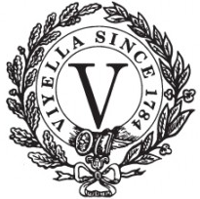
VIYELLA IS A Morrison McConnell BRAND.

