Running a map reduce java jar on EMR Cluster. This should same steps when python script running except below two steps in change.

Step 1) add the jar file to s3 directory under coursework/job

Select the Step Type => Custom JAR
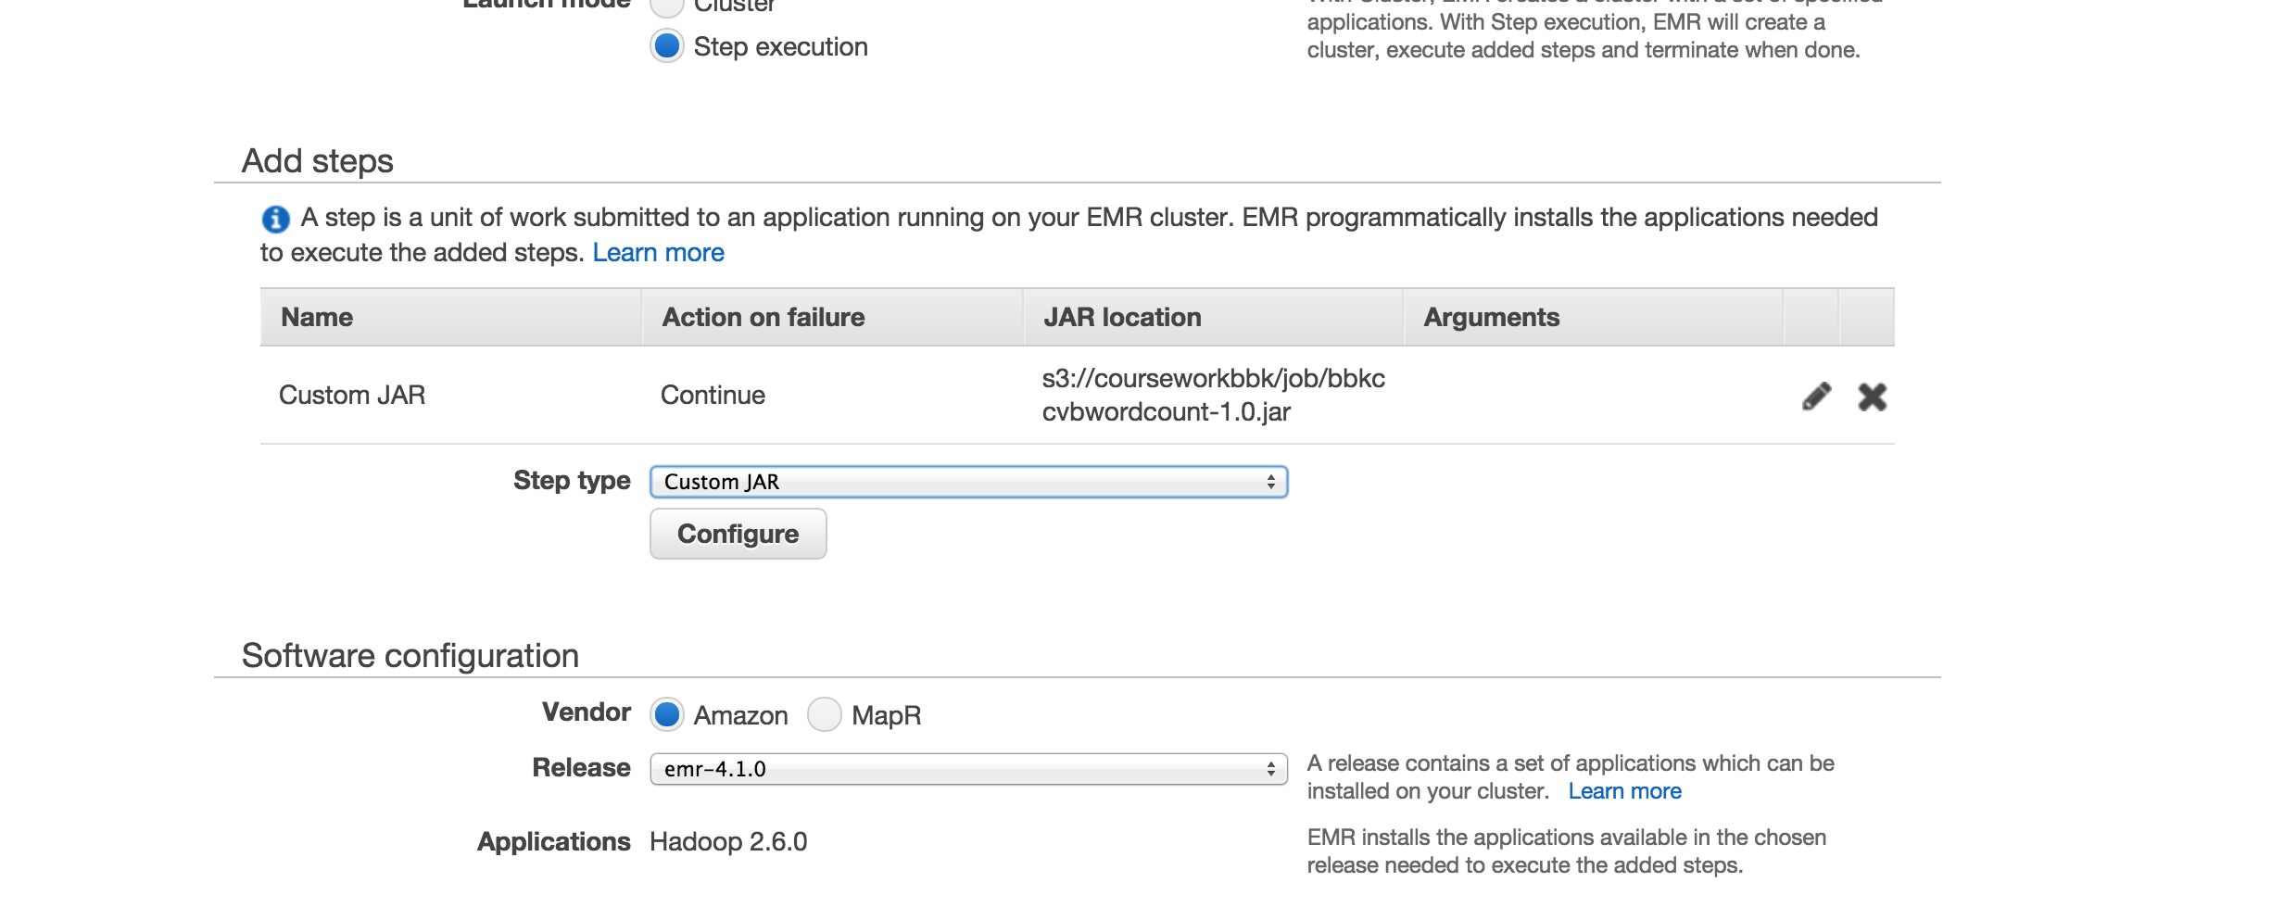

Step 2) Click on Configure

select the JAR location, where it is uploaded on s3, for example => coursework/job

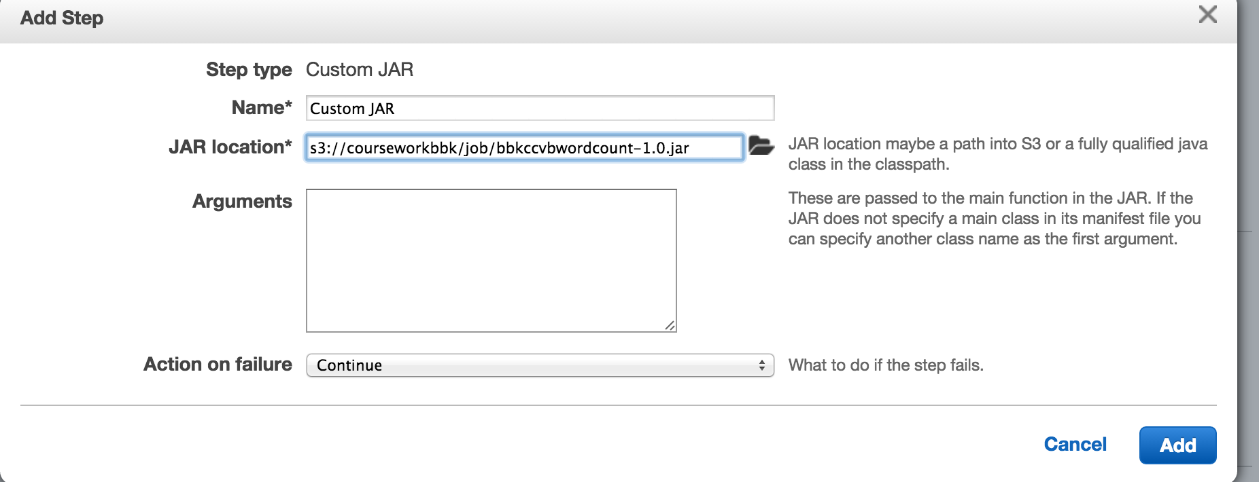
click Add.

And then submit the job.

The input and output already set up with this job as following:
input => s3://courseworkbbk/input
output => s3://courseworkbbk/output/wcjava2"
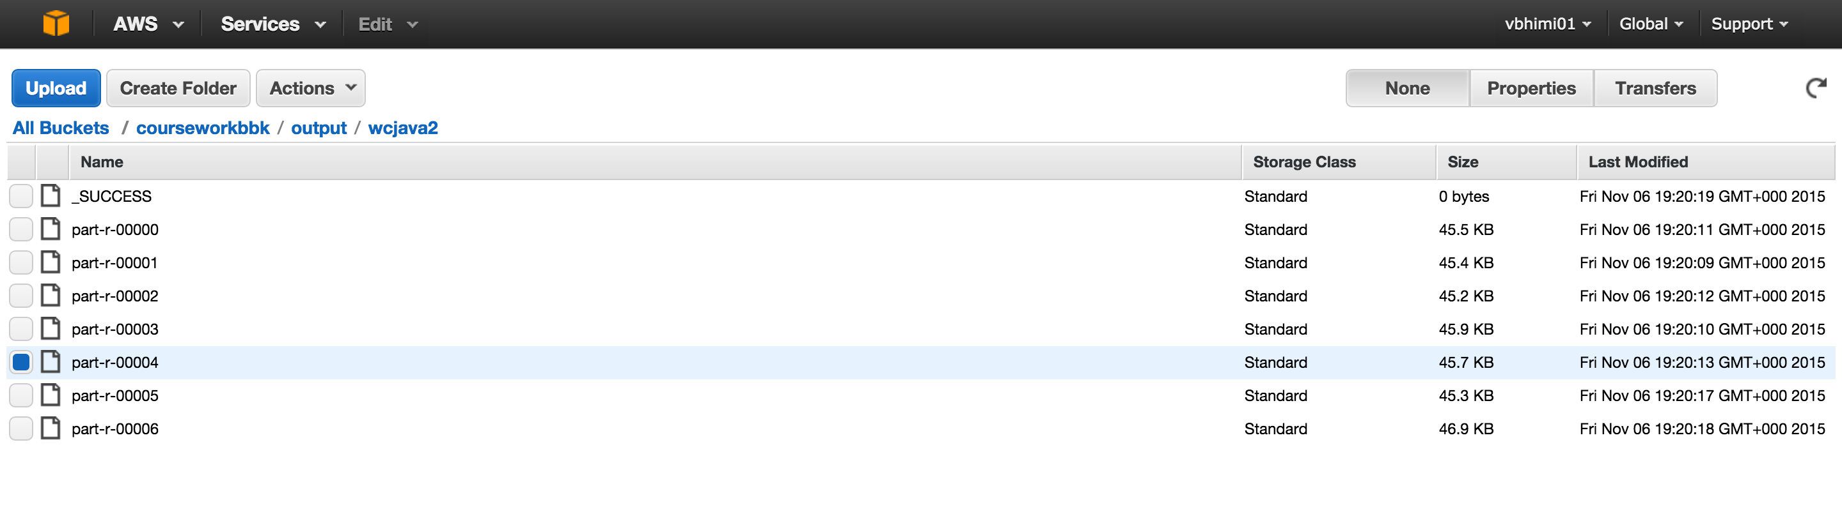
And also, if the output folder exists already, the program will delete the output folder and recreate it with fresh results.The output will be generated the files in out put directory.

