To
Amma and Appa
BIOGRAPHY
Santthosh Babu Selvadurai was born on 31st of December 1981 in Salem, Tamil Nadu, India. He received his Bachelor of Engineering (B.E) Degree in Electrical and Electronics Engineering from Coimbatore Institute of Technology, Coimbatore (TN), India in 2003. After his undergraduate studies he joined Computer Sciences Corporation (CSC) as a Programmer Analyst where he was working on Enterprise Computing Systems especially IBM z/OS for about 3 years. Santthosh has been a graduate student at North Carolina State University, Raleigh, NC since August 2006. During this time he worked under the guidance of Dr. Gregory T. Byrd in field of grid computing and web services. Santthosh served a 3 month internship term with EMC Corporation at RTP, Raleigh, NC during summer 2007 where he was involved with the implementation of a distributed information infrastructure for one of their products. He has also been a Teaching Assistant for Computer Systems Programming (ECE209) course during fall 2007 semester at NC State University.
ACKNOWLEDGMENTS
First, I would like to thank my parents for everything they gave me in life. My mother Vimala and father Selvadurai have been a constant source of inspiration nurturing my ideas and supporting my decisions all the way to my graduate studies in spite of several financial and social difficulties.
I sincerely thank my advisor Dr. Gregory T. Byrd for giving me an opportunity to work under his guidance. He has been a constant source of inspiration, encouraging me to achieve more in every walk of my graduate studies. I have learned several incredible things from him including joyful positive attitude towards work and perfection at doing things. I thank him for his trust, continuous support and for all of his time. Working under him has been a very rewarding experience.
I would like to thank Dr. Munindar P. Singh for developing my knowledge on web services, introducing to me the emerging world of service oriented computing and also for serving on my thesis committee.
I would like to thank Dr. Yan Solihin for inspiring and fostering my knowledge on parallel computing architectures, for his constructive comments and for serving on my thesis committee.
Finally, I thank the almighty for all the grace and support to achieve my goals.
TABLE OF CONTENTS
LIST OF FIGURES vii
LIST OF TABLES viii
INTRODUCTION 1
METASEARCH ENGINES 5
2.1 Information Retrieval Systems (IRS) 5
2.1.1 Information Systems 5
2.1.2 Approaches to information retrieval 5

2.2 Search and retrieval 5
2.2.1 Searching process 5
2.2.2 Retrieval models 5
2.2.3 User-centered information search models 5

2.3 Metasearch Engines 5
2.3.1 Goals and motivation 5
2.3.2 Component Architecture 5
2.3.3 Heterogeneity 5

RANK AGGREGATION & RESULT MERGING 6
3.1 Foundations 6
3.1.1 Similarity Functions 6
3.2 Merging Algorithms 6
3.2.1 Top Document search engine score (TopD) 6
3.2.2 Top SRR based search engine score (TopSRR) 6
3.2.3 Simple Similarity rank between SRR and query (SRRSim) 6
3.2.4 Compound similarity rank between SRR and Query (SRRSimMF) 6

3.3 Content Direction 6
3.3.1 Motivation 6
3.3.2 Content Directed Result merging algorithm (CDRM) 6
3.3.3 Use Cases 6

ARCHITECTURAL FRAMEWORK 7
4.1 Requirements 7
4.2 Design 7
4.3 Components 7
4.3.1 Query Segregator 7
4.3.2 Query Scheduler 7
4.3.3 Result Aggregator 7
4.3.4 Search Provider 7

4.4 Data 7
4.4.1 Artifact 7
4.4.2 Content direction 7

IMPLEMENTATION 8
5.1 Implementation Infrastructure 8
5.2 Framework 8
5.2.1 Configuration 8
5.2.2 Artifact Segregation 8
5.2.3 Metasearch Scheduling 8
5.2.4 Result Aggregation 8
5.2.5 Search Provider support 8
5.2.6 Content direction support 8

5.3 Metasearch Prototype 8
5.3.1 User Interaction Model 8
5.3.2 Features 8

EVALUATION and RESULTS 9
6.1 Evaluation Standards 9
6.1.1 TREC Tracks 9
6.1.2 TREC Web Track 9
6.1.3 TSAP Methodology 9

6.2 Test Bed 9
6.3 Evaluation Criteria 9
6.4 Results 9
CONCLUSION AND FUTURE WORK 10
7.1 Conclusion 10
7.2 Future work 10
REFERENCES 11

LIST OF FIGURES
[text]

LIST OF TABLES
[text]

Chapter 1

INTRODUCTION

Search engines are information retrieval mechanisms designed to find information stored on computer systems. They aid users to minimize the time required for finding required information and the amount of information that must be consulted to solve problems. Most popularly search engines are used to search the World Wide Web. Other kinds of search engines include enterprise search engines, personal search engines and mobile search engines. These search mechanisms over the recent past have taken several dimensions like personalized search, sponsored search, collaborative search, mobile search etc.,
Finding desired information on the web in a timely and cost effective ways is a problem of wide spread interest. But very often users need to consult several disjoint search engines to meet their information needs apart from regular web search. Also the gap between the rate of information explosion on the web and the speed of search crawlers is constantly increasing. More concerning factor is the wealth of information that deep web [1] hides from the web crawlers which have never been public indexed. Most of these deep web contents are highly relevant to every information need, market and domain. Studies report the existence of thousands of special-purpose search engines on the web [1] which help us mine the deep web as well. Querying the right of set of these individual engines to retrieve relevant information can be very time consuming and inefficient.
The solution to this problem is metasearch engines. A metasearch engine is a system that provides unified access to multiple existing search engines. A metasearch engine generally does not maintain its own index of documents; instead it queries several participating search engines and aggregates their individual results into a unified result set re-ranked based on the relevance of the query.
Metasearch engines increase the search coverage, solve the scalability issues in searching eclectic information sources, facilitate the invocation of multiple search engines and improve information retrieval effectiveness. Building a metasearch engine involves several design and technical challenges which include database or component engine selection, query analysis, query scheduling or dispatch, rank aggregation and result merging. Evidently, result merging is a key component of the metasearch system. The effectiveness of a metasearch system is closely related to the result merging algorithm it employs. Studies have shown that simple result merging strategies can outperform most popular web search engines [2].
In this thesis we develop a general purpose framework in Java to build metasearch engines, and use this system to evaluate a new type of result merging approach that deems to yield highly relevant results for user queries. The metasearch framework is highly modular and flexible. Component search engines can be added or removed on the fly. Any of the segregation (query preprocessing); aggregation (result merging) or scheduling modules can be dynamically changed at runtime to suit the context of the search. This dynamic nature of the framework helps us compare and evaluate the performance of individual search engines and different metasearch configurations. Component search engines are normally queried using Simple Object Access Protocol (SOAP), Remote Procedure Calls (RPC), XML-RPC (eXtensible Markup Language RPC) or AJAX (Asynchronous JavaScript and XML) calls. Our metasearch framework primarily uses Apache Lucene [3] a feature rich, open source, high performance, cross-platform text search engine library to provide the necessary underlying infrastructure support. Testing of the framework modules has been done using the JUnit [4] Library.
We make use of this framework to study a new type of rank aggregation technique referred as the content directed result merging algorithm. In this the user presets the perspective of his search by uploading a relevant document or by entering detailed description that can help the ranking mechanism to efficiently rank the metasearch result set. User feed back has been a key force to improving search result relevance [5], but this algorithm takes a radical approach by obtaining explicit user input and uses it to arrange the results in the most relevant order unlike conventional user feedback (like click patterns) based machine learning techniques[6].
A prototype metasearch engine implementation has been done based on the framework using Google Web Developer kit (GWD). The prototype is highly configurable, provides user interfaces to add and remove component engines, make simple queries and content directed queries by uploading the guide document or entering a descriptive text.
We evaluate the performance of our content directed result merging algorithm against similar result merging approaches and individual search engines by comparing the relevance of the obtained result set. Queries from TREC (Text REtrieval Conference) Web Track standards are used for evaluation.
Outline
The outline of this thesis is as follows.
Chapter 2 gives the information retrieval basics and an introduction about metasearch engines. The chapter explains the components of a metasearch engine, methods of querying several search engines, technical challenges in scheduling, coverage, timeliness and relevance of results.
Chapter 3 introduces rank aggregation and result merging; a key stage in metasearch. Different ranking algorithms and result merging strategies are discussed in this chapter. We propose a novel approach to ranking the metasearch result set using user provided content direction.
Chapter 4 explains the architecture of proposed metasearch framework model. The chapter outlines the need for a metasearch framework, design decisions and grounds for exploiting content direction in metasearch ranking.
Chapter 5 caters the implementation specific details of the framework and the metasearch engine prototype that we have built to evaluate the performance of the content direction algorithm.
Chapter 6 discusses in detail the problems in assessing search mechanisms, the evaluation strategy used for the framework and the context direction technique. The chapter also provides detailed comparison results on the performance our algorithm against individual search engines.

Chapter 2

METASEARCH ENGINES
This chapter provides a brief overview of Information Retrieval (IR) systems, problems of scale and complexity in IR, metasearch engines, their architectural overview.

2.1 Information Retrieval Systems (IRS)

2.1.1 Information Systems
An Information System (IS) is the system of persons, data records and activities that process the data and information in a given organization which may include manual processes and automated schemes. Computers have dominated information systems by aiding automation of information processing efforts. The four important computer based information systems are Management Information Systems (MIS), Database Management Systems (DBMS), Decision Support Systems (DSS), Question-Answering (QA) systems and Information Retrieval (IR) systems.
In the context of information systems, information retrieval can be defined as the one that deals with the representation, storage and access to documents or representatives of documents (document surrogates). The input information is likely to include natural language texts, document excerpts and abstracts. The output of an IR system is response to a search request containing sets of references. These references are intended to provide the users with information about items of potential interest. Information retrieval has significant overlap with other information systems. Figure 2.1 1 illustrates the functionality and overlap of each information system with information retrieval systems.

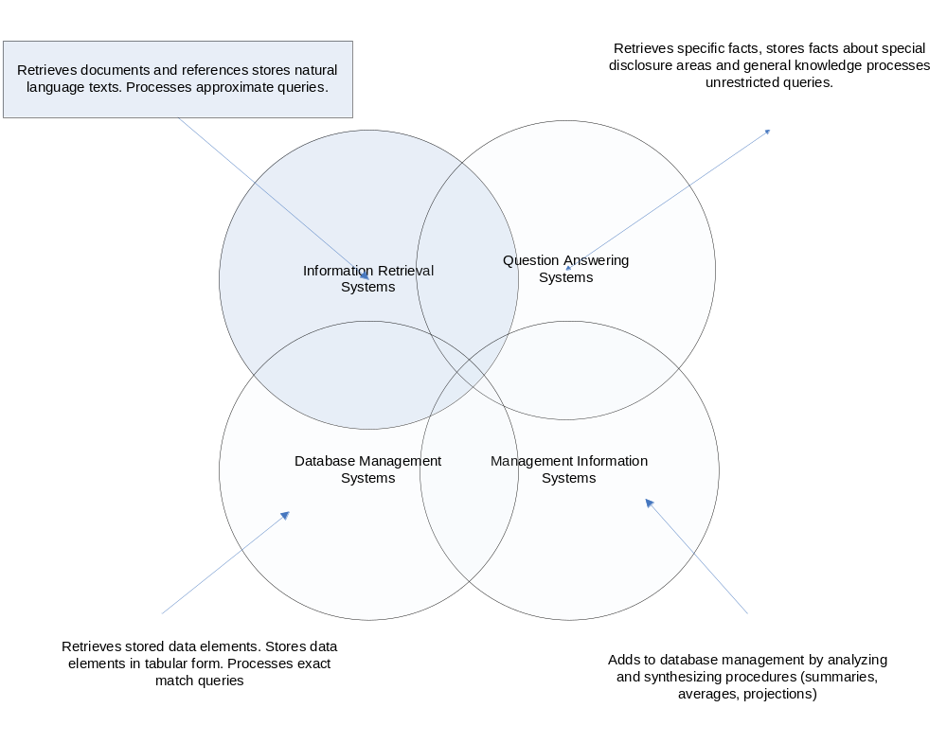
Figure 2.1 1 Overlap among information system types

2.1.2 Functional approach to IR
Several different information retrieval systems exist but most of them use a function approach to IR. Figure 2.1 2 provides an illustration to functional overview of information retrieval. According to this approach, information retrieval system consists of three components, a set of information items (DOCS), a set of requests (REQS) and a set of mapping mechanisms (SIMILAR) [6]. In a retrieval process the information items are first converted to a special form using a classification or indexing language (LANG). The indexing language is either pre-specified (controlled) or taken freely from the text of the information items and information requests (uncontrolled) or sometimes a combination of them. Whichever type is used, an information item is usually assumed to be representable by a list of elements from the indexing language.
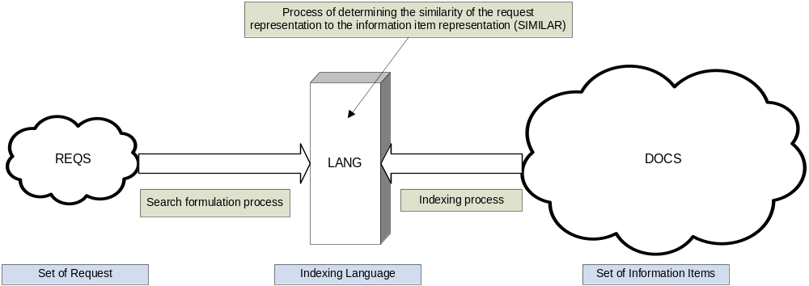
Figure 2.1 2 Functional Overview of information retrieval

The mapping of information items to the indexing language is called as indexing process. The requests are also converted into a representation consisting of elements from LANG, referred to as the query negotiation process.
Based on the elements of indexing language, procedures are setup to determine which information items are to be retrieved in response to a particular query. SIMILAR is the relation operator and retrieval function that determines the similarity of the various information items to a given request.

2.2 Search and retrieval

2.2.1 Searching process
A search process involves several steps. Flowchart 2.2 1 provides an illustration of how an informed user searching databases of information items that use controlled index languages can obtain optimal results [7].
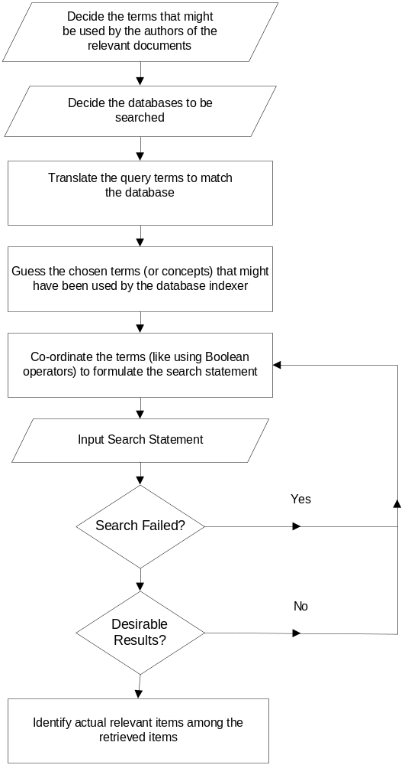
Figure 2.2 1 Steps to perform an optimal search

One major task in the searching process relates to the coordination of terms (First 4 steps in flowchart) in order to formulate the actual search statement. The result of search depends largely on how adequately the search terms are combined. Boolean search techniques have been widely used since the beginning of computerized information retrieval.

2.2.2 Retrieval models
Several information retrieval models have been proposed to study and improve retrieval process. The IR models can be broadly classified into three groups’ user-centric or cognitive models, system-centric models and alternative models.
The cognitive models take a holistic view of information retrieval, by taking into account not only the retrieval mechanisms used in matching queries with stored information but also the ways in which the user information needs can be formulated as a query, the human-computer interactions that take place during the search process, the social and cognitive environments in which the process takes place and how the information is used by the user to meet specific information need.
The system centric models provide an explicit statement on workings of the information search and retrieval mechanism. They are based on logical and mathematical principles. Boolean search, Probabilistic retrieval and Vector processing models are the widely used of system centric models. In a Boolean search model, queries are compared with the term set used to represent document contents. Probabilistic model does this comparison by computing relevance probabilities for the documents of a collection. The vector processing model represents both the documents and queries by term sets and compares global similarities between queries and documents. The Best match searching and relevance feed back model is also falls under the system centric models.
Alternative IR models have also been proposed which does not involve use of significant statistical analysis or probabilistic calculations. Two of the most popular alternative information retrieval models are the natural language processing model and the hypertext model.

2.2.3 Best match searching and relevance feed back model
The best match searching is aimed to produce a ranked output; hence it requires a method to measure the relative significance of retrieved items, which again requires some method of weighting search terms. A similarity measure comprises of two major components 1) a term weighting scheme that reflects the importance of a term by allocating numerical values to each index term in a query or document; and (2) a similarity coefficient which uses these weights to calculate the similarity between a retrieved item and a query.
A best match search matches a set of query words against the set of words corresponding to each item in the database, calculates a measure of similarity between the query and the item, and then sorts the retrieved items in order of decreasing similarity with query [6]. This involves some quantitative measure of similarity between the query and each of the items in the file, and the ranking is formed on the basis of these similarities. Studies show that weighting schemes that use term frequency, collection frequency and vector length normalization tend to produce the best results [8, 9].
The relevance feedback process is a controlled, automatic process for query reformulation, where the basic idea consists of choosing important terms attached to certain previously retrieved items that have been identified as relevant by the user, and of enhancing the importance of these terms in the new query formulation [10]. In this case, an initial search is carried out to produce a ranked list of output, and the user inspects a few top-ranking documents to ascertain their relevance to the given query. The user’s relevance data enables the system to calculate new set of weights that should reflect the importance of each query term more accurately. Studies have shown relevance feed back process to be an inexpensive and effective way of reformulating queries based on previously retrieved relevant and non-relevant documents [10].
This best match search and the relevance feedback model is the most relevant to our work as it provides a theoretical foundation for our content directed result merging algorithm.

2.3 Metasearch Engines

2.3.1 Motivation and Goals
Quiet often, information needs of users are stored in the databases of multiple search engines; this applies to the Word Wide Web as well. The rate of information explosion on the internet is much higher than the rate at which web search engines index the web, it is becoming much harder for individual search engines to keep themselves up to date with the expansion of internet [1]. Also users frequently require their search to cover personal or organizational databases along with the world wide web of documents.
It is highly inefficient and inconvenient for an ordinary user to invoke multiple search engines and identify useful documents from the returned result set. To support unified access to multiple search engines, a metasearch engine can be constructed. The key motivations behind the construction of a metasearch mechanism is to increase the search coverage of the web, solve the scalability problems of searching the web, facilitate invocation of multiple search engines, and improve the retrieval effectiveness.
In a session, a metasearch engine has to receive a query from the user through a user friendly interface, invoke underlying search engines (also referred as component search engines) with the user query as a parameter, retrieve information relevant to the query, unify the individual result sets into a single ranked list and order them in decreasing relevance. Different component search engines may accept queries in different formats; the user query may thus need to be translated to an appropriate format for each local system. Result sets are more likely to be a list of document identifiers as URLs for web pages or documents with a short description.

2.3.2 Component Architecture
Apart from the underlying search engines, a metasearch mechanism has four primary software components: a database selector, a document selector, query dispatcher and a result merger. Reference software component architecture of a metasearch engine is illustrated in Figure 2.3 1. The numbers on the edges indicate the sequence of actions for a query to be processed.
The problem of identifying potentially useful databases to search for a given query is known as the database selection. Database selector component is responsible for database selection for each query thereby avoids wasting of resources. The role of database selector is more pronounced when there is a long list of component engines that need to be queried, where as the users only need a minimal set of results. Database selection is not an issue when querying public databases like the internet search engines or a minimal set of data sources unless there are severe performance issues.

EMBED Visio.Drawing.11 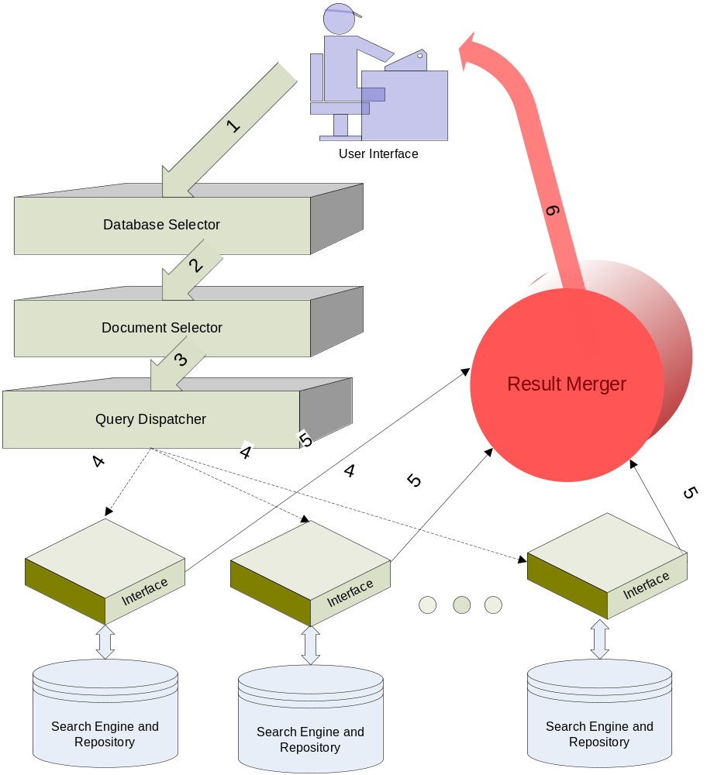
Figure 2.3 2 Metasearch Component Architecture

For each component search engine selected by the database selector; the document selector determines what documents to retrieve from the database of the search engine. Goal is to increase the retrieval effectiveness by minimizing the number of useless documents. Several factors may affect the selection of documents from a component search engine such as the number of useful documents, similarity function or context of search like web pages, videos, news, maps, books, documents, products etc.,
The query dispatcher is responsible for establishing a connection with the server of each selected search engine and passing the query to it. The original query may need to be translated to a new query before being sent to a component search engine. Say the query input to the metasearch engine may be Boolean or vector space queries where as the component engines may be serving heterogeneous information [11]. Query dispatcher may also try to adjust the relative weights of query terms in the original query to fetch optimal results.
Result merger combines the results into a single ranked list. This is the most important of components that impact the retrieval effectiveness. The relevance ordering of documents is directly related to the ranking algorithm used by the result merger. An ideal result merger would rank all the returned documents in descending order of their global similarities with the user query. We shall discuss several result merging documents in the next chapter.

2.3.3 Heterogeneity
One of the serious challenges in designing a metasearch engine is the management of complexities involved with heterogeneous environments of component search engines. Each component search engine many have its own indexing method, document term weighting scheme, query term weighting scheme, similarity function, document database, document versions and result presentation schemes.
Heterogeneity posts two major challenges with respect to database selection algorithms. One is to identify appropriate representatives that permit fast and accurate estimation of database usefulness at the same time the representatives should be small in comparison to the size of the database, should be easy to obtain and maintain. Our work does not deal with database selection hence we will not be discussing this in detail.
The result merging also faces issues due to heterogeneity of the component engines; the main problem is due to the fact that the same document may have different global and local similarities with a given query. Result merging techniques have to find ways to estimate the global similarities of documents so that documents returned from different component search engines can be properly merged.
In the next chapter we examine the techniques that have been proposed to deal with problems in result merging which is one of the key focuses of our research.
* * *
Chapter 3

RANK AGGREGATION & RESULT MERGING

3.1 Foundations
Traditional result merging techniques have been focusing on normalization of scores [11, 12] to make them more comparable across different search engines and thereby uniformly ranking the retrieved results. But these techniques require the component search engines to provide the local scores.
In the context of metasearch engines, Borda count [13] a voting-based result fusion is more appropriate. In Borda count, each component search engine is considered a voter that has a specified number of votes or points and each returned result is considered a candidate. Each voters top ranked candidate is assigned n points (where n is the number of candidates), the second top ranked candidate is given n-1 points and so on. For candidates that are not ranked by a voter (i.e. the result candidate was not retrieved by corresponding search engine), the remaining points of the voter will be evenly divided. The results are then ranked in a descending order of the total reported. For Borda count to be efficient each voter has to return a large number of results (in hundreds) and also the voters need to have substantial overlap among the retrieved results. There are also schemes that take search engine usefulness into consideration like D-WISE [21].
But all these require some data to be collected from each component search engine before hand. This is not applicable in a metasearch context where a component engine can join the metasearch on the fly. Therefore our research focuses only on result merging approaches without collecting any sample data in advance from component search engines.
The result records returned from today’s search engines are referred to as Search Result Records (SRRs). A typical SRR contains the URL, title and summary (snippet) of the retrieved document. Some of the earlier works [15, 16] have focused on utilizing the SRRs to gauge the relevance of the results, but these works primarily focus on merging news results rather than general purpose search results.
The most effective result merging methods described in [16] uses a combination of evidences of document title, snippet and the search engine usefulness. First, for each SRR the similarity between the query and its title and the similarity between the query and its snippet is computed; then the two similarities are linearly aggregated to rank the result. In the next section we discuss a list of such rank aggregation methods followed by a brief description of our content directed result merging strategy.

3.2 Merging Algorithms

3.2.1 Top Document search engine score (TopD)
Let S_{j} represent the usefulness score of search engine j with respect to query Q. The TopD method requires the document frequency of every term be collected in advance. TopD algorithm uses the similarity between Q and the top ranked document returned from search engine j (denoted as d_{1j}) to estimate S_{j}. This ranking assumes the highest ranked document to be the most relevant to the user query based on the search engines ranking criteria. The similarity functions used for comparison can be Cosine [15] or Okapi [14]. Once S_{j} is computed the ranking scores (rs_{ij}) can be computed using the expression
 | rs_{ij} = 1 – (r_{i} – 1) * S_{min} / (m*S_{j}) | …(1)

Here m is the total number of documents desired; S_{min} is the smallest search engine score among all search engines selected for this query and r_{i} is the local rank of a document returned from search engine j.
The technique is not very effective as the top ranked document needs to be retrieved from the local server for the merging process. Also the rank of top ranked results from all used search engines will be the same, therefore one needs to compute adjusted ranking scores by multiplying the ranking scores computed by S_{j}. If a document is retrieved by multiple search engines, we need to compute its final ranking score by summing up all the adjusted ranking scores.

3.2.2 Top SRR based search engine score (TopSRR)

TopSRR uses component search engines top n returned Search Result Records (SRRs) instead of the top ranked document to estimate the search engine score S_{j} with respect to the query Q. This is done with the intuition that the SRRs are representative of the original documents. Specifically, all the titles of the top n SRRs from search engine j are merged together to form a title vector TV_{j}, and all the snippets are also merged into a snippet vector SV_{j}. The similarities between query Q and TV_{j} and between Q and SV_{j} are computed separately and then aggregated into the score of search engine j. This search engine score is computed as
 | S_{j} = c₁ * Similarity (Q, TV_{j}) + (1-c₁) * Similarity (Q, SV_{j}) | …(2)

Where c₁ is a constant and Similarity function can be either of Cosine or Okapi.

3.2.3 Simple Similarity rank between SRR and query (SRRSim)

The SRRSim ranking scheme directly computes the rank of documents using SRRs instead of computing first computing the search engine scores and then the individual document ranks. The SRRSim uses the fact that the SRR are representative of the corresponding full document, thus one can rank SRRs returned from different search engines based on their similarities with the query directly using the right similarity function.

The similarity between a SRR R and a query Q is computed as the weighted sum of similarity between the title T of R and Q and the similarity between the snippet S of R and Q.
 | Sim(R,Q) = c₂ * Similarity(Q,T) + (1- c₂) * Similarity(Q,S) | …(3)

If a document is retrieved from multiple search engines with different SRRs, then the similarity between the query and each such SRR will be computed and the largest one will be used as the final similarity of this document with the query for result merging.

3.2.4 Compound similarity rank between SRR and Query (SRRSimMF)

All the aforesaid ranking algorithms propose metasearch engines to use only the similarity functions to determine the relevance of documents against the given query. They do not take the proximity frequency and ordering of terms into consideration. The impact of order and proximity of information in the result ranking is important and obvious. To better rank SRRs, this algorithm takes several features with respect to the query terms like the number of distinct query terms appearing in the title and the snippet (NDT), the total number of occurrences query terms in the title and the snippet (TNT), the location of the occurred query terms (TLoc), ordering and adjacency information (ADJ), and the window size containing the distinct occurred query terms (WS). To quantify the matches based on the different features identified above the SRRSimMF algorithm aggregates the scores into numeric values based on the following expressions
 | Similarity = TNDT * ( c₃ * Sim(T,Q) + (1-c₃) * Sim(S,Q)) / QLEN | …(4)

Here,

TNDT is the total number of distinct query terms appeared in title and snippet
QLEN is the length of the query
Optimal value of c₃ is 0.2 computed using a genetic algorithm [19], intuitively this means that lesser significance is given to the similarity between title and query and more significance is placed on the similarity between the query and the description.
 | Sim(T,Q) = S_{NDT} + (W₁ * S_{ADJ} + W₂ * S_{WS} + W₃ * S_{TNT}) / QLEN | …(5)
 | Sim(S,Q) = S_{NDT} + (W₁ * S_{ADJ} + W₂ * S_{WS} + W₃ * S_{TNS}) / QLEN | …(6)
 | S_{NDT} = Number of Distinct Query Terms (NDT) / QLEN | …(7)
 | S_{TNT} = Terms Distinct in Title (TDT) / Title Length (TITLEN) | …(8)
 | S_{TNS} = Terms Distinct in Snippet (TDS) / Snippet Length (SNIPPETLEN) | …(9)
 | S_{WS} =(Title/Snippet length – Window Size) / (Title/Snippet length) | …(10)
 | S_{ADJ} is set to 1 if the ordering is same in query and title/snippet otherwise the value is 0
 | W₁, W₂ and W₃ are weights for each of the terms

Studies [19] have shown that the window size and adjacency information offer little to the similarity calculation and they are computationally expensive, hence they can be safely ignored without much loss of similarity mapping. Hence equations (5) and (6) become
 | Sim(T,Q) = S_{NDT} + (S_{TNT} / QLEN) | …(11)
 | Sim(S,Q) = S_{NDT} + (S_{TNS} / QLEN) | …(12)

Equations (11) and (12) are the ones used in actual implementations.

3.3 Content Direction

3.3.1 Motivation
All general purpose search engines have a ceiling on the query length for performance reasons, which limits the effectiveness of the similarity functions and the retrieved results. Most times there isn’t enough information to judge the relevance between the query and the retrieved results. The best match searching and relevance feedback model discussed in section 2.2.3 show the importance of query reformulation for effective retrieval of matching results. Reformulation is an automatic, controlled process where the basic idea consists of choosing important terms attached to certain previously retrieved items that have been identified as relevant by the user (referred as guide artifact) and of enhancing that importance of these terms in the new query reformulation [9]. Studies have shown the relevance feed back model to be very effective but query reformulation has a significant computation and complexity overheads. Instead of query reformulation we suggest the use of guide artifact for similarity analyses in conjunction with the query and SRR to rank the results.

3.3.2 Content Directed Result merging algorithm (CDRM)

3.3.3 Use Cases

Chapter 4

ARCHITECTURAL FRAMEWORK

4.1 Requirements

4.2 Design

4.3 Components

4.3.1 Query Segregator

4.3.2 Query Scheduler

4.3.3 Result Aggregator

4.3.4 Search Provider

4.4 Data

4.4.1 Artifact

4.4.2 Content direction

Chapter 5

IMPLEMENTATION

5.1 Implementation Infrastructure

5.2 Framework

5.2.1 Configuration

5.2.2 Artifact Segregation

5.2.3 Metasearch Scheduling

5.2.4 Result Aggregation

5.2.5 Search Provider support

5.2.6 Content direction support

5.3 Metasearch Prototype

5.3.1 User Interaction Model

5.3.2 Features

Chapter 6

EVALUATION and RESULTS

6.1 Evaluation Standards

6.1.1 TREC Tracks

6.1.2 TREC Web Track

6.1.3 TSAP Methodology

6.2 Test Bed

6.3 Evaluation Criteria

6.4 Results

Chapter 7

CONCLUSION AND FUTURE WORK

7.1 Conclusion

7.2 Future work
Chapter 8

REFERENCES
[1] Michael K. Bergman, 2001, The Deep Web Surfacing Hidden Value, http://www.press.umich.edu/jep/07-01/bergman.html
[2] W. Meng, C. Yu, and K. Liu. Building efficient and effective metasearch engines. ACM Computing Surveys, 2002.
[3] Apache Lucene, 2006, http://lucene.apache.org/
[4] JUnit.org Resource for Test Driven Development, 2007, http://www.junit.org/
[5] T. Joachims, F. Radlinski, Search Engines that Learn from Implicit Feedback, IEEE Computer, Vol. 40, No. 8, August, 2007.
[6] Gerald Salton, Michael J. McGill, Introduction to Modern Information Retrieval, McGraw-Hill Book Company 1983.
[7] Cleverdon, C. ‘Optimizing convenient online access to bibliographic databases’ In: P. Willet (ed.), Document retrieval systems, London, Taylor Graham, 1988 32-41.
[8] Al-Hawamdeh, S. and Willet, P., ‘Comparison of index term weighting schemes for the ranking of paragraphs in full-text documents’, International journal of information and library research, 1, 1989, 116-30
[9] Salton, G. and Buckley, C., ‘Term-weighting approaches in automatic test retrieval’, Information processing and management, 24(5), 1988, 513-23
[10] Salton, G. and Buckley, C., ‘Improving retrieval performance by relevance feedback’, Journal for American Society for Information Science, 41(4), 1990, 288-97

