1. Install Jupyter notebook and run the first program and share the screenshot of the output.

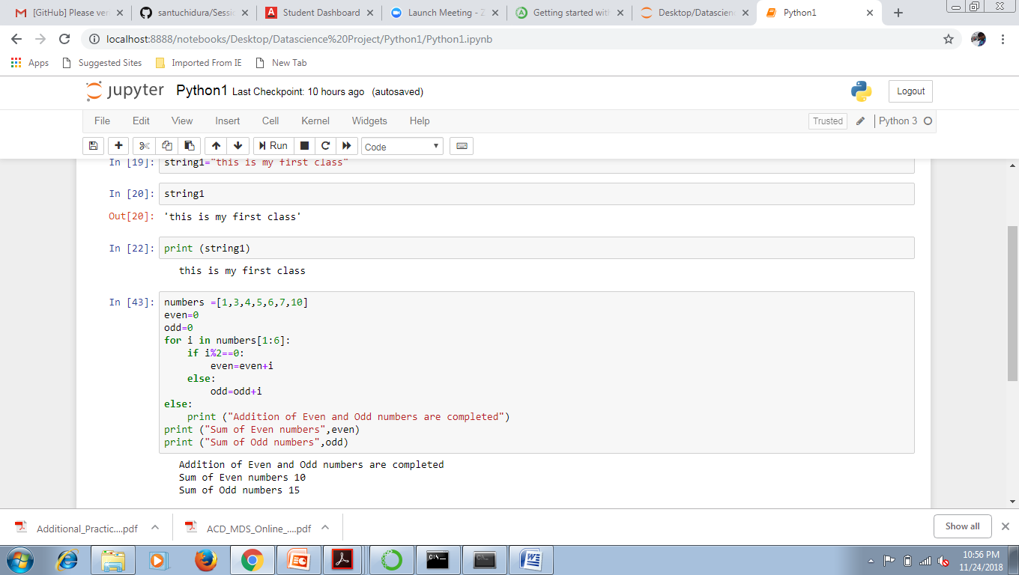

2. Write a program which will find all such numbers which are divisible by 7 but are not a

multiple of 5, between 2000 and 3200 (both included). The numbers obtained should be printed

in a comma-separated sequence on a single line.

Code:

Num = range(2000,3200,7)

Res = list()

index = 0

for i in Num:

if i%5 == 0:

continue

else:

Res.append(i)

print (Res)

screen shot:

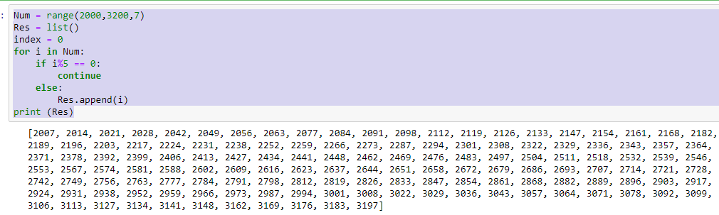

3. Write a Python program to accept the user's first and last name and then getting them printed

in the reverse order with a space between first name and last name.

Code:

Fname = input("What is your first name? ")

Lname = input("What is your Last name? ")

print(Lname + " " + Fname)

Screen Capture of the execution:

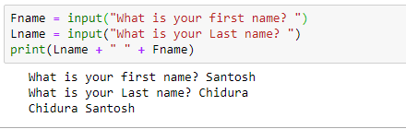

4. Write a Python program to find the volume of a sphere with diameter 12 cm.

Formula: V=4/3 \* π \* r 3

Code:

Dia = 12

Rad = Dia/2

Pie = 22/7

Volume =((4/3)\*Pie\*(Rad\*\*3))

print ("The volume of a cylender with diameter 12 is " + str(Volume))

Screen Capture:

