# Hackathon-Angular

0.Create Friend Model with FriedID,FriendName,Place

1.Create Friend Service with following functions

Friends:Friend[]=[]

AddFriend(item:Friend)

{

This.Friends.Push(item)  
}

Create a Add-Friend Component

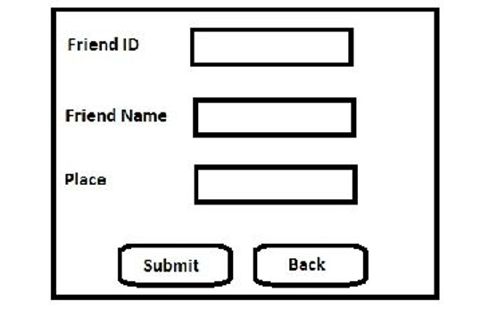

Create the above form using React/Template driven form

On creating submit button friend details are adding frinds list using AddFriend service function