Services in Angular are a great way to share information among components that **do not know each other.**

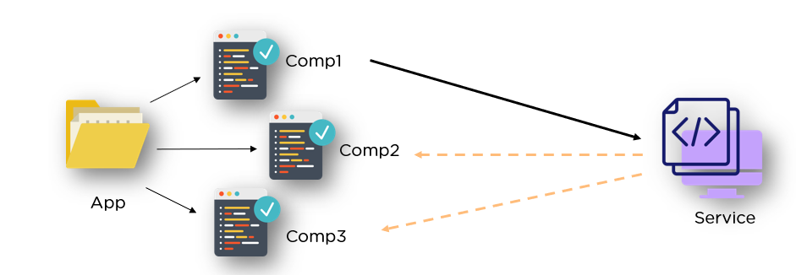

When we are developing an Angular app, we will most likely run into a scenario in which we need to use the same code across multiple components. In that case, **Services**will help us. We can share the services code among various components.

**Features of Angular Services**

* Services in Angular are simply typescript classes with the @injectible decorator. This decorator tells angular that the class is a service and can be injected into components that need that service. They can also inject other services as dependencies.
* these services are used to share a single piece of code across multiple components. These services are used to hold business logic.
* Services are used to interact with the backend(API)
* [**Components**](https://appdividend.com/2018/01/28/angular-components-tutorial-example-scratch/)use to display and present the data. **Services**use to fetch the data from the API.

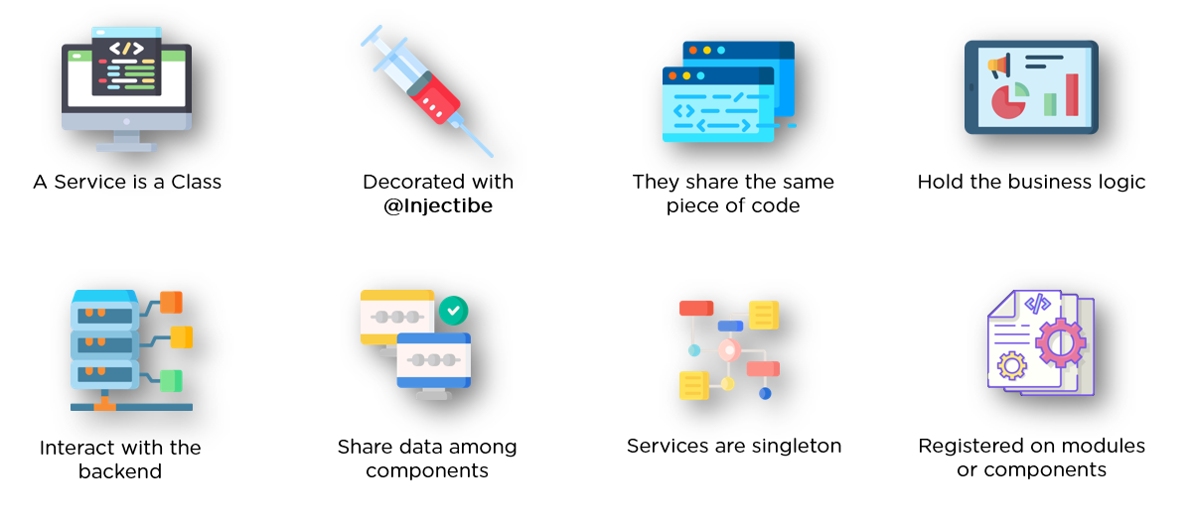

* In angular, the services are singletons, meaning that only one instance of a service that gets created, and the same instance is used by every building block in the application.
* A service can be registered as a part of the module, or as a part of the component. To register it as a part of the component, you’ll have to specify it in the providers’ array of the module.

**Creating Angular Service**

**Using Angular CLI**

Creating service is easy if you use Angular CLI. It is just one command which does the all work. It will generate the service code just like above example.

|  |
| --- |
|  |
| **ng g service calc** |

**Global service vs Local Service Injection**

To inject the service, you have two options.

**1) Inject as ‘global service’**

To inject as global service, inject the **service into root module**.

|  |
| --- |
| **Global service injection - app.module.ts** |
| **import { BrowserModule } from '@angular/platform-browser';**  **import { NgModule } from '@angular/core';**    **import { AppComponent } from './app.component';**  **import { CalcService } from './service/calc.service';**    **@NgModule({**  **declarations: [**  **AppComponent**  **],**  **imports: [**  **BrowserModule**  **],**  **providers: [CalcService],**  **bootstrap: [AppComponent]**  **})**  **export class AppModule { }** |

**2) Inject as ‘local service’**

To inject as local service, inject the **service into component** directly.

|  |
| --- |
| **Local service injection - app.component.ts** |
| import { Component } from '@angular/core';  import { CalcService } from './service/calc.service';    @Component({    selector: 'app-root',    templateUrl: './app.component.html',    styleUrls: ['./app.component.css'],    providers: [CalcService]  })  export class AppComponent {    title = 'app';      constructor(calc:CalcService){      //Use calc    }  } |