* Cloud computing is the delivery of computing services over the internet.
* Computing services include common IT infrastructure such as virtual machines, storage, databases, and networking.
* Other services include Internet of Things (IoT), machine learning (ML), and artificial intelligence (AI).
* The cloud models define the deployment type of cloud resources. The three main cloud models are: private, public, and hybrid.
* Private cloud provides much greater control for the company and its IT department.
* Private cloud may be hosted from your on site datacenter.
* Private cloud comes greater cost.
* A public cloud is built, controlled, and maintained by a third-party cloud provider.
* A hybrid cloud is a computing environment that uses both public and private clouds

| **Public cloud** | **Private cloud** | **Hybrid cloud** |
| --- | --- | --- |
| No capital expenditures to scale up | Organizations have complete control over resources and security | Provides the most flexibility |
| Applications can be quickly provisioned and deprovisioned | Data is not collocated with other organizations’ data | Organizations determine where to run their applications |
| Organizations pay only for what they use | Hardware must be purchased for startup and maintenance | Organizations control security, compliance, or legal requirements |
| Organizations don’t have complete control over resources and security | Organizations are responsible for hardware maintenance and updates |  |

* When comparing IT infrastructure models, there are two types of expenses to consider. Capital expenditure (CapEx) and operational expenditure (OpEx).
* CapEx is typically a one-time, up-front expenditure to purchase or secure tangible resources. A new building, repaving the parking lot, building a datacenter, or buying a company vehicle are examples of CapEx.
* OpEx is spending money on services or products over time. Renting a convention center, leasing a company vehicle, or signing up for cloud services are all examples of OpEx.
* Cloud computing falls under OpEx because cloud computing operates on a consumption-based model. With cloud computing, you don’t pay for the physical infrastructure, the electricity, the security, or anything else associated with maintaining a datacenter. Instead, you pay for the IT resources you use. If you don’t use any IT resources this month, you don’t pay for any IT resources.
* Cloud computing is the delivery of computing services over the internet by using a pay-as-you-go pricing model. You typically pay only for the cloud services you use.
* Cloud Computing offers 3 types of service which includes Iaas,Paas,Saas
* Infrastructure as a service (IaaS) is the most flexible category of cloud services, as it provides you the maximum amount of control for your cloud resources. In an IaaS model, the cloud provider is responsible for maintaining the hardware, network connectivity (to the internet), and physical security.
* In a PaaS environment, the cloud provider maintains the physical infrastructure, physical security, and connection to the internet. They also maintain the operating systems, middleware, development tools, and business intelligence services that make up a cloud solution.
* Software as a service (SaaS) is the most complete cloud service model from a product perspective. With SaaS, you’re essentially renting or using a fully developed application. Email, financial software, messaging applications, and connectivity software are all common examples of a SaaS implementation.
* Azure provides more than 100 services

**Azure accounts**

* To create and use Azure services, you need an Azure subscription.
* One Azure Account can have many subscriptions.
* For example, your company might use a single Azure account for your business and separate subscriptions for development, marketing, and sales departments.

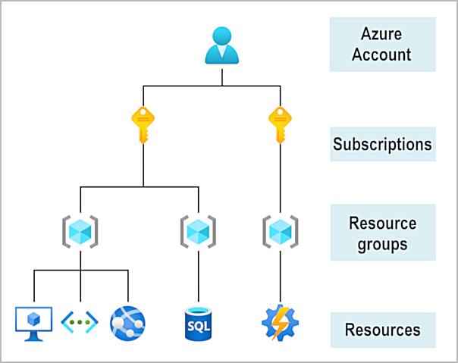

* The core architectural components of Azure may be broken down into two main groupings: the physical infrastructure, and the management infrastructure.
* The physical infrastructure for Azure starts with datacenters. Conceptually, the datacenters are the same as large corporate datacenters. They’re facilities with resources arranged in racks, with dedicated power, cooling, and networking infrastructure.
* Azure has datacenters around the world.
* Datacenters are grouped into Azure Regions or Azure Availability Zones that are designed to help you achieve resiliency and reliability for your business-critical workloads.

**Regions**

* A region is a geographical area on the planet that contains at least one, but potentially multiple datacenters that are nearby and networked together with a low-latency network.
* When you deploy a resource in Azure, you'll often need to choose the region where you want your resource deployed.

**Availability Zones**

* Availability zones are physically separate datacenters within an Azure region.
* Each availability zone is made up of one or more datacenters equipped with independent power, cooling, and networking.
* An availability zone is set up to be an isolation boundary. If one zone goes down, the other continues working. Availability zones are connected through high-speed, private fiber-optic networks.

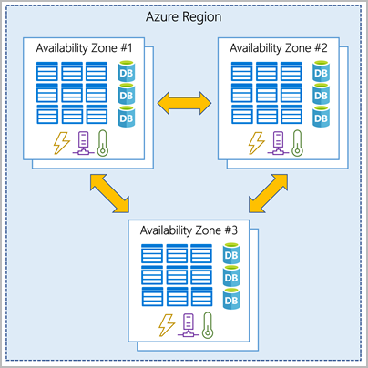

### **Region pairs**

* Most Azure regions are paired with another region within the same geography (such as US, Europe, or Asia) at least 300 miles away.
* This approach allows for the replication of resources across a geography that helps reduce the likelihood of interruptions because of events such as natural disasters, civil unrest, power outages, or physical network outages that affect an entire region.
* For example, if a region in a pair was affected by a natural disaster, services would automatically fail over to the other region in its region pair.
* Examples of region pairs in Azure are West US paired with East US and South-East Asia paired with East Asia.
* 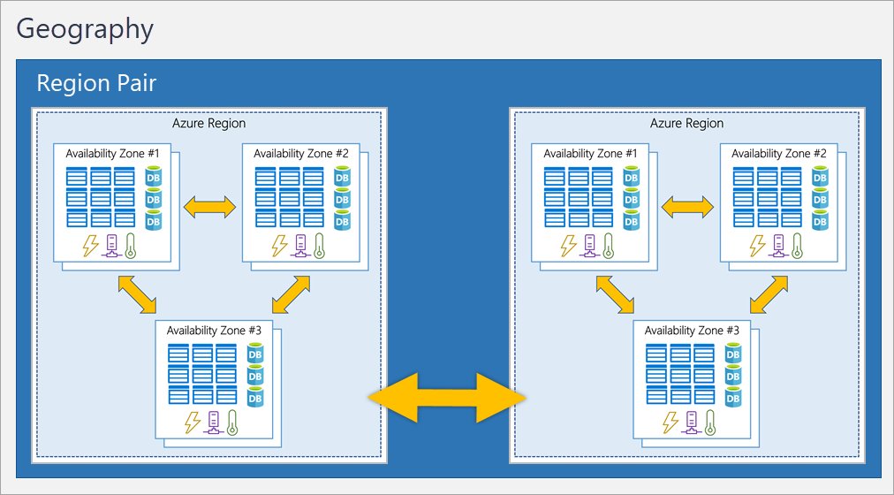

# Azure management infrastructure

* The management infrastructure includes Azure resources and resource groups, subscriptions, and accounts.
* Understanding the hierarchical organization will help you plan your projects and products within Azure.

## **Azure resources and resource groups**

* A resource is the basic building block of Azure. Anything you create, provision, deploy, etc. is a resource. Virtual Machines (VMs), virtual networks, databases, cognitive services, etc. are all considered resources within Azure.
* Resource groups are simply groupings of resources. When you create a resource, you’re required to place it into a resource group.
* Resource groups provide a convenient way to group resources together. When you apply an action to a resource group, that action will apply to all the resources within the resource group.
* If you delete a resource group, all the resources will be deleted. If you grant or deny access to a resource group, you’ve granted or denied access to all the resources within the resource group.
* 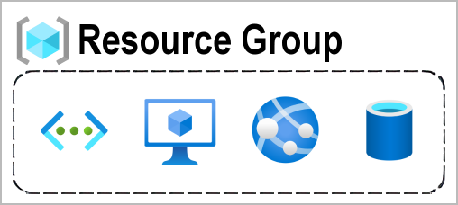

## **Azure subscriptions**

* In Azure, subscriptions are a unit of management, billing, and scale.
* Similar to how resource groups are a way to logically organize resources, subscriptions allow you to logically organize your resource groups and facilitate billing.
* A subscription provides you with authenticated and authorized access to Azure products and services.

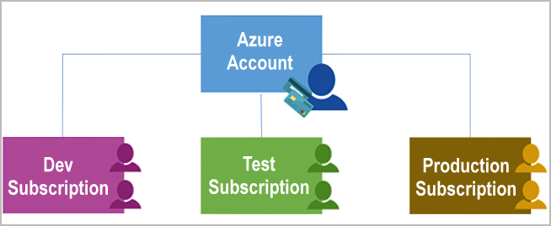

* An Azure subscription links to an Azure account, which is an identity in Microsoft Entra ID or in a directory that Microsoft Entra ID trusts.
* An account can have multiple subscriptions, but it’s only required to have one. In a multi-subscription account, you can use the subscriptions to configure different billing models and apply different access-management policies.
* You can use Azure subscriptions to define boundaries around Azure products, services, and resources. There are two types of subscription boundaries that you can use:
* **Billing boundary**: This subscription type determines how an Azure account is billed for using Azure. You can create multiple subscriptions for different types of billing requirements. Azure generates separate billing reports and invoices for each subscription so that you can organize and manage costs.
* **Access control boundary**: Azure applies access-management policies at the subscription level, and you can create separate subscriptions to reflect different organizational structures. An example is that within a business, you have different departments to which you apply distinct Azure subscription policies. This billing model allows you to manage and control access to the resources that users provision with specific subscriptions.

## Azure management groups

* Resources are gathered into resource groups, and resource groups are gathered into subscriptions.
* If you have many subscriptions, you might need a way to efficiently manage access, policies, and compliance for those subscriptions. Azure management groups provide a level of scope above subscriptions.
* You organize subscriptions into containers called management groups and apply governance conditions to the management groups.
* All subscriptions within a management group automatically inherit the conditions applied to the management group, the same way that resource groups inherit settings from subscriptions and resources inherit from resource groups. Management groups give you enterprise-grade management at a large scale, no matter what type of subscriptions you might have. Management groups can be nested.

