Azure Functions

Write an ARM Template to deploy the azure function along with the code and other required configurations.

Step 1: Go to azure portal <https://portal.azure.com>. Select “create a new resource” option and type “template deployment” in the marketplace.

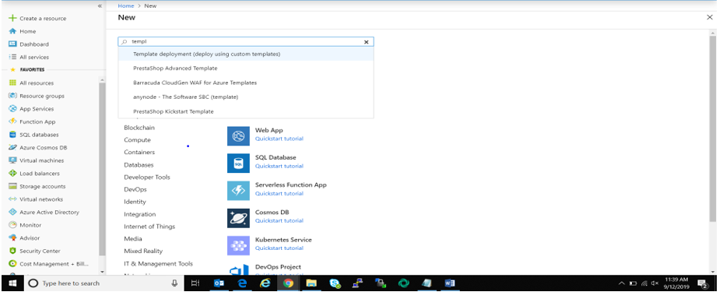

Step 2: Click on “Create”and select “build own template using editor” option.

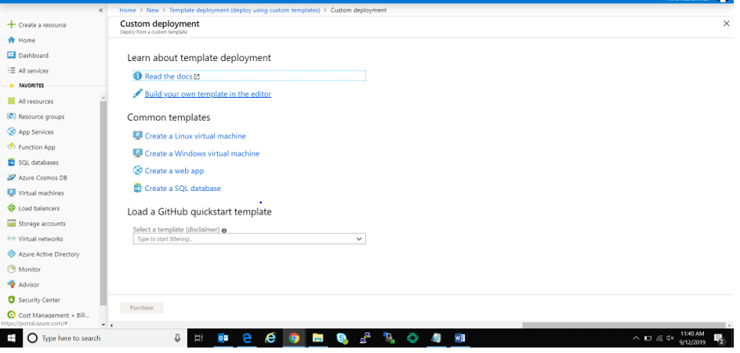

Step 3: In the editor, write the ARM template to create the Azure Functions as shown.

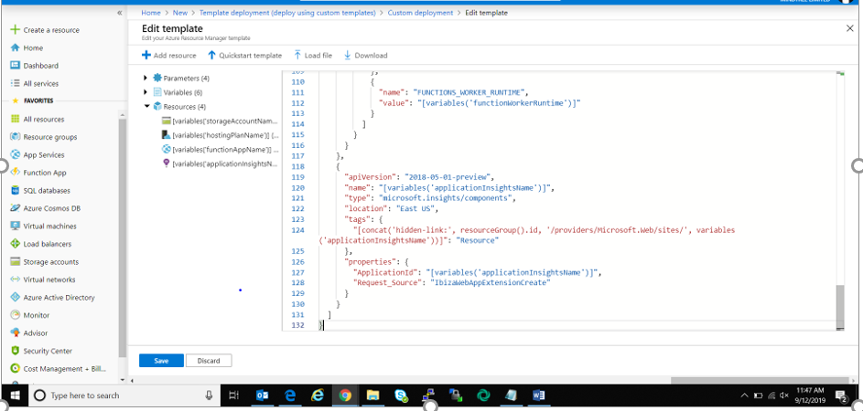

Step 4: Click on Save and fill the required configuration details and click on purchase. After this, we get a notification that the deployment in under progress.

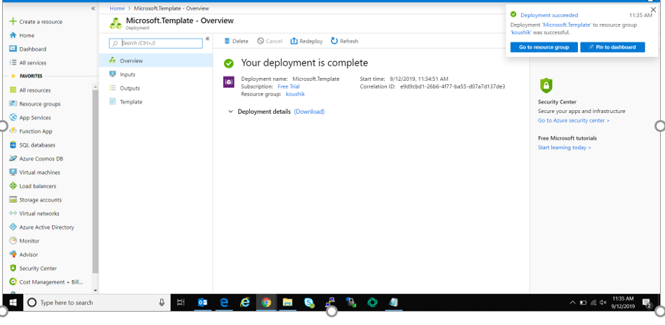

After the deployment is completed, we can access the Azure function as shown.

