* Platform as a service offering
* Azure App services are used to host web applications and services.
* Use it host
  + A.Web Applications.
  + B.Rest API’s
  + C.Backend services for mobile applications.
* Supported Programming Languages and frameworks
  + .Net & .Net Core
  + Java & Ruby
  + Node.Js & PHP
  + Python

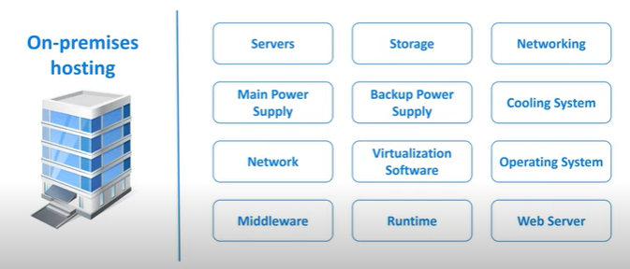

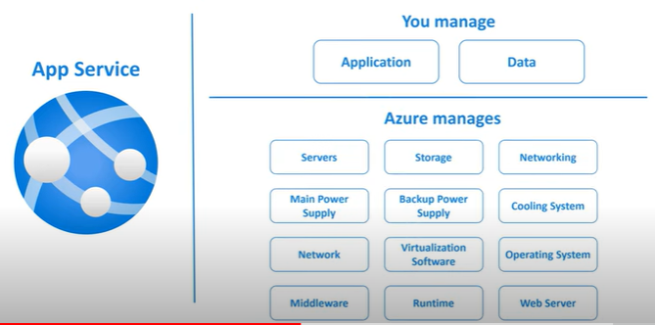

App Service Features and Benefits

* Fully Managed Environment.
* Multiple Programming languages and frameworks are supported.
* Scalability(Scale the resources up and down based on the demand)
* Compliance
* Security
* Containerization and Docker.
* DevOps Optimization
* Access on-premises data