Introduction

Azure Backup is the modern way to take backup in the Cloud, and it is a zero infrastructure solution that allows us to deploy any backup infrastructure.

Step 1 - Verifying our Database Server named BattiDB is running

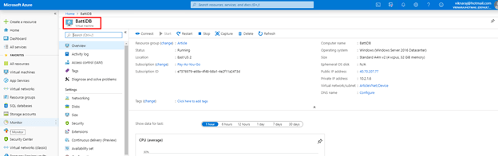

Step 2 - Installing Backup and Site Recovery

Go to the “+ Create a Resource” and search Backup and Site Recovery and then click “Create”.

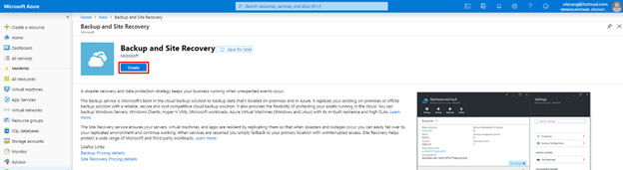

Step 3 - Creating the Recovery Service Vault

On the "Create Recovery Service Vault" screen, select the Subscription, Resource Group, and then enter the Vault Name “BattiDBBackup” and click “Review+Create”.

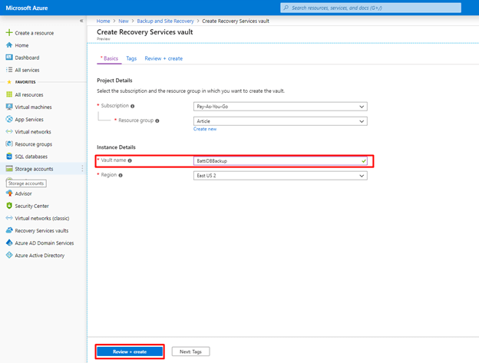

Step 4 - Creating a Backup

After you have successfully deployed, go to the backup named “BattiDBBackup” and click “+ Backup”.

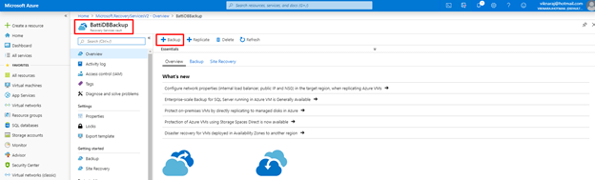

Step 5 - Selecting the Workloads and Backup Details

In the Backup Goal, select the Workload location as ”Azure”, and then select "What do you want to backup" as “SQL Server in Azure VM”, and then click “Start Discovery”.

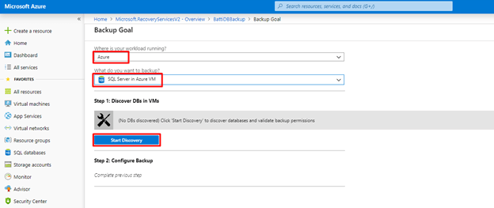

Step 6 - Discovering the Database VMs

When we click the “Start Discovery” Button, It will show the Virtual Machine's Name, then select the Database virtual machine named “BattiDB” that we have already deployed, and then click “Discover DBs”

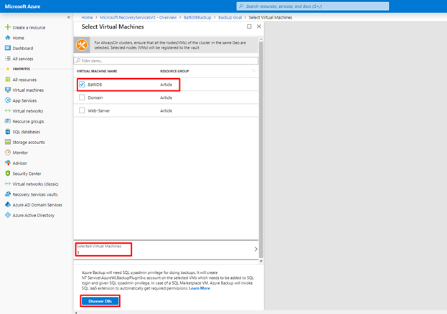

Step 7 - Configuring the Backup

After Discovering the VMs, Click “Configure Backup”.

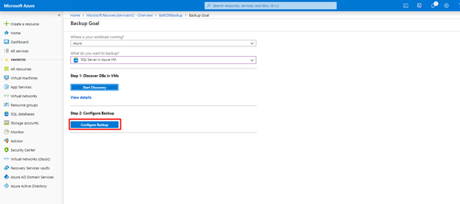

Step 8 - Selecting the Database

In the Items to Backup we can select single Database or we can fully select the database that we want, after selecting the database Select “On” under the AUTOPROTECT and then click “Ok”.

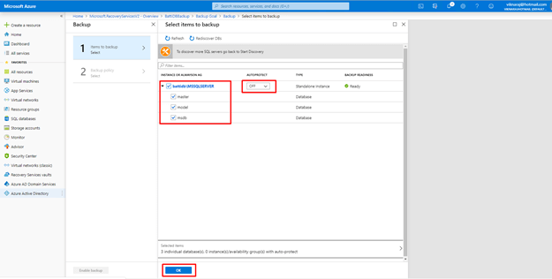

Step 9 - Creating the Backup Policy

In the Backup policy “Create New” policy under the Choose Backup Policy.

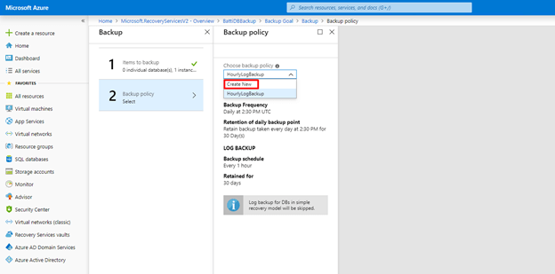

Step 10 - Assigning the Backup Policy

In the new policy Enter the Policy name and set the full backup policy and then click “Ok”

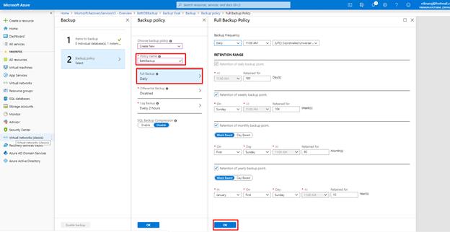

Step 11 - Finalizing the Backup Policy

After setting the Policy we can select the Log backup and SQL Backup Compression, and then click “Ok”.

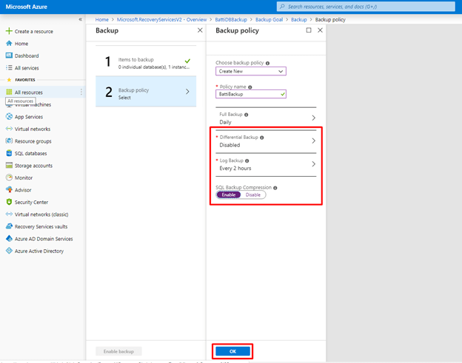

Step 12 - Enabling the Backup

After completing the settings click “Enable Backup”

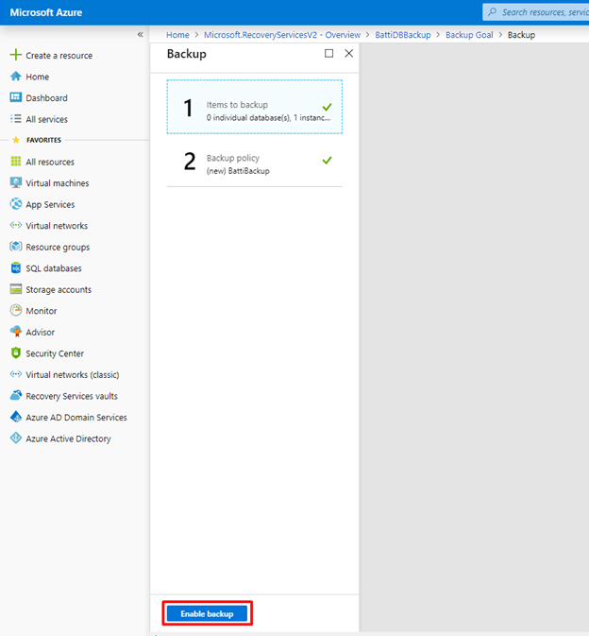

Step 13 - Verifying the Backup Jobs

After enabling the Backup job, we need to check if the Backup is running, so Click “Backup Jobs” and verify if there are any errors.

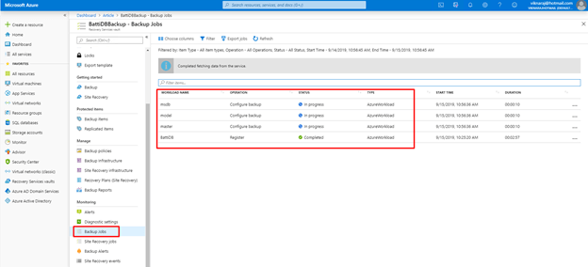

Step 14 - Verifying the Backup Items

After successfully completed the Backup Jobs, we can verify our Backup Items. If we want to Recover the Backup we can select the Backup Item and recover it from the “Backup items”.

