**Create resource groups**

1. Sign in to the [Azure portal](https://portal.azure.com/).
2. Select **Resource groups**

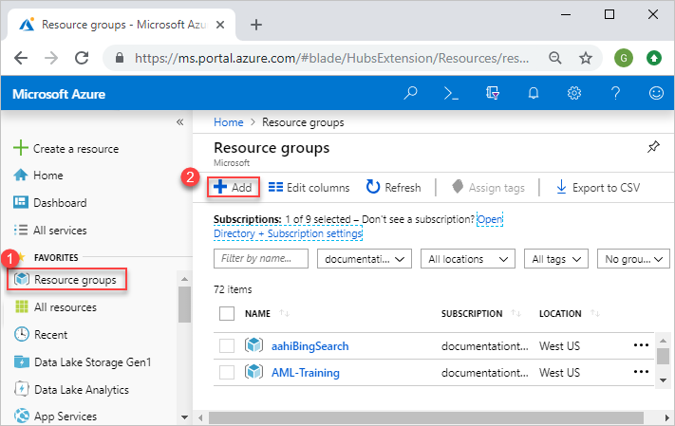

1. Select **Add**.
2. Enter the following values:
   * **Subscription**: Select your Azure subscription.
   * **Resource group**: Enter a new resource group name.
   * **Region**: Select an Azure location, such as **Central US**.

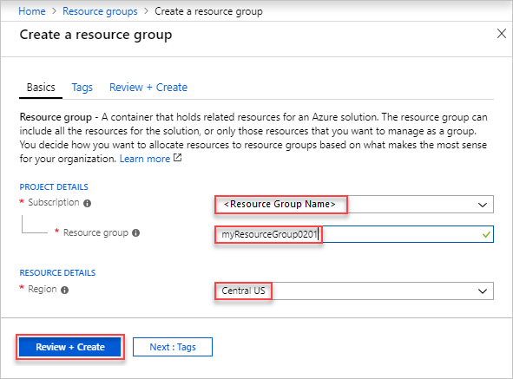

1. Select **Review + Create**
2. Select **Create**. It takes a few seconds to create a resource group.
3. Select **Refresh** from the top menu to refresh the resource group list, and then select the newly created resource group to open it. Or select **Notification**(the bell icon) from the top, and then select **Go to resource group** to open the newly created resource group

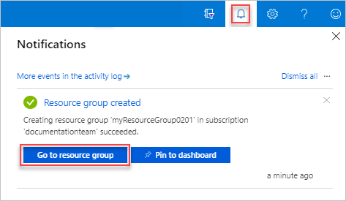

**List resource groups**

1. Sign in to the [Azure portal](https://portal.azure.com/).
2. To list the resource groups, select **Resource groups**

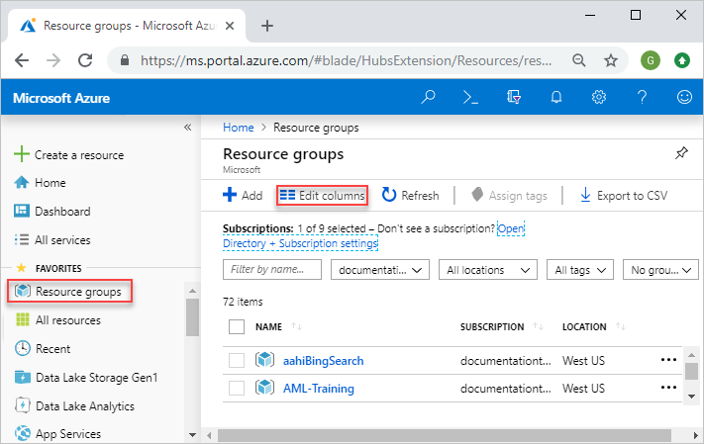

1. To customize the information displayed for the resource groups, select **Edit columns**. The following screenshot shows the addition columns you could add to the display:

**Open resource groups**

1. Sign in to the [Azure portal](https://portal.azure.com/).
2. Select **Resource groups**.
3. Select the resource group you want to open.

**Delete resource groups**

1. Open the resource group you want to delete. See [Open resource groups](https://docs.microsoft.com/en-us/azure/azure-resource-manager/management/manage-resource-groups-portal#open-resource-groups).
2. Select **Delete resource group**.

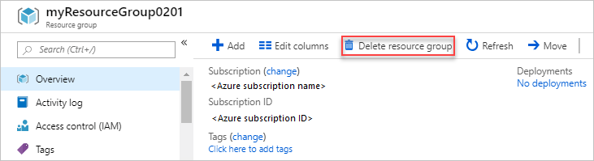

## Using Azure Shell

Follow the steps provided below to create a Resource Group using Azure Cloud Shell.

* Log in to the [Microsoft Azure Cloud Shell](https://shell.azure.com/).
* In order to create a new resource group, execute the following command.

az group create --name myResourcegroup201 --location centralus