**How to Create a Free Azure Account Step by Step**

Guide for creating a free Azure account. What services can you use for free? What is Directory or subscription and what type of subscription Azure offers?



**Creating the Free Azure account**

1. Go to <https://azure.microsoft.com/free>.
2. Click on “Start for free” button.
3. You will be redirected to a sign-in form. You need the Microsoft account. If you don’t have any, created one or there is also the possibility to use [GitHub](https://github.com/)account since Microsoft bought it.

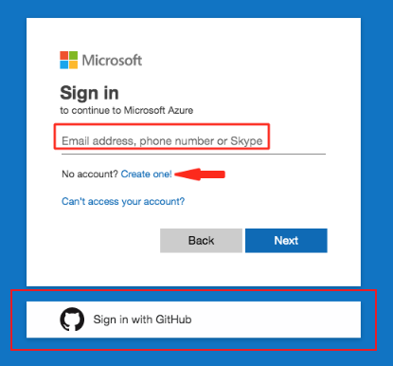

Microsoft sign-in form

4. After your successful authorization you will be redirected to Identity verification by card form. For those who also do not like to give credit card initials

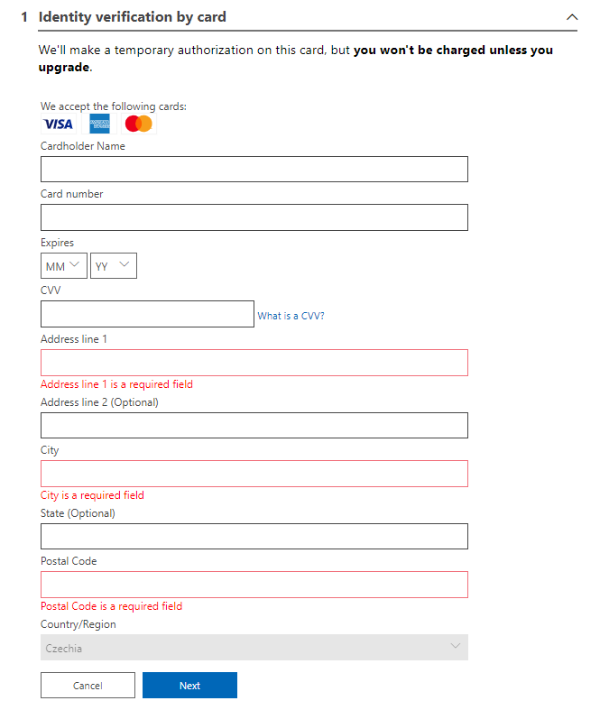

Identity verification by card form

5. Now that only remains is checking the agreement, click sign up and your Azure account is created. Congratulations!

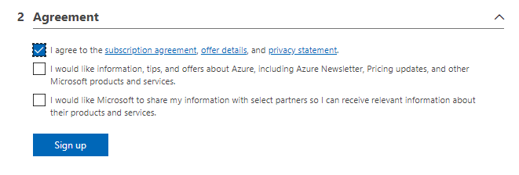

Agreement and sign up button

6. If you weren’t have been redirected to [Azure Portal, please use this link.](https://portal.azure.com/)

**Free Services with Free Account**

1. **€170 or $200 free credit** for the duration of the first month. When your first month ends, the credit expires and you will be asked to choose one of the available subscriptions.
2. **12 months of popular services for free.**
3. **25 services independently for free.** Offer might differ in different regions.

The structural list of free services and advantages can be found on [the same page which we used for registration](https://portal.azure.com/free). Scroll down and you should find it.

**Directory**

Each Microsoft account or Microsoft service is associated with the Azure Active Directory (AAD). AAD is Microsoft’s cloud-based identity and access management service.

From Xbox account to Office365, if you are using one of Microsoft’s services, you have an account associated AAD and there is the directory (Tenant)dedicated just for you.

The directory is a cloud-based identity and it always has its human-readable identifier which ends with *onmicrosoft.com* suffix. Such an identifier is globally unique. You can see the name of your AAD after clicking your name at top right corner and then click at *switch directory* link.

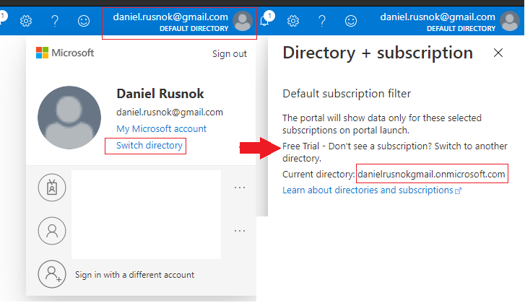

Displaying the name of your directory in Azure Portal

**Subscriptions**

One Directory can hold multiple subscriptions. It serves as a single billing unit for Azure resources. This is the most often used subscription types:

1. **Pay-as-you-go** — As the title refers, you will be billed monthly for resources you used in the current month. This is an obvious choice after one-month free trial. If you want to use just free services, you have nothing to worry about.
2. **Azure Open Licencing** — Credits bought from third-party retailers. You will obtain the code which one you going to apply threw online form in Azure Portal.
3. **Visual Studio Enterprise Subscription** — if you are a user of VS Enterprise, you are provided with free monthly credits in the amount of $200.

There are also more enterprise subscriptions which include the Azure support services. What is worth mentioning is that you cannot deploy any service without the active subscription.

If you are not interested in the free trial month, you can immediately upgrade your subscription threw button *Upgrade*in top left corner of Azure Portal home page.



Upgrade button in Azure Portal

Subscription can also be added threw page subscription. You can be navigated there threw interactive search field at the top.

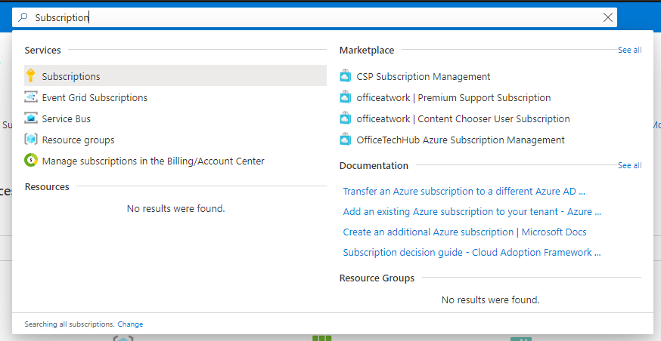

Search subscriptions

Or, if you are really newbie and doesn’t play with the settings of your homepage, you should be able to see the link to the subscriptions page in *Azure services* section and also in *Navigate* section.

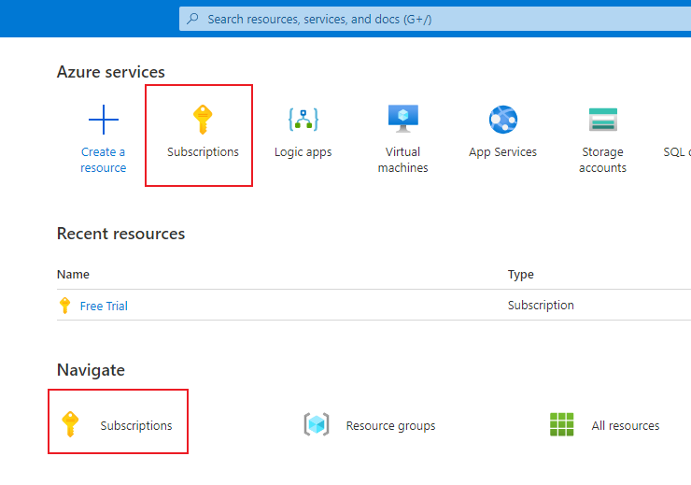

Subscription links at Azure Portal homepage

Once you will be at Subscriptions page, use the button *Add*. You will be redirected to page with subscription offers. As you can see in the image below, I have disabled the Pay-As-You-Go *Select offer* button, because my free trial month is still running. But I would be able to upgrade my account threw provide link next to it.

