**Azure Blob storage**

* Azure Blob storage is Microsoft's object storage solution for the cloud.
* Blob storage is optimized for storing massive amounts of unstructured data.
* Unstructured data is data that doesn't adhere to a particular data model or definition, such as text or binary data.

## Steps To Create Azure Blob Storage

**Step 1)** Log in to [**Azure Portal**](https://portal.azure.com/) (Please make sure you have a subscription before doing all this. If you created a free account for the first time, you’ll already have a FREE TRIAL subscription for 1 month).

***Note:***If you don’t know how to get a free Azure account then click on [**Azure Free Trial Account**](https://k21academy.com/microsoft-azure/create-free-microsoft-azure-trial-account/) to know more

**Step 2)** The first and foremost step in creating Blob Storage is setting up the ‘Storage Account’.  To create one, log in to the Azure portal, then click on ‘**Storage Accounts**‘.

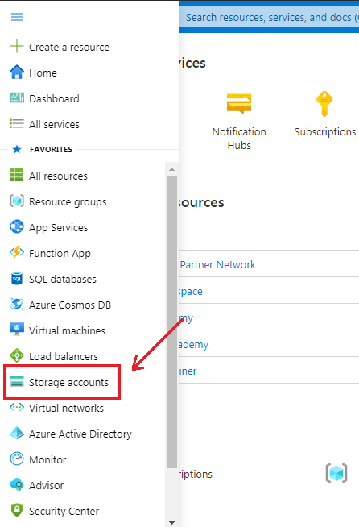

**Also Check:**how to create [**Azure Custom Roles**](https://k21academy.com/microsoft-azure/az-104/create-azure-custom-roles-using-azure-portal/)using the Azure portal. Click here

**Step 3**: After clicking on Storge Account, the following screen will appear and then click on ‘**+** **New**‘ to proceed further.

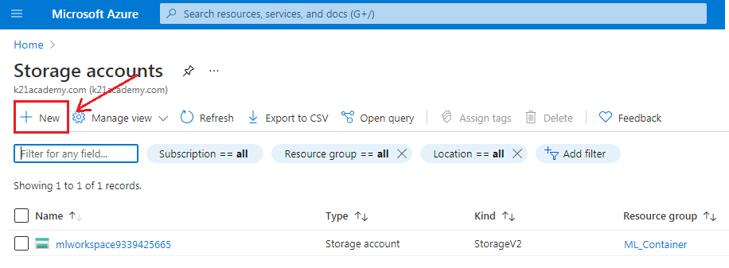

**Step 4**: After clicking on New, it will take you to the next page and asks you to fill in the following details:

1. Subscription – It tells you about the billing, invoice details, and the current subscription.
2. Resource Group – If you are creating a new resource group, it will show (New) before the name.
3. Storage Account name – Specify the name of the account.
4. Region – Specify your region or location.
5. Performance – It offers two types of performance option. **Standard** (uses HDD Hard Disk Drives to store data) **Premium** ( uses SSD Solid-State Drives to store data)
6. Redundancy – Through Redundancy, Azure ensures that data is protected at times of failure.

Click on ‘**Create**‘, after filling in all the details.

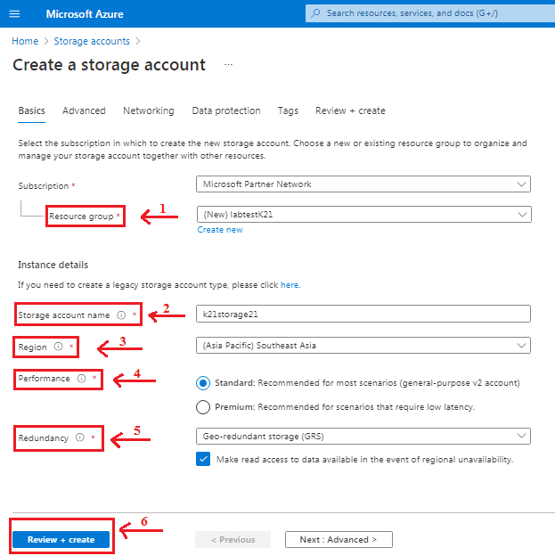

**Also Read:**Our previous blog post on [**Azure Cost Management**](https://k21academy.com/microsoft-azure/az-104/azure-cost-management-tips/).

**Step 5**: Azure Storage Account provides four types of Redundancy Storage as shown in the below sample. We will go with Geo-redundant Storage (GRS) for the demo purpose.

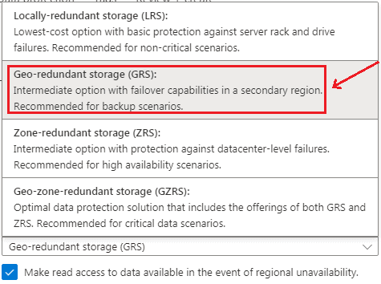

**Step 6:** When you click on the ‘Create’ button, it takes you to the next screen that shows the deployment status. After deployment gets completed, click on ‘**Go to resource**‘.

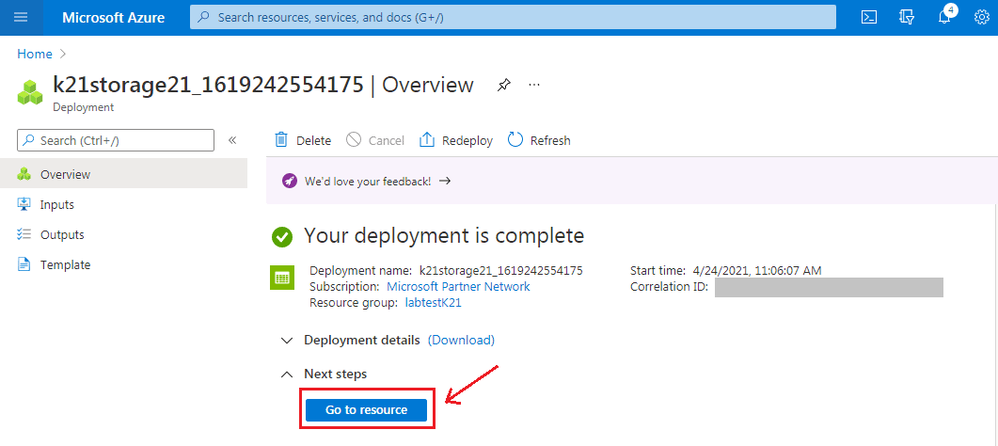

**Read More:**About [**Azure Proximity Placement Groups**](https://k21academy.com/microsoft-azure/az-104/azure-proximity-placement-groups-when-to-use-and-what-to-expect/).

**Step 7:** The following screen will appear, showing an ‘**Overview’** of the created Storage Account. The next step is to click on ‘**Containers**‘ to select Blob Storage. We have chosen the ‘**Hot Access**‘ tier for a demo purpose. One can choose according to their requirements.

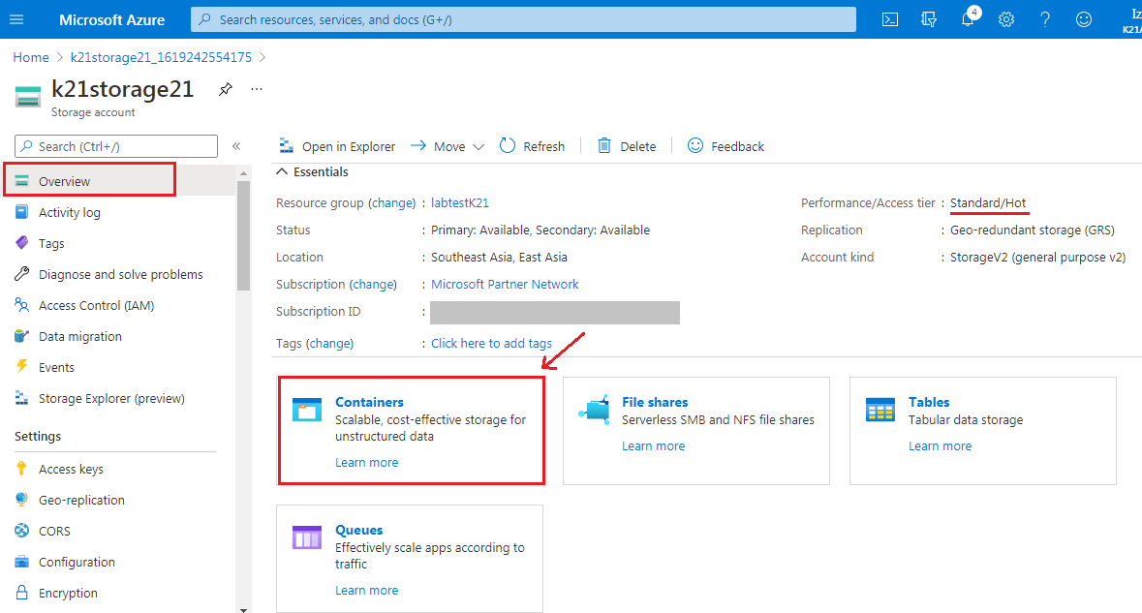

**Step 8**: Now, we have to create a new Container for that click on ‘**+ Container**‘.

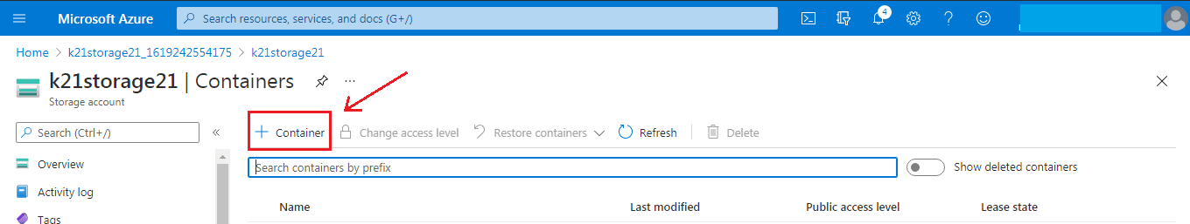

**Also Check:**Our blog post on [**Azure Availability Zones**](https://k21academy.com/microsoft-azure/az-104/az-104-region-availability-zone-availability-sets-and-fault-domainupdate-domain-in-microsoft-azure/).

**Step 9**: After clicking on + Container, it will ask to fill in the container’s name (it should be unique) and select access level. For the demo purpose, we have selected Blob Public Level access. Click ‘**Create**‘ to proceed further.

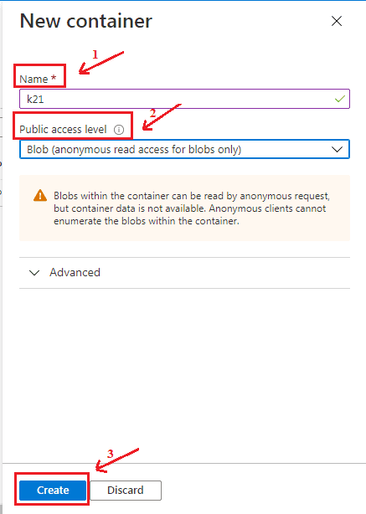

**Step 10**:  Hence we have successfully created the blob storage as we can see container k21 appears under the storage.

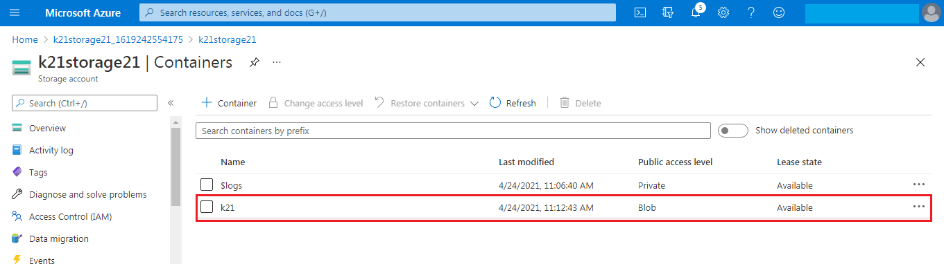

**Read More:**About [**AZ 104 Certification**](https://k21academy.com/microsoft-azure/az-104/az-104-microsoft-azure-administrator-certification-exam-everything-you-need-to-know/).

**Step 11**: Next, select the Storage Account and click on ‘ **Access keys**‘ to find the connection string. Website’s code gets authenticated to interact with created Storage Account through this Connection Strings. All you need to do here is copy the connection string and paste it into the website’s code, and you are good to go.

