**What is Azure Storage?**

As mentioned before, Azure Storage is the modern-day solution to all storage problems. Its storage capacity is limitless, virtually. Being a pay-as-you-go model, it gives you the flexibility of paying only for what you have used. Azure Storage services support different clients like .NET, Ruby, Java, etc. which gives developers an option.  
To access any of the storage services, you must have an Azure Storage account. To do so, first, create an Azure account.

**Features of Azure Storage**

Let us look at the features:

* **Durability and high availability:**Stored data is replicated and kept in different geographical locations. Hence, in the case of any hardware failure, you have your replicas safe and so your data. Also, if there is any natural disaster, your data will remain secure and you can avail them pretty easily.
* **Scalability:**The storage is massively scalable depending on the requirements. Data is automatically scaled up to accommodate any peak demands.
* **Security:**Accessing any information by an intruder from your storage is not an easy task, and hence your data is secure. Azure Storage uses a shared key model to authenticate a user. Usage of the shared access signature (SAS) can restrict access to data.
* **Accessibility:**You can access your data from anywhere over HTTP or HTTPS. You can write your code on Azure PowerShell or on Azure CLI. [Azure Storage Explorer](https://intellipaat.com/blog/guide-to-azure-storage-explorer/) and Azure portal provide you with an easy way to work with your data.

**Azure Storage Types**

There are four primary Azure Storage types with additional disk storage.

* **Azure blob storage**: It is optimized to store huge unstructured data. Storage is in terms of binary large objects (BLOBs).
* **Azure table storage**: It has now become a part of [Azure Cosmos DB](https://intellipaat.com/blog/what-is-azure-cosmos-db/). Azure table stores structured [NoSQL data](https://intellipaat.com/blog/nosql-database-tutorial/).
* **Azure file storage:**It is a fully managed file sharing service in the cloud or on-premise via the Server Message Block (SMB) protocol.
* **Azure queue storage:**It is a storage service that stores messages that can be accessed through HTTP or HTTPS from any part of the globe.
* **Disk storage:**It is a virtual hard disk (VHD) that is of two types: managed and unmanaged.

**Azure Blob Storage**

‘Blob’ stands for Binary Large Object and includes text files, images, audios, and videos. [Azure Blob](https://intellipaat.com/blog/tutorial/microsoft-azure-tutorial/azure-blob-storage/) is a service that stores massive unstructured data that can be accessed from any place via protocols like HTTP or HTTPS.



**Here are Azure blob’s responsibilities:**

* Storing files for shared access
* Video and audio streaming
* Storing data for analysis
* Writing to the log file
* Storing data for disaster recovery, backup, and archiving

**There are three types of blobs:**

* **Block Blobs:**It is an accumulation of small blocks that have their own unique block IDs. One block blob can contain up to 50,000 blocks. You can work parallelly by uploading multiple blocks at a time which decreases the upload time. The size of a single block blob is slightly higher than the normal, 4.75 TB, so the total size is 100 MB x 50,000 blocks. You can insert, delete, and replace blobs.
* **Append Blobs:** Append blobs also comprises blocks, but when you modify these blobs new blocks are added at the end. Here, you cannot update or delete any existing blocks and the unique ID is kept a secret, whereas in block blob unique IDs are exposed.
* **Page Blobs:**They are comprised of 512-byte pages that are optimized for arbitrary read and write operations. To create a page blob, you must first define the maximum size of the blob. You can then add or update the content of the page blob. The maximum size of a page blob is 8 TB.

Let us now see what all Azure blobs offer and at what cost.

**Azure Blob Storage Pricing**

The total cost of this service depends on:

* The volume of data stored/month
* Types of operations performed
* Number of operations performed
* Data transfer cost, if any
* The selected data redundancy option

Now, before checking out the pricing options, let me briefly explain the data redundancy options in Azure Cloud Storage.

|  |  |
| --- | --- |
| Locally redundant storage (LRS) | Keeps multiple copies of your data in one data center. It provides 99.99% (eleven 9s) durability over a given year. |
| Zone redundant storage (ZRS) | Keeps multiple copies of your data in different data centers in different regions. It provides 99.99% (twelve 9s) durability. |
| Geo-redundant storage (GRS) | Holds multiple copies of your data in one region and replicates the data to the second region, asynchronously. The durability is sixteen 9s. |
| Read-access geo-redundant storage (RA-GRS) | Allows read access from the second region, which is used for GRS, and the read availability is 99.99% and durability is sixteen 9s. |

***Get certified from top***[***Azure course in Hyderabad***](https://intellipaat.com/microsoft-azure-training-hyderabad/)***Now!***

Coming back to Azure blob pricing, here are the options if you opt for LRS:  
**Data Storage Pricing (in Rupees):**

|  |  |  |  |  |
| --- | --- | --- | --- | --- |
|  | Premium | Hot | Cool | Archive |
| First 50 TB/month | 12.8888/GB | 1.3220/GB | 1.0576/GB | 0.1322/GB |
| Next 450 TB/month | 12.8888/GB | 1.2691/GB | 1.0576/GB | 0.1322/GB |
| Over 500 TB/month | 12.8888/GB | 1.2162/GB | 1.0576/GB | 0.1322/GB |

|  |  |  |  |  |
| --- | --- | --- | --- | --- |
|  | Premium | Hot | Cool | Archive |
| Write Operations (per 10,000) | 1.5070 | 3.3049 | 6.6097 | 7.9316 |
| List and Create Container Operations (per 10,000) | 4.2963 | 3.3049 | 3.3049 | 3.3049 |
| Read Operations (per 10,000) | 0.1203 | 0.2644 | 0.6610 | 396.5775 |
| All other operations (per 10,000), except Delete which is free | 0.1203 | 0.2644 | 0.2644 | 0.2644 |
| Data Retrieval (per GB) | Free | Free | 0.6610 | 1.5864 |
| Data Write (per GB) | Free | Free | Free | Free |

**Data Transfer and Operations Pricing (in Rupees):**

Let us now move on to the next storage type, the Azure table storage.

**Azure Table Storage**

Azure table storage service stores structured NoSQL data.



It is schemaless, i.e., the data does not have a fixed structure. You can easily store datasets that do not require any joins or foreign keys. You can denormalize them to make quicker access. You can scale up the tables based on your requirements.  
Let us look at its pricing options.

**Azure Table Storage Pricing**

For storage using Azure table, here are the pricing options:

|  |  |  |  |  |
| --- | --- | --- | --- | --- |
| Capacity | LRS | GRS | RA-GRS | ZRS |
| GB/month | GB | 3.9658/GB | 4.9573/GB | 3.7147/GB |

And for **operations and data transfers**, it costs Rs.0.023795/1000 transactions.

Let us now quickly see the other storage types.

**Azure File Storage**

It provides managed file sharing in the cloud. Applications on Azure can easily share files between the virtual machines, and they are accessible via SMB.



Responsibilities of Azure file storage are:

* Replacing on-premise file servers
* Making lift and shift of applications easy to the cloud and offering both classic and hybrid lift and shift
* Simplifying cloud development with diagnostic share, shared application settings, and Dev/Test/Debug

Let us take a look at the pricing now.

**Azure File Storage Pricing**

The pricing is with respect to the LRA redundancy option.  
**Data Storage Pricing (in Rupees):**

|  |  |  |
| --- | --- | --- |
|  | Premium | Standard |
| GiB/month | 9.518/used GiB | 3.966/used GiB |
| Snapshots GiB/month | 7.932/used GiB | 3.966/used GiB |

**Operations and Data Transfer Pricing (in Rupees):**

|  |  |  |
| --- | --- | --- |
|  | Standard | Premium |
| Put and Create Container Operations | 0.9915 | Free |
| List Operations (per 10,000) | 0.9915 | Free |
| Other operations, except Delete, (free) per 10,000 | 0.0992 | Free |
| Geo-replication Data Transfer (per GiB) | NA | Free |

For **file sync**, the price is Rs.330.482/month.  
Next comes the last primary storage type, Azure Queue. Let us see what it has to offer.

**Azure Queue Storage**

Azure queue stores a large number of messages that can be accessed from any location using HTTP or HTTPS.  
The size of a queue message can be up to 64 KB.  
The uses of Azure queue storage are:

* It creates a backlog of work done and processes, asynchronously.
* It carries messages from the Azure web role to the Azure worker role.

**Azure Queue Storage Pricing**

**Data Storage Option:**

|  |  |  |  |
| --- | --- | --- | --- |
|  | LRS | GRS | RA-GRS |
| Storage in GB/month | 2.9744/GB | 3.9658/GB | 4.9573/GB |

**Operation and Data Transfer Pricing (in Rupees):**

|  |  |  |  |
| --- | --- | --- | --- |
|  | LRS | GRS | RA-GRS |
| Queue class 1 operations (in 10,000) | 0.0238 | 0.0238 | 0.0238 |
| Queue class 2 operations (in 10,000) | 0.0238 | 0.0238 | 0.0238 |
| Geo-replication Data Transfer (per GB) | NA | Free | Free |

We are finally done with discussing the primary storage types. Now, let us see what disk storage is.

**Azure Disk Storage**

Azure Managed Disk is a virtual hard disk which is mostly like a physical disk that is virtualized.  
Azure Disk Storage is further divided into two:

* Managed
* Unmanaged

You can have one storage account for each Azure region, which makes it limitless. In unmanaged disks, you need to have storage accounts that can hold the disks for Azure VM.  
Managed disks provide you with two kinds of encryptions:

* Storage Service Encryption
* Azure Disk Encryption

Let us see the pricing of Azure Disk Storage.

**Azure Disk Storage Pricing**

There are four types of managed disks:

* Ultra SSD Managed Disks
* Premium SSD Managed Disks
* Standard SSD Managed Disks
* Standard HDD Managed Disks

Here are the pricing options for ultra SSD managed disk:

|  |  |  |  |  |  |  |  |  |  |
| --- | --- | --- | --- | --- | --- | --- | --- | --- | --- |
| Disk Size (GiB) | 4 | 8 | 16 | 32 | 64 | 128 | 256 | 512 | 1024–65536 (in increments of 1 TiB) |
| IOPS Range | 100–1200 | 100–2400 | 100–4800 | 100–9600 | 100–19200 | 100–38400 | 100–76800 | 100–160000 | 100–160000 |
| Throughput Range (MB/s) | 1–300 | 1–600 | 1–1200 | 1–2000 | 1–2000 | 1–2000 | 1–2000 | 1–2000 | 1–2000 |

For further details on Azure Disk Storage pricing, please follow the page: https://azure.microsoft.com/en-in/pricing/details/managed-disks/

**Azure Storage Explorer**

Azure Storage Explorer is used to manage the contents of your Azure Storage account. You can easily work with it on different OS like Windows, Mac, and Linux.  
Storage Explorer offers you various ways to connect with your storage accounts. For example, you can connect and manage your local storage and your accounts associated with Azure subscription.  
To get started, you need to download and install Azure Storage Explorer.  
In the next section, we will see how to create an Azure Storage account and use Azure Storage Explorer to create blobs, queues, files, and tables.

**Azure Storage: Hands-on**

In this section, you shall see how to get started with an Azure Storage account and also a demo of the types of storage.  
Let us start with creating the Azure Storage account.

**Creating Azure Storage Account**

**Step 1:**Login to your Azure account. In your dashboard, search for **Storage**

1. Click on Storage

2. Click on Storage accounts

[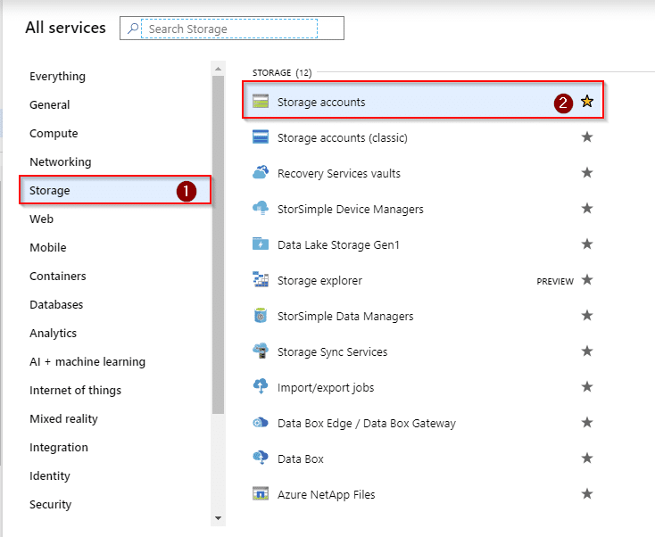](https://intellipaat.com/mediaFiles/2018/07/AzureStorage1-1.png)  
**Step 2:**Let us add an account now. Select **Add**or click on**Create an account** that appears at the bottom of the screen  
[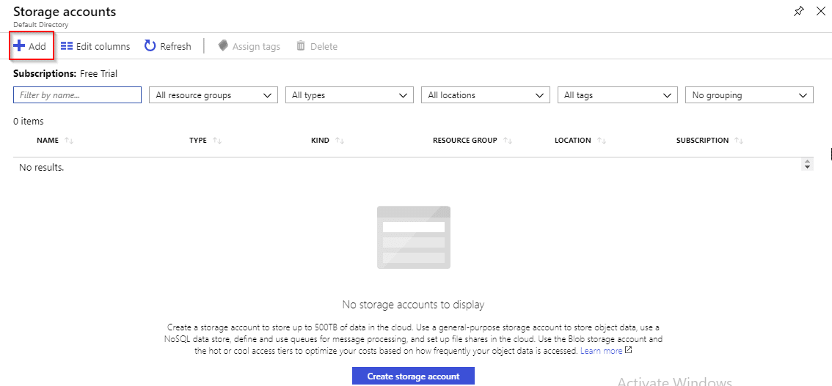](https://intellipaat.com/mediaFiles/2018/07/AzureStorage2.png)  
**Step 3:**You will be asked to fill in a few things.

1. Create a resource group if you don’t have one. If you already have it, then select the same

2. Name your account

3. Select the nearest location

[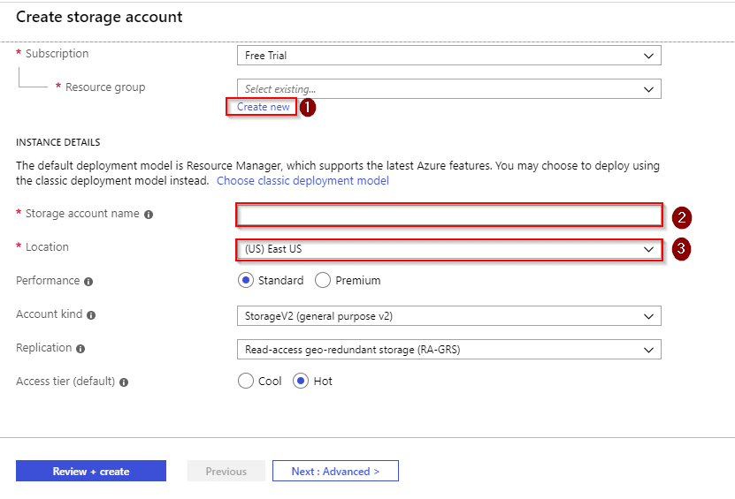](https://intellipaat.com/mediaFiles/2018/07/AzureStorage3.png)  
**Step 4:** Coming to the first step of **Step 3,**select **Create new** and add a name to your resource group  
[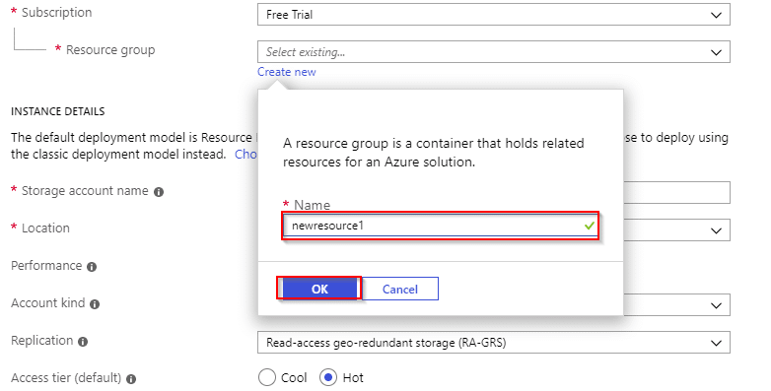](https://intellipaat.com/mediaFiles/2018/07/AzureStorage4.png)  
**Step 5:**After you have filled everything, click on **Review + create**.  
Check your options and details and then select **Create**  
[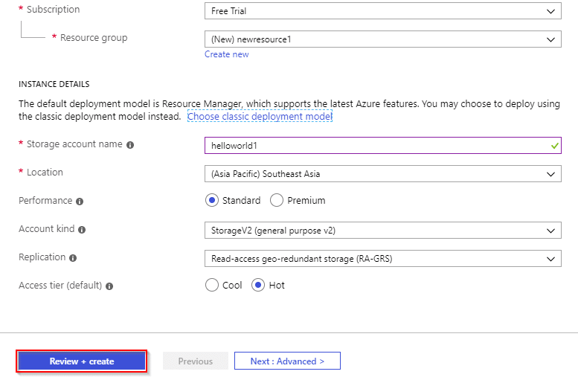](https://intellipaat.com/mediaFiles/2018/07/AzureStorage5.png)  
[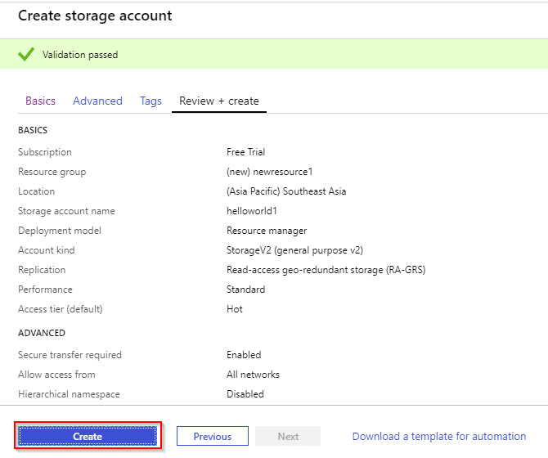](https://intellipaat.com/mediaFiles/2018/07/AzureStorage6-1.png)  
**Step 6:**After you press on **Create,**you will see a notification that your storage account has been deployed  
[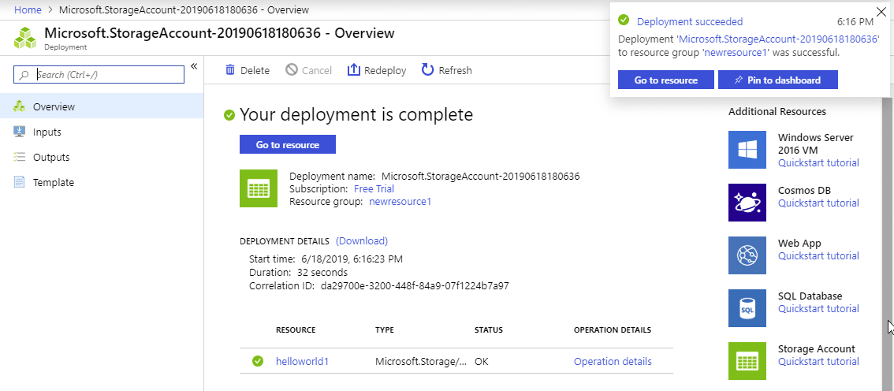](https://intellipaat.com/mediaFiles/2018/07/AzureStorage7.png)  
**Step 7:**

1. Go to **Access keys**on the left menu

2. Copy the name of your account and save it in a notepad

3. In the same notepad, copy and paste the link of key1/key2 and Connection strings.

[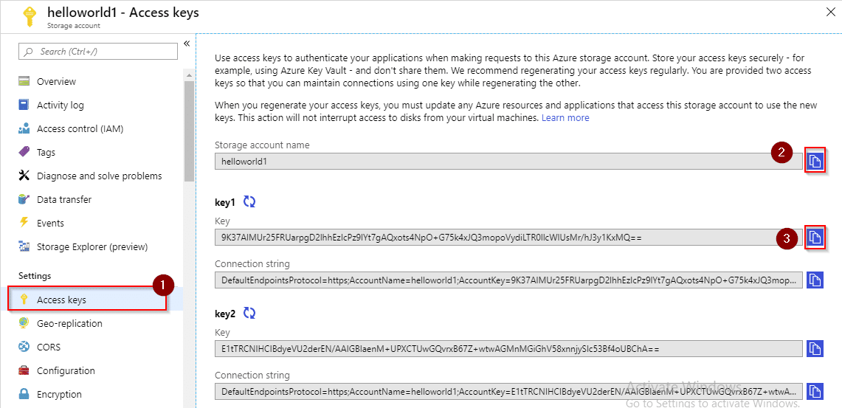](https://intellipaat.com/mediaFiles/2018/07/AzureStorage8.png)

**Azure Storage Explorer: Hands-on**

Before moving on with the types of storage, let us install the Azure Storage Explorer. We will be working with it for blobs, queues, files, and tables.  
**Step 8:**Search for Azure Storage Explorer and open the link. You will be able to see an option to download. Select your OS and click on the download link  
[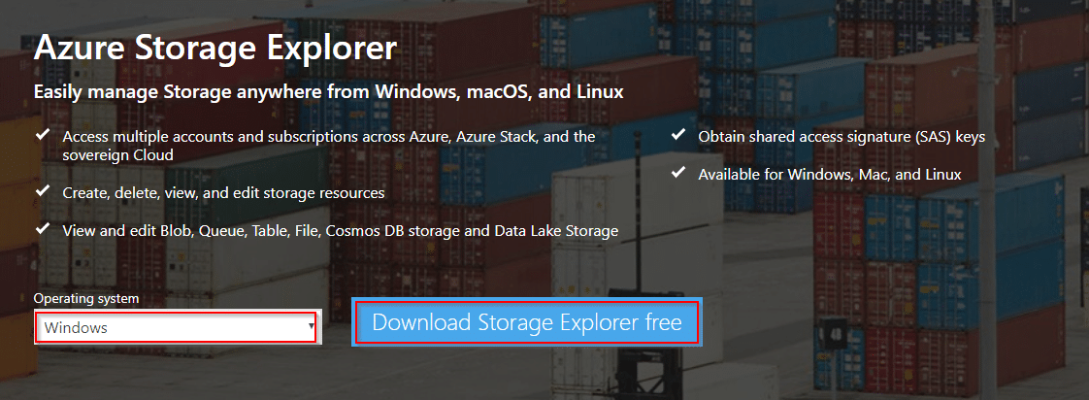](https://intellipaat.com/mediaFiles/2018/07/AzureStorage9.png)  
**Step 9:**After downloading it, install the explorer. Once done, it will ask you to connect with your Azure Storage account. Select the radio button **Use a connection string**and click on **Next**  
[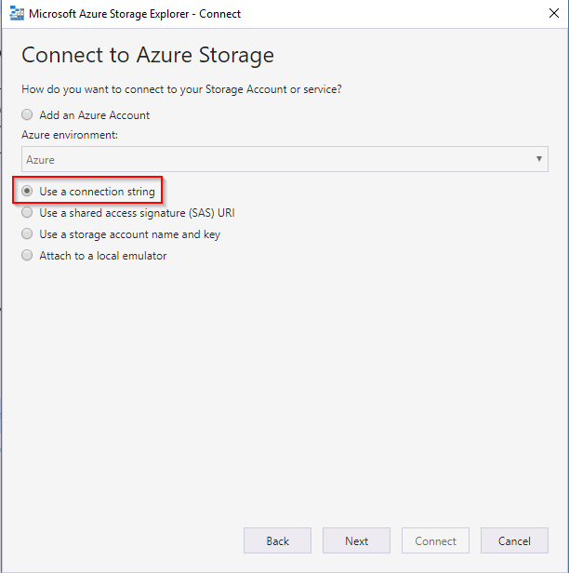](https://intellipaat.com/mediaFiles/2018/07/AzureStorage10.png)  
**Step 10:**Remember the notepad where you saved the details in **Step 7?**

1. Enter the storage account name

2. Paste the Connection string link that you saved

3. Click on **Connect** for connecting with your Azure Storage account

[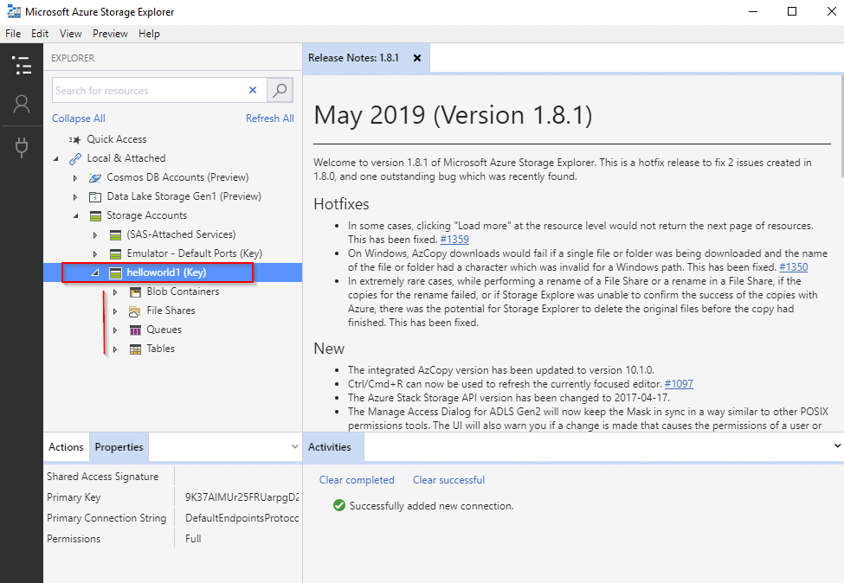](https://intellipaat.com/mediaFiles/2018/07/AzureStorage11.png)  
**Step 11:**Once you are connected, you will be able to see your account on the left side. When you expand it, you can see the storage types  
[](https://intellipaat.com/mediaFiles/2018/07/AzureStorage12.png)

**Azure Blob: Hands-on**

Let us now create a blob and see if we can access any file from the URL  
**Step 12:**In Storage Explorer, right-click on **Blob Containers**, select **Create Blob Container,**and enter a name for your container  
[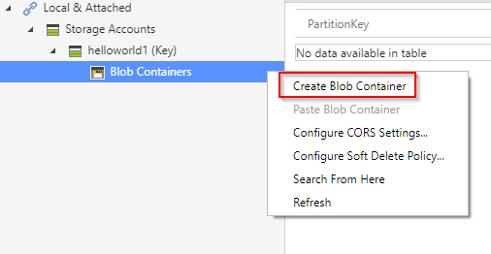](https://intellipaat.com/mediaFiles/2018/07/AzureStorage13.png)  
**Step 13:**Once done, click on the blob container that you have created. Select **Upload**and you can choose from uploading a folder or a file. Let’s upload a file here.  
[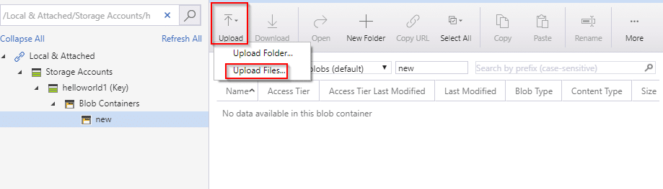](https://intellipaat.com/mediaFiles/2018/07/AzureStorage14.png)**Step 14:**Browse for any file or folder that you want to upload and select it. You can also choose the type of blobs. In this hands-on, let’s take the default option. Now, click on **Upload**  
[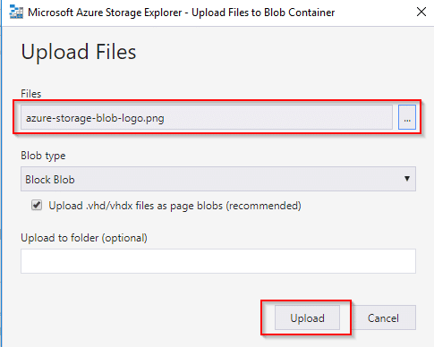](https://intellipaat.com/mediaFiles/2018/07/AzureStorage15.png)  
**Step 15:**Now that you have uploaded a file, go to Azure portal and to your storage account. Select **Blobs**and you will be able to see the container that has been created. Once you select the container, you can see the file that was uploaded  
[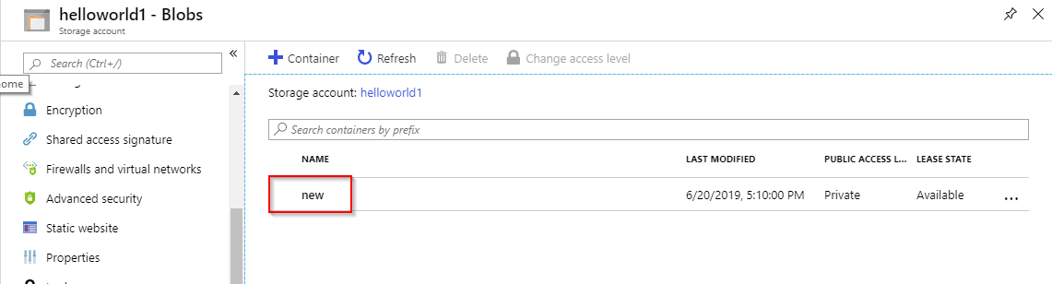](https://intellipaat.com/mediaFiles/2018/07/AzureStorage16.png)  
[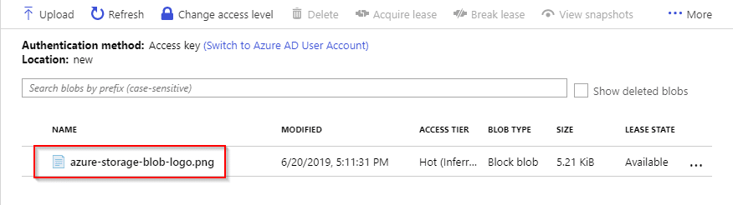](https://intellipaat.com/mediaFiles/2018/07/AzureStorage17.png)  
**Step 16:**Click on the uploaded file and you can view the details. There is a URL given, which you need to copy  
[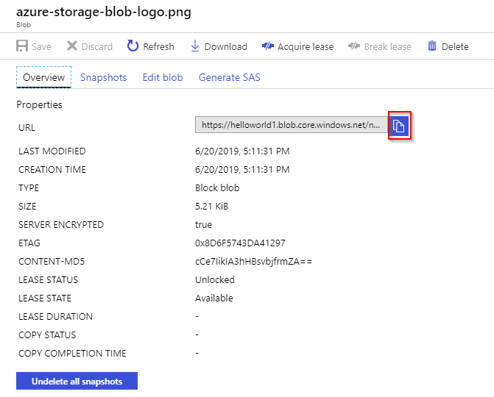](https://intellipaat.com/mediaFiles/2018/07/AzureStorage34.png)  
**Step 17:** To be able to view the file/folder, you need to change the access level of your blob account. In order to do that, go to the container and right-click on it. You can see a drop-down menu where you can select **Change access level.**  
**[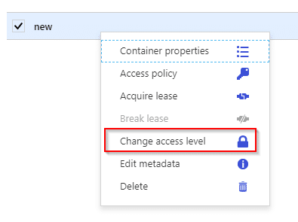](https://intellipaat.com/mediaFiles/2018/07/AzureStorage35.png)**  
**Step 18:**Once you select it, you can see a pop-up that has a drop-down menu for Public access level. Select the last option, **Container,** and close the window. After doing that, open a new tab and paste the URL. Voila! There is your file.  
[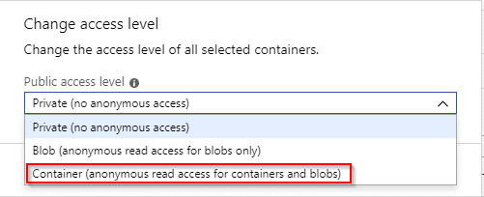](https://intellipaat.com/mediaFiles/2018/07/AzureStorage36.png)  
[](https://intellipaat.com/mediaFiles/2018/07/AzureStorage21.png)

**Azure Table: Hands-on**

**Step 19:** Under the storage account on Storage Explorer, select **Table**and you will be able to see a few tables (which are empty). Right-click on **Tables**and select **Create Table**  
**[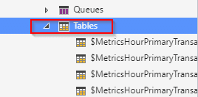](https://intellipaat.com/mediaFiles/2018/07/AzureStorage22.png)[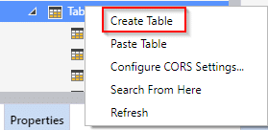](https://intellipaat.com/mediaFiles/2018/07/AzureStorage23.png)**  
**Step 20:**Name the new table and click on **Add**to add a column in your table  
[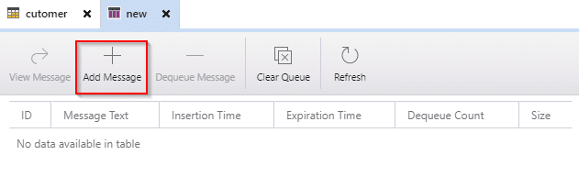](https://intellipaat.com/mediaFiles/2018/07/AzureStorage24.png)  
**Step 21:**Let us now add some column details

1. You can see **Add Property**at the bottom of the screen. Once you click on it, you can see a row add in on the screen below the two existing rows. After performing the following steps, you will be to see the column that you have entered

2. Enter the column name that you want to insert into the table

3. Choose the data type of your column value

4. Enter the value

Click on **Insert**

[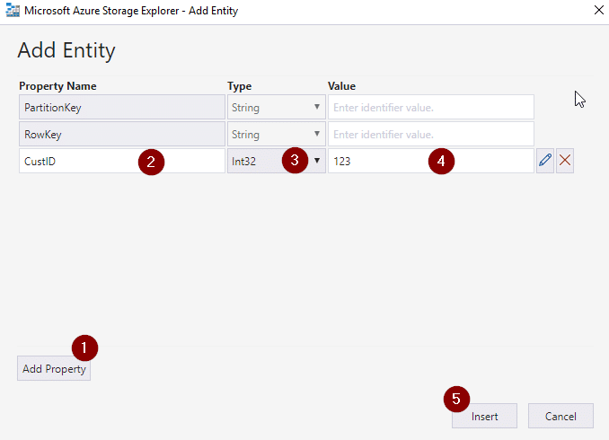](https://intellipaat.com/mediaFiles/2018/07/AzureStorage25.png)

**Azure File: Hands-on**

**Step 22:**Go to the portal and click on **Files**under the storage account. Click on **File share**to create a new file  
[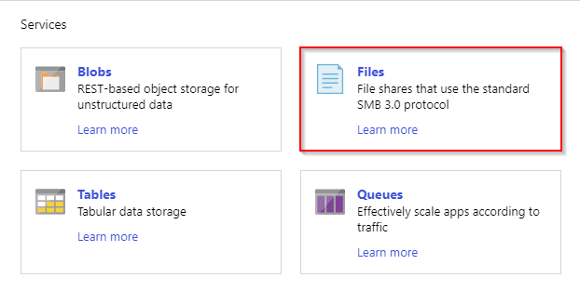](https://intellipaat.com/mediaFiles/2018/07/AzureStorage27.png)  
[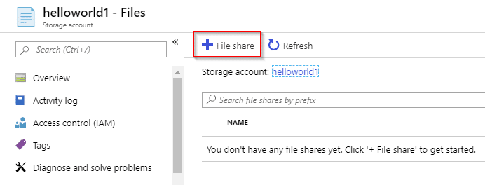](https://intellipaat.com/mediaFiles/2018/07/AzureStorage28.png)  
**Step 23:**

1. Enter the name that you want to keep for your file

2. Specify the number of Quota (GiB)

3. Press on **Create**

[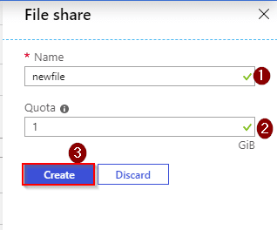](https://intellipaat.com/mediaFiles/2018/07/AzureStorage29.png)  
**Step 24:**Select the name of your file and right-click on it. Select **Properties**and you will be redirected to a window that has a URL. Copy the URL and save it in a notepad  
[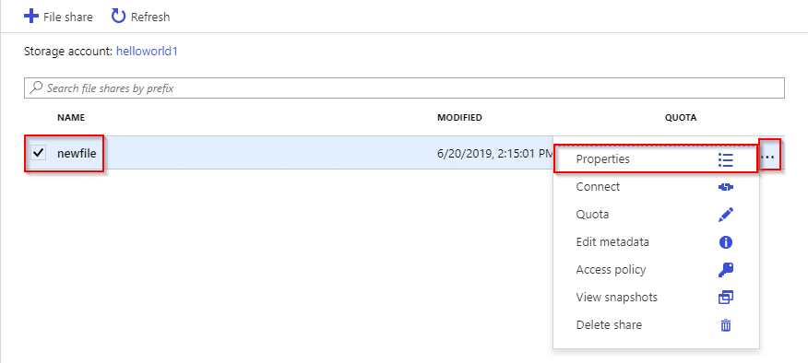](https://intellipaat.com/mediaFiles/2018/07/AzureStorage30.png)  
[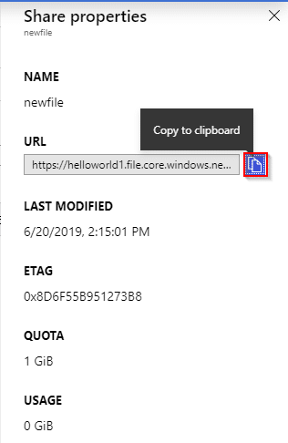](https://intellipaat.com/mediaFiles/2018/07/AzureStorage31.png)  
**Step 25:**Right-click on the **This PC**on your desktop and select **Map network drive**  
[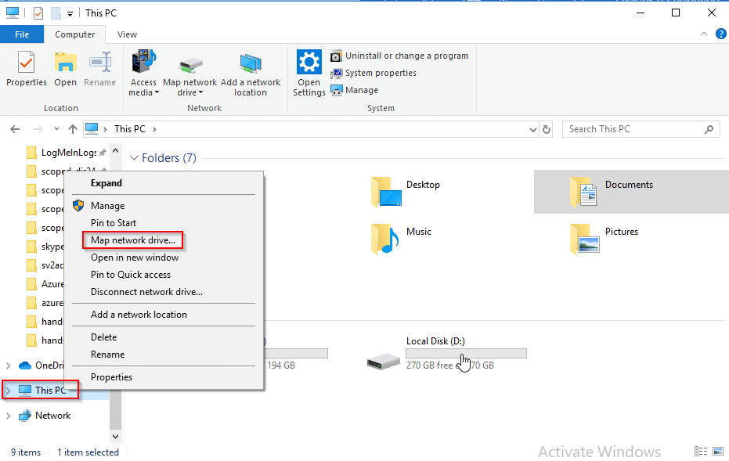](https://intellipaat.com/mediaFiles/2018/07/AzureStorage32.png)  
**Step 26:**Once you do that you can see a small window that will ask for some details.

1. Paste the URL from **Step 24.**Change the link according to the example given as shown below

2. Tick the second box

3. Click on **Finish**

[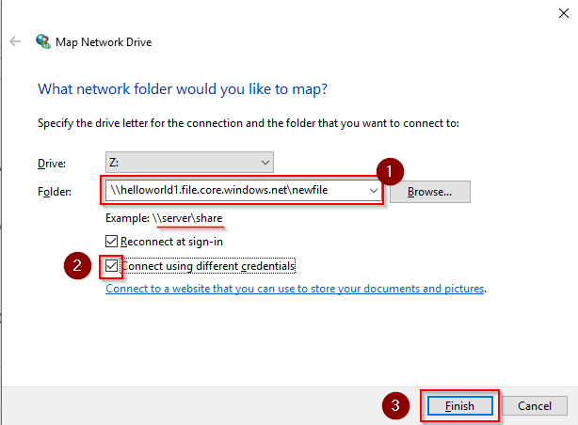](https://intellipaat.com/mediaFiles/2018/07/AzureStorage33.png)  
**Step 27:**You will be prompted to enter network credentials

1. Enter your storage account name

2. Paste the link of your access key

3. Select **OK**to proceed

You can see that a new storage space has been created.  
[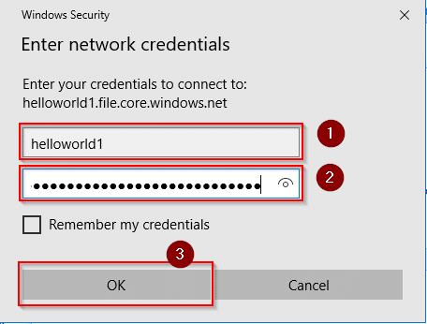](https://intellipaat.com/mediaFiles/2018/07/AzureStorage37.png)  
[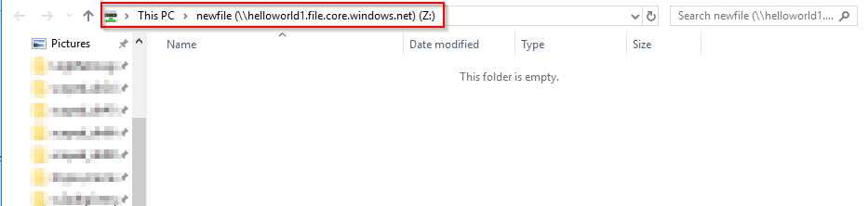](https://intellipaat.com/mediaFiles/2018/07/AzureStorage38.png)  
**Step 28:**Let us upload a file in our drive now. Go to the portal and select the file that we created in **Step 24.**Click on **Upload**and you can see a pop up

1. Browse for the file to be uploaded

2. Click on **Upload**to upload the file

[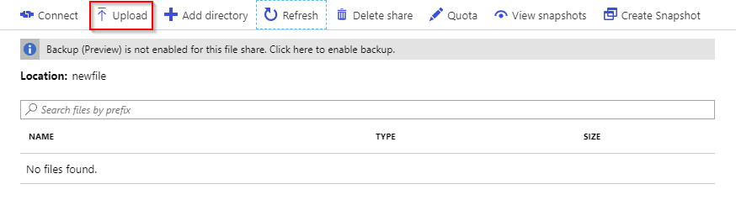](https://intellipaat.com/mediaFiles/2018/07/AzureStorage39.png)  
[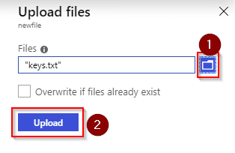](https://intellipaat.com/mediaFiles/2018/07/AzureStorage40.png)  
**Step 29:**You can see the file in the drive that you have created on your computer

[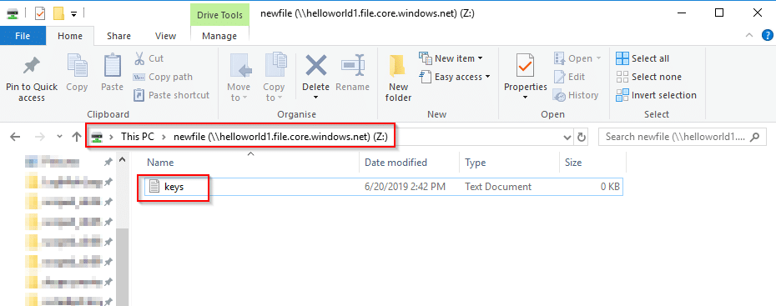](https://intellipaat.com/mediaFiles/2018/07/AzureStorage41.png)

**Azure Queue: Hands-on**

**Step 30:**Go to Storage Explorer, right-click on **Queues**and select**Create Queue** to create a new queue. Name the queue and select **Add Message**  
[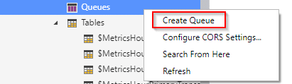](https://intellipaat.com/mediaFiles/2018/07/AzureStorage42.png)  
[](https://intellipaat.com/mediaFiles/2018/07/AzureStorage43.png)  
**Step 31:**

1. Write a message in the given space

2. Enter a number in the **Expires in** field

3. Now, select if you want it to be in seconds, minutes, days, months, etc. so that it will dequeue itself after the specified time

If you want, you can tick the box below to encode the message. Otherwise, leave it as is

1. Select **OK**to proceed

You can see the message once it is created.  
[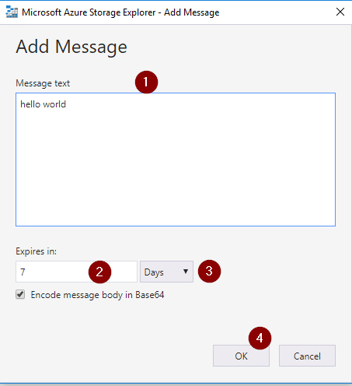](https://intellipaat.com/mediaFiles/2018/07/AzureStorage44.png)  
[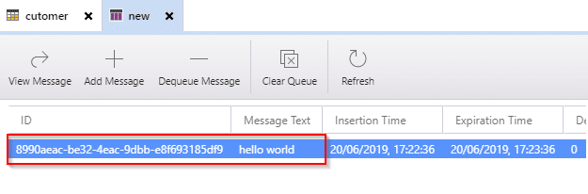](https://intellipaat.com/mediaFiles/2018/07/AzureStorage45.png)  
**Step 33:**Go to the portal and navigate to **Queue** from your storage account. You will be able to see the message. Since the specified expiration time is 7 minutes in this hands-on, it will get deleted after 7 minutes and you can no longer view it after you refresh the screen  
[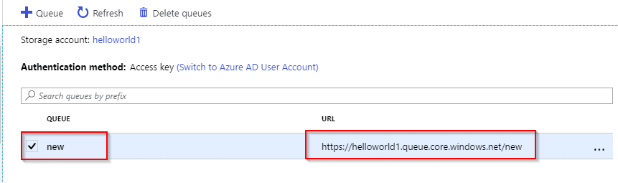](https://intellipaat.com/mediaFiles/2018/07/AzureStorage46.png)