**Azure Storage?**

**Azure Storage**is the cloud storage solution for modern applications that rely on durability, availability, and scalability to meet the need of their customers.

The very first thing you need, to use storage in azure is a **storage account.**

**Storage Accounts**

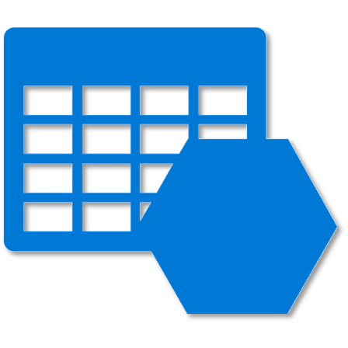

To use any storage type in azure, you first have to create an account in Azure. After creating an account, you can transfer data to or from services in your storage account. Create a storage account to store up to 500 TB of data in the cloud. Use the Blob storage account and the hot or cool access tiers to optimize your costs based on how frequently your object data is accessed.

A storage account can be of two types:

1. General Purpose
2. Blob Storage

Let’s discuss each one of them in detail:

**General Purpose Storage Account**

A general purpose storage account provides a space where, it gives you access to blobs, queues, files and tables, all of these services in a unified account. A general-purpose storage account can be used to store object data, can be used as a NoSQL data store, can be used to define and use queues for message processing, and set up ***file shares*** in the cloud.

As mentioned, primarily there are 4 types of storage types in azure:

* Tables
* Blobs
* Queues
* File Storage

**Tables**

The **Azure Table** storage service stores large amounts of structured data. The service is a NoSQL datastore which accepts authenticated calls from inside and outside the Azure cloud. Azure tables are ideal for storing structured, non-relational data.

**Blobs**

**Azure Blob** storage is a service that stores unstructured data in the cloud as objects/**blobs**. **Blob**storage can store any type of text or binary data, such as a document, media file, or application installer. **Blob** storage is also referred to as object storage.

**Queues**



**Azure Queue** storage is a service for storing large numbers of messages that can be accessed from anywhere in the world via authenticated calls using HTTP or HTTPS. A single **queue** message can be up to 64 KB in size, and a **queue** can contain millions of messages, up to the total capacity limit of a storage account.

**File Storage**

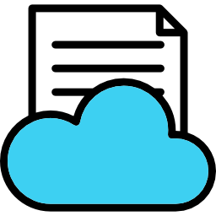

A **File Storage** share is an SMB **file** share in **Azure**. All directories and **files** must be created in a parent share. An account can contain an unlimited number of shares, and a share can store an unlimited number of **files**, up to the 5 TB total capacity of the **file** share.

**Blob Storage**

Blob storage accounts are specialized in storing blob data and can also be used to choose an **access tier**, which allows you to specify how frequently data in the account is accessed. You can choose an access tier suitable for your storage and which suits your expenses.

There are two types of access tier:



**Hot:**This access tier grants us the lowest latency possible. Hence, it should be used with data which is frequently accessed. Naturally, since it offers low latency it is more expensive.



**Cold:**This access tier is less in performance than the “Hot” access tier i.e offers higher latency than the former access tier. That being said, it comes with a lesser price tag and hence can be used for data which is less frequently accessed.

Moving on, both these storage account types i.e **blob storage** and **general purpose storage account** are designed to be highly available. With high availability, you can be assured that your files hosted on azure will be available 24×7. And high availability is only possible using replication.

**Replication**

There are basically 4 types of replication in Azure:

**Locally Redundant Storage**

Locally Redundant Storage (LRS) replicates your data three times within a storage scale unit i.e inside a datacenter. The datacenter resides in the region where you created your storage account. A write request returns successfully only when it has been written to all three replicas. Each of these replicas reside in separate fault domains and upgrade domains within one storage scale unit.

**Zone Redundant Storage**

Zone-Redundant Storage (ZRS) replicates your data asynchronously across datacenters within one or two regions in addition to storing three replicas similar to LRS, thus providing higher durability than LRS. Data stored in ZRS is durable even if the primary datacenter is unavailable or unrecoverable.

**Geo-Redundant Storage**

Geo-redundant storage (GRS) replicates your data to a secondary region that is hundreds of miles away from the primary region. If your storage account has GRS enabled, then your data is durable even in the case of a complete regional outage or a disaster in which the primary region is not recoverable.

**Read Access Geo-Redundant Storage**

Read-access geo-redundant storage (RA-GRS) maximizes availability for your storage account, by providing read-only access to the data in the secondary location, in addition to the replication across two regions provided by GRS.