TDD stands for Test Driven Development

it’s a design process in software development.

**Lifecycle of TDD**

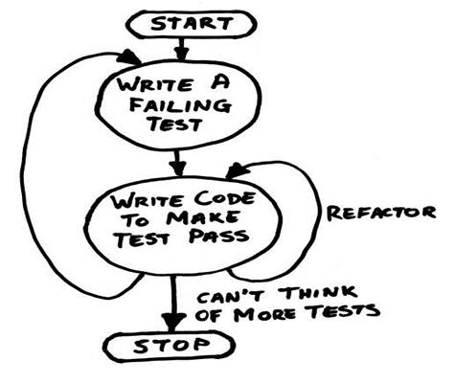

The above image depicts the lifecycle; TDD goes through. Typically, it starts with writing negative test cases, then it keeps refining and refactoring the code until it passes.

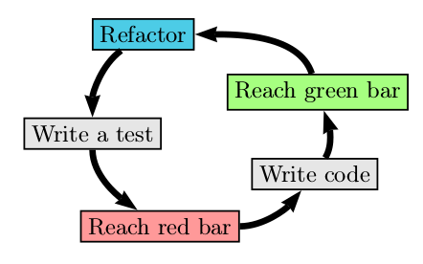

Test-Driven Development (TDD) consists of writing the tests before writing the code as illustrated in the workflow above.

First of all, the test is written and must fail at the beginning. Then, the code is written so that the test passes. Then, the test must be executed and must succeed. Then, the code is refactored. Then, the test must be executed again to ensure that the code is correct.

To summarize, this is done through five steps:

1. Write a test.
2. The test must fail at the beginning.
3. Write the code so that the test passes.
4. Execute the test and ensure that it passes.
5. Refactor the code.

We can notice that in the workflow illustrated above, the test is executed after refactoring the code. This ensures that the code is still correct after the refactoring.

**Unit Test cases**

Unit Test cases are coded to test specific aspects of a functionality.

They are created to test positive, negative and exception scenarios.

They are independent with other tests in terms of scenario and execution order.

**Unit Test Frameworks**

There are several frameworks available in .Net

* MS Test (Microsoft.VisualStudio.TestTools.UnitTesting)
* Nunit (Can be downloaded from NuGet)
* Xunit (Can be downloaded from NuGet)

**Mocking**

Mocking is a method to create a dummy object of any concrete object. At times, when we test any particular method and it has a set of dependencies, we create a mock or dummy object to mimic the real object or dependency.

**Code Coverage**

Code coverage is the term used to present the percentage of code blocks covered as part of unit test cases. Generally having code coverage more than 80% is considered as good coverage however in some cases even 70% coverage is considered as good especially when there are lot of UI components involved.