Data Binding in Blazor

1. What Is Data Binding in Blazor?
Data Binding is the mechanism that connects UI elements (Razor components) with C# data (fields, properties, or models) so that:
- Data flows from the component to the UI
- User interactions flow from the UI back to the component
Blazor uses component-based rendering, and data binding ensures the UI automatically re-renders when state changes.

2. Why Data Binding Is Important
In Blazor applications, data binding enables:
- Dynamic UI updates without manual DOM manipulation
- Clean separation of UI and business logic
- Reactive user interfaces
- Simplified form handling and validation
Without data binding, every UI update would require explicit JavaScript or manual refresh logic.

3. Types of Data Binding in Blazor
Blazor primarily supports the following binding styles:
- One-Way Data Binding
- Two-Way Data Binding
- Event-Based (Manual) Binding
- Parameter Binding (Parent → Child)

4. One-Way Data Binding
Concept
Data flows only from the component (C#) to the UI.
Example
<h3>Hello, @UserName</h3>

@code {
string UserName = "Blazor Learner";
}
Key Points
- UI reflects the value of UserName
- Changes in UI do not update UserName
- Re-render happens automatically when UserName changes in code

5. Two-Way Data Binding (@bind)
Concept
Data flows both ways:
- Component → UI
- UI → Component
This is widely used in forms and inputs.

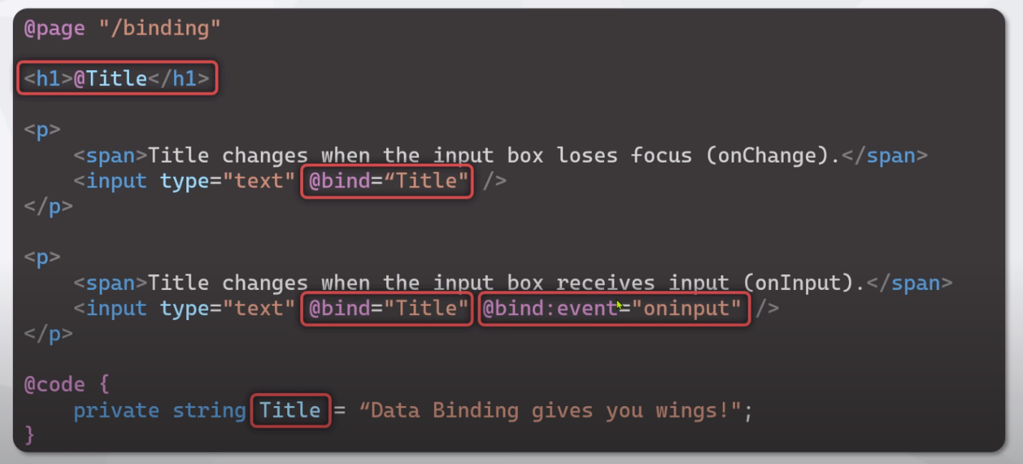
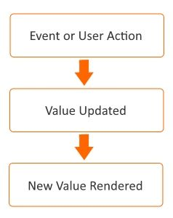
Example
<input @bind="Name" />
<p>You entered: @Name</p>

@code {
string Name = "";
}
How @bind Works Internally
@bind is syntactic sugar for:
- value
- onchange (or another event)
Equivalent expanded form:
<input value="@Name"
@onchange="e => Name = e.Value.ToString()" />

6. Binding with Different Input Controls
Control Type | Binding Example
TextBox | <input @bind="Text" />
Checkbox | <input type="checkbox" @bind="IsActive" />
Select | <select @bind="SelectedValue">
Number | <input type="number" @bind="Age" />
Numeric Binding Example
<input type="number" @bind="Age" />

@code {
int Age;
}
Blazor automatically handles type conversion.

7. Event-Based (Manual) Data Binding
Concept
You manually handle events and update state.
Example
<input @oninput="OnInputChanged" />
<p>@Message</p>

@code {
string Message;

void OnInputChanged(ChangeEventArgs e)
{
Message = e.Value?.ToString();
}
}
When to Use
- Custom validation logic
- High-frequency events (oninput)

8. Binding with Component Parameters (Parent → Child)
Parent Component
<ChildComponent Title="Dashboard" />
Child Component
<h3>@Title</h3>

@code {
[Parameter]
public string Title { get; set; }
}
Key Characteristics
- One-way binding by default
- Parent controls the data
- Child receives data via [Parameter]

9. Two-Way Binding Between Components
Blazor supports two-way binding between components using:
- [Parameter]
- EventCallback<T>
Child Component
<input @bind="Value" />

@code {
[Parameter] public string Value { get; set; }
[Parameter] public EventCallback<string> ValueChanged { get; set; }
}
Parent Component
<ChildComponent @bind-Value="UserName" />

10. Data Binding with Models (Forms)
Model Binding Example
<EditForm Model="@user">
<InputText @bind-Value="user.Name" />
<InputNumber @bind-Value="user.Age" />
</EditForm>

@code {
User user = new();

class User
{
public string Name { get; set; }
public int Age { get; set; }
}
}
Benefits
- Strong typing
- Validation support
- Clean form structure

11. Rendering and State Change
Blazor automatically re-renders a component when:
- A bound value changes
- An event handler completes
- StateHasChanged() is called explicitly
This makes data binding reactive by design.

