Blazor Chart Components using Syncfusion

🔷 What We Are Using
- Blazor 10.0 (Preview concepts are compatible with .NET 8/9 as well)
- Syncfusion Blazor Charts
- Syncfusion is a software company that provides a large suite of enterprise-grade UI components and developer tools used to build modern applications across web, desktop, and mobile platforms.
- Same chart APIs across:
  - Blazor Web App
  - Blazor Server
  - Blazor WebAssembly
✅ Important: Syncfusion components are UI-layer agnostic — once configured, charts behave identically across hosting models.

1️⃣ Getting Started with Syncfusion Charts
Step 1: Create Blazor 10.0 Apps
Blazor Web App
dotnet new blazor -n SyncfusionCharts.WebApp
Blazor Server App
dotnet new blazorserver -n SyncfusionCharts.Server
Blazor WASM App
dotnet new blazorwasm -n SyncfusionCharts.Wasm

Step 2: Install Syncfusion Package
dotnet add package Syncfusion.Blazor

Step 3: Register Syncfusion
Program.cs
builder.Services.AddSyncfusionBlazor();
Add License (Free Community License Available)
Syncfusion.Licensing.SyncfusionLicenseProvider
.RegisterLicense("YOUR_LICENSE_KEY");

_Imports.razor
@using Syncfusion.Blazor
@using Syncfusion.Blazor.Charts

wwwroot/index.html (WASM) or _Layout.cshtml
<link href="_content/Syncfusion.Blazor/styles/bootstrap5.css" rel="stylesheet" />
<script src="_content/Syncfusion.Blazor/scripts/syncfusion-blazor.min.js"></script>

2️⃣ Working with Data
Sample Data Model
public class SalesData
{
public string Month { get; set; }
public double Revenue { get; set; }
public DateTime Date { get; set; }
}
Sample Data Source
List<SalesData> Data = new()
{
new() { Month = "Jan", Revenue = 35, Date = new DateTime(2024,1,1) },
new() { Month = "Feb", Revenue = 40, Date = new DateTime(2024,2,1) },
new() { Month = "Mar", Revenue = 55, Date = new DateTime(2024,3,1) }
};

3️⃣ Basic Chart Structure
<SfChart Title="Monthly Sales">
<ChartPrimaryXAxis ValueType="ValueType.Category"></ChartPrimaryXAxis>
<ChartPrimaryYAxis Title="Revenue"></ChartPrimaryYAxis>

<ChartSeriesCollection>
<ChartSeries DataSource="Data"
XName="Month"
YName="Revenue"
Type="ChartSeriesType.Line">
</ChartSeries>
</ChartSeriesCollection>
</SfChart>

4️⃣ Chart Dimensions
<SfChart Width="800px" Height="400px">
or responsive:
<SfChart Width="100%" Height="350px">

5️⃣ Axis Types (Critical Interview Topic)

🟢 Category Axis
Used for string-based data
<ChartPrimaryXAxis ValueType="ValueType.Category" Title="Month" />
✔ Months
✔ Product names
✔ Regions

🔵 Numeric Axis
Used for numbers
<ChartPrimaryYAxis ValueType="ValueType.Double"
Minimum="0"
Maximum="100"
Interval="10"
Title="Sales" />

🟣 DateTime Axis
Used for time-series data
<ChartPrimaryXAxis ValueType="ValueType.DateTime"
LabelFormat="MMM yyyy" />
Bind:
XName="Date"

🟠 Logarithmic Axis
Used for large value ranges
<ChartPrimaryYAxis ValueType="ValueType.Logarithmic"
LogBase="10"
Title="Growth Rate" />
✔ Financial
✔ Scientific
✔ Analytics dashboards

6️⃣ Axis Labels & Customization
<ChartPrimaryXAxis
LabelIntersectAction="LabelIntersectAction.Rotate45"
LabelStyle="new ChartAxisLabelStyle { Color = \"blue\" }" />
Formatting
<ChartPrimaryYAxis LabelFormat="{value}K" />

7️⃣ Axis Customization (Advanced)
<ChartPrimaryXAxis
MajorGridLines="new ChartAxisMajorGridLines { Width = 0 }"
MajorTickLines="new ChartAxisMajorTickLines { Width = 0 }" />
✔ Clean dashboards
✔ Executive-friendly visuals

8️⃣ Stripline (Highlight Ranges)
<ChartPrimaryYAxis>
<ChartAxisStriplines>
<ChartStripline
Start="40"
End="60"
Text="Target Range"
Color="#e0f3ff" />
</ChartAxisStriplines>
</ChartPrimaryYAxis>
✔ SLA thresholds
✔ Warning zones
✔ Performance bands

9️⃣ Multiple Panes (Multi-Axis Charts)
<SfChart>
<ChartPanes>
<ChartPane Height="50%" />
<ChartPane Height="50%" />
</ChartPanes>

<ChartSeriesCollection>
<ChartSeries PaneIndex="0" Type="ChartSeriesType.Line" />
<ChartSeries PaneIndex="1" Type="ChartSeriesType.Column" />
</ChartSeriesCollection>
</SfChart>
✔ KPI dashboards
✔ Finance + Volume comparisons

🔟 Chart Types (With Practical Examples)
📈 Line Chart
Type="ChartSeriesType.Line"
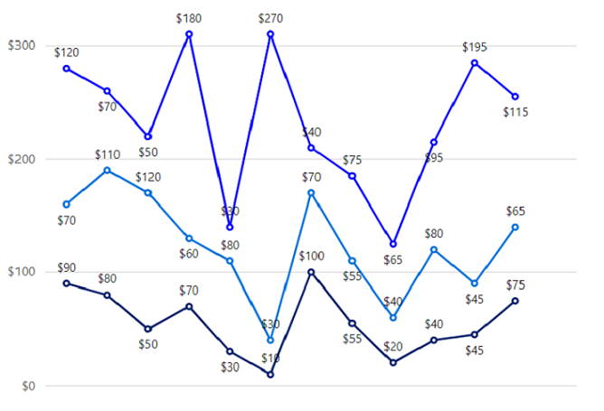
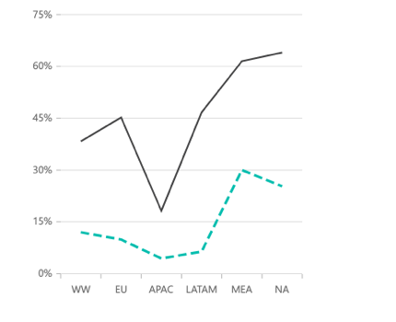

🌊 Area Chart
Type="ChartSeriesType.Area"
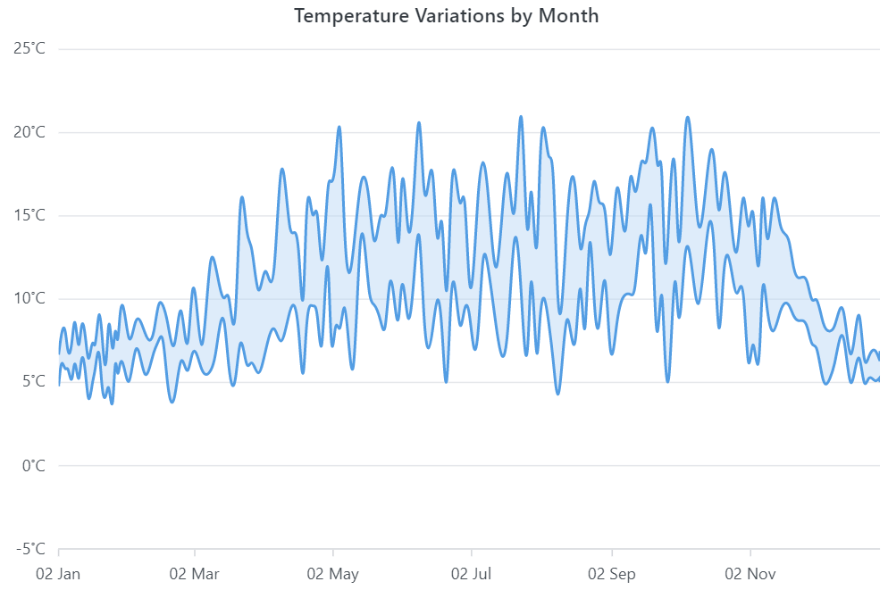
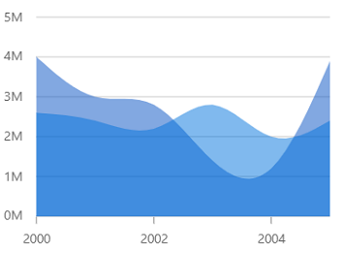

📊 Bar / Column Chart
Type="ChartSeriesType.Column"
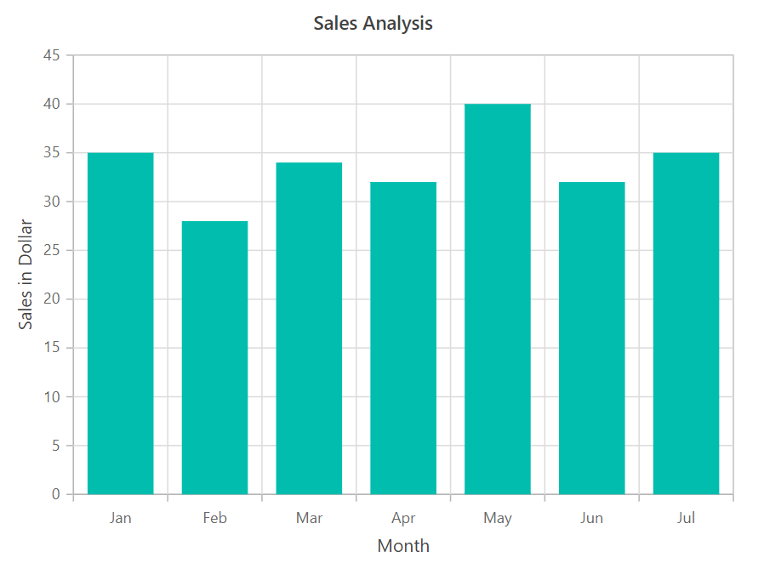
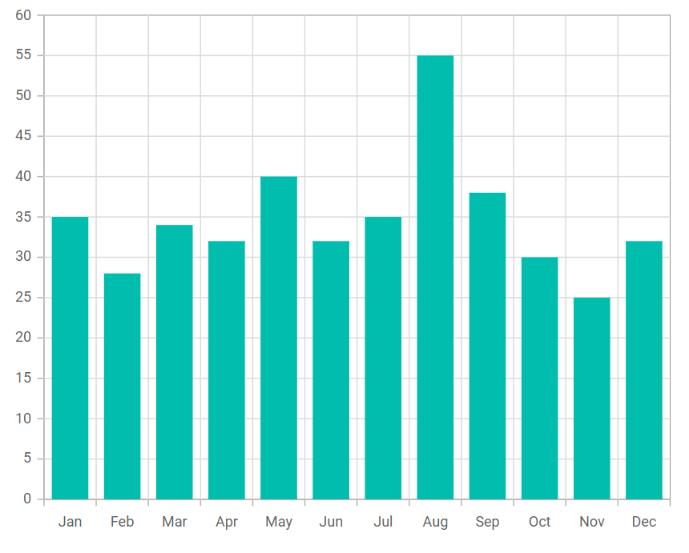

🔵 Scatter & Bubble Charts
Type="ChartSeriesType.Scatter"
Type="ChartSeriesType.Bubble"
Size="BubbleSize"
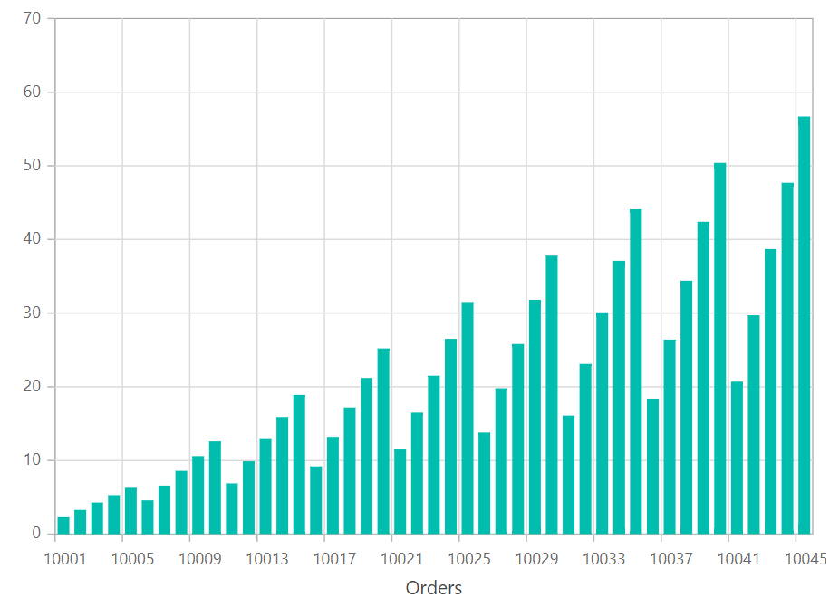
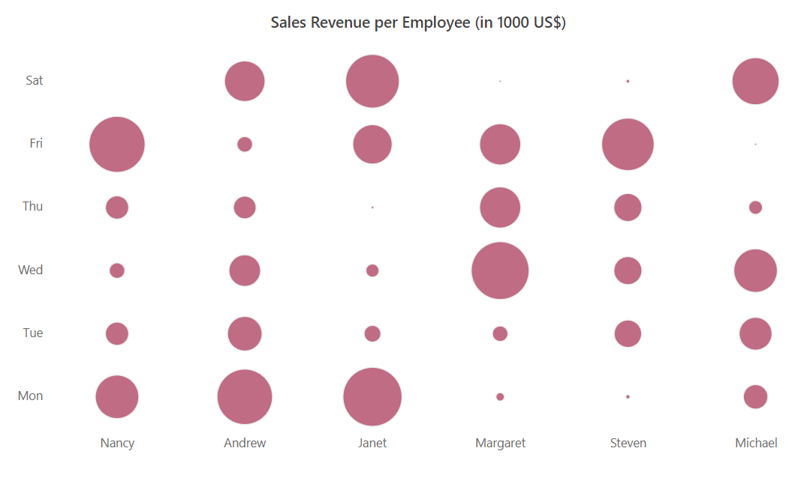

🔀 Mixed Chart (Most Asked in Interviews)
<ChartSeriesCollection>
<ChartSeries Type="ChartSeriesType.Column"
DataSource="Data"
XName="Month"
YName="Revenue" />

<ChartSeries Type="ChartSeriesType.Line"
DataSource="Data"
XName="Month"
YName="Revenue" />
</ChartSeriesCollection>
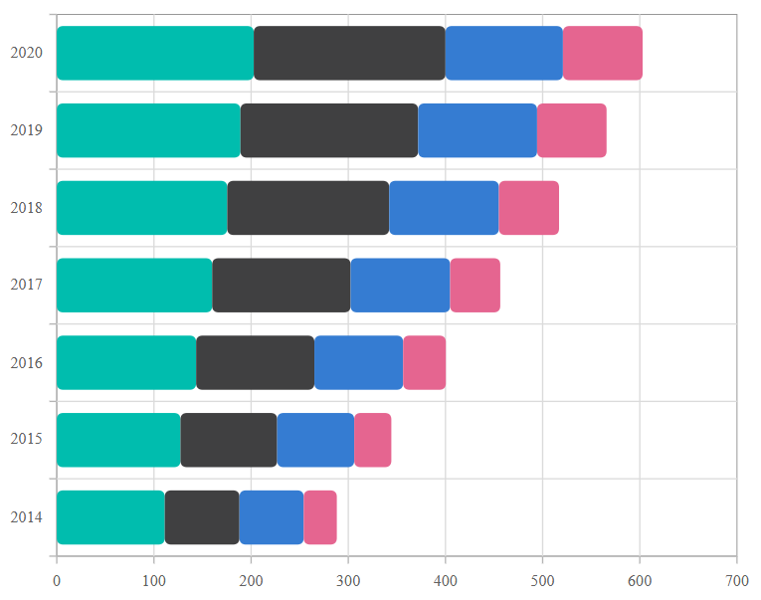
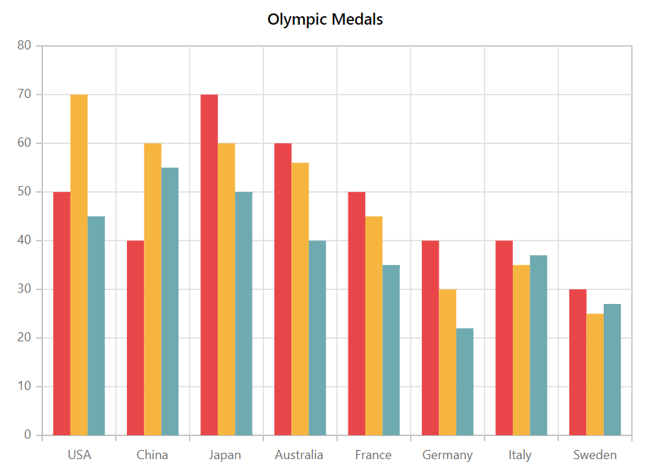

🔚 Final Notes (Real-World Guidance)
✔ Same chart code works in Web App / Server / WASM
✔ Prefer DateTime axis for analytics
✔ Use Striplines + Tooltips for dashboards
✔ Mixed charts = enterprise reporting standard

