Introduction: Blazor Charts with Chart.js
BlazorExpress.ChartJS is a Blazor wrapper around Chart.js, enabling you to render rich, interactive charts in Blazor applications without writing JavaScript manually.
Why use BlazorExpress.ChartJS?
- Native Blazor component model
- Strongly-typed configuration (C# instead of JS)
- Works with Blazor WebAssembly and Blazor Server
- Supports all major Chart.js chart types
- Easy data binding and dynamic updates

Blazor Hosting Models (NET 8)
1. Blazor WebAssembly (.NET 8)
Execution: Runs entirely in the browser (via WebAssembly)
Best for:
- Client-side dashboards
- Offline/PWA scenarios
- Public analytics portals
Chart behavior:
- Chart rendering + data processing in the browser
- Data fetched via HTTP APIs
2. Blazor WebApp (.NET 8) – Server
Execution: UI logic runs on the server, UI updates via SignalR
Best for:
- Internal dashboards
- Secure data visualization
- Heavy server-side processing
Chart behavior:
- ChartJS rendering still happens in browser
- Configuration & data come from server
Important: BlazorExpress.ChartJS works identically in both models, only the hosting differs.

Installation & Basic Setup
dotnet add package BlazorExpress.ChartJS
Add the Chart.js script in index.html (WASM) or _Host.cshtml (Server):
<script src="https://cdn.jsdelivr.net/npm/chart.js"></script>

Basic Chart Component Example (Shared)
@using BlazorExpress.ChartJS

<Chart Config="@_config" />

@code {
private ChartConfig _config = new ChartConfig
{
Type = ChartType.Bar,
Data = new ChartData
{
Labels = new[] { "Jan", "Feb", "Mar", "Apr" },
Datasets = new[]
{
new ChartDataset
{
Label = "Sales",
Data = new double[] { 120, 190, 300, 250 },
BackgroundColor = new[] { "blue" }
}
}
}
};
}

Chart Types (Concept + Practical Use)
Bar Chart
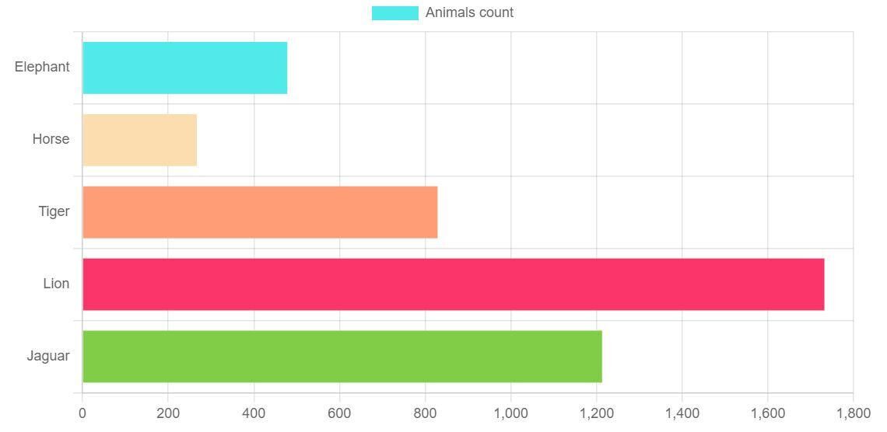
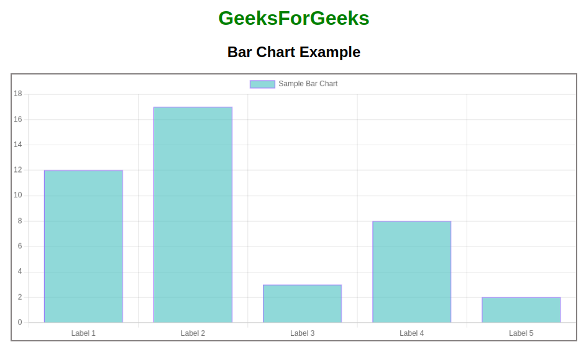
Use cases
- Monthly sales
- Comparison between categories
Type = ChartType.Bar

Line Chart
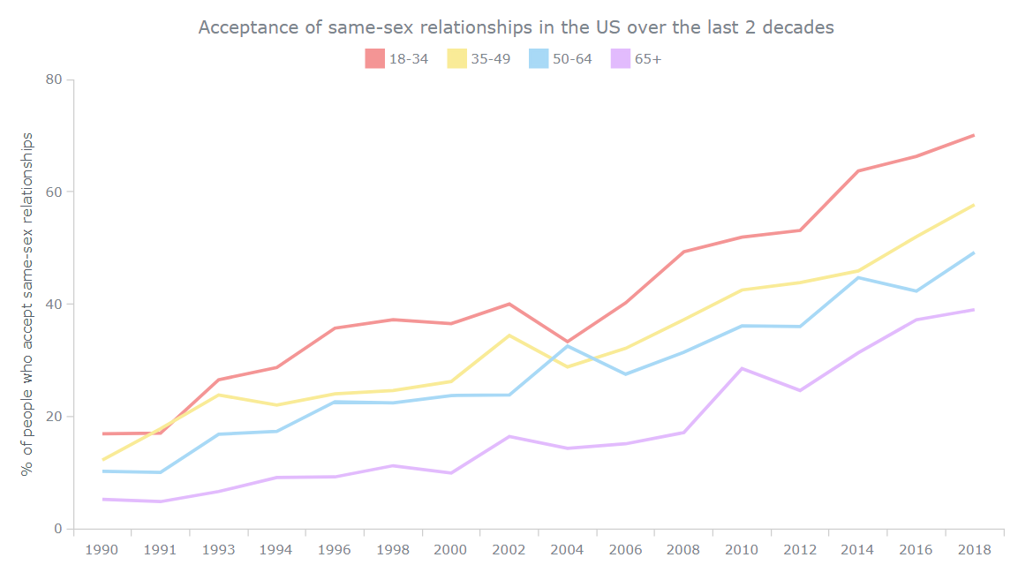
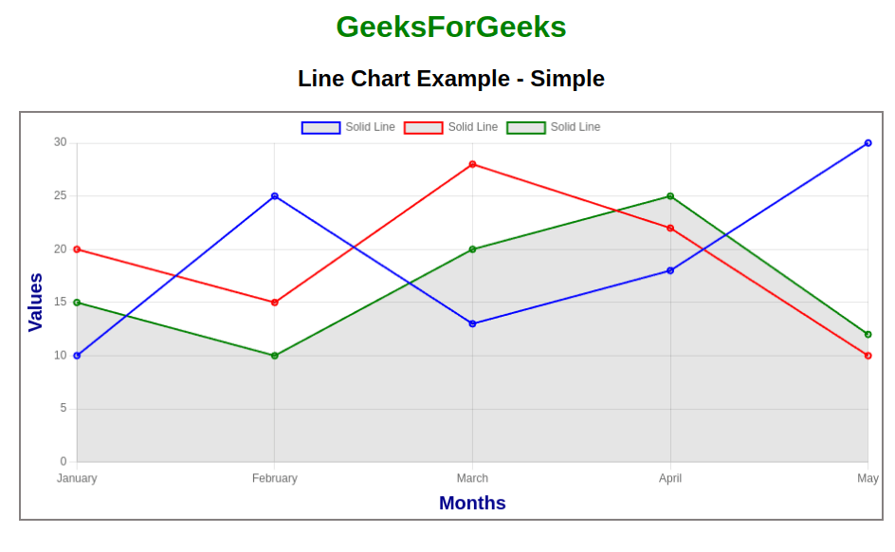
Use cases
- Trends over time
- Performance metrics
Type = ChartType.Line

Pie Chart
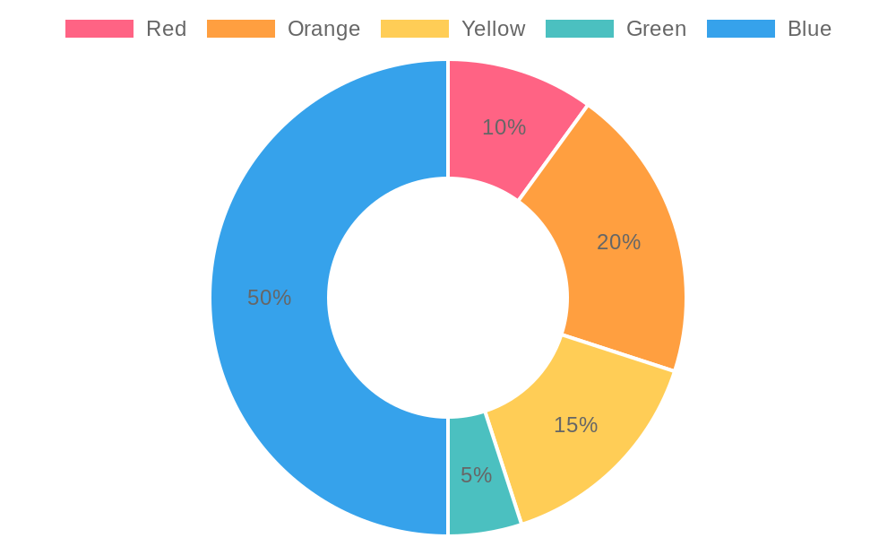
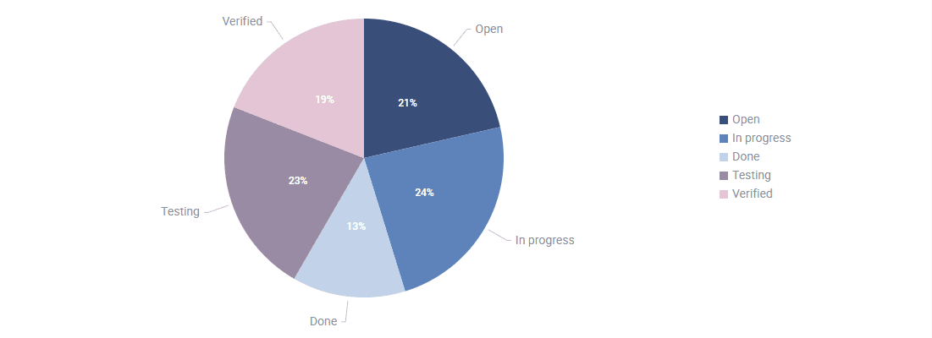
Use cases
- Percentage distribution
- Market share
Type = ChartType.Pie

Doughnut Chart
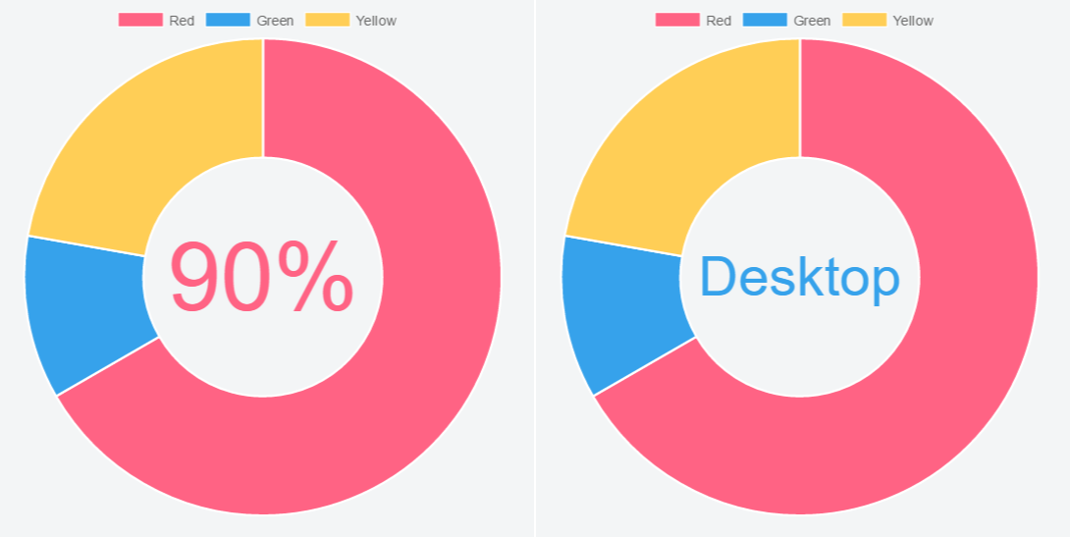
Use cases
- KPI dashboards
- Compact summaries
Type = ChartType.Doughnut

Bubble Chart

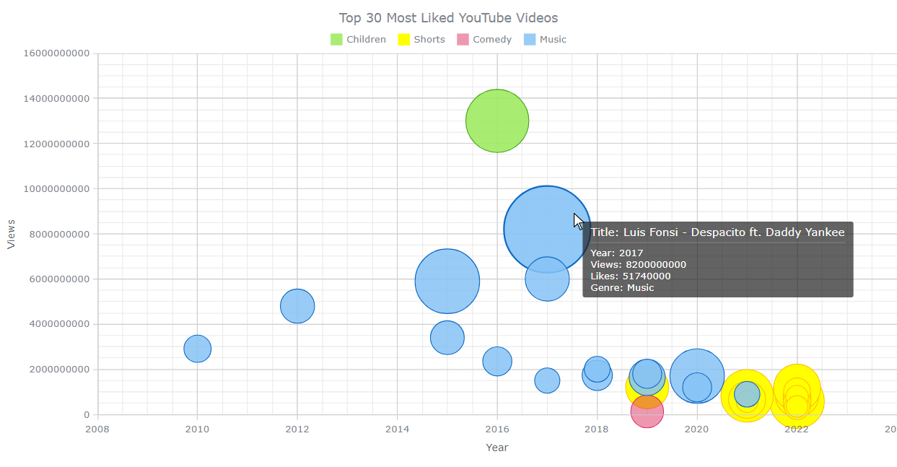
Use cases
- Risk analysis
- Multi-dimension data (X, Y, Size)
Type = ChartType.Bubble
Each data point includes x, y, and r (radius).

Scatter Chart
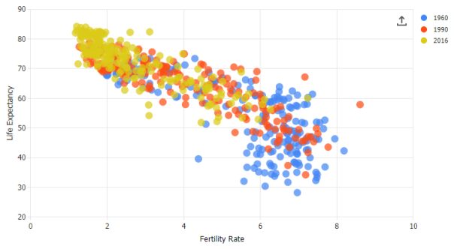
Use cases
- Correlation analysis
- Scientific data
Type = ChartType.Scatter

Radar Chart
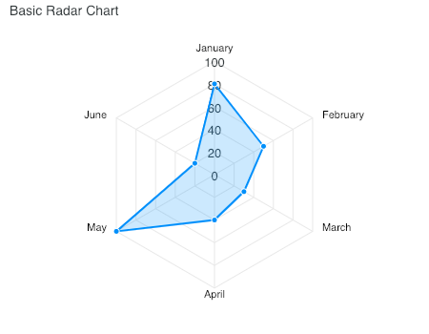
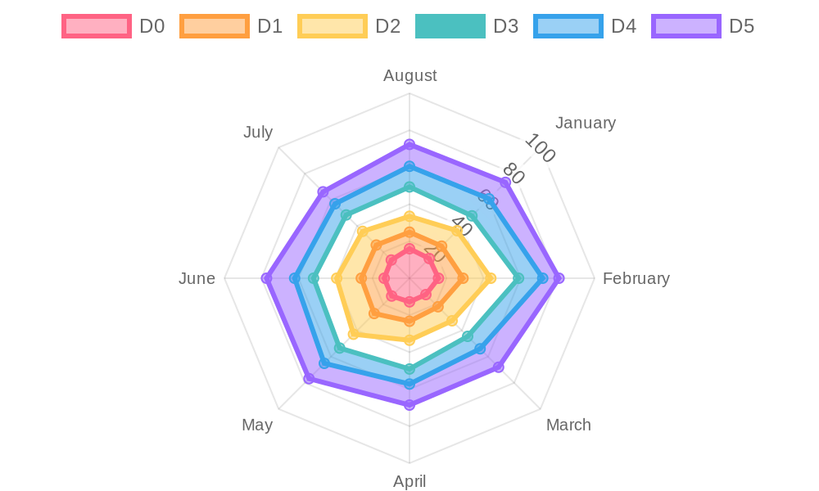
Use cases
- Skill comparison
- Performance evaluation
Type = ChartType.Radar

Polar Area Chart
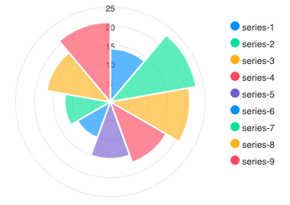
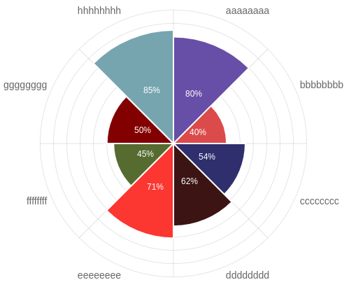
Use cases
- Weighted categorical data
- Circular data representation
Type = ChartType.PolarArea

Dynamic Data Update Example
<button @onclick="UpdateChart">Update</button>

@code {
void UpdateChart()
{
_config.Data.Datasets[0].Data =
new double[] { 150, 220, 180, 300 };
}
}
The chart automatically re-renders due to Blazor’s state change detection.

When to Use Which Chart
Chart Type | Best For
Bar | Comparisons
Line | Trends
Pie/Doughnut | Proportions
Bubble | Multi-dimension
Scatter | Correlation
Radar | Multi-metric comparison
PolarArea | Circular weighted data

Summary
- BlazorExpress.ChartJS provides a clean C# abstraction over Chart.js
- Works seamlessly with Blazor WebAssembly & Server (.NET 8)
- Supports all major chart types
- Ideal for dashboards, analytics, and reporting systems

