Integrating Azure OpenAI, with ASP.NET Core + Blazor (Server or WASM)
1️⃣ Setting up an Azure OpenAI Service
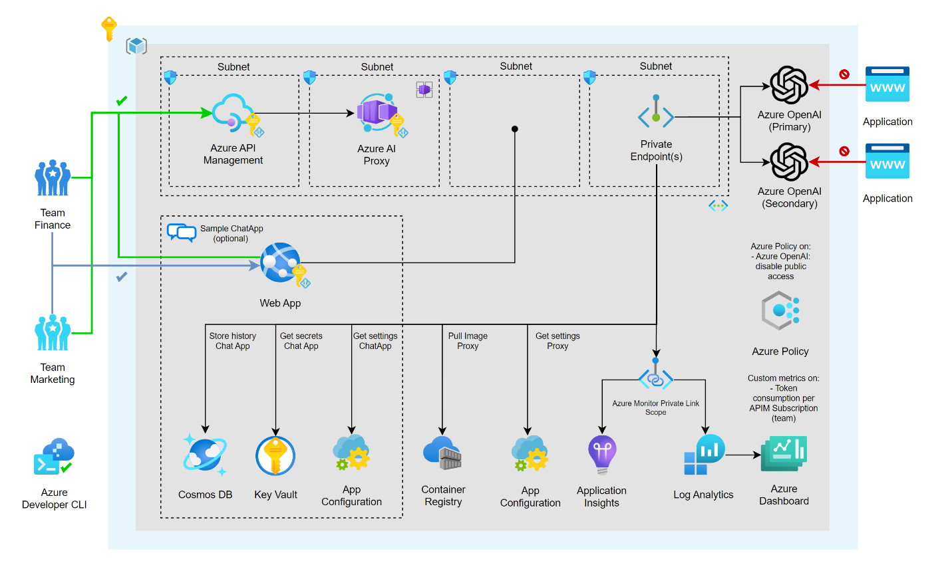

What is Azure OpenAI?
Azure OpenAI Service provides enterprise access to OpenAI models (GPT-4.x, GPT-4o, embeddings, etc.) with:
- Azure AD & API key security
- Regional compliance
- Private networking
- SLA & enterprise governance

Step-by-Step Setup
1. Create the Azure OpenAI resource
- Azure Portal → Create Resource
- Search Azure OpenAI
- Select region (important for latency + compliance)
- Pricing tier: Standard S0
2. Deploy a model
Azure OpenAI requires model deployment names.
Example:
Model | Deployment Name
GPT-4o-mini | gpt-chat
text-embedding-3-large | embeddings
⚠️ You never call the model name directly—only the deployment name

Required Configuration
// appsettings.json
{
"AzureOpenAI": {
"Endpoint": "https://your-openai-resource.openai.azure.com/",
"ApiKey": "YOUR_API_KEY",
"ChatDeployment": "gpt-chat",
"EmbeddingDeployment": "embeddings"
}
}

2️⃣ Implementing Smart Pasting (AI-assisted paste)
What is Smart Pasting?
When a user pastes raw or messy content, AI:
- Cleans formatting
- Summarizes
- Converts to structured text (Markdown / JSON / bullets)
- Removes sensitive data
Architecture
Clipboard → Blazor UI
→ API → Azure OpenAI
→ Cleaned Output → UI

Blazor Demo – Smart Paste
Razor Component
<textarea @onpaste="HandlePaste" class="form-control" rows="6"></textarea>

<p><b>AI Enhanced:</b></p>
<textarea class="form-control" rows="6">@enhancedText</textarea>
Code-Behind
private string enhancedText;

private async Task HandlePaste(ClipboardEventArgs e)
{
var pastedText = await JS.InvokeAsync<string>(
"navigator.clipboard.readText");

enhancedText = await _aiService.SmartPasteAsync(pastedText);
}
AI Prompt Logic
public async Task<string> SmartPasteAsync(string input)
{
var prompt = $"""
Clean and structure the following text.
Remove noise, fix grammar, and return concise bullet points.

Text:
{input}
""";

return await SendToOpenAI(prompt);
}

3️⃣ Implementing a Smart Text Area (Context-Aware AI Writing)

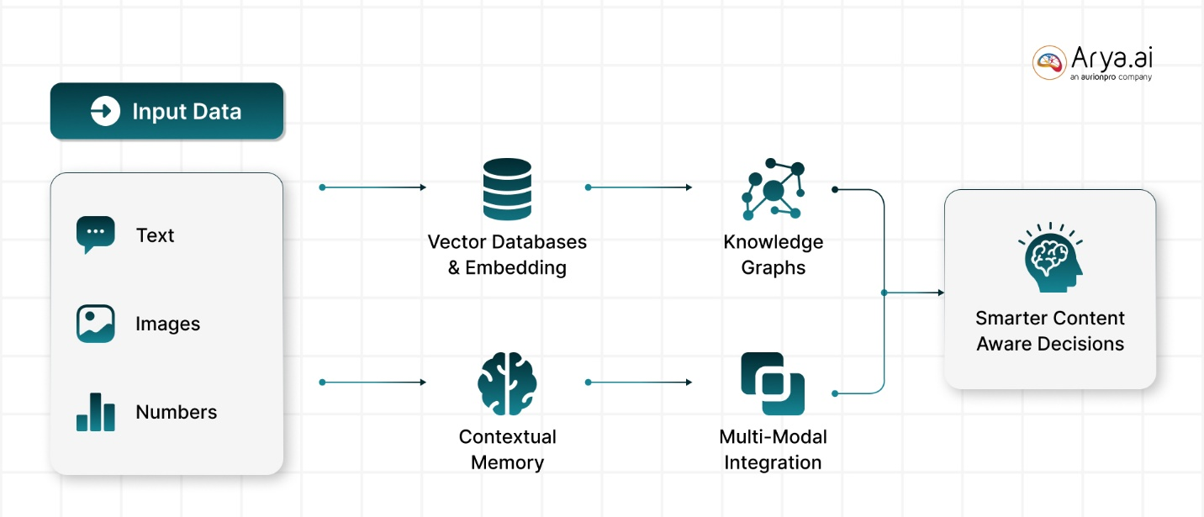
What Makes a Text Area “Smart”?
- Suggests next sentence
- Improves tone
- Auto-completes based on context
- Grammar + clarity optimization

Smart Text Area Example
<textarea @bind="userText" class="form-control"></textarea>
<button @onclick="ImproveText">Improve</button>

<p><b>Suggestion:</b> @aiSuggestion</p>
private async Task ImproveText()
{
aiSuggestion = await _aiService.EnhanceTextAsync(userText);
}
public async Task<string> EnhanceTextAsync(string text)
{
var prompt = $"""
Improve clarity and professionalism.
Do not change meaning.

Text:
{text}
""";

return await SendToOpenAI(prompt);
}
📌 Use cases
- Email drafting
- Code comments
- Requirement descriptions
- User stories (Jira 👍)

4️⃣ Adding a ChatBot (Conversational AI)
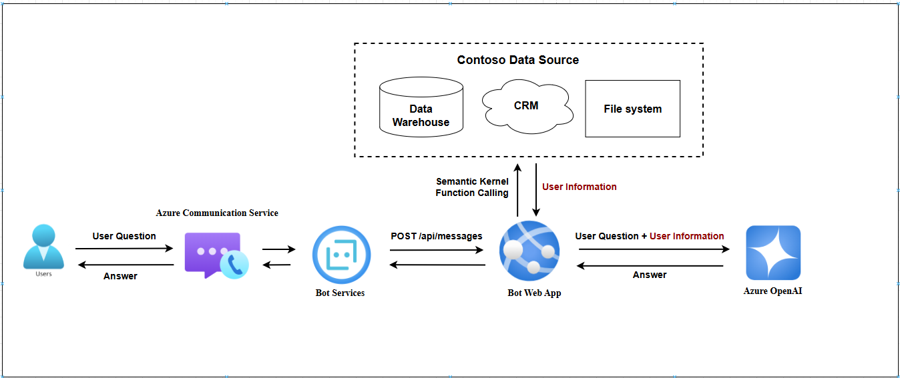

Core Concepts
- System Prompt → defines bot personality
- Conversation Memory
- User Messages
- Assistant Responses

ChatBot UI (Blazor)
<input @bind="userMessage" />
<button @onclick="Send">Send</button>

@foreach (var msg in chatHistory)
{
<p><b>@msg.Role:</b> @msg.Content</p>
}
private async Task Send()
{
var reply = await _aiService.ChatAsync(chatHistory, userMessage);
chatHistory.Add(("User", userMessage));
chatHistory.Add(("AI", reply));
}

Chat Service Logic
public async Task<string> ChatAsync(
List<(string Role, string Content)> history,
string userInput)
{
var messages = history.Select(h =>
$"{h.Role}: {h.Content}");

var prompt = string.Join("\n", messages)
+ $"\nUser: {userInput}\nAI:";

return await SendToOpenAI(prompt);
}
💡 Production tip
- Persist history in Redis / SQL
- Trim context to avoid token explosion

5️⃣ Connecting Azure OpenAI to an Existing Data Index (RAG)
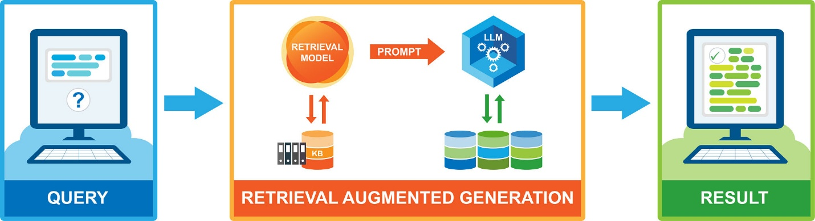

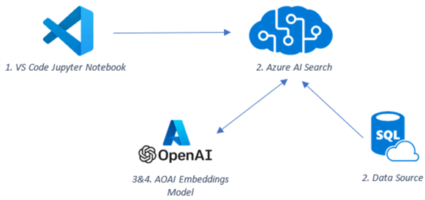
Why RAG?
LLMs:
- ❌ Do not know your private data
- ❌ Hallucinate
Retrieval-Augmented Generation (RAG) solves this.

High-Level Flow
User Question
↓
Generate Embedding
↓
Search Vector Index (Azure AI Search)
↓
Inject Retrieved Data into Prompt
↓
Azure OpenAI Answer

Embedding Generation
public async Task<float[]> CreateEmbedding(string text)
{
// Call embedding deployment
}

Querying Existing Data
var results = await _searchClient.SearchAsync<SearchDocument>(
vector: embedding,
top: 5
);

Final Prompt (RAG)
Answer using ONLY the context below.
If not found, say "Data not available".

Context:
- Product A price is 100
- Product B discontinued

Question:
What is the price of Product A?

🔐 Security & Best Practices
✔ Use server-side calls only (never expose API key)
✔ Rate limit AI endpoints
✔ Log prompts & responses (for audits)
✔ Validate user input (prompt injection defense)
✔ Cache responses where possible

🧠 Summary
Feature | What AI Adds
Smart Pasting | Clean & structured input
Smart Text Area | Context-aware writing
ChatBot | Conversational UX
Data Index (RAG) | Enterprise-safe AI answers

