1. Parent → Child Communication (Parameters)
Purpose
Used when a parent component passes data to a child component.
Mechanism
- [Parameter]
- [Parameter] with EventCallback (for interaction)
2. Child → Parent Communication (EventCallback)
Purpose
Used when a child component needs to notify the parent (e.g., button click, form submit).
Mechanism
- EventCallback
- EventCallback<T>
Example
ParentComponent.razor
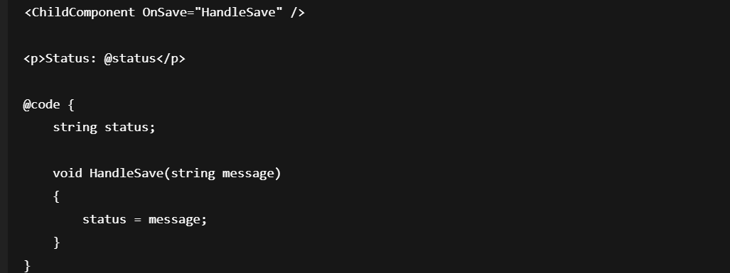
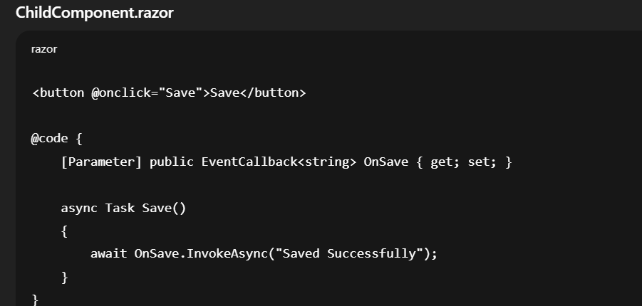

Key Points
- Asynchronous by design
- Keeps components loosely coupled
3. Parent ↔ Child (Two-Way Binding)
Purpose
Used when both parent and child need to stay in sync.
Mechanism
- @bind-Value
- Value + ValueChanged
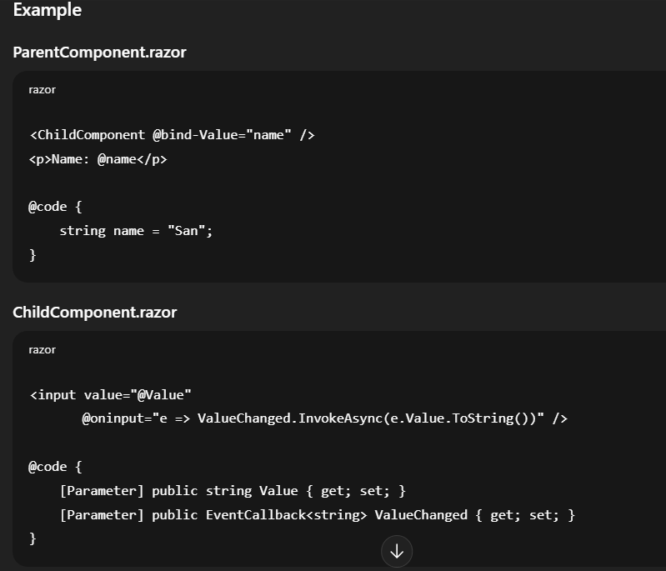

Key Points
- Convention-based (Value / ValueChanged)
- Common in form controls
4. Cascading Parameters (Implicit Parent → Many Children)
Purpose
Used to share common data across many nested components (e.g., user info, theme, culture).
Mechanism
- <CascadingValue>
- [CascadingParameter]
Example
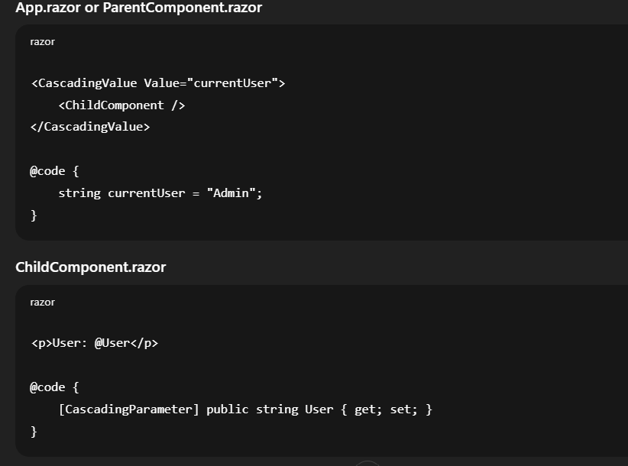
Key Points
- No explicit parameter passing
- Ideal for global data
- Avoid overuse (can reduce clarity)
5. Sibling Components Communication (State Container / Service)
Purpose
Used when components do not have a direct parent-child relationship.
Mechanism
- Shared service (State Container)
- Dependency Injection
- Events / NotifyStateChanged
Example
StateService.cs
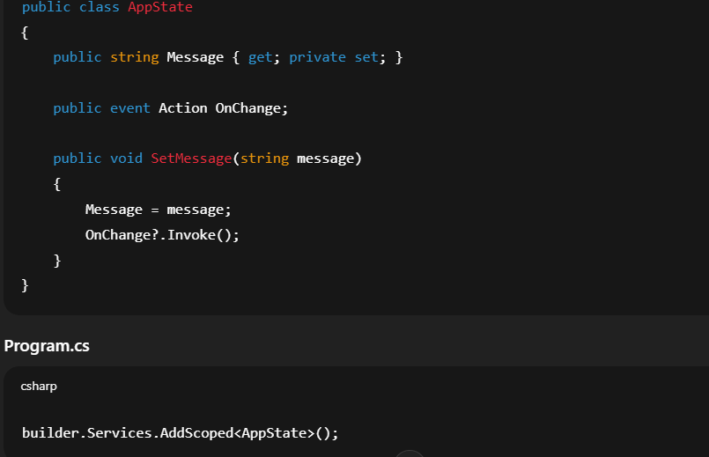
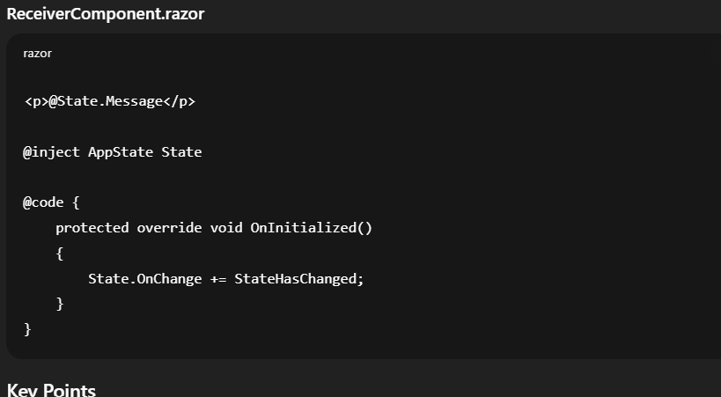
• Best for large applications
• Enables decoupled communication
6. Component Reference (@ref) – Direct Method Calls
Purpose
Used when a parent needs to call a child’s public method.
Example
ParentComponent.razor
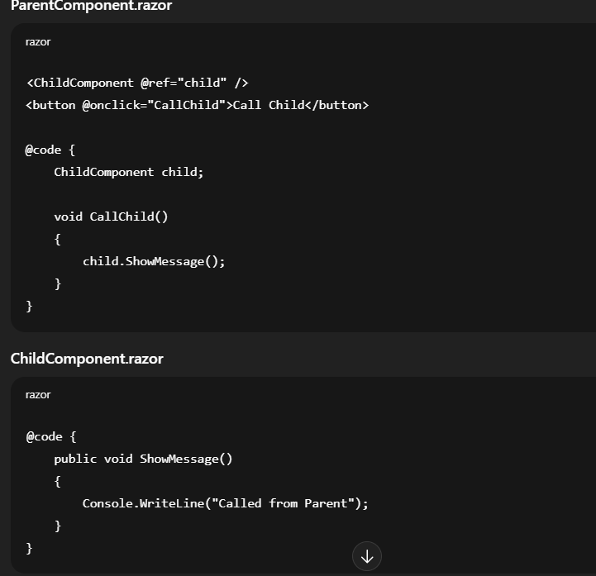

Key Points
- Tight coupling
- Avoid for state management
- Useful for UI control (dialogs, focus)
7. Choosing the Right Approach
Scenario Recommended Pattern
Parent → Child [Parameter]
Child → Parent EventCallback
Two-way binding @bind
Deep hierarchy Cascading Parameters
Siblings / Unrelated State Container
Direct control @ref

