1. What Is Data Binding in Blazor?
Data binding connects UI elements (HTML/razor components) with C# properties so that:
- UI updates when data changes
- Data updates when the user interacts with the UI
Blazor supports both synchronous and asynchronous binding scenarios.
2. Synchronous Data Binding
Definition
Synchronous data binding occurs when:
- Data is already available in memory
- No async operations (async/await)
- UI updates immediately on user interaction
This is the most common form of binding.
Example 1: Two-Way Synchronous Binding
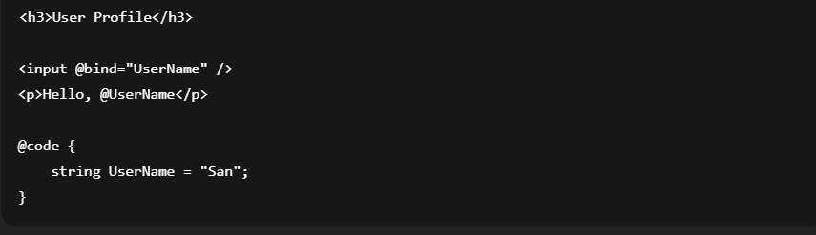
How It Works
- @bind creates two-way binding
- UI and property stay in sync
- Change happens in the same thread
- No waiting, no async lifecycle involved
Important Behavior
By default, Blazor uses:
@bind:event="onchange"
So the value updates after focus loss (Tab or click outside).

Immediate Update (Like Angular)
<input @bind="UserName" @bind:event="oninput" />
Now updates happen on every keystroke.

When to Use Synchronous Binding
- Form inputs
- Local calculations
- Toggle switches
- UI state (show/hide, enable/disable)
3. Asynchronous Data Binding
Definition
Asynchronous data binding occurs when:
- Data comes from API, database, or external service
- Uses async/await
- UI updates after the async operation completes
This is essential for real applications.
4. Asynchronous Binding with Lifecycle Methods
Example 2: Load Data from API
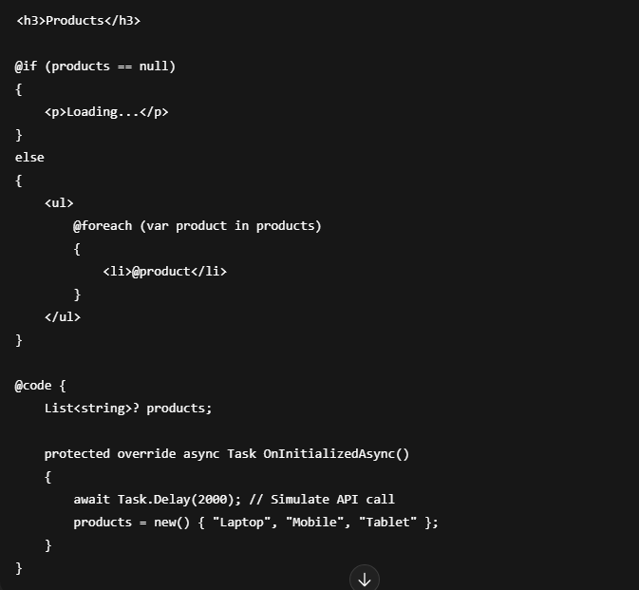
What Is Happening
- Component renders first
- OnInitializedAsync() runs
- UI shows Loading...
- Data arrives
- UI re-renders automatically
5. Async Binding Triggered by User Action
Example 3: Button Click with Async Update
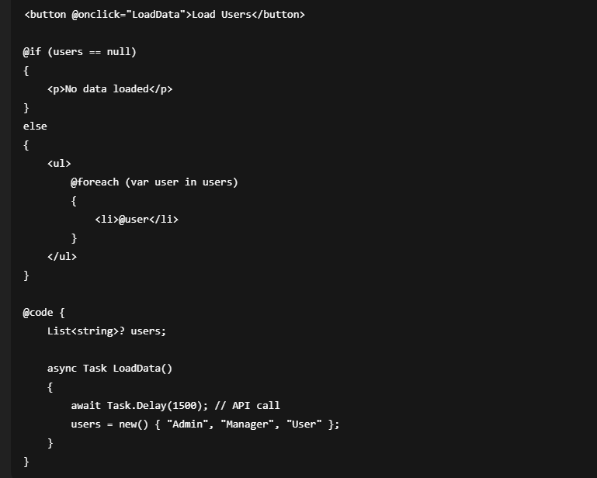

Key Point
- Event handler is async
- UI updates only after await completes
- No blocking of UI thread
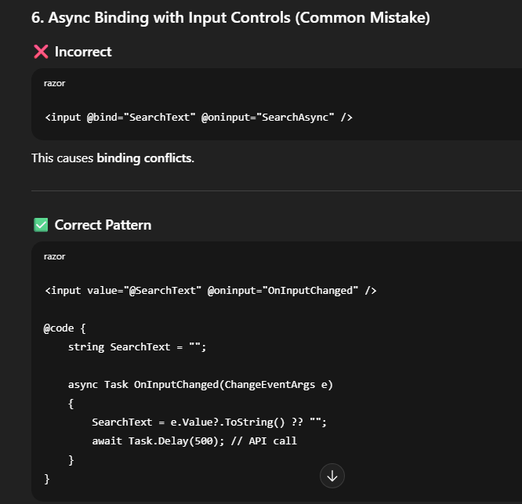

7. Synchronous vs Asynchronous Binding – Comparison
Aspect | Synchronous | Asynchronous
Execution | Immediate | Awaited
Thread | Same thread | Non-blocking
Data Source | Local | API / DB
Lifecycle | Simple | Lifecycle-based
UI Feedback | Instant | Loading states
Usage | Forms, UI state | Real applications

