1. Overview of ASP.NET Core SignalR
What is SignalR?
ASP.NET Core SignalR is a real-time communication framework.
It allows:
- Server ➜ Client push
- Client ➜ Server calls
- Bi-directional, low-latency messaging
Traditional HTTP vs SignalR
HTTP | SignalR
Request–Response | Persistent connection
Client must poll(Client must refresh regularly | Server pushes instantly
Stateless | Stateful connection
Transport mechanisms (automatic fallback)
- WebSockets (preferred)
- Server-Sent Events
- Long Polling
Core Concepts
Concept | Meaning
Hub | Central class for client–server communication
Client | Browser / Blazor / JS / Mobile
Method Invocation | Client calls server & vice-versa
ConnectionId | Unique per connected client
Groups | Broadcast to subsets of users
2. ASP.NET Core Blazor + SignalR (Big Picture)
Why SignalR fits Blazor perfectly
- Blazor UI updates are state-driven
- SignalR triggers UI refresh automatically
- No manual JavaScript polling
Blazor hosting models
Model | SignalR usage
Blazor Server | Uses SignalR internally already
Blazor WebAssembly | Uses SignalR explicitly (client → API)

🔷 3. .NET API (Browser / Backend)
We need:
- A Web API
- A SignalR Hub
- Endpoint mapping

🔷 4. Create the Solution (Step-by-Step)
Step 1: Create the Backend API
dotnet new webapi -n ChatApi
cd ChatApi
Step 2: Create Blazor WebAssembly App
dotnet new blazorwasm -n ChatClient
Solution structure:
ChatSolution
│
├── ChatApi (SignalR Hub)
└── ChatClient (Blazor UI)

🔷 5. Add the SignalR Client Library
Backend (API)
Already included:
<PackageReference Include="Microsoft.AspNetCore.SignalR" />
Blazor WebAssembly
dotnet add ChatClient package Microsoft.AspNetCore.SignalR.Client

🔷 6. Add a SignalR Hub (Backend)
📁 ChatApi/Hubs/ChatHub.cs
using Microsoft.AspNetCore.SignalR;

namespace ChatApi.Hubs;

public class ChatHub : Hub
{
public async Task SendMessage(string user, string message)
{
// Broadcast to ALL connected clients
await Clients.All.SendAsync("ReceiveMessage", user, message);
}
}
Explain to students
- Hub = communication gateway
- SendMessage = callable from clients
- Clients.All = broadcast

🔷 7. Add SignalR Services & Endpoint
📁 ChatApi/Program.cs
using ChatApi.Hubs;

var builder = WebApplication.CreateBuilder(args);

builder.Services.AddControllers();
builder.Services.AddSignalR();

builder.Services.AddCors(options =>
{
options.AddDefaultPolicy(policy =>
{
policy
.AllowAnyHeader()
.AllowAnyMethod()
.AllowCredentials()
.SetIsOriginAllowed(_ => true);
});
});

var app = builder.Build();

app.UseCors();

app.MapControllers();
app.MapHub<ChatHub>("/chathub");

app.Run();
Key teaching points
- AddSignalR() registers services
- MapHub<ChatHub>("/chathub") exposes endpoint
- CORS is mandatory for WASM

🔷 8. Create Razor Chat Component (Blazor)
📁 ChatClient/Pages/Chat.razor
@page "/chat"
@implements IAsyncDisposable

<h3>SignalR Chat</h3>

<input @bind="user" placeholder="Your name" />
<input @bind="message" placeholder="Message" />
<button @onclick="Send">Send</button>

<ul>
@foreach (var msg in messages)
{
<li>@msg</li>
}
</ul>

🔷 9. Chat Component Code-Behind
📁 Chat.razor.cs
using Microsoft.AspNetCore.SignalR.Client;

public partial class Chat
{
private HubConnection? hubConnection;
private string user = string.Empty;
private string message = string.Empty;
private List<string> messages = new();

protected override async Task OnInitializedAsync()
{
hubConnection = new HubConnectionBuilder()
.WithUrl("https://localhost:5001/chathub")
.WithAutomaticReconnect()
.Build();

hubConnection.On<string, string>("ReceiveMessage", (user, msg) =>
{
messages.Add($"{user}: {msg}");
InvokeAsync(StateHasChanged);
});

await hubConnection.StartAsync();
}

private async Task Send()
{
if (hubConnection is not null)
{
await hubConnection.SendAsync("SendMessage", user, message);
message = string.Empty;
}
}

public async ValueTask DisposeAsync()
{
if (hubConnection is not null)
{
await hubConnection.DisposeAsync();
}
}
}

🔷 10. Explain the Flow (Very Important for Students)
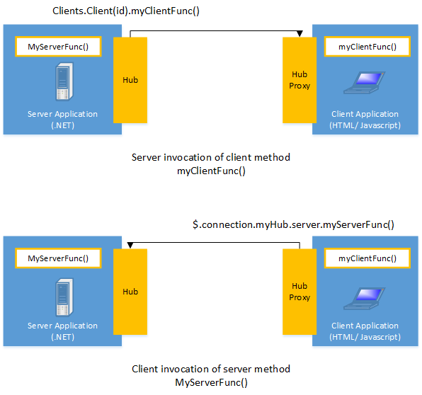

Step-by-step message flow
- Blazor client connects to /chathub
- User clicks Send
- SendMessage() called on Hub
- Hub broadcasts via Clients.All
- All clients receive ReceiveMessage
- UI updates automatically

🔷 11. Run the Demo
Start API
dotnet run --project ChatApi
Start Blazor
dotnet run --project ChatClient
Open two browser windows → real-time chat ✨

🔷 12. Common Errors & Fixes
Error | Cause | Fix
404 /chathub | Endpoint not mapped | MapHub missing
CORS error | WASM cross-origin | AllowCredentials()
Messages not updating | UI not refreshed | InvokeAsync(StateHasChanged)
Disconnects | Network drops | WithAutomaticReconnect()

🔷 13. Real-World Use Cases
- Live chat
- Notifications
- Stock prices
- Dashboards
- Multiplayer games
- Collaboration tools

