gRPC Services in Blazor Applications

1. Introduction to gRPC
What is gRPC?
gRPC (Google Remote Procedure Call) is a high-performance, contract-first, binary communication framework built on:
- HTTP/2
- Protocol Buffers (Protobuf) for serialization
- Strongly typed service contracts
Instead of REST endpoints (/api/products/1), gRPC exposes methods:
GetProduct(ProductRequest) → ProductResponse
Key Characteristics
Feature | Description
Transport | HTTP/2
Payload | Binary (Protobuf)
Contract | .proto file
Performance | Very high
Streaming | Client, Server & Bi-Directional
Typing | Strongly typed
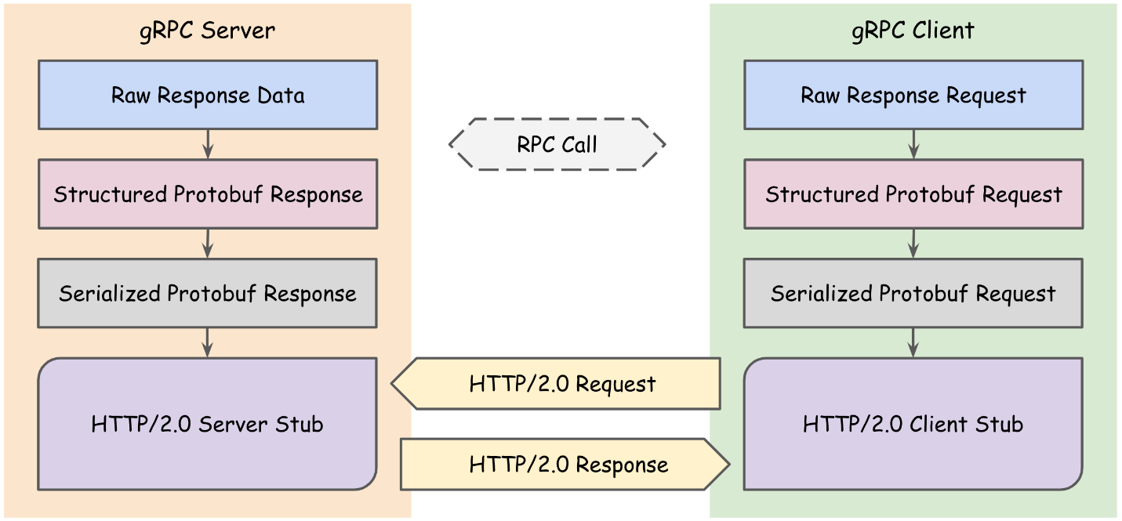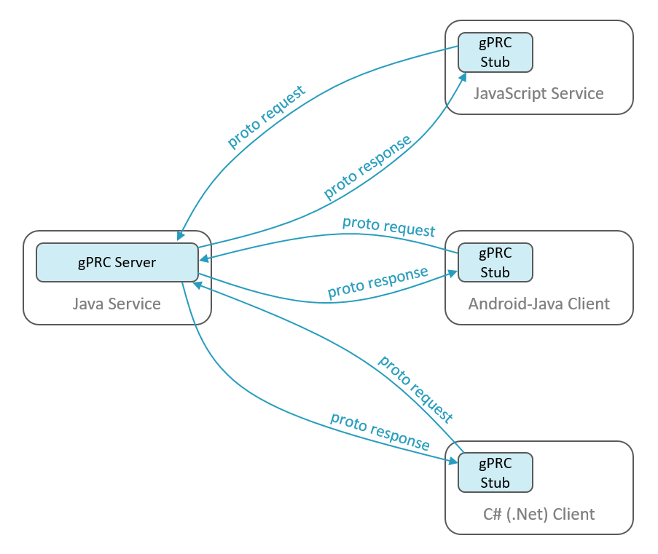
Why gRPC in Blazor?
- Extremely fast service-to-service calls
- Ideal for Blazor Server
- Excellent for microservices
- Compile-time safety

⚠️ Important limitation
- Blazor WebAssembly (browser) cannot call gRPC directly (browser HTTP/2 restrictions)
- Solution: gRPC-Web

2. Comparing gRPC and Web API
REST (Web API) vs gRPC
Aspect | Web API (REST) | gRPC
Protocol | HTTP/1.1 / HTTP/2 | HTTP/2
Format | JSON (text) | Protobuf (binary)
Contract | Optional (Swagger) | Mandatory (.proto)
Speed | Moderate | Very fast
Payload Size | Large | Very small
Streaming | Limited | Native
Browser Friendly | Yes | No (needs gRPC-Web)
When to use REST
- Public APIs
- Browser-only clients
- Third-party integrations
When to use gRPC
- Internal microservices
- High-performance systems
- Blazor Server
- Service-to-service communication

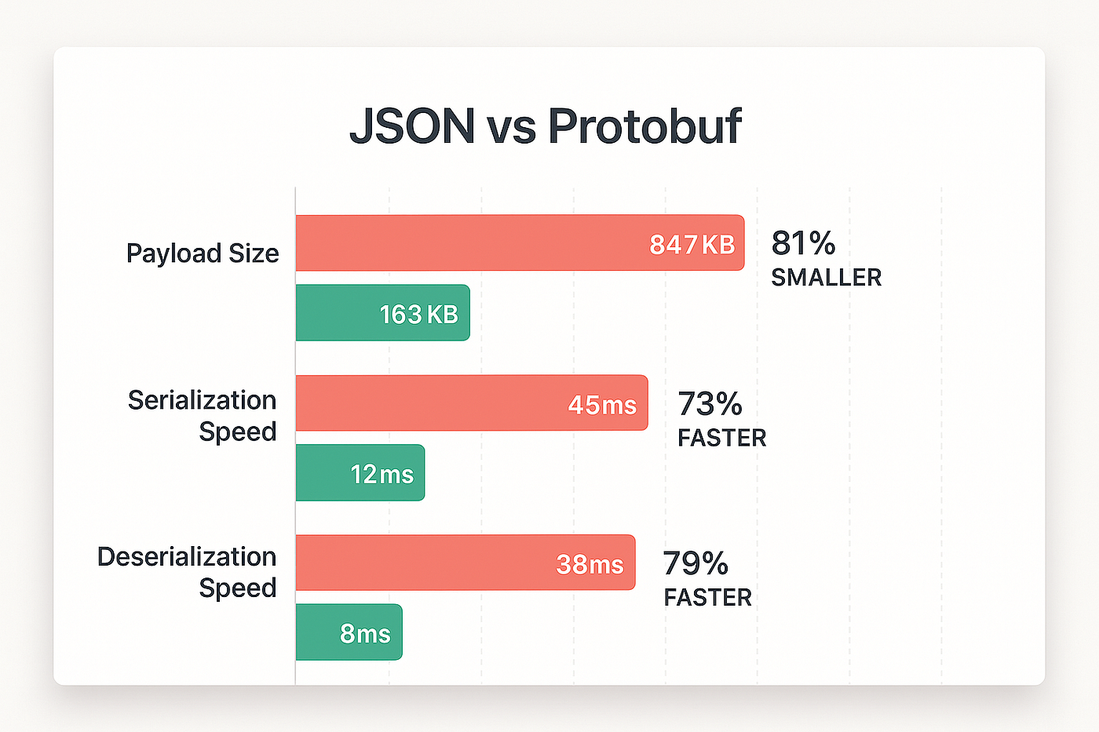
3. Implementing gRPC Service in a Blazor Application (.NET 10.0)
We will build:
- gRPC Service
- Blazor Server client
- Blazor WebAssembly client (via gRPC-Web)

3.1 Create a gRPC Service (.NET 10.0)
Step 1: Create gRPC Project
dotnet new grpc -n ProductGrpcService
cd ProductGrpcService

Step 2: Define Protobuf Contract
📁 Protos/product.proto
syntax = "proto3";

option csharp_namespace = "ProductGrpcService";

service ProductService {
rpc GetProduct (ProductRequest) returns (ProductReply);
}

message ProductRequest {
int32 id = 1;
}

message ProductReply {
int32 id = 1;
string name = 2;
double price = 3;
}

Step 3: Implement gRPC Service
📁 Services/ProductServiceImpl.cs
using Grpc.Core;

namespace ProductGrpcService.Services;

public class ProductServiceImpl : ProductService.ProductServiceBase
{
public override Task<ProductReply> GetProduct(
ProductRequest request,
ServerCallContext context)
{
return Task.FromResult(new ProductReply
{
Id = request.Id,
Name = "Laptop",
Price = 75000
});
}
}

Step 4: Configure gRPC
📁 Program.cs
var builder = WebApplication.CreateBuilder(args);

builder.Services.AddGrpc();

var app = builder.Build();

app.MapGrpcService<ProductServiceImpl>();
app.MapGet("/", () => "gRPC Server Running");

app.Run();

3.2 Consume gRPC in Blazor Server (.NET 10.0)
Step 1: Create Blazor Server App
dotnet new blazorserver -n BlazorGrpcClient

Step 2: Add gRPC Client Packages
dotnet add package Grpc.Net.Client
dotnet add package Google.Protobuf
dotnet add package Grpc.Tools

Step 3: Add product.proto to Client
📁 Protos/product.proto
<ItemGroup>
<Protobuf Include="Protos\product.proto" GrpcServices="Client" />
</ItemGroup>

Step 4: Configure gRPC Client
📁 Program.cs
builder.Services.AddGrpcClient<ProductService.ProductServiceClient>(o =>
{
o.Address = new Uri("https://localhost:5001");
});

Step 5: Use gRPC in Blazor Component
📁 Pages/Product.razor
@inject ProductService.ProductServiceClient Client

<h3>Product</h3>

<button class="btn btn-primary" @onclick="LoadProduct">
Load Product
</button>

@if (product != null)
{
<p>@product.Name - ₹@product.Price</p>
}

@code {
ProductReply? product;

async Task LoadProduct()
{
product = await Client.GetProductAsync(
new ProductRequest { Id = 1 });
}
}

3.3 Consume gRPC in Blazor WebAssembly (gRPC-Web)

Key Concept
Browsers cannot use native gRPC, so we enable gRPC-Web.

Step 1: Enable gRPC-Web on Server
dotnet add package Grpc.AspNetCore.Web
📁 Program.cs
app.UseGrpcWeb();

app.MapGrpcService<ProductServiceImpl>()
.EnableGrpcWeb();

Step 2: Configure Blazor WASM Client
builder.Services.AddScoped(sp =>
{
var handler = new GrpcWebHandler(
GrpcWebMode.GrpcWebText,
new HttpClientHandler());

var channel = GrpcChannel.ForAddress(
"https://localhost:5001",
new GrpcChannelOptions { HttpHandler = handler });

return new ProductService.ProductServiceClient(channel);
});

Step 3: Use Same Razor Code
The component code remains unchanged, which is a major benefit of gRPC.

4. Summary
Architecture Recommendation
Scenario | Recommendation
Blazor Server | Native gRPC
Blazor WASM | gRPC-Web
Public APIs | REST
Internal Microservices | gRPC
Key Takeaways
- gRPC is faster and safer than REST
- .proto defines the contract
- Ideal for Blazor Server & microservices
- Blazor WASM requires gRPC-Web

