Debugging the Code in Blazor
Debugging is the systematic process of finding, understanding, and fixing defects in an application. In Blazor, debugging differs slightly depending on hosting model:
- Blazor Server → runs on the server (.NET runtime on IIS/Kestrel)
- Blazor WebAssembly (WASM) → runs in the browser (Mono/.NET runtime in WebAssembly)
We will cover both in detail.

1. Making Things Break (Intentional Failure)
Before learning debugging, you must intentionally break code to observe:
- Where the failure occurs
- How the debugger behaves
- What tools are available
Common Ways to Break Code in Blazor
- NullReferenceException
- Logic bugs (wrong output)
- Async timing issues
- UI not updating
- JavaScript interop failures

Example 1: NullReferenceException
Component: Counter.razor
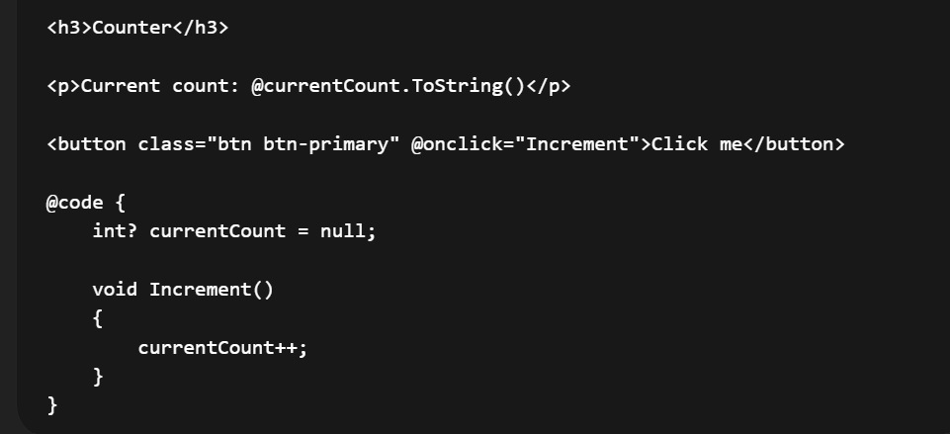
What breaks?
- currentCount.ToString() throws NullReferenceException
This is ideal for learning breakpoints and stack traces.

2. Debugging Blazor Server
How Blazor Server Works (Debug Perspective)
- Code executes on the server
- UI updates sent via SignalR
- Debugging is almost identical to ASP.NET Core MVC

Debugging Setup (Blazor Server)
- Open project in Visual Studio
- Select Debug
- Press F5
- Browser launches automatically

Using Breakpoints
Set a breakpoint inside a component:
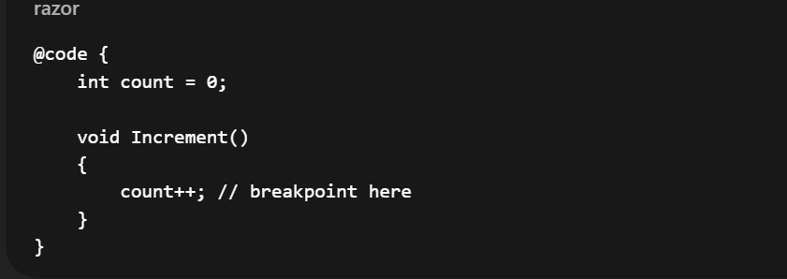
What You Can Inspect
- Local variables
- Component state
- Call stack
- Dependency-injected services

Example: Debugging a Service Issue
Service
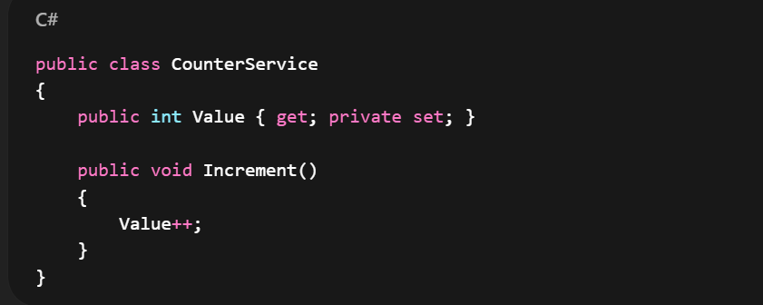

Component
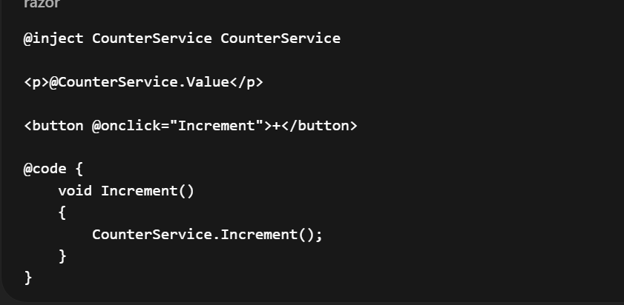
Debugging Focus
- Is the service registered as Singleton?
- Is state persisting across requests?

Common Blazor Server Debugging Issues
Issue | Cause
UI freezes | SignalR connection lost
State resets | Incorrect DI lifetime
Multiple users sharing state | Singleton misuse
JS interop fails | Prerendering issue

3. Debugging Blazor WebAssembly (WASM)
Key Difference
Blazor Server | Blazor WASM
Runs on server | Runs in browser
.NET CLR | Mono WASM runtime
Easy debugging | More complex debugging

Debugging in Visual Studio
- Set startup project
- Run with Debug
- Browser launches
- Debugger attaches to WASM runtime
You can:
- Set breakpoints in .razor and .cs
- Inspect variables
- Step through code
⚠️ Debugging may feel slower due to WebAssembly execution.

Example: Debugging API Call
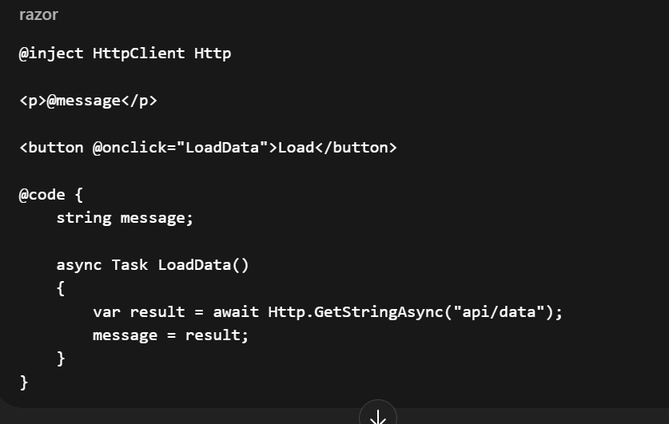
Breakpoints
- Before API call
- After response
- On exception

Common WASM Debugging Problems
Problem | Explanation
Breakpoint not hit | Browser debugger not attached
Null values | Async lifecycle timing
Slow debugging | WASM runtime overhead
API fails | CORS / HTTPS issues

4. Debugging Blazor WebAssembly in the Web Browser
This is critical for instructors.
Chrome / Edge DevTools
Press F12

Console Debugging
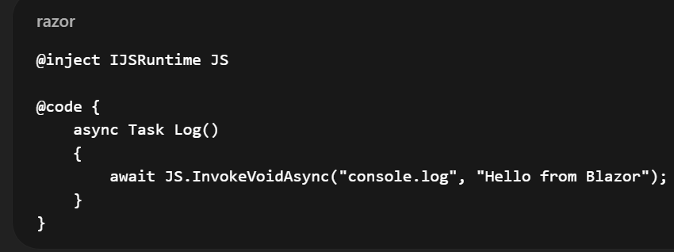
Use Console tab to:
- View logs
- Catch JS errors
- Inspect network calls

Network Tab (Very Important)
Used to debug:
- API failures
- HTTP status codes
- Payload issues
Steps:
- Open DevTools
- Go to Network
- Trigger API call
- Inspect request/response

Source Tab (Advanced)
- View compiled WASM files
- Inspect JS interop files
- Debug JavaScript isolation modules

5. Hot Reload (Blazor Productivity Feature)
What Is Hot Reload?
Hot Reload allows you to:
- Modify code
- Save file
- See UI changes without restarting the app

What Hot Reload Supports
Change Type | Supported
HTML markup | Yes
CSS | Yes
Simple C# logic | Yes
Method signature | No
DI registration | No

Example: Hot Reload in Action
Change markup:
<h3 style="color:red">Counter</h3>
Save file → UI updates instantly.

Hot Reload Limitations (Important for Exams & Interviews)
- Cannot add new classes
- Cannot change method signatures
- Sometimes requires restart for state reset

6. Debugging Lifecycle Issues (Very Common)
Example: OnInitialized vs OnAfterRender
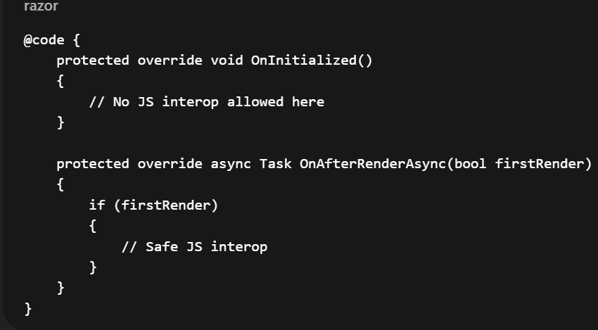
Common Error
JavaScript interop calls cannot be issued at this time
Debugging Insight
- Check lifecycle method
- Verify render mode

Blazor Debugging Comparison
Feature | Server | WASM
Breakpoints | Excellent | Good
Browser tools | Limited | Essential
Performance | Fast | Slower
Hot Reload | Stable | Improving

8. Real-World Debugging Checklist
- Set breakpoints early
- Inspect DI lifetimes
- Check browser console
- Verify API endpoints
- Restart app if Hot Reload fails
- Understand lifecycle methods

