Deploying Blazor applications to Production

1.Blazor .NET 10 supports three execution models, each with different deployment characteristics:
Model | Runtime Location
Blazor Server / InteractiveServer | Server
InteractiveWebAssembly | Browser + Server
Blazor WebAssembly Standalone | Browser only

2. Continuous Delivery (CD) Options for Blazor
Continuous Delivery ensures that every commit can be deployed safely.
Common CD Pipeline Stages
- Source Control
  - GitHub / Azure DevOps / GitLab
- Build
  - dotnet restore
  - dotnet build
- Test
  - Unit tests (xUnit, bUnit)
- Publish
  - dotnet publish -c Release
- Deploy
  - IIS / Azure / Linux / Docker
Popular CD Tools
Tool | When to Use
GitHub Actions | Open-source or GitHub-hosted code
Azure DevOps Pipelines | Enterprise CI/CD
GitLab CI | GitLab-hosted repos
Jenkins | On-premise automation
Example: Publish Command Used in Pipelines
dotnet publish -c Release -o ./publish
This output folder is what gets deployed.

3. Hosting Options for Blazor Apps
High-Level Hosting Choices
Hosting Platform | Supported Blazor Models
IIS (Windows) | All
Azure App Service | All
Linux (Nginx + Kestrel) | Server, WASM Hosted
Docker / Kubernetes | All
Static Hosting (CDN) | WASM Standalone

4. Hosting Blazor Server / InteractiveServer
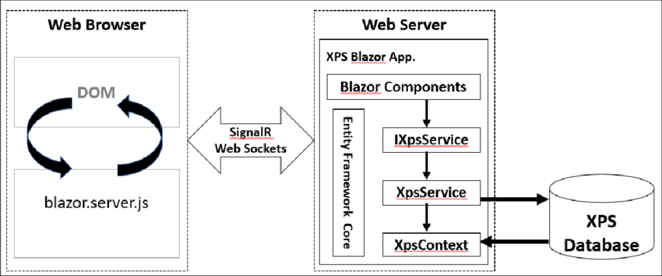

How It Works
- UI rendered on the server
- Browser communicates via SignalR
- Fast initial load
- Requires persistent connection
Deployment Characteristics
- Deployed like ASP.NET Core MVC
- Needs:
  - .NET Runtime on server
  - WebSockets enabled(Communication Protocol)
- Not suitable for offline usage
Typical Hosting Targets
- IIS
- Azure App Service
- Linux + Nginx

5. Hosting InteractiveWebAssembly (Blazor Web App)
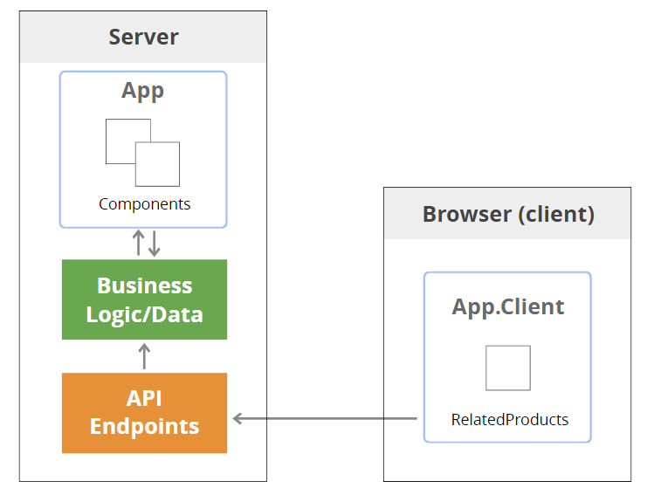

How It Works
- App starts as server-rendered
- Later switches to WebAssembly
- Best balance of:
  - SEO
  - Performance
  - Interactivity
Deployment Characteristics
- Single ASP.NET Core app
- Includes:
  - Server project
  - WASM assets
- Hosted like a normal ASP.NET Core app
Typical Hosting Targets
- IIS
- Azure App Service
- Docker
Production Benefits
- Faster first paint
- Reduced server load after hydration
- Modern default for .NET 10

6. Hosting Blazor WebAssembly Standalone
How It Works
- Entire app runs in browser
- Server only provides static files
- Calls APIs via HTTP
Deployment Characteristics
- Output is static files
  - .html
  - .js
  - .wasm
- No .NET runtime needed on server
Hosting Targets
- IIS
- Azure Static Web Apps
- CDN (CloudFront, Azure CDN)
- Nginx
Production Benefits
- Scales easily
- Offline capable
- Very low hosting cost
Limitations
- Larger initial download
- SEO requires prerendering strategy
- API must be hosted separately

7. Hosting on IIS (Windows Server)

IIS Hosting Model
Prerequisites
- Windows Server
- IIS installed
- ASP.NET Core Hosting Bundle from Microsoft
Deployment Steps (Typical)
- Publish the app:
dotnet publish -c Release
- Copy published files to IIS site folder
- Create Application Pool:
  - No Managed Code
  - Integrated pipeline
- Configure web.config (auto-generated)
IIS Hosting Support Matrix
Blazor Type | IIS Support
Blazor Server | Yes
InteractiveServer | Yes
InteractiveWebAssembly | Yes
WASM Standalone | Yes (static files)

8. Environment Configuration in Production
Use environment-based configuration:
appsettings.Production.json
builder.Configuration
.AddJsonFile("appsettings.Production.json");
Set environment variable:
ASPNETCORE_ENVIRONMENT=Production

9. Choosing the Right Deployment Model
Scenario | Recommended Model
Internal enterprise app | Blazor Server
Public SEO-friendly app | InteractiveWebAssembly
SPA / PWA | WASM Standalone
Low-cost hosting | WASM Standalone
Real-time dashboards | Server

10. Summary
- Continuous Delivery automates build, test, and deployment
- Hosting choice depends on Blazor execution model
- IIS remains a first-class production host
- InteractiveWebAssembly is the preferred modern default in .NET 10

