push notifications in a Blazor PWA application

1. What Are Push Notifications?
Push notifications are server-initiated messages delivered to a user’s device even when the application is not open. In a Blazor PWA, they are handled by the browser, not by .NET directly.
Key characteristics:
- Work when the app is closed
- Delivered via the browser’s push service
- Displayed using a Service Worker
- Require explicit user permission

2. Why Push Notifications in Blazor PWA?
Blazor PWAs use push notifications for:
- Order status updates (e-commerce)
- Alerts and reminders
- Background system notifications
- Re-engagement of users
Because Blazor runs on WebAssembly, push notifications are implemented using standard Web APIs, not Blazor-specific APIs.

3. Core Architecture
Push notifications in a Blazor PWA involve four actors:
- Blazor WebAssembly App
- Service Worker
- Browser Push Service (Chrome, Edge, Firefox)
- Application Server (ASP.NET Core API)
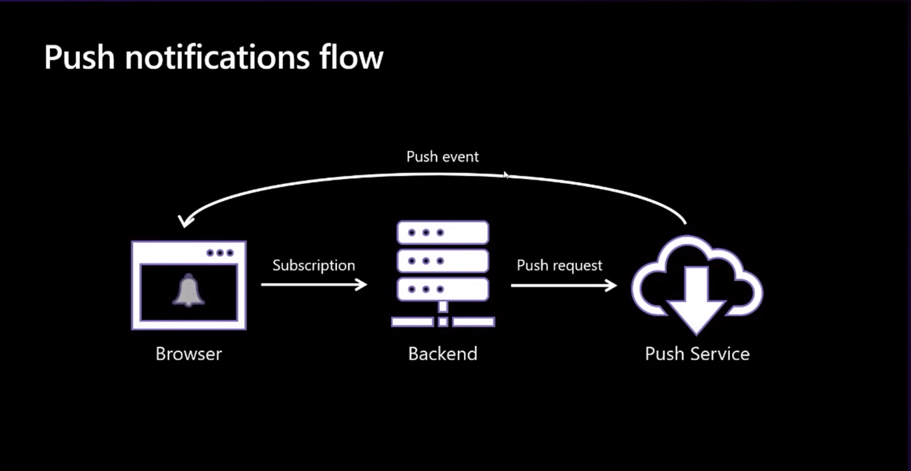
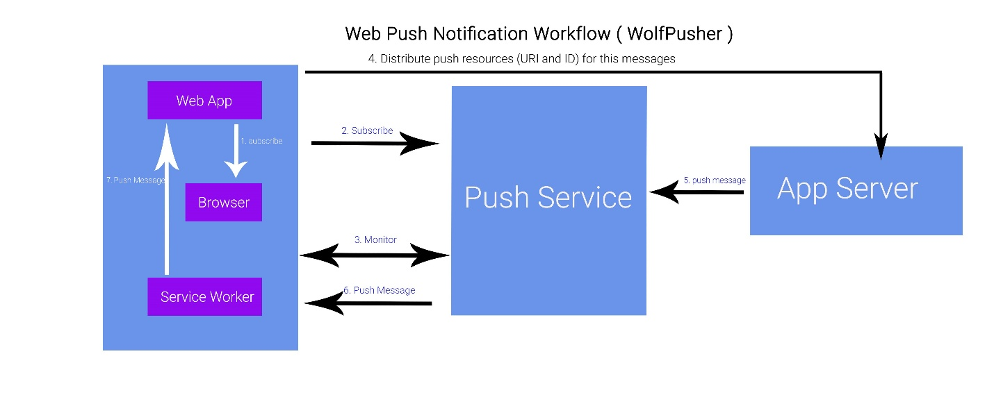

4. Key Components Explained
4.1 Service Worker (Mandatory)
A Service Worker is a background JavaScript file that:
- Runs independently of the Blazor app
- Receives push events
- Displays notifications
In Blazor PWA, this is typically:
wwwroot/service-worker.js
Without a service worker, push notifications cannot work.

4.2 Push Subscription
A push subscription uniquely identifies a browser + device.
It contains:
- Endpoint URL
- Public key
- Authentication secret
This subscription is:
- Created in the browser
- Sent to your backend
- Stored for later use

4.3 VAPID Keys
VAPID (Voluntary Application Server Identification) keys are used to:
- Authenticate your server with the browser push service
- Prevent push abuse
They include:
- Public key (shared with client)
- Private key (kept on server)

5. High-Level Flow (Step-by-Step)
Step 1: User Opens Blazor PWA
The app loads and registers the service worker.
Step 2: Request Permission
The browser prompts:
“Allow notifications?”
Step 3: Create Push Subscription
If allowed:
- Browser generates a subscription
- Blazor app sends it to backend API
Step 4: Store Subscription
Backend saves subscription in database.
Step 5: Server Sends Push Message
Backend sends a message using:
- Subscription endpoint
- VAPID private key
Step 6: Service Worker Displays Notification
The browser wakes the service worker and shows the notification.

6. Where Blazor Fits In
Blazor’s role is orchestration, not delivery.
Blazor handles:
- Requesting permission
- Calling JavaScript via JS interop
- Sending subscription data to backend
JavaScript handles:
- Push APIs
- Service Worker events
Server handles:
- Message generation
- Secure push delivery

7. JavaScript Responsibilities
Push notifications rely on Web Push APIs, which are not available directly in .NET.
JavaScript is responsible for:
- Notification.requestPermission()
- serviceWorkerRegistration.pushManager.subscribe()
- Handling push events
- Displaying notifications
Blazor calls these via JavaScript Interop.

8. Service Worker Push Handling (Conceptual)
Inside service-worker.js:
self.addEventListener("push", event => {
const data = event.data.json();

self.registration.showNotification(data.title, {
body: data.message,
icon: "/icon-192.png"
});
});
This runs even if Blazor is not loaded.

9. Backend Role (ASP.NET Core API)
The backend:
- Stores push subscriptions
- Sends notifications using Web Push protocol
- Uses VAPID private key
- Can trigger notifications from:
  - Background jobs
  - Business events
  - Scheduled tasks
Blazor never sends push messages directly.

10. Limitations & Constraints
Important constraints to understand:
Limitation | Explanation
HTTPS required | Push works only over HTTPS
Browser support | Not supported on iOS Safari (limited support improving)
User permission | Mandatory and revocable
No guarantee | Delivery is best-effort
Payload size | Typically < 4 KB

11. Blazor Server vs Blazor WASM
Feature | Blazor WASM PWA | Blazor Server
Push notifications | Fully supported | Not applicable
Offline support | Yes | No
Service Worker | Required | Not used
Background execution | Yes | No
Push notifications are only practical in Blazor WebAssembly PWA.

12. Common Use Cases in Blazor PWA
- Order shipped notification
- Session expiry warning
- New message alerts
- System maintenance notices
- Daily reminders

13. Summary
- Push notifications in Blazor PWA rely on browser standards, not Blazor APIs
- Service Workers are the backbone
- Blazor coordinates via JavaScript Interop
- Backend handles secure message delivery
- Works even when the app is closed

