1. Building a Progressive Web App (PWA)
A Progressive Web App is a web application enhanced with modern browser capabilities to behave like a native application(mobile app) while remaining deployable as a website.
Core idea
Use web standards (HTML, CSS, JavaScript) + browser APIs to deliver:
- Offline capability
- Installabilit
- Background processing
- Native-like UX
A Blazor WebAssembly PWA:
- Runs entirely in the browser
- Executes .NET code on WebAssembly
- Uses Service Workers for offline support
- Uses Web App Manifest for installation metadata
2. Key Features of a PWA
1. Offline Support
- Cached assets and API responses
- Works with flaky or no network
2. Installable
- Appears as an app icon
- Launches in standalone window (no browser UI)
3. Responsive
- Works on mobile, tablet, desktop
4. Secure
- HTTPS enforced
5. Automatic Updates
- New version activates silently via service worker lifecycle
3. Who Uses PWAs in 2026?
Industry | Use Case
E-commerce | Offline browsing, fast reloads
SaaS(Software as a Service) | Installable dashboards
FinTech(Financial Technology) | Secure lightweight apps
Education | Cross-platform learning apps
Government | Low-bandwidth support

4. Why PWAs Are Preferred
• No app-store dependency
• Lower maintenance cost
• Instant updates
• Single codebase
5. Creating a Blazor WebAssembly Application as a PWA
Step 1: Create Project (PWA Enabled)

This automatically generates:
- wwwroot/manifest.json
- wwwroot/service-worker.js
Step 2: Understand the Project Structure
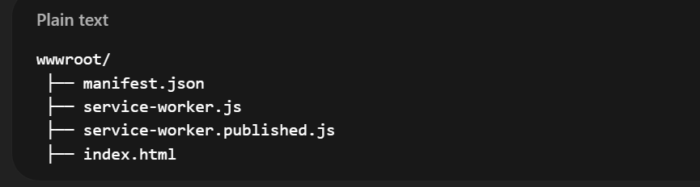

Step 3: Web App Manifest (manifest.json)
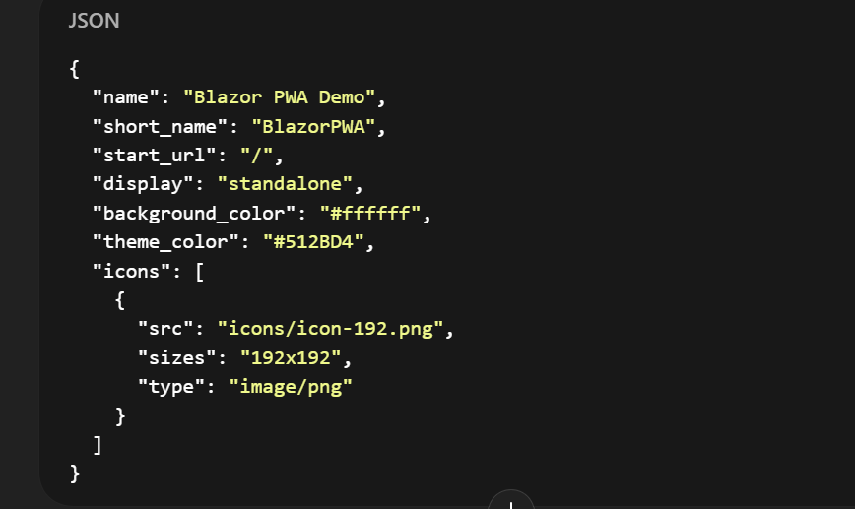
Important properties
- display: standalone → removes browser chrome
- start_url → app entry point
- icons → required for install prompt
Step 4: Service Worker (service-worker.published.js)
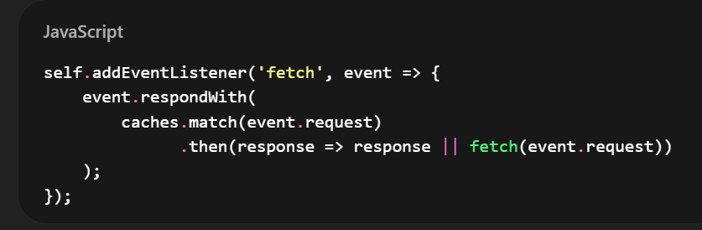
This enables:
- Cache-first strategy
- Offline fallback
- A Service Worker is a special JavaScript file that runs in the background of the browser, separate from the main web page.

