1. What Is Event Handling in Blazor?
Event handling is the mechanism by which a Blazor component reacts to user interactions such as:
- Mouse clicks
- Keyboard input
- Form submission
- Focus/blur
- Change events
Blazor uses Razor syntax to bind DOM events directly to C# methods, eliminating JavaScript for most UI logic.
2. How Event Handling Works Internally (High Level)
- User interacts with a DOM element (e.g., clicks a button)
- Browser raises a DOM event
- Blazor intercepts the event
- Event is dispatched to the component
- Bound C# method executes
- Component state changes
- Blazor triggers re-render (diff + DOM patch)
No full page reload occurs.
Hooking into event delegates
In Blazor, UI events (such as onclick, onchange, onsubmit) are handled by delegates.
When you “hook into an event delegate,” you are assigning a method (or lambda) to an event, so that Blazor invokes that method when the event occurs.
At runtime, Blazor:
- Captures the browser event
- Maps it to a .NET event delegate
- Invokes your C# method
1. Basic Hooking: Method Group to Delegate
This is the simplest and most common way.
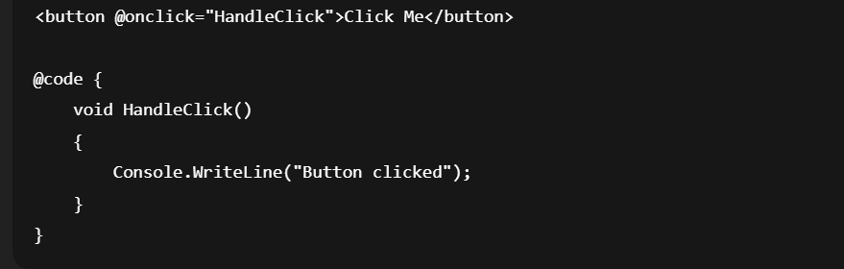
What happens internally
- @onclick expects a delegate of type EventCallback<MouseEventArgs>
- HandleClick matches the delegate signature
- Blazor hooks HandleClick into the event delegate
Hooking Using Lambda Expressions
Used when:
- You want to pass parameters
- You want inline logic
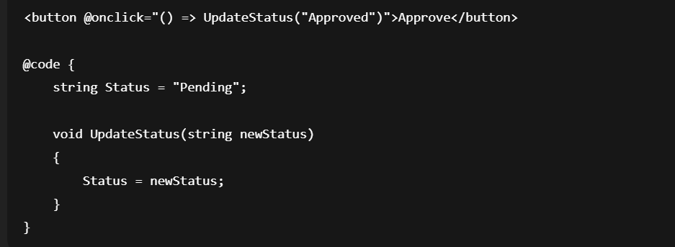
Here:
- The lambda () => UpdateStatus("Approved") is converted into a delegate
- That delegate is hooked into the onclick event
3. Hooking with Event Arguments
Some events provide event argument data.
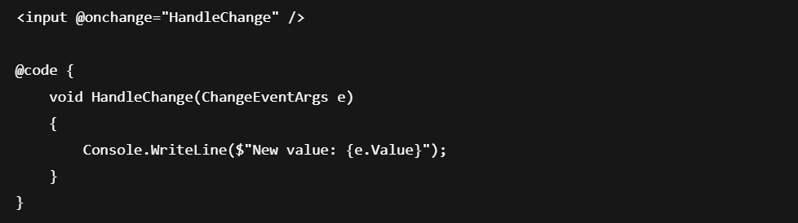
Delegate signature:
void HandleChange(ChangeEventArgs e)
Blazor ensures:
- Browser event → ChangeEventArgs
- Delegate is invoked with populated data

3. Basic Event Binding – @onclick
Demo 1: Button Click Counter
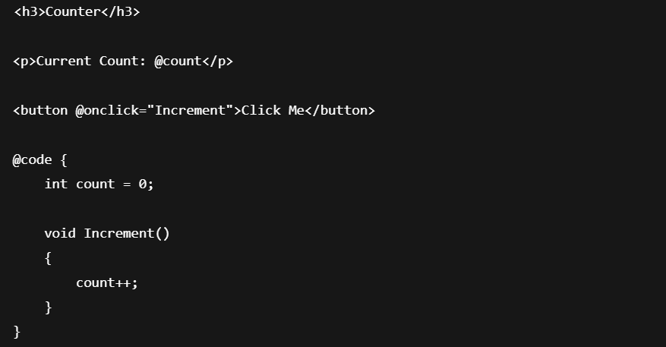
Key Points
- @onclick binds the DOM click event
- Method can be void, Task, or async Task
- State change automatically triggers UI refresh

4. Inline Lambda Event Handlers
Used when logic is simple or contextual.
Demo 2: Inline Handler
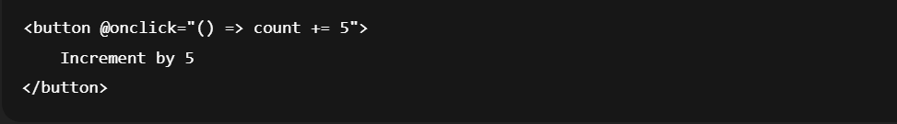
When to Use
- One-line logic
- No reuse needed
When NOT to Use
- Complex logic
- Reusability required
6. Handling Input Events (@onchange, @oninput)
6.1 @onchange (Default)

Triggered when focus leaves the input.
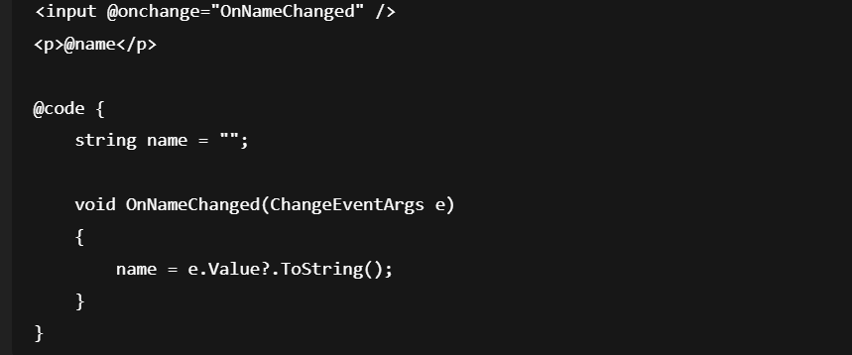

6.2 @oninput (Real-time)

Triggered on every keystroke.

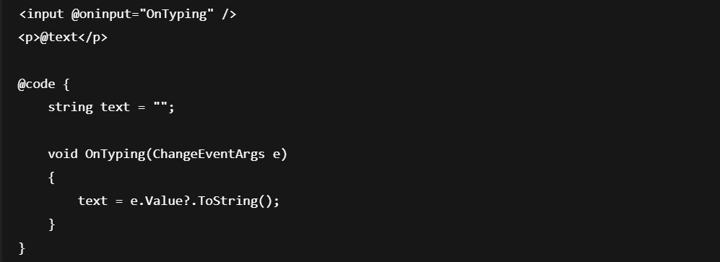
7. Keyboard Events
Demo 4: Detect Enter Key
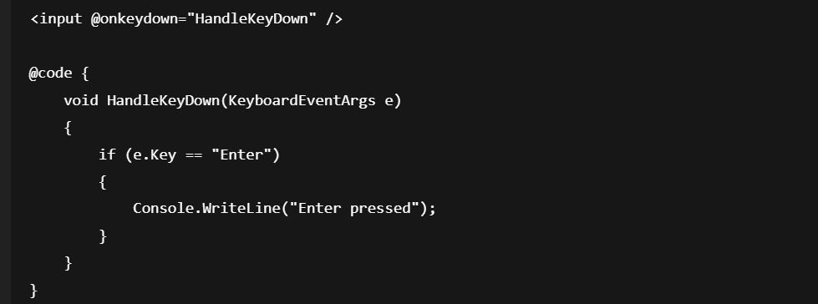
Common Keyboard Events
Event Purpose
@onkeydown Key pressed
@onkeyup Key released
@onkeypress Character input
9. Event Modifiers
Blazor provides event modifiers to control behavior.
9.1 @onclick:preventDefault
@onclick:preventDefault stops the browser’s default behavior for an element after the click occurs, while still allowing the Blazor event handler to run.
This is equivalent to JavaScript:
event.preventDefault();
In Blazor, it is expressed declaratively:
@onclick:preventDefault

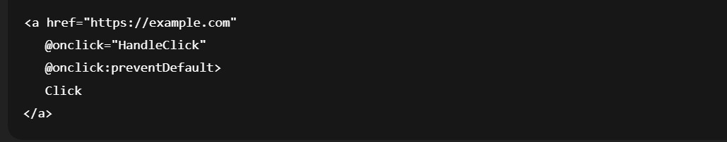

Prevents navigation.
3. Example 1: Prevent Link Navigation
Problem
Clicking a link navigates away immediately.
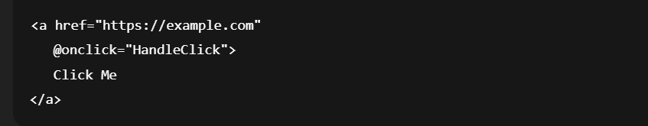
Solution
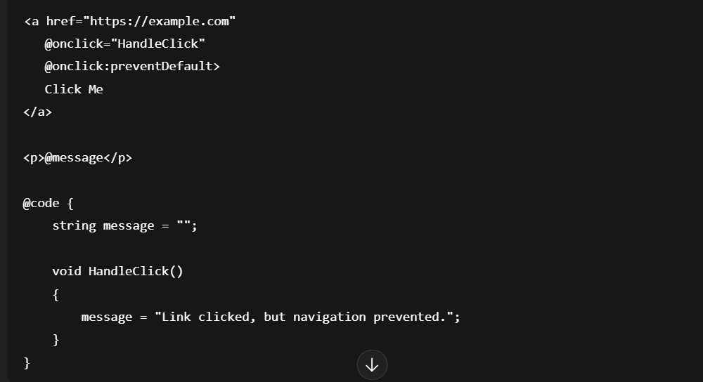
Result
- Click event fires
- Navigation does not occur
- Page remains intact

4. Example 2: Prevent Form Submission
Problem
Form reloads the page on submit.
<form>
<button type="submit" @onclick="Save">Save</button>
</form>
Solution
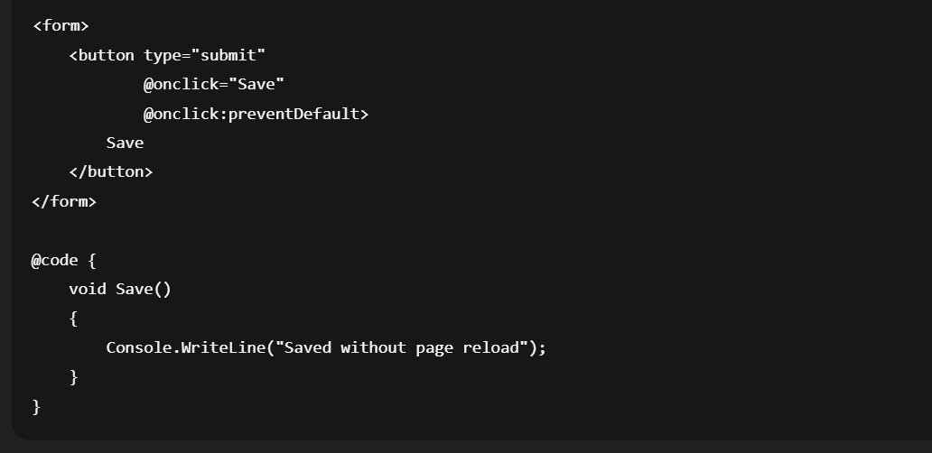

9.2 @onclick:stopPropagation
What is stopPropagation?
@onclick:stopPropagation stops an event from bubbling up the DOM tree.
It is the Blazor equivalent of JavaScript:
event.stopPropagation();
It does NOT:
- Prevent the browser’s default action
- Stop the Blazor handler itself
It ONLY stops the event from reaching parent elements.

2. Why Event Bubbling Matters
In the browser:
- Events start at the target element
- Then bubble upward to parent elements
Example:
button → div → body → document
Without stopping propagation:
- Clicking a button triggers all parent handlers
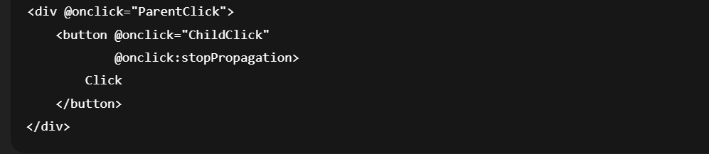
Stops event bubbling.

3. Basic Example (Problem)
Without stopPropagation
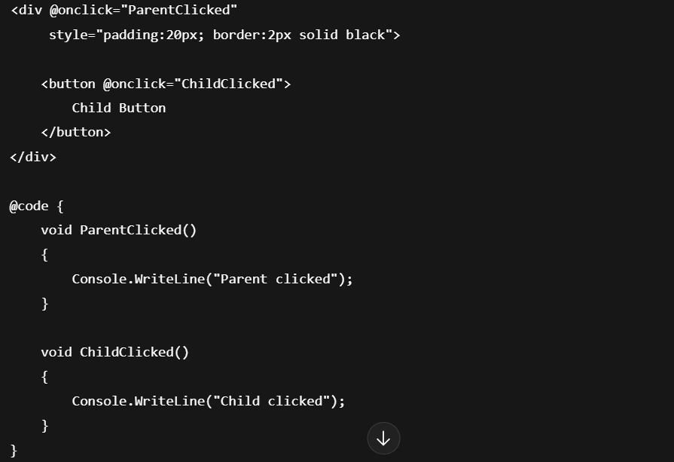
Result (Click Button)
Child clicked
Parent clicked

4. Solution: @onclick:stopPropagation
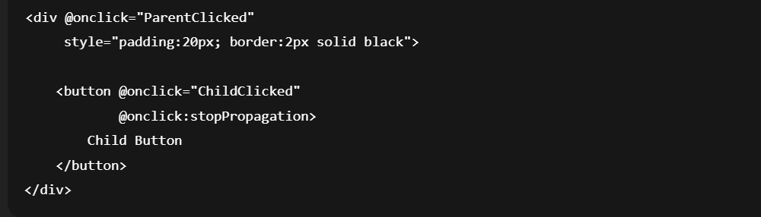
Result (Click Button)
Child clicked
Parent handler is not executed.

5. Real-World Use Case: Card with Action Buttons
Problem
Clicking Delete should not open the card.
<div class="card" @onclick="OpenDetails">
<h4>Order #123</h4>

<button @onclick="Delete">
Delete
</button>
</div>
Clicking Delete:
- Deletes the item
- Also opens details (undesired)

Correct Implementation
<div class="card" @onclick="OpenDetails">
<h4>Order #123</h4>

<button @onclick="Delete"
@onclick:stopPropagation>
Delete
</button>
</div>

@code {
void OpenDetails()
{
Console.WriteLine("Opening details...");
}

void Delete()
{
Console.WriteLine("Deleting...");
}
}
When You SHOULD Use stopPropagation
Use it when:
- Child actions exist inside clickable containers
- You want action buttons inside cards, lists, rows
- Context menus inside rows
- Modal close buttons inside overlays

stopPropagation vs preventDefault
Feature | stopPropagation | preventDefault
Stops bubbling | ✅ Yes | ❌ No
Stops default action | ❌ No | ✅ Yes
Allows handler | ✅ Yes | ✅ Yes

Combined Usage
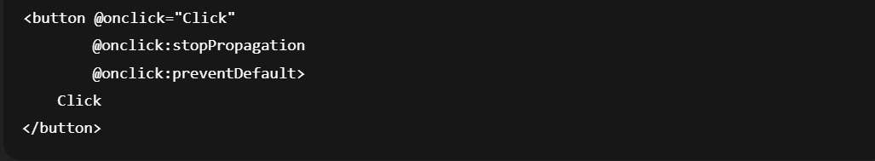
Async Event Handlers
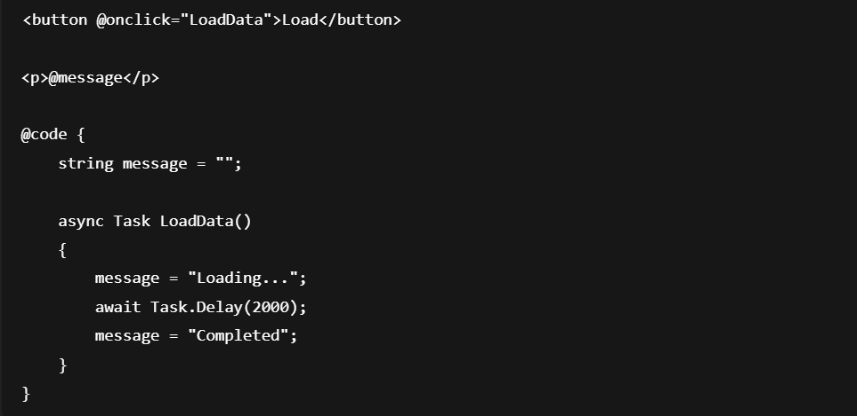

Best Practice
- Always use async Task
- Avoid async void

