# Azure Boards

* Azure boards are one of the main services of Azure DevOps
* Azure Board is an interface or a service of DevOps through which teams can manage their projects throughout the entire development lifecycle.
* It allows the team to track their tasks, work status, user stories, backlogs, features, and track bugs and defects in the project.
* Track user stories, backlog items, tasks, features, and bugs associated with your project
* You track work by adding work items based on the process and work item types
* Azure Boards used in a project to
  + Track the work with Kanban boards
  + Work with backlog
  + Team Dashboard
  + Reporting
* Azure Board provides a drag and drops feature to update the Kanban board.
* Azure Boards are fully compatible with scrum

# Use of Azure Boards

Azure Boards are useful in

* Manage and track work
* It provides a clear picture of work done
* You can give access to the board to your stakeholder allow him to see the progress of your development.
* We can manage scrum, sprint with azure boards.
* Manage your product backlog
* Get diff types of reports.

# Who Will Work on Azure Boards?

* The Whole Team
* The development team will work on managing the work (task, stories, bugs, etc.)
* PO will work to manage the backlog
* Stakeholders will work to see the status of what the team is doing
* The scrum master will work on the azure board to get a different types of reports and to see the progress of the team.

# Azure Board Types

* There are four types of work item processes while creating the new project
  + Basic
  + Agile
  + CMMI
  + Scrum
* The type of board depends on these work item process
* Each type provides different types of work items and workflow.

# Azure DevOps Process Templates

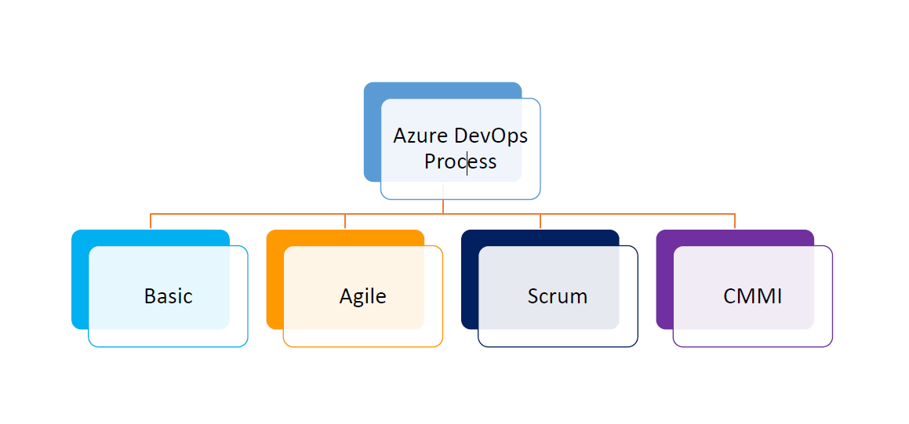

# CMMI vs. Agile vs. Scrum

* CMMI (Capability Maturity Model Integration) is used for the improvement of the current process to attain certain levels.
* Agile is a methodology that promotes continuous iteration of development and testing in the software development process.
* Scrum is an Agile process to focuses on delivering the business value in the shortest time It deals with a new process

# What is a Work item

* A work item is a unit of work that has several characteristics and is a part of your product development.
* Characteristics (Title, Description, Assigned To, Complete by, etc.)
* Example (Epic, Userstroy, Bug, Improvement, etc.)
* Work item Fields
  + **Title**: Enter the description of 255 char or less and we can modify the title at any time.
  + **AssignedTo**: Assign the work item to the team member responsible for performing the work.
  + **State**: Represent the current state (Column of Kanban board) (Todo, doing, done) of a work item.
  + **Reason**: Represent the reason for the state change.
  + **Area**: Represent the area path associated with the product or team.
  + **Iteration**: Represents the sprint or the iteration in which the work is to be completed.
  + **Description**: The Details of the work item
  + **Effort**: A relative estimate of the time required to complete a workflow.
  + **Discussion**: This field is used to add a comment to give/ask for information or to start a discussion regarding the work item.
  + **Start Date**- StartDate of the work item
  + **Target Date**- An end date indicating the successful workflow of a work item.
  + **Priority**- Represents the number that specifies the value of this work item to a business
    - **1**: Product cannot ship without the successful resolution of the work item , and it should be addressed as soon as possible.
    - **2**: Product cannot ship without the successful resolution of the work item , but it does not need to be addressed immediately.
    - **3**: Resolution of the work item is optional based on resources, time and risk.
    - **4**: Resolution of the work item is not required.

# Work item in Azure Boards (Basic)

* There are 3 work items in Azure board with basic process
* Epic
* Issue
* Task (smallest unit of the work)

Note: An Epic has multiple issues and an issue have multiple tasks

# Work Flow

* Work flow is the process of updating work item progress.
* Ex: basic work flow(TODO->InProgress->Done)

# Kanban Board

* Kanban board is useful for visualizing and track project progress
* Easily identify who is working on what tasks and the status of those tasks
* Create transparency between the team and the stakeholders
* Easy and user-friendly status change option by just drag and drop

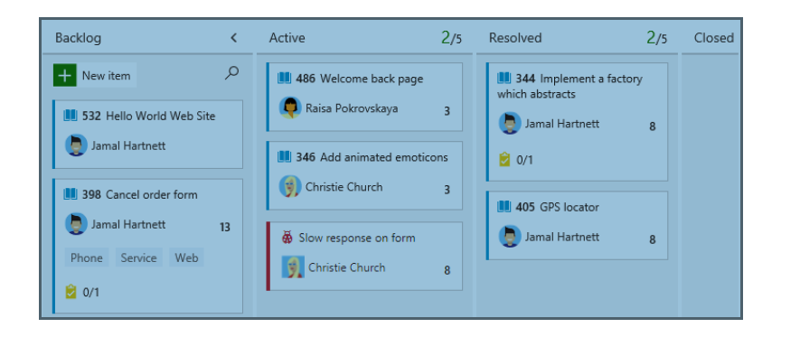

# What is Backlog

* A backlog is a collection of work items which will be used for future development.
* There are two types of backlog
* Product backlog
* Sprint backlog
* Product backlog is an ordered list of everything that is know to be need in the product
* Sprint backlog is a collection of work items which are in TOTO state
* Backlog is used for
  + Quickly define the task(user story, bug, product backlog etc)
  + Manage Priority
  + Add details and estimate to the backlog item in advance
  + Quickly assign work items to the team members
  + Group work items in a hierarchy
  + Forecast work to estimate what can be delivered within a sprint
  + Save time in sprint planning

# Burndown Graph

* Burndown graph represents the remaining work of a Scrum Team.
* The vertical axis represents the story points or hours and horizontal axis represent the dates (between the sprint start date and end date)

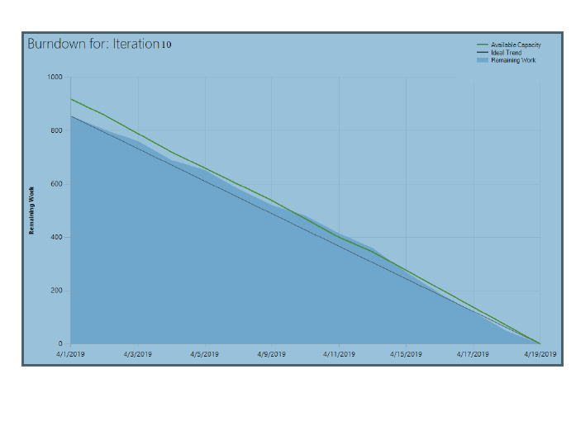

# Velocity

* Velocity is the measurement of backlog items completed in a single sprint by Team members
* Helps in forecasting future sprints and the backlog items that a team can complete

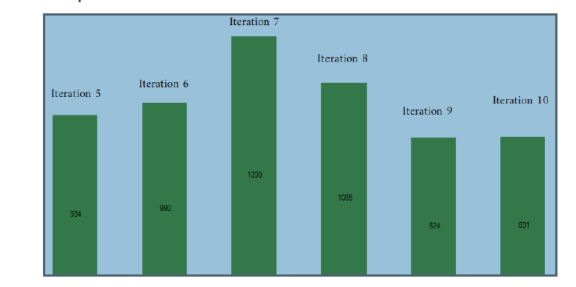

# Agile -How Does Scrum Work?

