## **What is Azure DevOps**

Azure DevOps, a modern DevOps tool of planning, developing, testing and deploying modern apps with optimized release cycle for quality delivery of applications.

Microsoft is rebranding and repositioning its Visual Studio Team Services (VSTS) coding collaboration service as 'Azure DevOps.

Azure DevOps provides a tool which can help you to track software building progress and help you to take decision to deliver great software to end users.

Azure DevOps services are not dependent on cloud or platform.

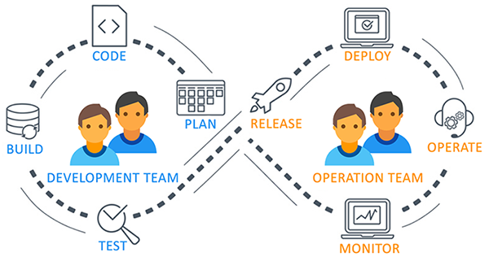

## **Benefits of Azure DevOps**

Azure DevOps allows the users to develop, deploy, and monitor code without opening multiple interfaces.

### Continuous Integration & Continuous Delivery (CI - CD)

When the code is committed, it automatically builds and is tested for errors, enabling bugs detection early. Business organizations can achieve fast and identical deployment to the production environment at any given time.

### Automation Testing

The use of automated tests, such as security and compliance tests identify problems at the testing phase. We can quickly provision resources and configures the entire production environment in a quick time.

### Any Platform, Any Language

It supports various platforms and a runs on multiple frameworks. The developers using Java, Node, PHP, .NET, and Python can efficiently work on it.

### App Insights

Azure Application Insights provides insights through application performance management and instant analytics. You can monitor infrastructure health with Azure Log Analytics and Azure Monitor.

Azure DevOps includes the following services/Components:

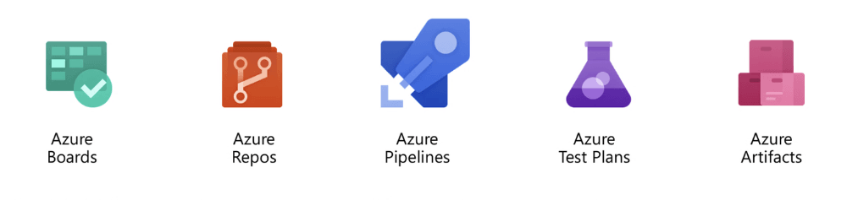

### Azure Pipelines (Build and Release)

Azure Pipeline is a cloud-hosted pipelines for fast CI/CD that works with any language, platform, and cloud. By connecting to any source control like GitHub, this service can release changes continuously to any cloud. YAML files are very useful in writing build and release definitions. Azure Pipelines has components like build, release, library, task groups, deployment groups. Azure Pipelines has advance workflows with native container support and features which allow monitoring CI/CD stages.

### Azure Boards (Work)

Azure Boards helps to plan, track, and discuss work across the team. Azure Boards is a powerful agile tool for managing Kanban board, reporting, product backlog.

* Azure boards have components like work items, backlogs, Boards, queries, sprints details.
* Work item can be bug, epic, issue, task or features. This service is sprint ready and built for insights to improve productivity.
* We can manage user authentication and authorization, team, project, and organization-level settings. Azure Boards helps you to write query to retrieve specific work items from the system.

### Azure Artifacts (Packages)

Azure Artifact service manages the dependencies used in source code. Azure Artifacts can host and share package (like NPM, Nuget, Maven) feeds from public and private sources.

* These artifacts simplify job building process.
* These stored artifacts are easy to integrate with Azure Pipelines.
* Azure Artifacts are managed package hosted on cloud and indexed.

### Azure Repos

Azure Reops service includes unlimited cloud-hosted private Git repository for your project. This is standard Git service and works as distributed source controls.

* Azure Repos supports all Git clients and all IDEs, all editor.
* You may do effective Git code review, can raise pull requests.
* Azure Repos supports branching strategy, so that you can we can merge the code after successful build and passing all the test case to maintain high code quality.
* Access to the repositories are managed by Azure AD, hence source code access management is fast and easy.

### Azure Test Plans

Azure test plan service helps to do automated and manual testing. Testing of an app is integral part of CI/CD and agile process. Simple XML files can be used for load testing as well.

* Azure Test Plans provides manual and exploratory testing tools. Hence, executing multiple scenario based scripted test gives end to end traceability.
* Test results are beneficial to record software bugs and defects.
* Automated tests will typically execute in a Pipeline.
* Stakeholder’s feedback can be captured in work items.

## **Tools for Azure DevOps**

Azure DevOps works well with most of the DevOps tools.

|  |  |
| --- | --- |
| Category | Tools Name |
| Configuration Tools | Chef, Ansible, Puppet |
| Continuous Integration | Jenkins |
| Microservices | Docker |
| Collaboration | Slack, Trello |
| Monitoring | Kibana, Grafana |
| Development | Visual Studio |

