# Azure Repos

* Azure Repo is used to manage and track your code and its changes while working with a team
* Azure Repos is a set of version control tools that you can use to manage your code.
* Version control systems are software that help you track changes you make in your code over time.
* Use version control to save your work and coordinate code changes across your team.
* Version control keeps a history of your development so that you can review and even roll back to any version of your code with ease.
* Azure Repos provides two types of version control:
* [Git](https://docs.microsoft.com/en-us/azure/devops/repos/get-started/what-is-repos?view=azure-devops#git): distributed version control
* [Team Foundation Version Control (TFVC)](https://docs.microsoft.com/en-us/azure/devops/repos/get-started/what-is-repos?view=azure-devops#tfvc): centralized version control
* Azure repos supports IDE like Visual Studio, VS Code, Eclipse, Command line and IntelliJ etc.
* Supports code import of an existing repo from GitHub, Bitbucket and GitLab

# Git

* Git is the most commonly used version control system today and is quickly becoming the standard for version control.
* Git is a distributed version control system, meaning that your local copy of code is a complete version control repository.
* These fully functional local repositories make it is easy to work offline or remotely. You commit your work locally, and then sync your copy of the repository with the copy on the server.
* Git in Azure Repos is standard Git. You can use the clients and tools of your choice, such as Git for Windows, Mac, partners' Git services, and tools such as Visual Studio and Visual Studio Code.

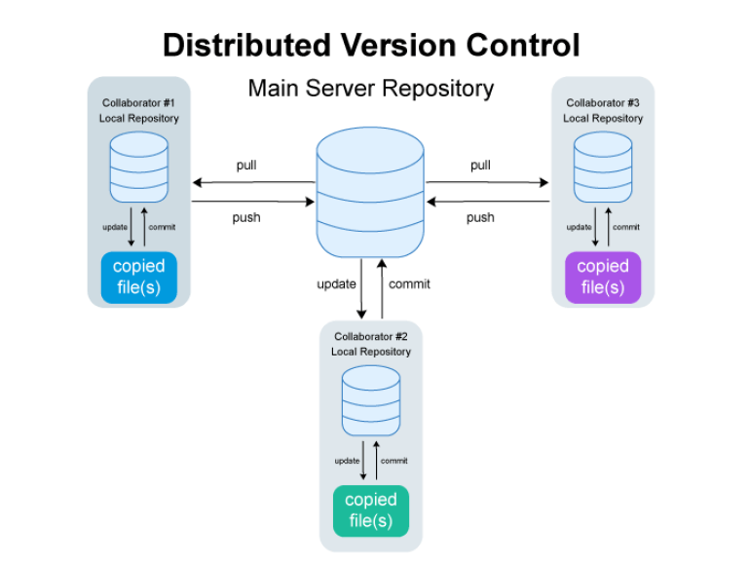

# TFVC

* Azure Repos also supports Team Foundation Version Control (TFVC). TFVC is a centralized version control system.
* A Centralized Version Control system provided by Azure DevOps to manage your code and files and track changes you make in your code over time.

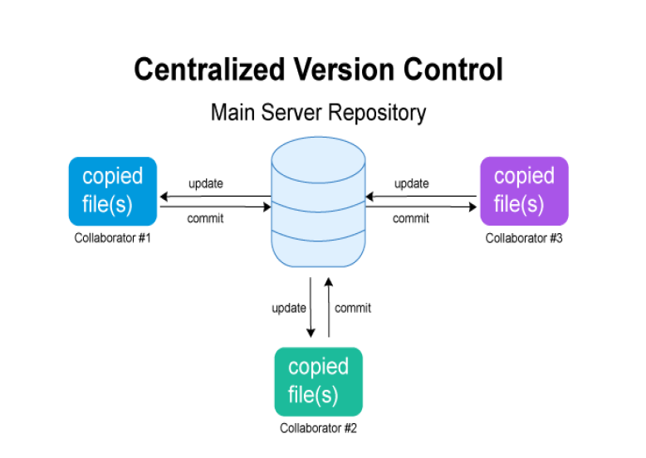

# Git vs GitHub

|  |  |
| --- | --- |
| A free and open source version control system to manage code | A cloud based service based on git  to manage code |
| A command line tool | Offers GUI interface |
| Creates a local repository to track  changes locally instead of storing  them on a server | Repository is created on cloud to  store code in a centralized location |
| No user management | Built in user management |

# Git Work Flow

